Advanced Software Engineering Jagadish Tirumalasetty (#39)

Challenge #1 Surya Botcha (#9)

1. Design

* Architecture Diagram:

We tried to build our application around the API provided by SUPERMARKETAPI.COM as the GroceryServerAPI referred in the Challenge had discontinued issuing developer keys.

As the API primarily returned huge xmls as response we decided to process them directly in the app rather them storing them in DB and again reading them just to display on the app. As all the screens and results were specific to user input criteria and the grocery search results where on fly we avoided using db.

APIs/WebServices

Service Request and Response Processorsor

Mobile Application

* Class Diagram:



1. Features Implemented:

Grocery Search (<http://www.SupermarketAPI.com/api.asmx/COMMERCIAL_SearchByProductName>?)

Store Search (<http://www.SupermarketAPI.com/api.asmx/CitiesByState>?)

And Geogle Geo Location Service.

Data Model:

XML Schema for Items

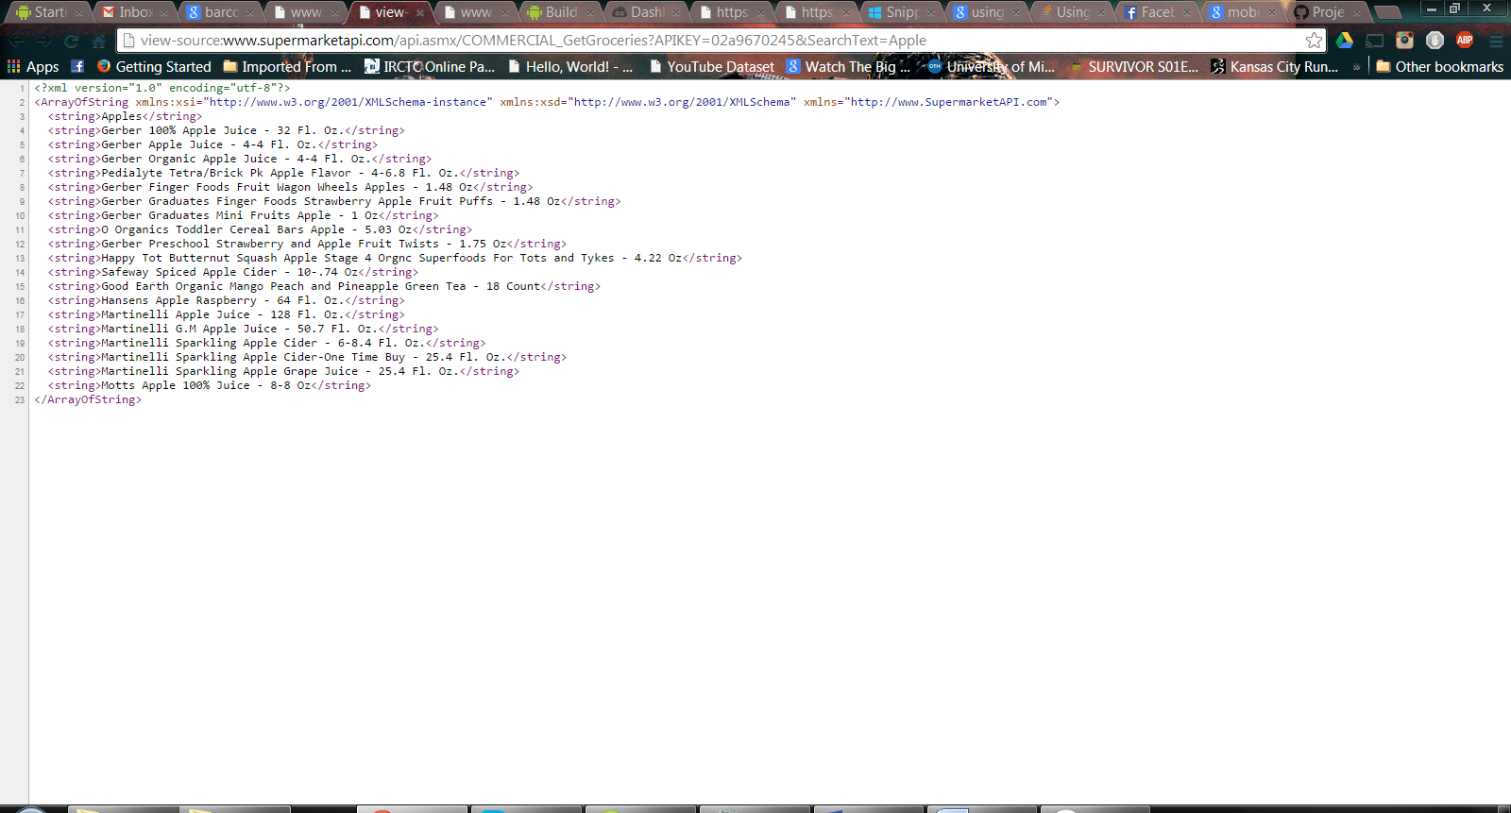

XML SCHEMA FOR STORE LOCATIONS

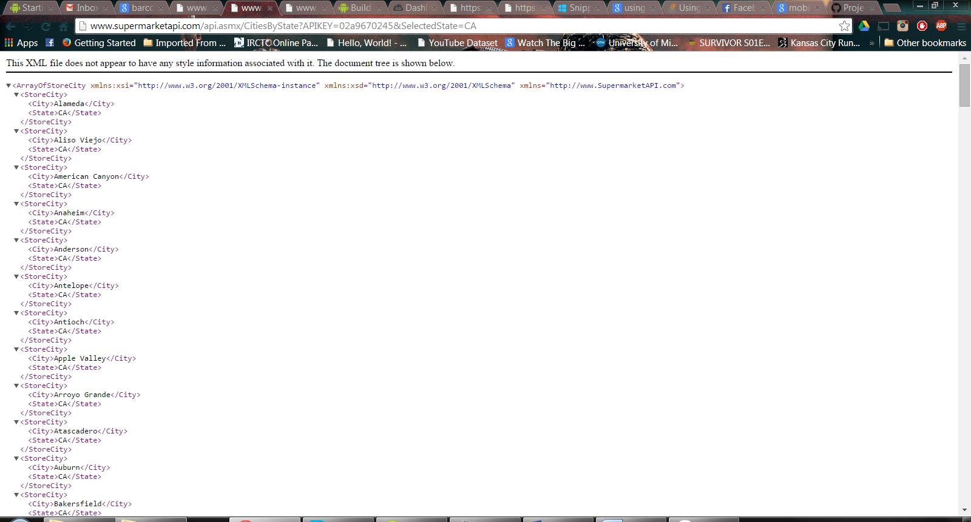

1. Screen Shots :

We could not capture screen shots cause of a problem with emulator which wasn’t loading on my system. Tried taking help from others for compatible device but could not find one as everyone was busy too. We will try to find a proper device/machine and try to show the whole app on demo.

1. APIs

* Supermarketapi.com (as mentioned in above sections)
* GeoLocationServices.

1. GitHub

<https://github.com/jagadishtirumalasetty/Projects/tree/master/ASE>

1. References

<https://github.com/DynamsoftRD/Android-Barcode-Reader>

<http://developer.android.com/training/basics/firstapp/building-ui.html>

<http://stackoverflow.com/>