**Report:** Lab 1 – Part 1, Group Submission

**Group 10**

**Jagadish, Murali, Sai Sowmya, Prudhvi**

**_____________________________________________________________________________________**

1. **Sensor Tag**

Below is the pic of our sensor tag identified in the device list

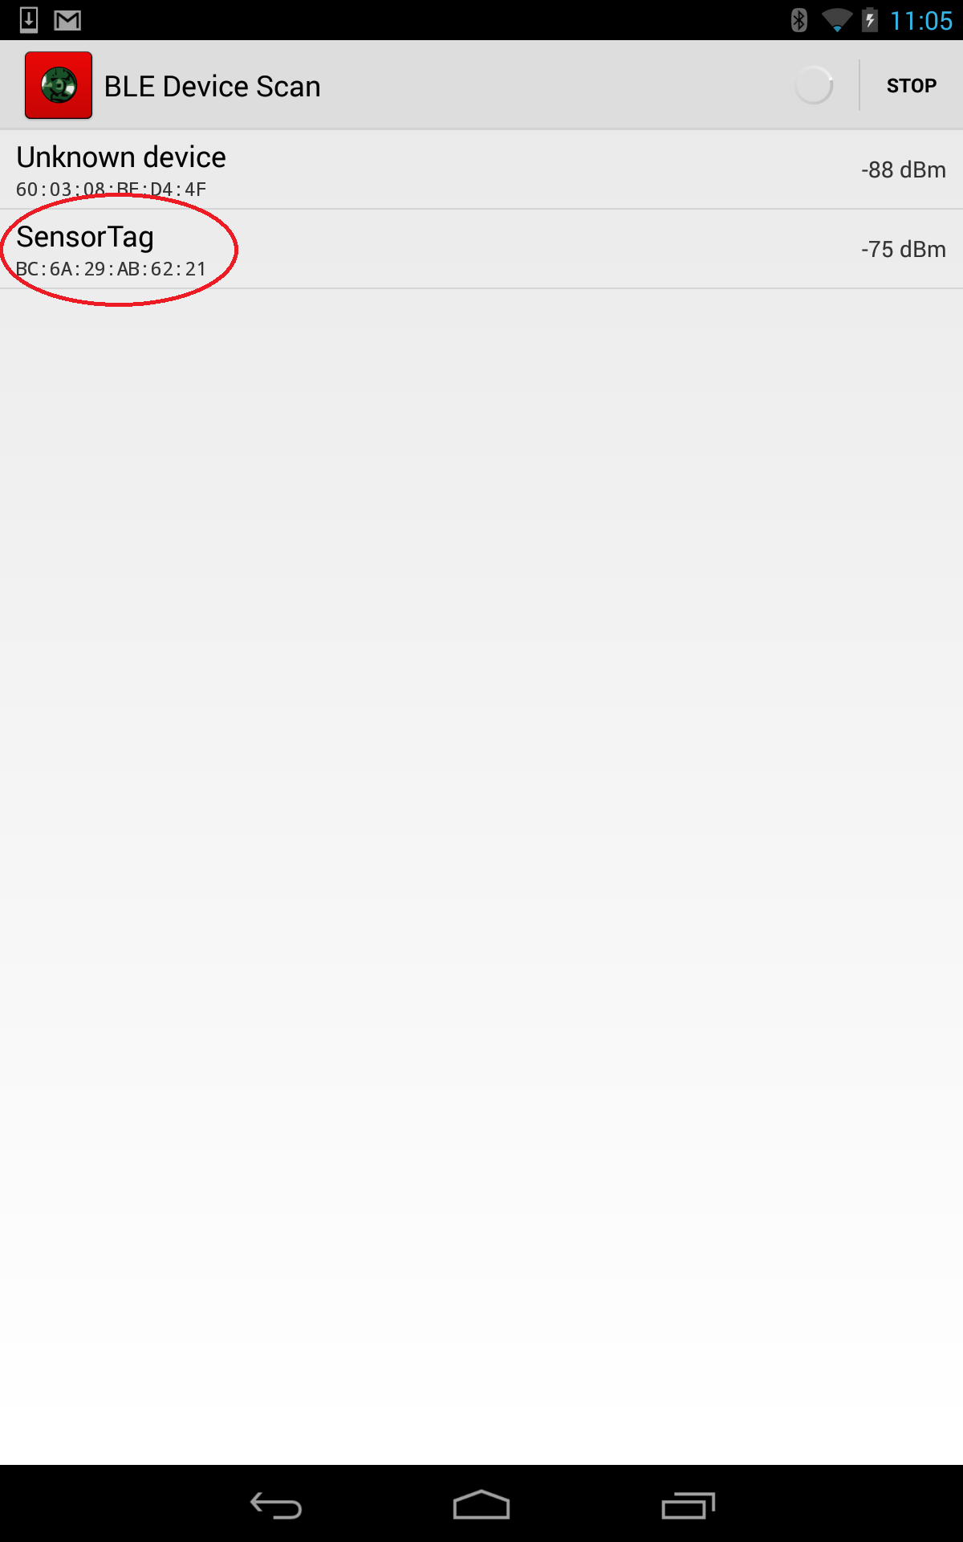

Image of data being read

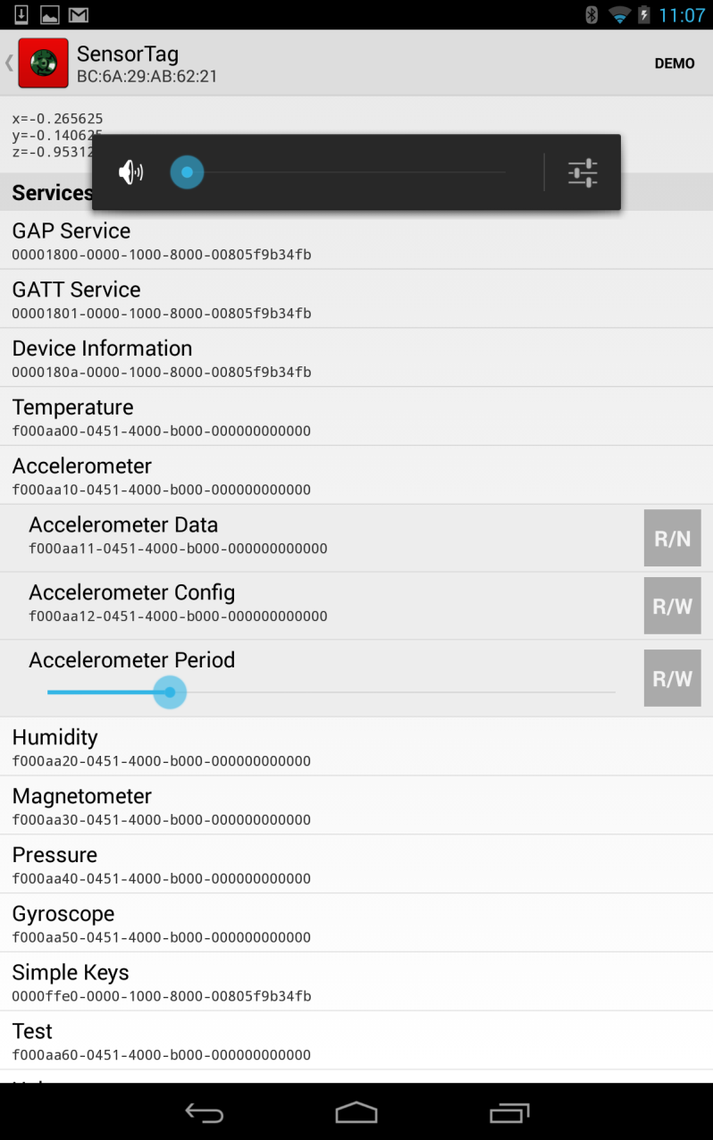

**Source Code:**

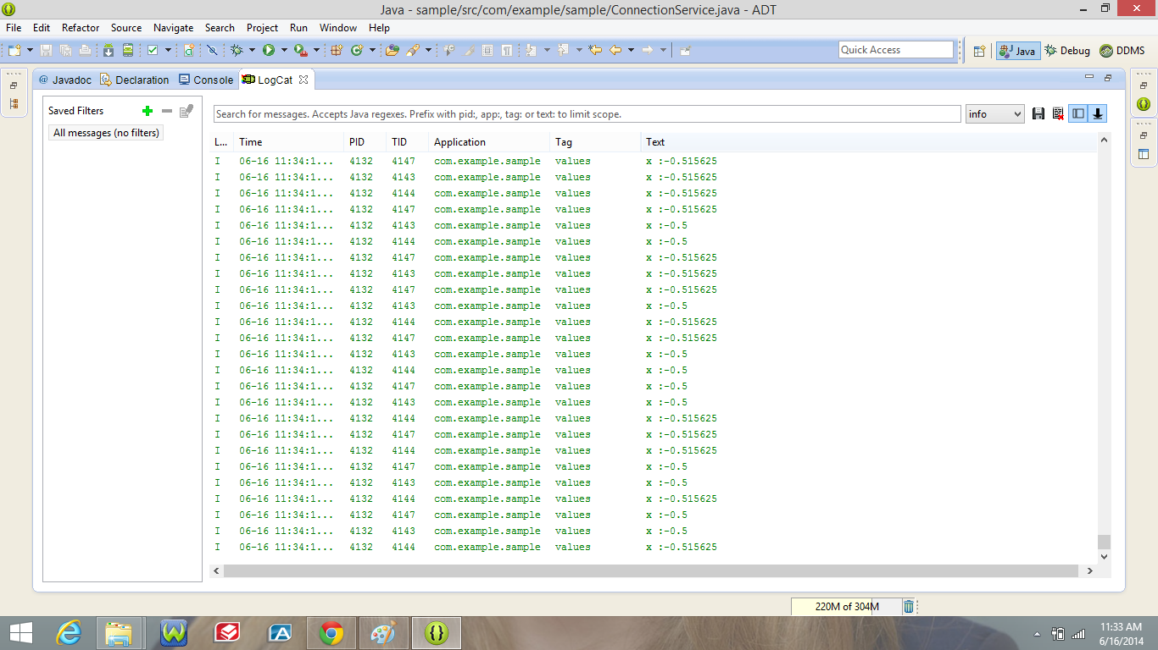

1. **Built in sensor.**

**Source Code:**

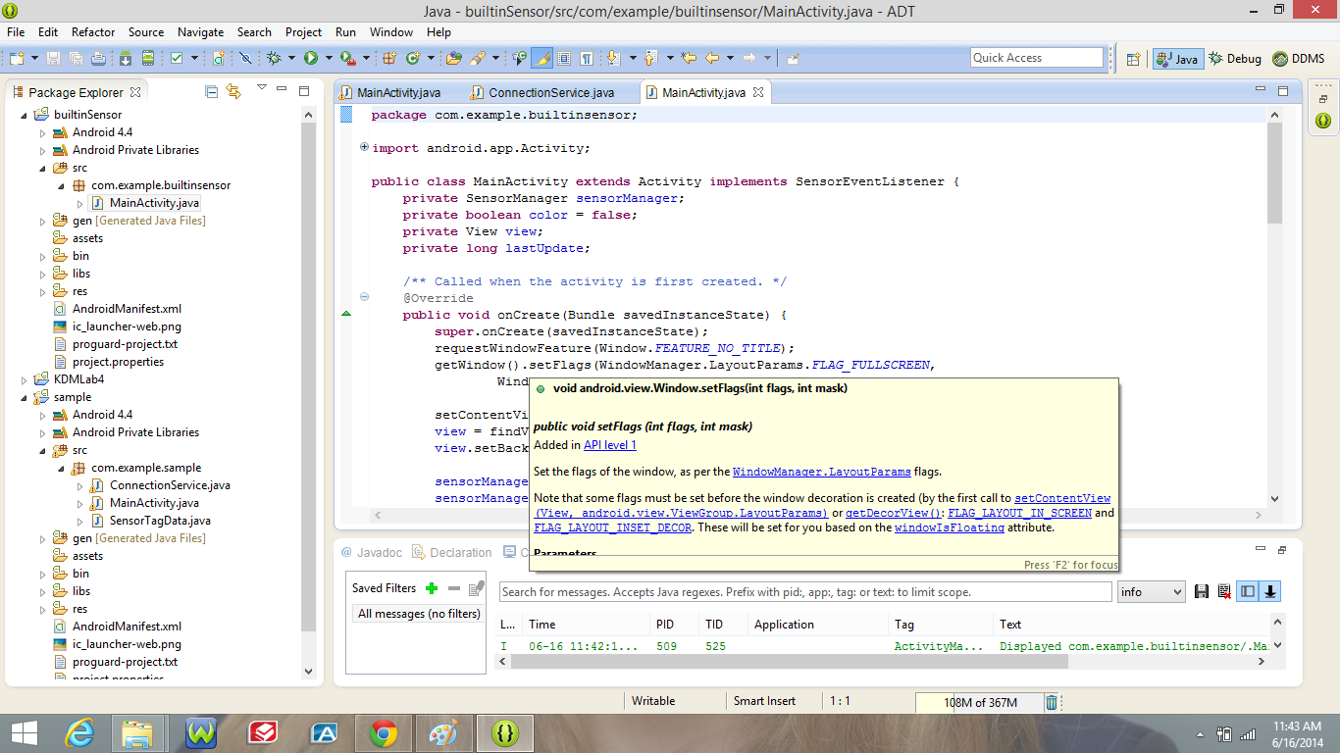

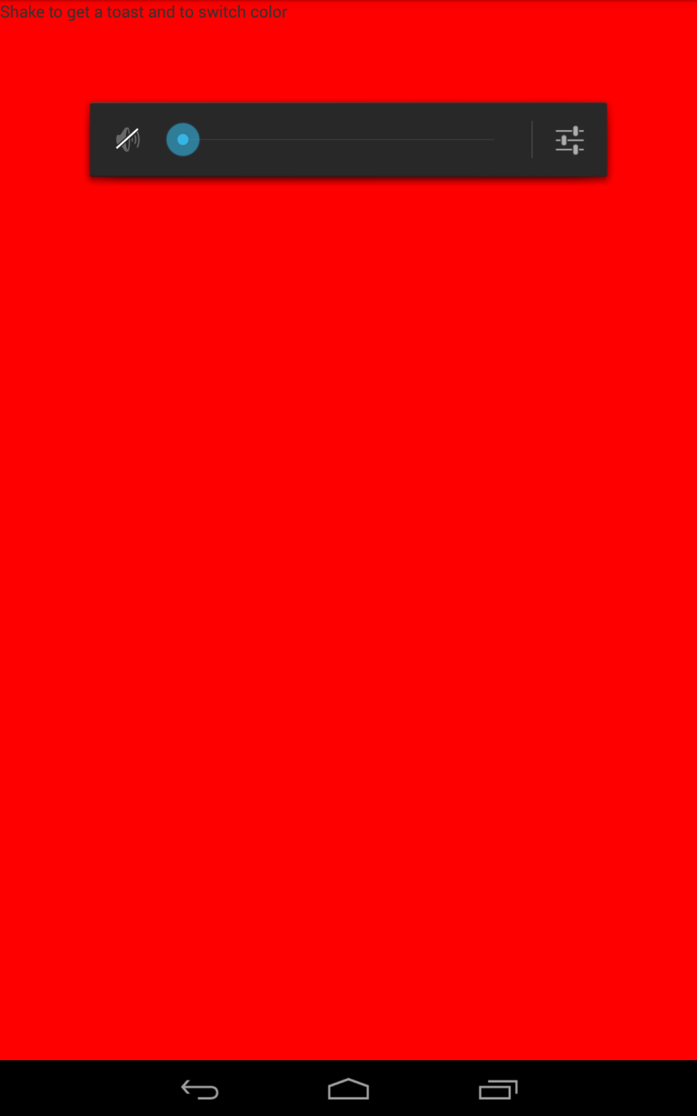

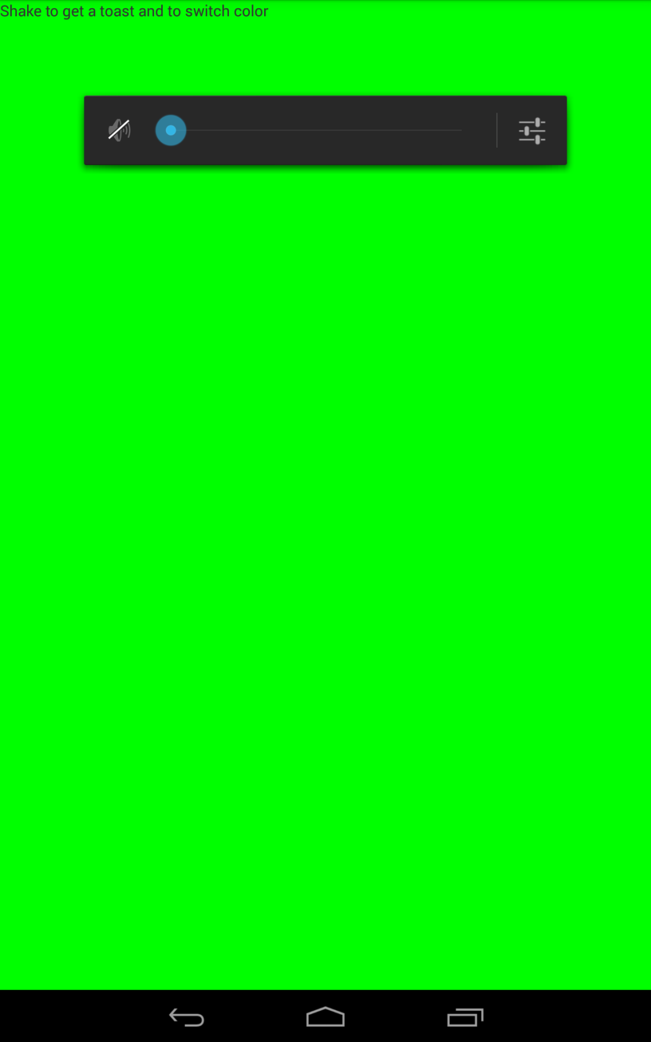

**4) Gesture recognition**

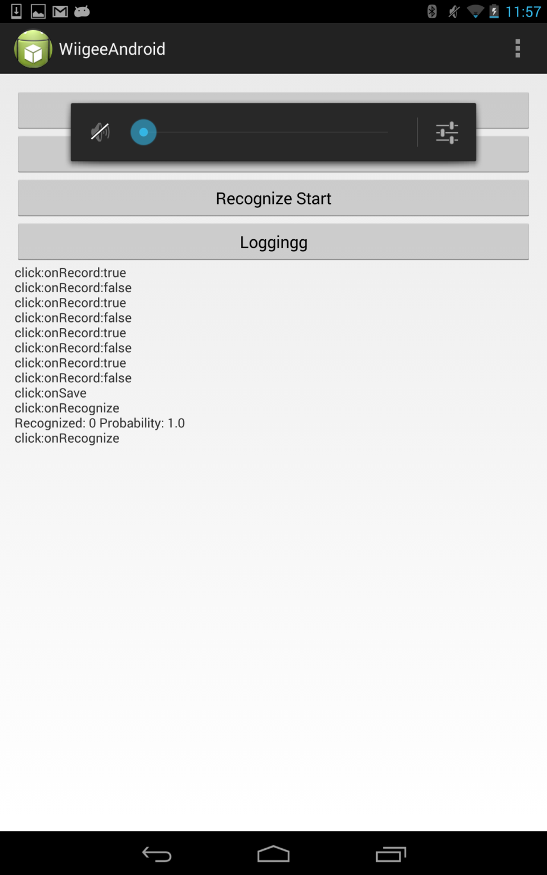

**5) We could not get hold of the watch device. Would update this section again.**