**CLOUDERA INSTALLATION AND WORD COUNT EXAMPLE**

To implement the word count example.

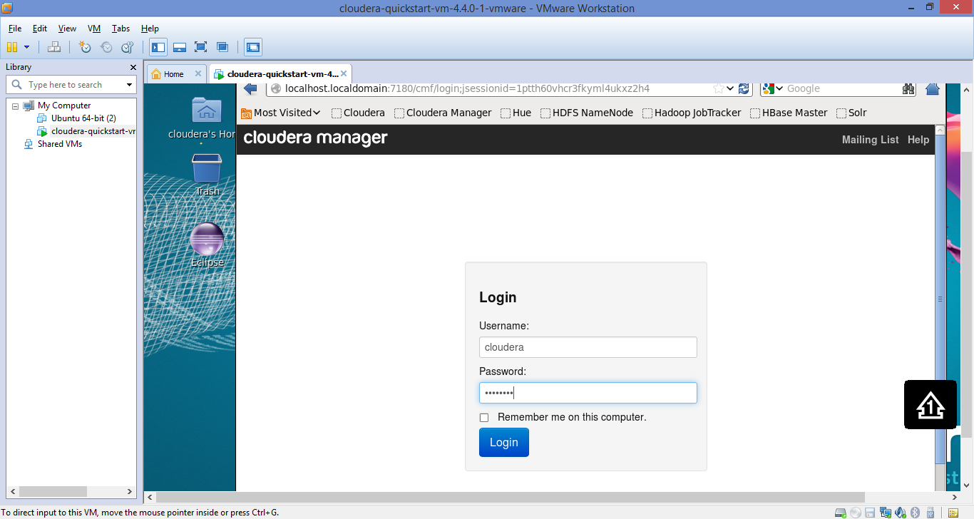

Word count execution:

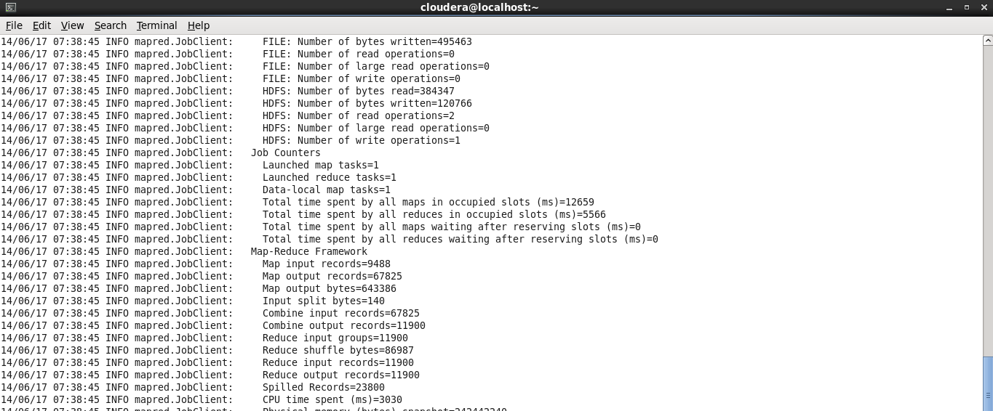

Word count Result

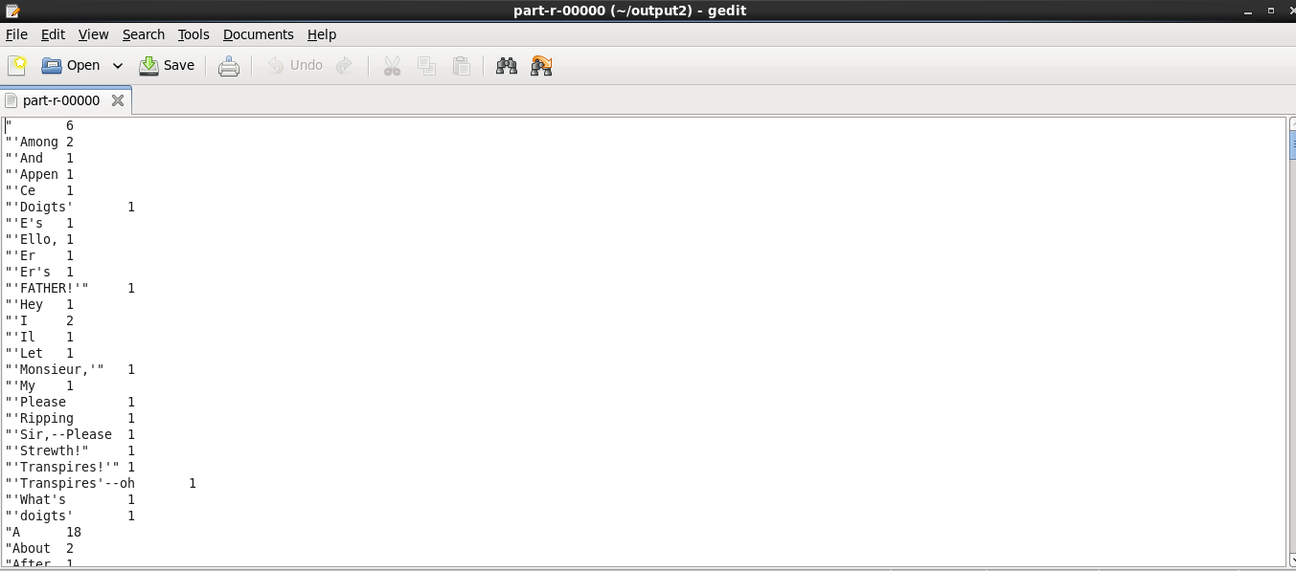

Github URL: <https://github.com/jagadishtirumalasetty/Projects/tree/master/BIGDATA/Lab1>