CS590BD Jagadish Tirumalasetty

Lab 2 Report #16143014

1. Creating data from the sensors.

Have modified the app1-app3 sample project to read humidity, accelerometer and gyrometer data.

Have appended the data together along with date and time to form a tab spaced data file.

Have placed the updated code in the Gituhub link as well.

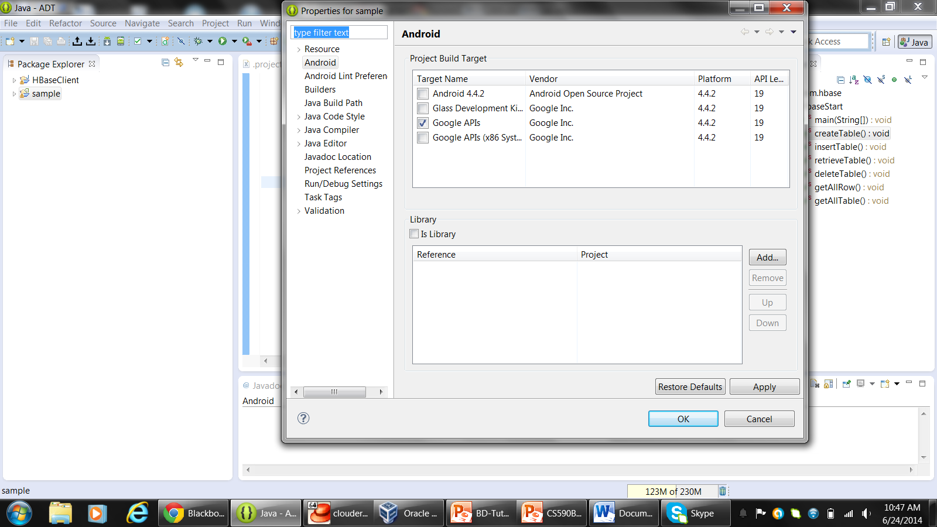

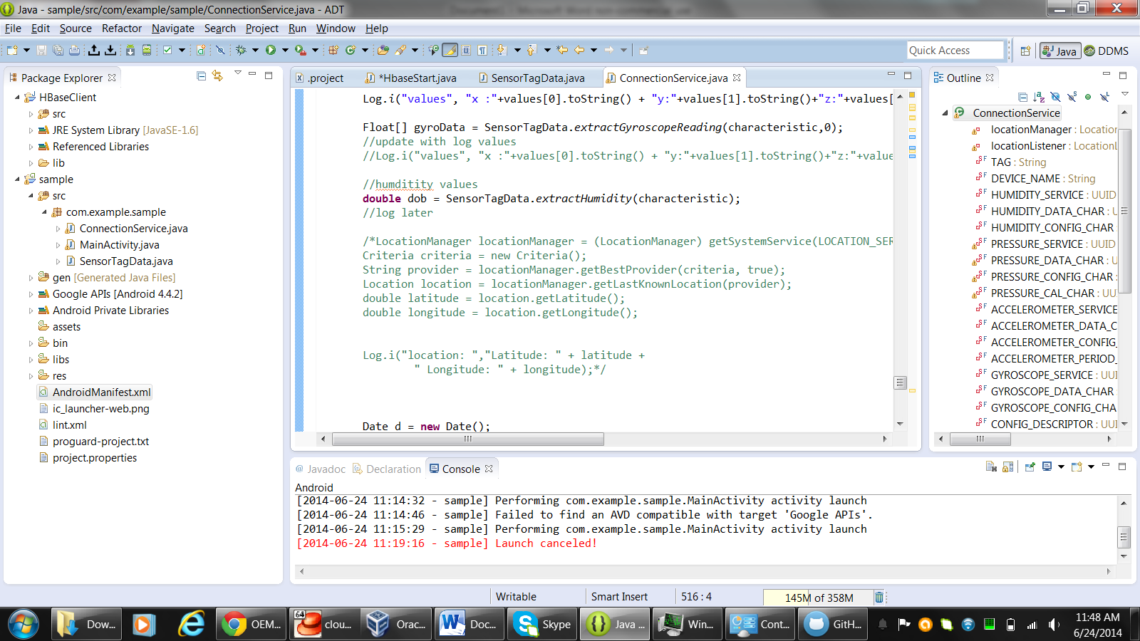

1. Uploading the data Onto HBase

Update the Hbase_Updated sample project to update column family.

Created the table with name SensorL2T3014 on 147 server

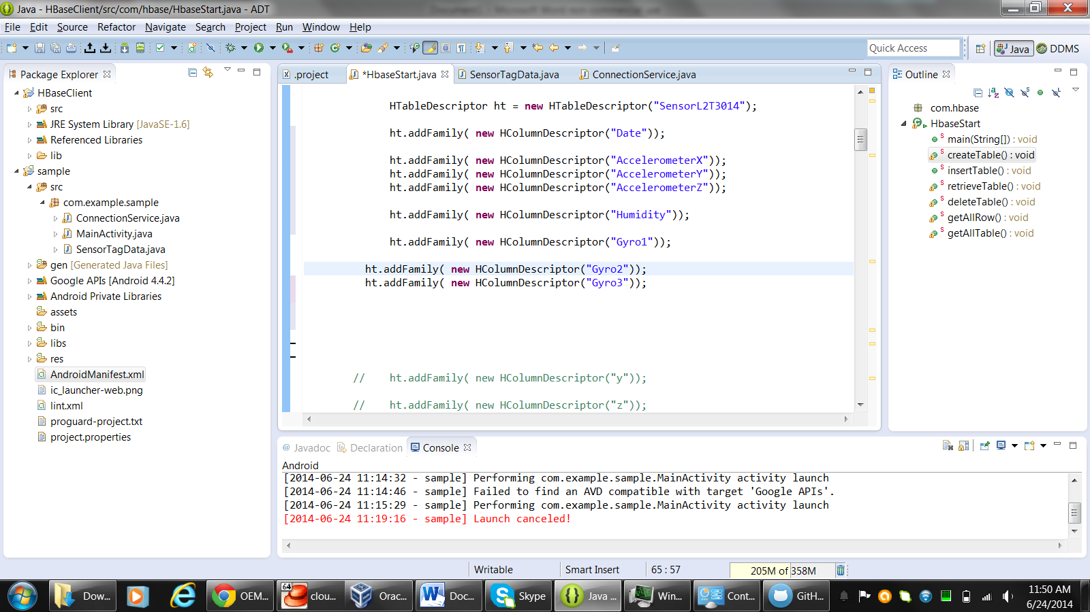

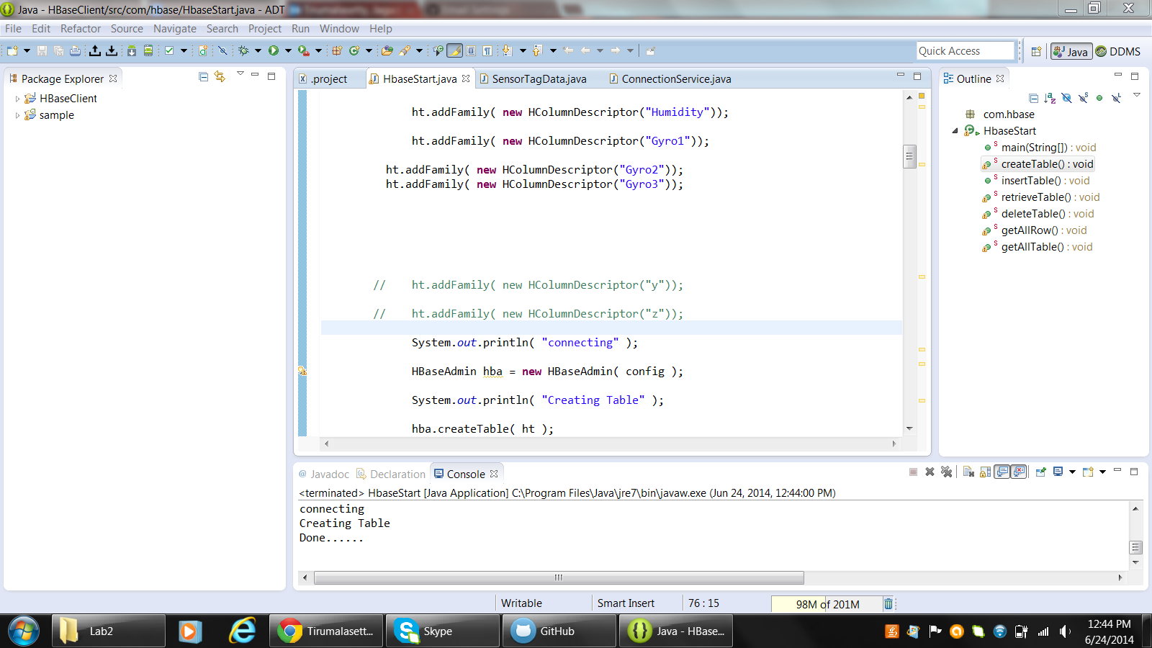

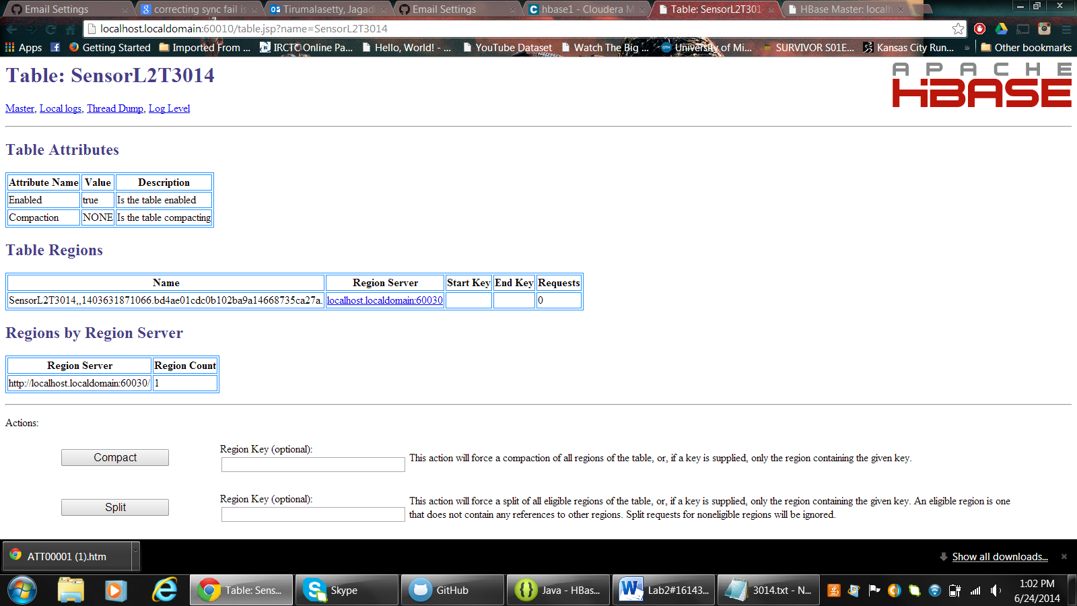

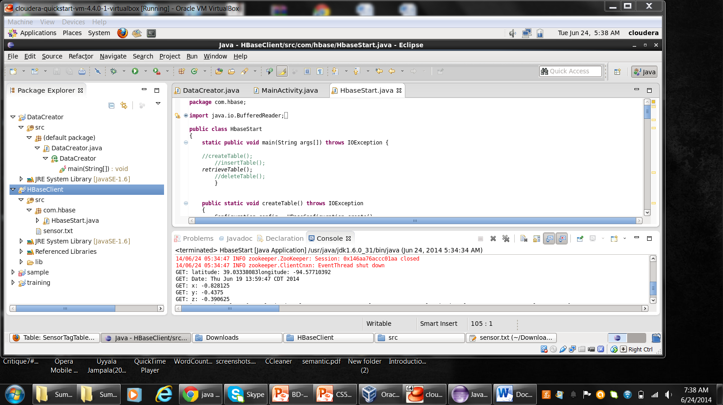

https://github.com/jagadishtirumalasetty/Projects/tree/master/BIGDATA/Lab2