<http://jsfiddle.net/jagadish_t/Q9a7G/5/>

1. Create a new jsfiddle Editor.

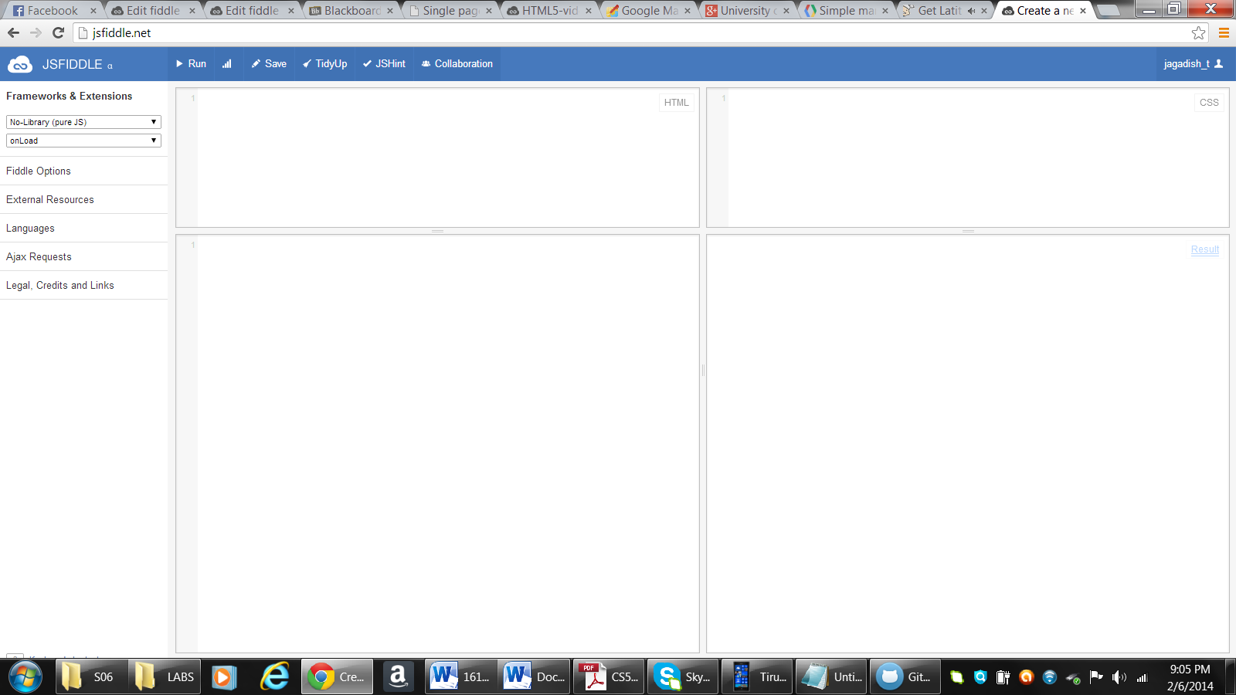

1. Create the HTML layout.

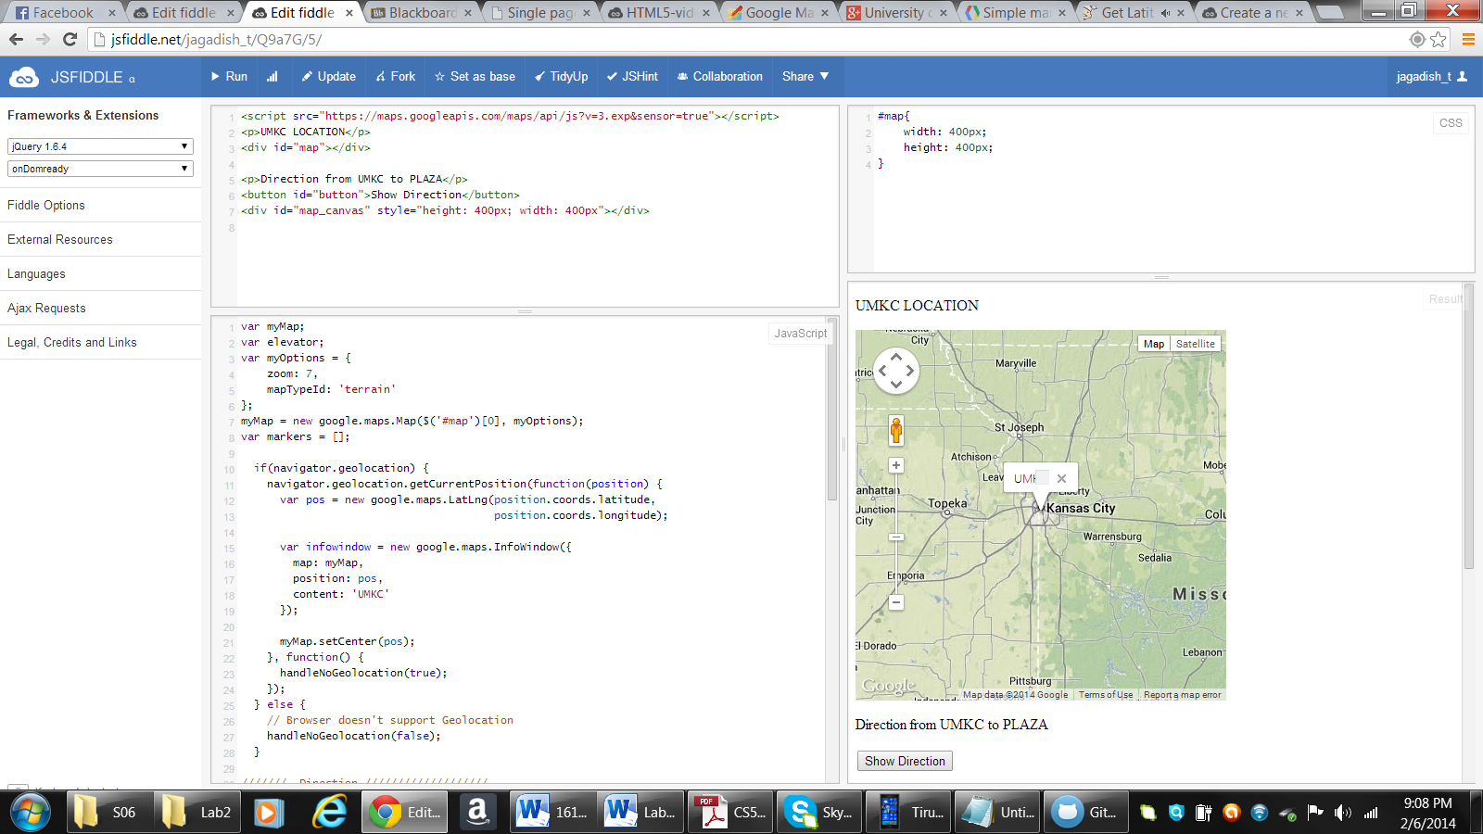

1. Add the JavaScript functions.

