Backup General Procedures:

- Using the command WRKMLBSTS check all the drives are in OPERATIONAL UNPROTECTED.
- Check whether expired tapes are available for that particular system before 30 mins and if not assign 2 expired tapes and check whether it is available in Media library.
- Monitor the backup status only in console.
- Do not use WRKMLMBRM command more than one at a time.
- Monitor the backup status using the following commands WRKMLBSTS, WRKJOB job name, DSPLOGBRM and WRKMEDIBRM frequently till successful completion.
- After completion of backup check all the subsystems are started which were ended during start of the backup.
- Use cwbping <system name> command (Connection Verification Program) from DOS command prompt to verify the connections available for a particular system. Please refer attached screenshot.
- Use WRKMEDIBRM to check the not saved objects count and if found refer the backup JobLog for the not saved objects list.
- If any object is not saved in Daily backup, verify that either the object is saved in Weekly or Monthly backup. If not, take appropriate action to save that object.
- If any damaged object is found, refer KM article “Process to find Damaged Objects and recovery procedure” to recover and save those objects in separate media with expiration date as permanent.
- In case of any Tape drive failures, Deallocate the particular tape drive with the matching serial number for all the systems. Inform the team members to do the same.

Backup Resubmission Procedure:

- Run the exit points (only when you are not rerunning the backup) of the control group if backup ends abnormally using the STRBKUBRM command and once completion perform health check for the system.
- Use the alternate backup timings which are available, during backup failure for resubmission.
- If any backup ends in halfway find the sequence from control group till which it ran and use STRBKUBRM command to complete the remaining in order to avoid rerunning from first unnecessarily.(Only if outage permits)
- Do not rerun the backup at any cause if sufficient backup window is not available and make sure the system is available to the users before release time.
- Need to execute Control Group exit points and BRMSMAINT Jobs, if backup is failed abnormally or partially ended.

Special Procedures for few systems:
- IASO1300 - MQM needs to ended manually to continue backup if control group fails to do so.
- IASO1300 - Need to call backup failure program MSDGPL/BCKFAILPGM if backup fails (only when you are not rerunning the backup).
- IASO1320 - Daily backup runs in restricted mode so do all checks prior to that. If the backup is resubmitted then make sure the jobs STREXPBRM, STRMNTBRM, STRSBS, STRTCP, STRORACLE, STREUORAC, STRQMQM, STRWEBAPPL, STRCRESBS, STRRMTWTR are executed accordingly to bring the system active.
- IASO1800 - 3 Control groups run for daily backup, please refer attached backup procedure document.
- IASO1809 - 2 Control groups run for daily backup, please refer attached backup resubmission document.
- FAAE6804 – Backup is triggered from tool AUTOMATOR. Hence we should just monitor the backup. If in case of any abnormal situation like backup long run or any job ended abnormally then immediately contact Application team.

Weekly Backup Instructions:
- Check and assign two expired Medias for weekly backups before 30 mins.
- Verify the scheduled job timing with the provided excel sheet timings.
- Verify the scheduled Remedy outage to avoid unplanned outages for the systems. Please change the outage if you find any discrepancy.
- Verify the Tape library status and Tape drive status (Status: – Operational and Unprotected)
- In case of any Tape drive failures, Deallocate the particular tape drive with the matching serial number for all the systems. Inform the team members to do the same.
- Resubmit failed weekly backup with proper remedy outage, if alternative window is available.

Additional points For Interactive weekly backup submission:

- Last Failed weekly backup systems needs to be submitted interactively in the following week. (Systems which don’t have alternative backup window)
- Omit the current weekly backup job.
- Submit the Weekly backup job interactively using STRBKUBRM command with submit batch job option *NO.
- Do not log into the weekly job log for more time to check the backup progress, for backups which are submitted interactively.

CWBPING command screenshot:

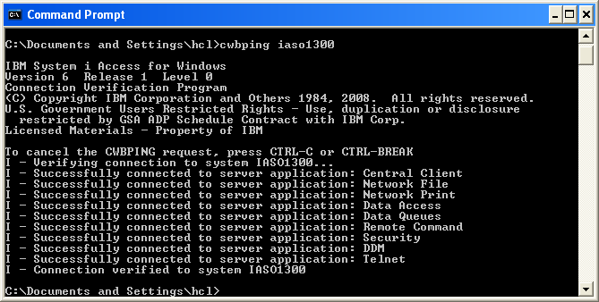

Reference Documents:

