AS/400 Drive Mapping

- In order to map the requested drive on user’s desktop, make sure the IFS path exist in the concerned AS/400 system
- Now request user for a net meeting to map the mentioned drive.
- Take control of user’s desktop and go to computer- Map network drive
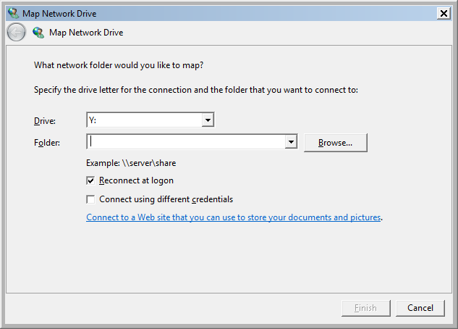
- In the folder column, mention the requested IFS path name \\server\share
Eg. \\IASO1030\jde\Bulgaria and click on finish. You will be requested for username & password and click on OK
Username: system name\profile name
Password: AS/400 & windows passwords must be similar and same needs to be entered.
Important Note: - Please ask the user to type the password only in lower case even though if the user has upper case in the password.

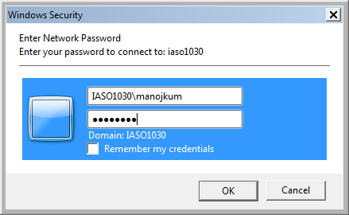

- The requested drive will be mapped as shown below
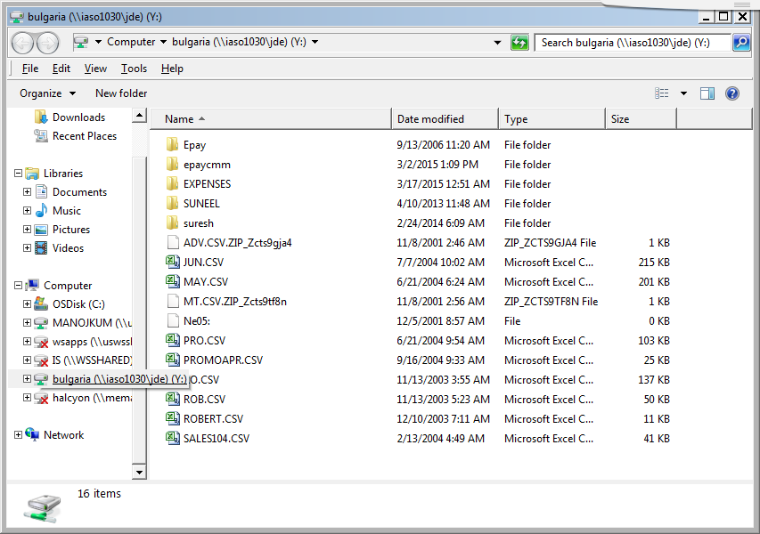

If in case user faces issue in connecting the IFS folder then check the below.
Make sure the requested user has authority to the mentioned IFS location.
For e.g. the given location in IASC1079 system is /JDE/Portugal/ptpayroll
WRKLNK ‘/JDE’ then take option 9= Work with authority. If the user is not having the authority then follow the below steps to provide the authority.
CHGAUT OBJ('/JDE') USER(XXXXXX) DTAAUT(*RWX) OBJAUT(*ALL)
CHGAUT OBJ('/JDE/Portugal ') USER(XXXXXX) DTAAUT(*RWX) OBJAUT(*ALL)
CHGAUT OBJ('/JDE/Portugal/ptpayroll ') USER(XXXXXX) DTAAUT(*RWX) OBJAUT(*ALL)

Also need to check if the user’s id is enabled in iSeries Support for Windows Network Neighborhood access. This can be viewed through Iseries navigator.
Open Navigator -> Network -> Servers -> TCP/IP -> i5/OS NetServer
Now right click on i5/OS NetServer and click on Disabled User IDs.
If the user id is found in the list then enable the user id.

