AS/400 Object Authority Management
For all the authority related requests you should have a User service request or Work order.
IMPORTANT NOTE: MAKE SURE THE OBJECT WHICH YOU ARE GOING TO EDIT DOES NOT HAVE ANY OBJECT LOCK.
This documents explains the below.
TO GRANT/MODIFY/REVOKE AUTHORITY TO AN OBJECT.
WORK WITH AUTHORIZATION LIST.
TO CHANGE THE OBJECT AUTHORITY FOR 'N’ NUMBER OF OBJECTS IN A SINGLE COMMAND.
TO CHANGE THE OBJECT OWNER OF AN OBJECT.
TO CHANGE THE AUTHORITY OF IFS.

Use the command WRKOBJLCK OBJ(LIBRARY NAME/OBJECT NAME) OBJTYPE(*TYPE)
To grant/modify/revoke authority to an object.
Use the below command.
WRKOBJ OBJ(LIBRARY NAME/OBJECT NAME) OBJTYPE(*TYPE)
For e.g. WRKOBJ OBJ(HCL/HCL) OBJTYPE(*FILE)
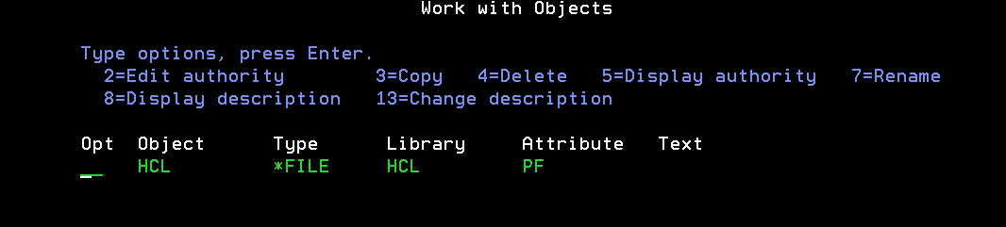
Now take option 2 = Edit authority, against the object and hit ENTER
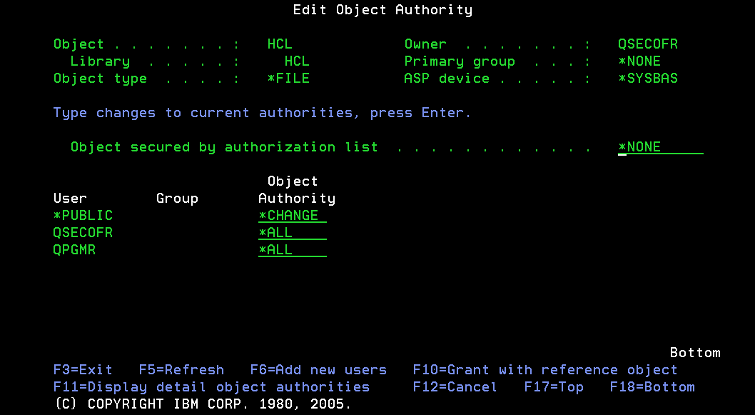
TO ADD NEW AUTHORITY
Take F6=Add new users.
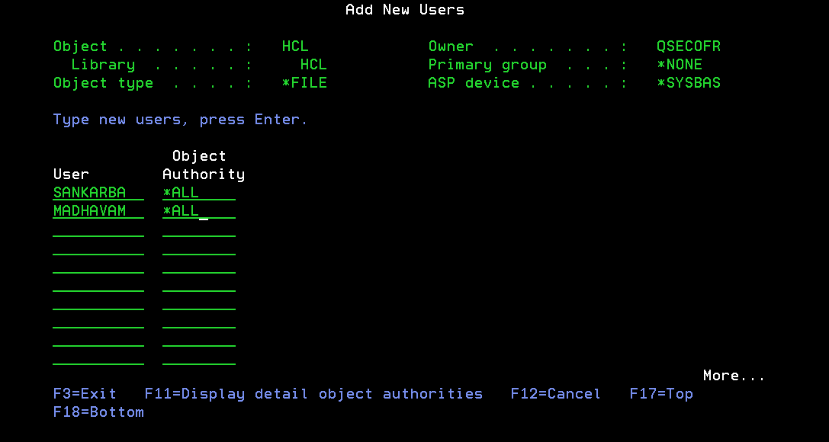
Add the new user name with the corresponding authority as requested in the case. Simultaneously you can grant authority to more user profiles by adding them one by one.
Take F11 for Display detail object authorities
First Object Authorities.
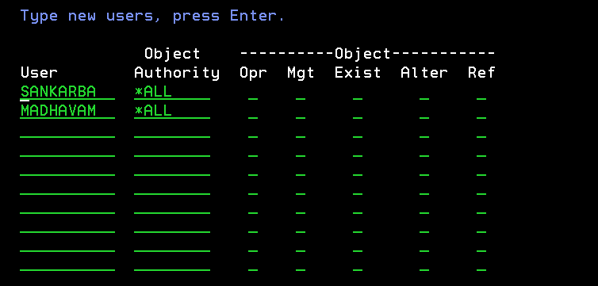
Again press F11 one more time to display the data authorities.
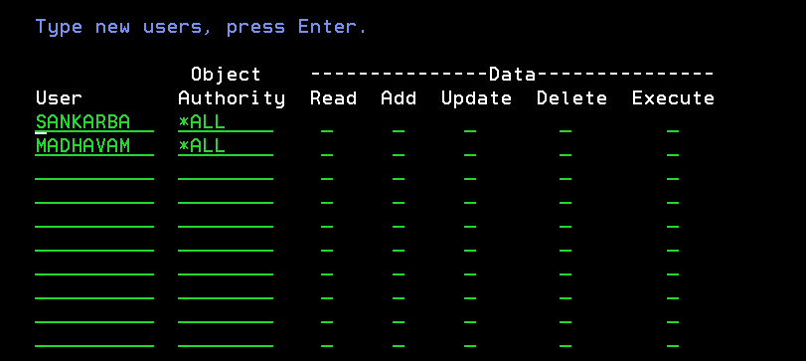
Note:-
Authorities can be *EXCLUDE, *ALL, *CHANGE, *USE and user defined.
Only for user defined, you need to manually key in the authorities(mark x on required column) for both object and data.

TO MODIFY EXISTING AUTHORITY.
Change the object authority as required.
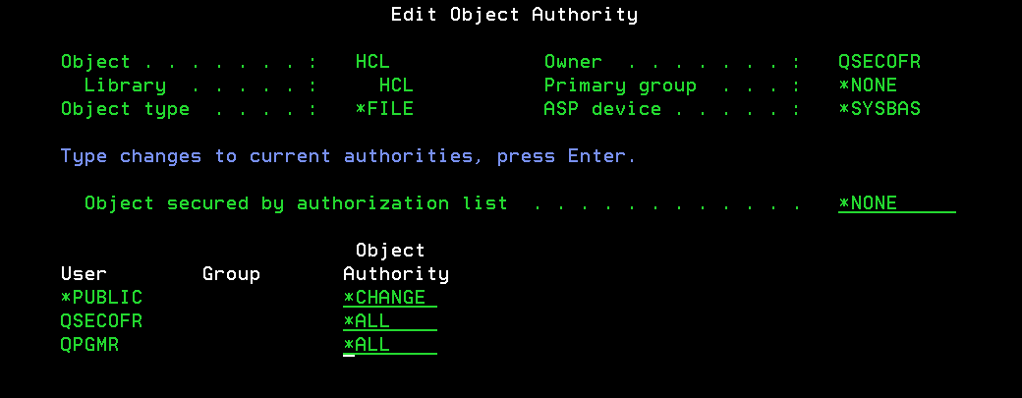
For e.g. change *PUBLIC to *EXCLUDE and hit enter.
The object authority will be changed.
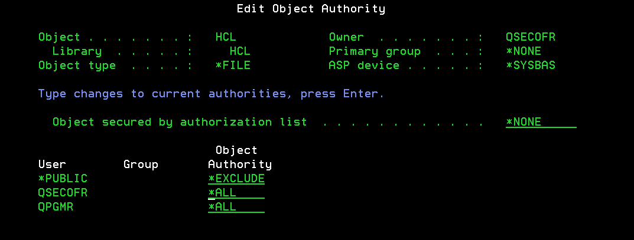

TO REVOKE EXISTING AUTHORITY.
Leave the object authority as blank and hit enter to revoke the authority to the user.
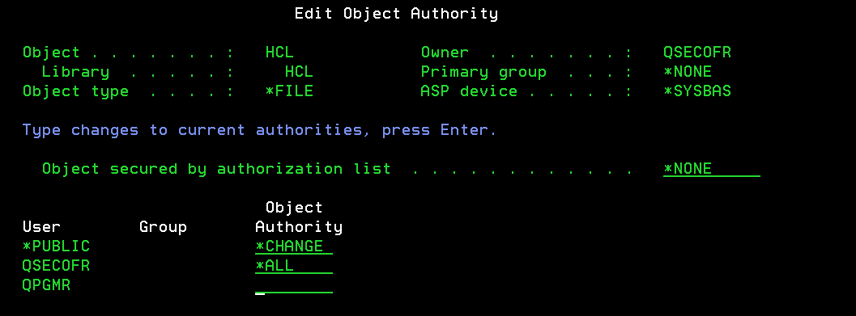
The authority will be revoked for the user.

WORK WITH AUTHORIZATION LIST
Use the command.
WRKAUTL AUTL(Authorization list name)
For e.g. WRKAUTL AUTL(UPDDTA)
To add/change/remove use option 2=Edit
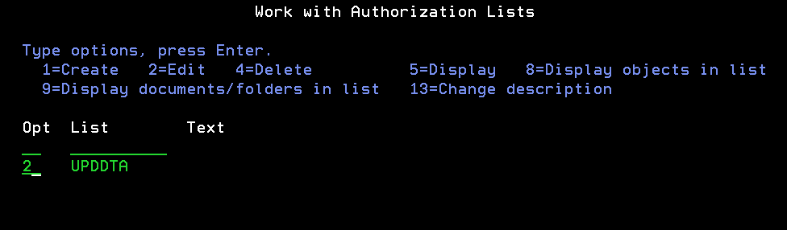
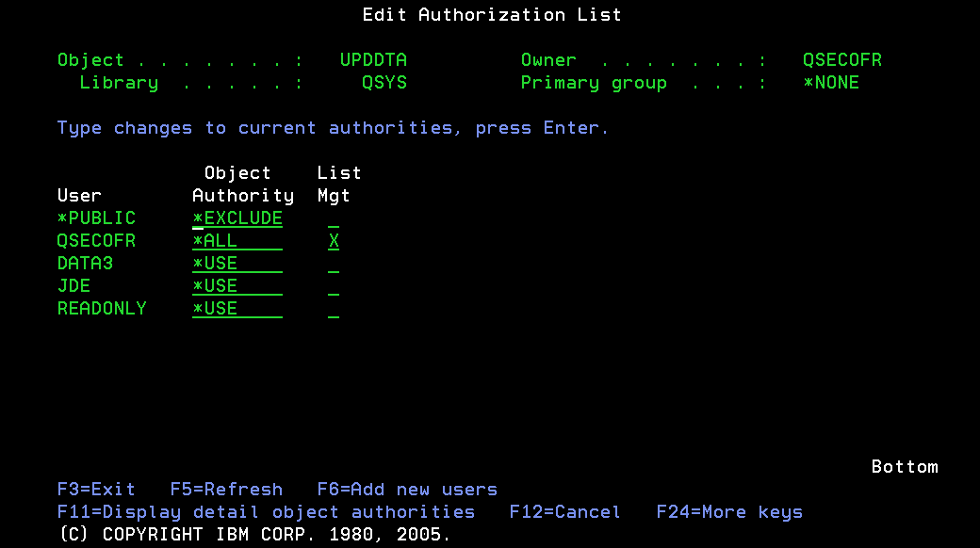

To add use option F6 = Add new users.
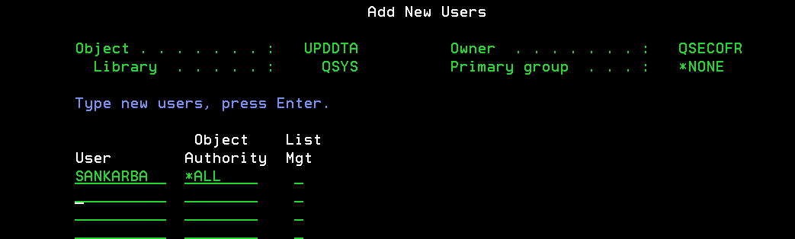
To modify, change the object authority as per the request and hit ENTER.
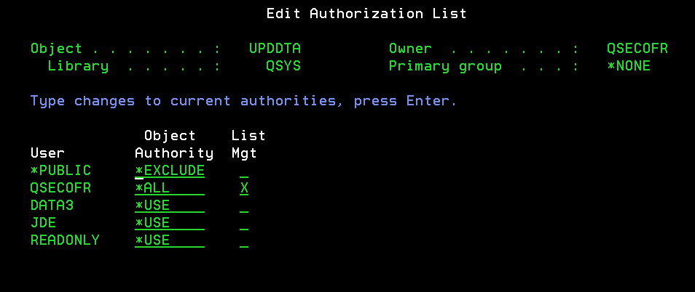

For e.g. changed the authority of *PUBLIC to *CHANGE and hit ENTER.
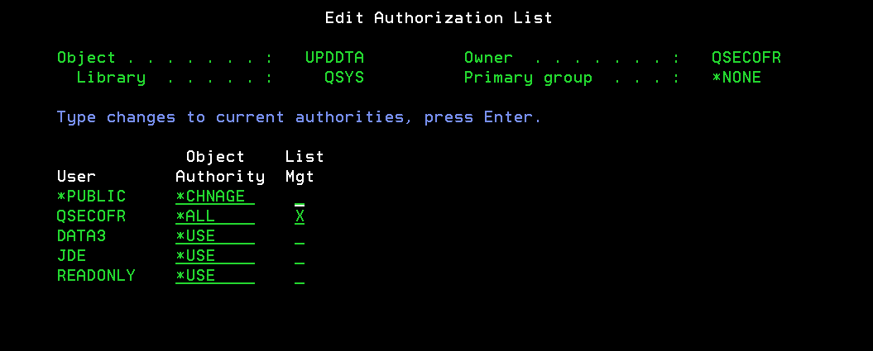
To remove leave the object authority as blank and hit enter to revoke the authority to the user.
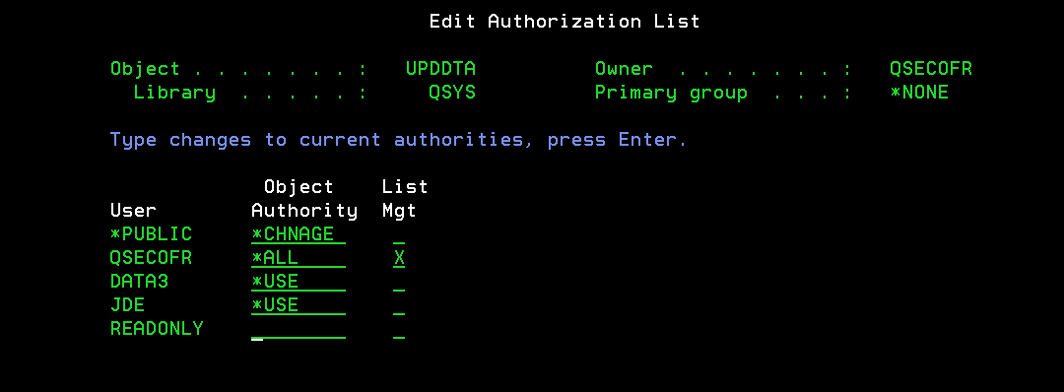
TO CHANGE THE OBJECT AUTHORITY FOR 'N’ NUMBER OF OBJECTS IN A SINGLE COMMAND
Use the command GRTOBJAUT and key in the required details as shown below.
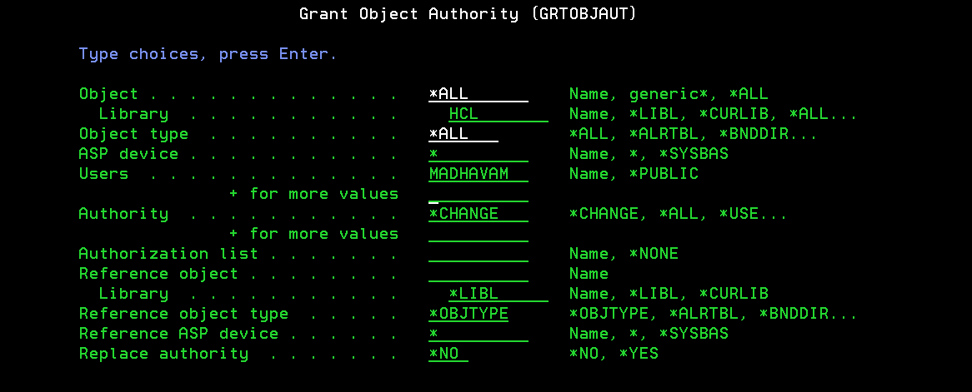
Hit ENTER.

TO CHANGE THE OBJECT OWNER OF AN OBJECT
Use the command CHGOBJOWN and key in the required details as shown below.
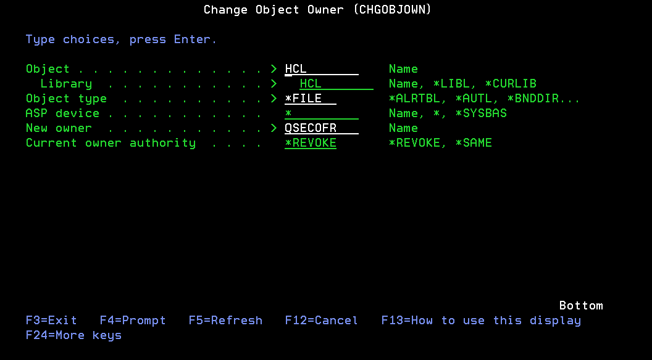
TO CHANGE THE AUTHORITY OF IFS
Use the command CHGAUT and key in the required details as shown below.
