AS/400 Printer Management

Types of printers in AS/400.
- LAN or Network printer (Create/Modify)
- Remote printer (Create/Modify)
- Virtual printer (Create)
LAN or Network printer.
Steps to create:
Step 1: Make sure you have Incident case (User Service Request) or a Work order case with the below details.
- System name(s)
- IP address
- Type of printer – LAN or Network
- Manufacturer model
- Printer Name to be created
Step 2: Login to the AS/400 system(s) and make sure the given IP address is reachable. Use PING command to check the same. If the IP is not pinging then update it to the user and get the valid IP address.
Step 3: Use the below command to create a LAN printer.
CRTDEVPRT DEVD(XXXXXX) DEVCLS(*LAN) TYPE(3812) MODEL(1) LANATTACH(*IP) PORT(9100) FONT(11) FORMFEED(*AUTOCUT) INACTTMR(*SEC15) PARITY(*NONE) STOPBITS(1) TRANSFORM(*YES) MFRTYPMDL(XXXXXXX) RMTLOCNAME(XX.XX.XX.XX) SYSDRVPGM(XXXXXXXX) TEXT(XXXXXXXX)

Note: - MFRTYPMDL and SYSDRVPGM depend upon the Printer which is configured.
Once the device is created, the OUTQ and writer will be created automatically in the name of the device.
Use the below link for Information on Printers from Various Manufacturers
http://www-01.ibm.com/support/docview.wss?uid=nas8N1019605

Step 4: VARY ON the newly created device.

After the device is created use the command WRKDEVD <device name>
Take option 8= Work with status and then vary on the device by taking option 1.

Step 5: Use the below command to start the writer.

STRPRTWTR DEV(XXXXX)
Writer will be started and the same can be checked using the command WRKWTR.

Step 6: Use the below command to check the OUTQ.

WRKOUTQ OUTQ(XXXXX*)
Now you can see the writer running for this OUTQ.

Step 7: Check the printer by giving a test print.

DSPSYSSTS OUTPUT(*PRINT)
WRKJOB, take option 4 to view the spool file and locate the print of the Display System Status.
Take option 2 to edit and the printer name to the newly created device name and page down, mark the save fie to *YES. Then hit enter.

Step 8: Request the user to check the printer from their end. The same can be monitored using the WRKOUTQ command.

Steps to modify the existing printer:
Step 1: Make sure you have Incident case (User Service Request) or a Work order case with the below details.
- System name(s)
- New IP address
- Type of printer – LAN or Network
- Manufacturer model
- Existing printer name
Step 2: Login to the AS/400 system(s) and make sure the given new IP address is reachable. Use PING command to check the same. If the IP is not pinging then update it to the user and get the valid IP address. Also make sure the printer name already exists in the system.

Step 3: End the writer if it is active.
Use the command WRKWTR NAME* (check if it is active).
If active use the command ENDWTR WTR(XXXXX) OPTION(*IMMED) to end it.

Step 4: Vary off the printer device.
Use the command WRKDEVD <device name>
Take option 8= Work with status and then vary off the device by taking option 2.

Step 5: Use the below command to modify the LAN printer.
WRKDEVD <device name> and take option 2 to change.
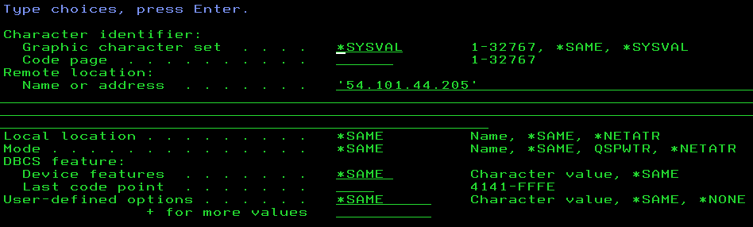
Now change the IP address of the printer.
If required change the MFRTYPMDL and SYSDRVPGM
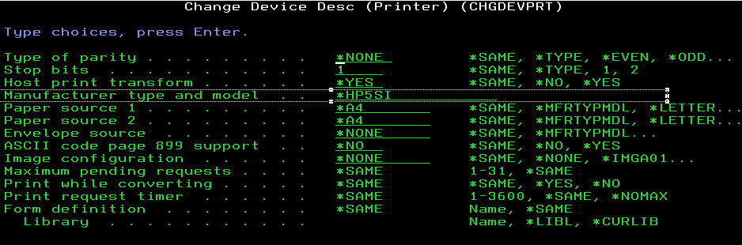
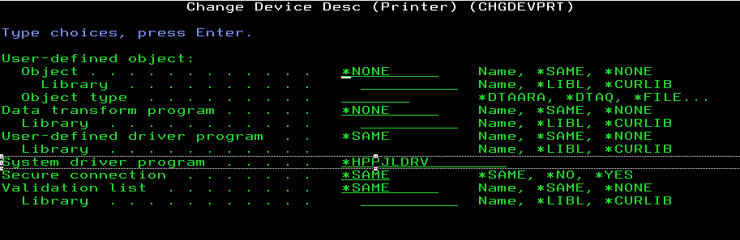
Finally hit enter.
Step 6: Vary on the printer device.
Use the command WRKDEVD <device name>
Take option 8= Work with status and then vary on the device by taking option 1.

Follow the steps from step 5 in topic Steps to create:
Note: - To monitor the printer job use the command WRKJOB <printer name>

Remote Printer

Steps to create:
Step 1: Make sure you have Incident case (User Service Request) or a Work order case with the below details.
- System name(s)
- Remote IP address
- Remote OUTQ name (if required)
- Type of printer – Remote
- Manufacturer model
- Name of the OUTQ to be created

Step 2: Login to the AS/400 system(s) and make sure the given new IP address is reachable. Use PING command to check the same. If the IP is not pinging then update it to the user and get the valid IP address. Also make sure the printer name already exists in the system.

Step 3: Create the remote OUTQ
Use the CRTOUTQ command to create a Remote Output Queue. This enables the AS/400 to automatically output data translated by Host Print Transform to the Printer

Example

CRTOUTQ OUTQ(QGPL/CTRMTPRT02) RMTSYS(*INTNETADR) RMTPRTQ(CTRMTPRT02) AUTOSTRWTR(1) CNNTYPE(*IP) DESTTYPE(*OTHER) MFRTYPMDL(*HP5) INTNETADR('54.61.1.100') TEXT('CTC Data Center Printer')

Important Note:
The value *IP must be used for CNNTYPE
The value *OTHER must be used for DESTTYPE
The value used for MRFTYPMDL will depend on the attached printer. Use the
'F4' to obtain a list of the possible choices
The value used for INTNETADR must be the same as the IP address of your Printer.

Few more examples

CRTOUTQ OUTQ(QGPL/EKB5CLP001) RMTSYS(*INTNETADR) RMTPRTQ('pr1') AUTOSTRWTR(1) CNNTYPE(*IP) DESTTYPE(*OTHER) MFRTYPMDL(*WSCST) WSCST(TLABARCODE/IT44WSCST) INTNETADR('54.4.82.224') USRDFNOPT('pr1 ') TEXT('Ticket Printer')

CRTOUTQ OUTQ(QGPL/0141as400) RMTSYS(*INTNETADR) RMTPRTQ(CTRMTPRT02) AUTOSTRWTR(1) CNNTYPE(*IP) DESTTYPE(*OTHER) MFRTYPMDL(*HP5) INTNETADR('54.23.56.83') TEXT('Printer wspt0141 @ WS3EF-51F')

Finally hit enter. To start the remote writer, use the command STRRMTWTR.
Steps to modify the existing remote OUTQ:
Step 1: Make sure the writer is not active for the remote OUTQ.
Use the command WRKOUTQ <OUTQ NAME*> and take option 9 = Work with Writers.
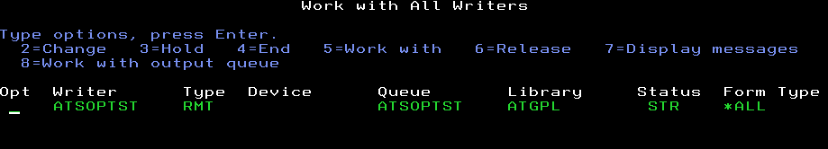
Take option 4, prompt to end it with *IMMED option.
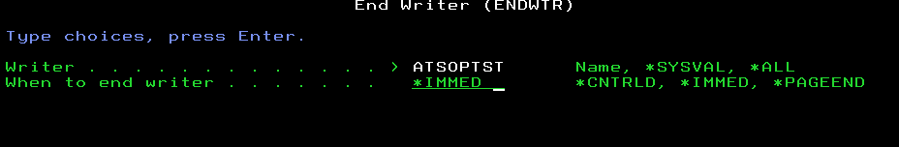
Step 2: Modify the remote OUTQ
Use the command WRKOUTQ <OUTQ NAME*> and take option 2 = Change
Change all the required information and then hit enter.
Start the remote writer by using the command STRRMTWTR.
Important Note: For the remote writer the device description will not be available.
To monitor the printer job use the command WRKJOB <printer name>

Virtual Printer
Steps to create:
Step 1: Make sure you have Incident case (User Service Request) or a Work order case with the below details.
- System name(s)
- Type of printer – Virtual
- Printer Name to be created (generally ISID with PRT as suffix)
Step 2: Create Virtual printer
Open a new session and follow the below instruction.
Provide the system name, work station ID and select the type of emulation as Printer.
Select the check box for auto reconnect and hit enter
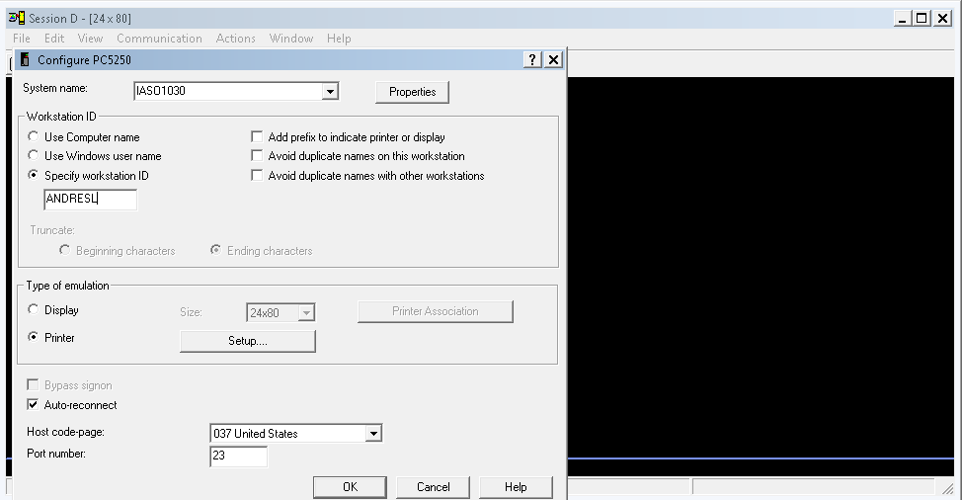
On the next screen, you should be prompted for user name and password.
Once logged in then you should be able to see the below screen.
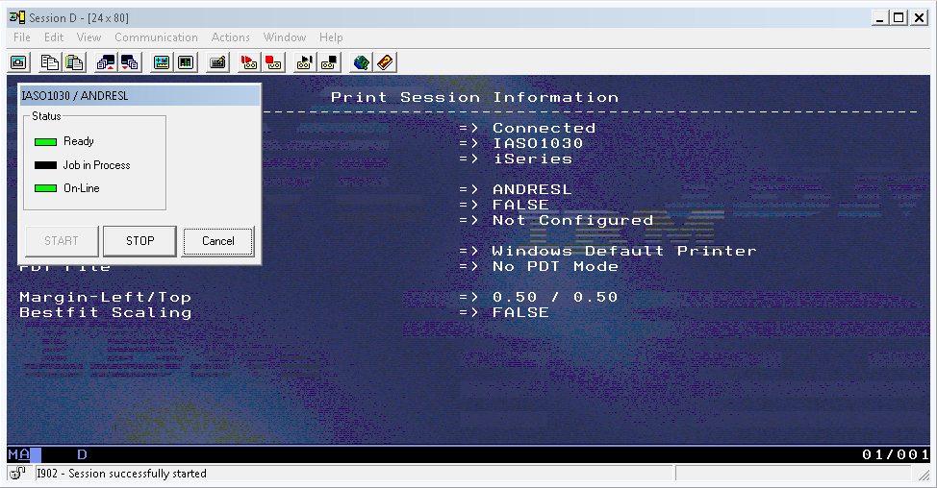
The above screen shot shows that the virtual printer has been created.
When you give test print you will be asked to select the printer from the given list as shown below.
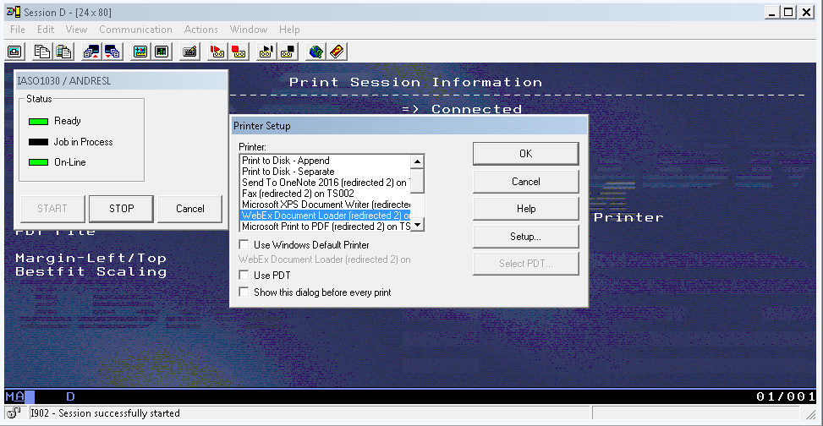
Select the appropriate printer name and hit enter.
Going further ask the user to use the printer name which is created and also make sure the user is opening the printer session before giving the print from the AS/400 session.

Step 3: Save the session in the user’s desktop.
Click on File and select Save as.
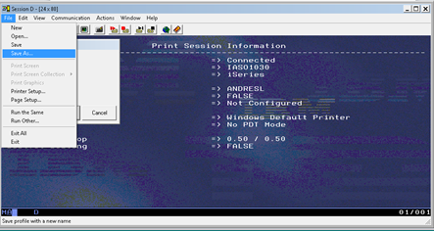
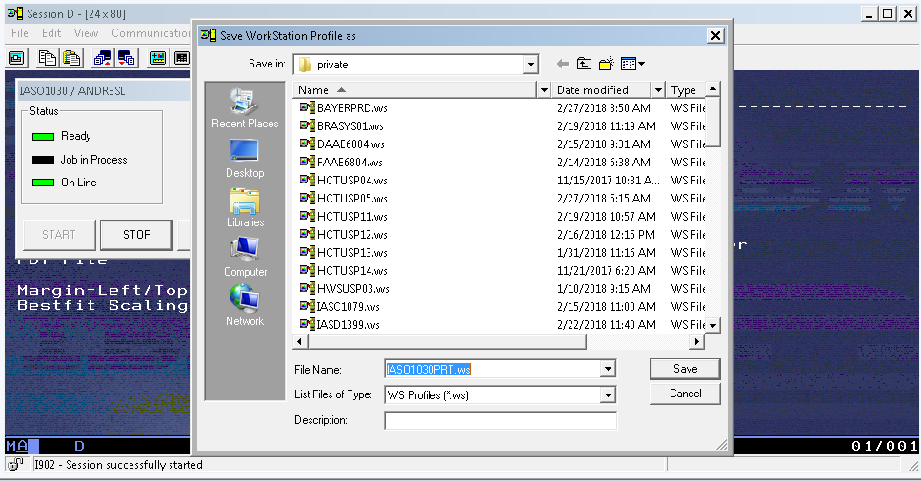
Save the printer session in the user’s desktop.

Important Note: - If in case the device is not created automatically and when you get the below information in DSPMSG QSYSOPR.
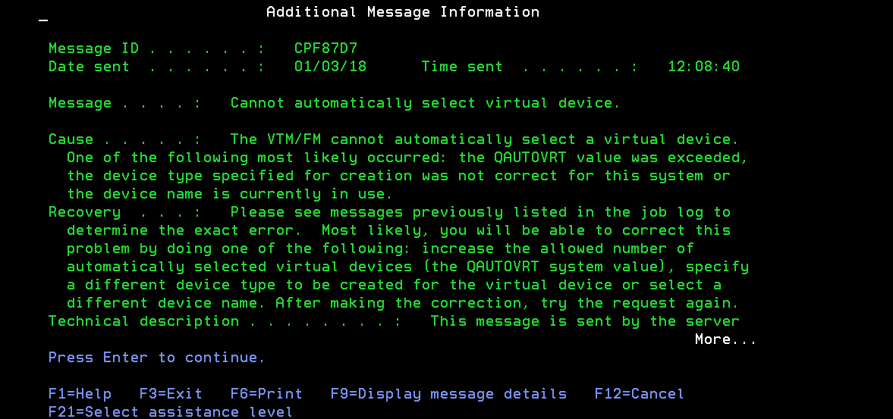
We have to create the device for virtual printer manually. Follow the below instruction to do the same.
- Check for any similar virtual printer in the system by using the command WRKDEVD DEVD(*VRTPRT)
- Copy the device by using the option 3=Copy and provide the Device description.
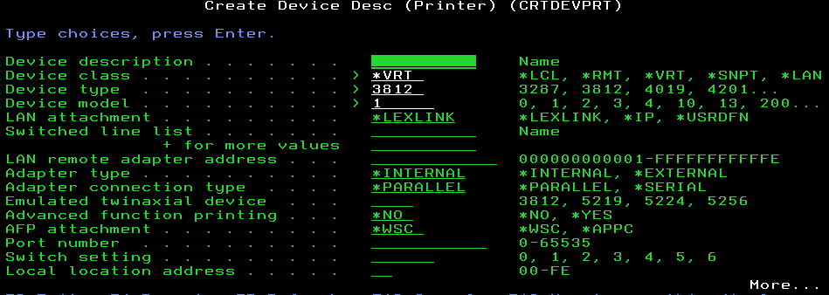
In the next page you will find a parameter name d Attached controller.
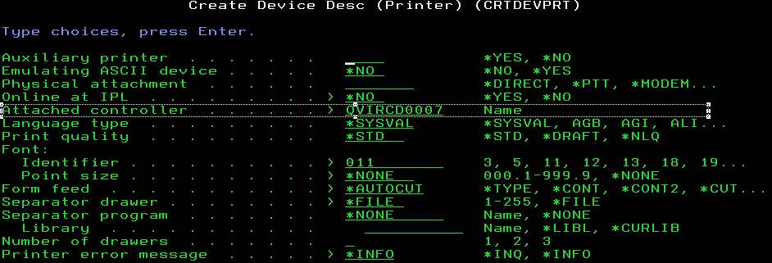
You can view the available controllers in the system using the command WRKCTLD CTLD(QVIR*)
By giving the controller name and then hit enter. If the controller can accommodate the device then the device will be created. If not you will receive the below error message.
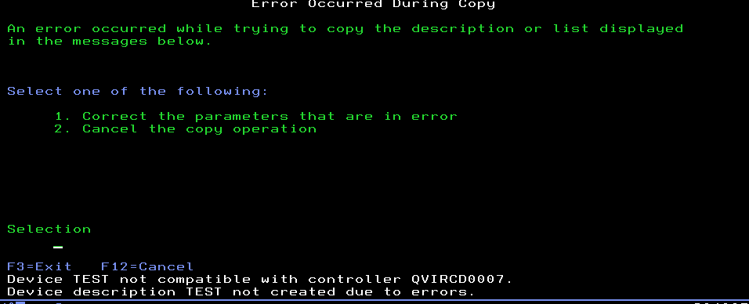
Take option 1 and you will be redirected to the previous page.
Now change the attached controller to another existing controller name and try changing the controller name until the new device is created.

