PROCESS TO RESTORE A LIBRARY OR A SPECIFIC OBJECT(S) FROM A LIBRARY

It is mandatory to have a Remedy case(User Service Request or Work Order) from the user with the below information before the restoration activity.

Source system and Target system.
Source library and Target library (either full library restore or specific object(s) restore).
Backup Type - Daily or Weekly or Monthly or Yearly or Quarterly - specific date is required.
Restoration priority - Emergency or Normal.

Note: -
- Always for a full library restore it is advised to perform the restore from a full save rather than cumulative or incremental save.
- In case of emergency request and if the tape is at offsite (IRON MOUNTAIN) get an email from the requestor stating the business justification for the emergency restoration. The same should be attached in the Remedy case which is raised to Data center operations team for tape recall.
- If the restoration is in production system then it is advised to be performed during OFF business hours.

Check the tape details by the following steps.

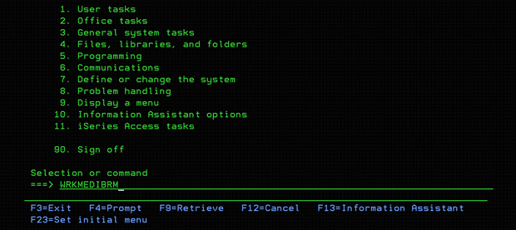

Now take F4 (prompt the command WRKMEDIBRM)

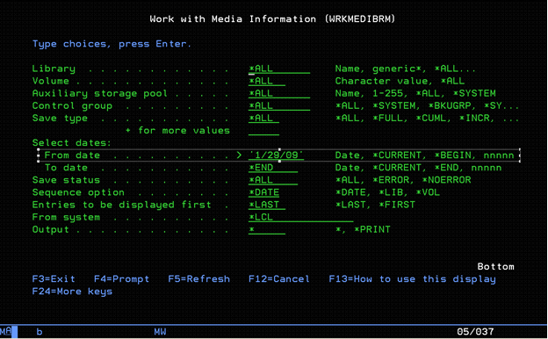

Enter the date as shown in above screenshot and hit ENTER.
From the below screen you can get the tape details. For example here it is IC2352.

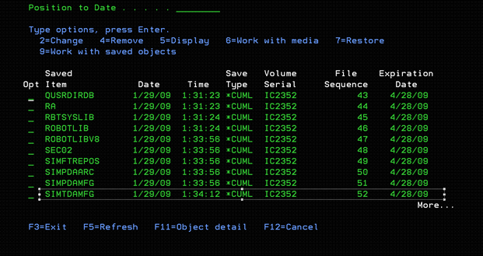

Please check in the system whether the tape is still in CTC Tape library or it is sent to offsite i.e. IRON MOUNTAIN.

If it is in onsite continue with the restoration.

If it is in offsite raise a remedy case to CTC Data center operations by providing the required information like tape details and business justification email (only in case of emergency tape recall). Draft an email to CTC Data center operations about the details of the case.
If it is an Emergency tape recall, raise the remedy case with high priority.

Once the requested tape(s) are loaded in the Tape library CTC will notify us, then the restoration can be started.

Make sure you change the move policy of the tape to *NONE

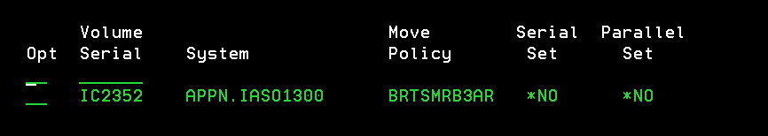

Take option 2 against the tape and change the move policy to *NONE and hit ENTER.

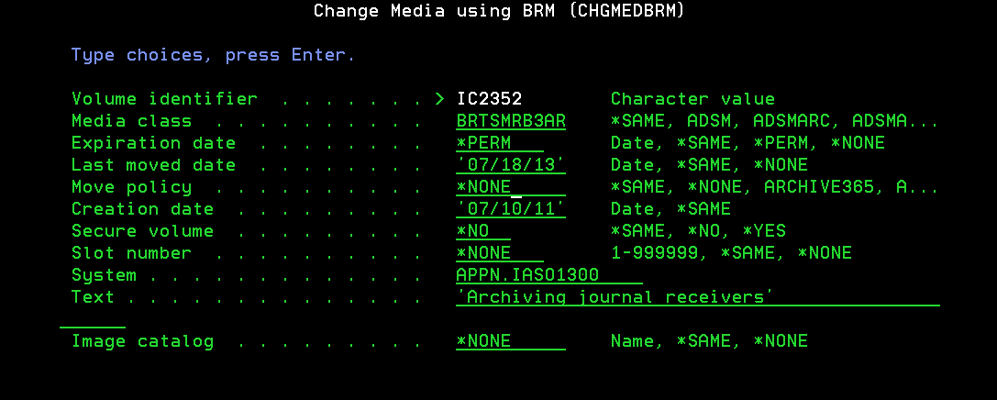

Login to the target system where we have to restore the library, access the tape from the target system by the following steps.

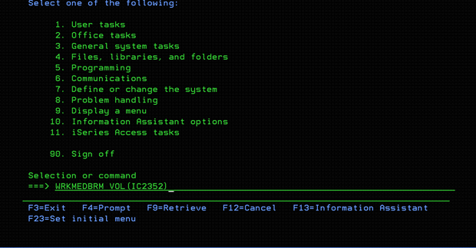

Hit ENTER.

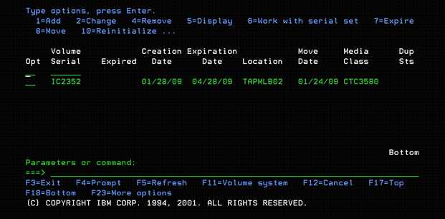

Take OPT 13 to Display the contents

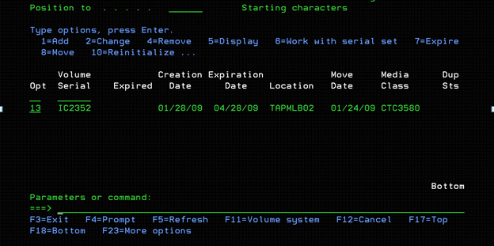

Now select the library from the list which needs to be restored and take option 7 against it.

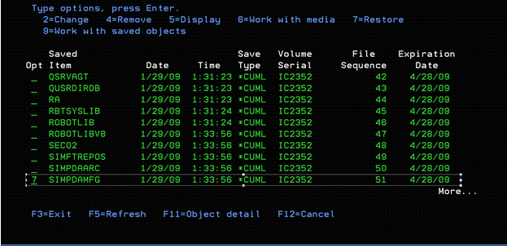

Here comes the two ways of restoration, to perform full library restore follow the instructions as per SECTION A , if you have to restore only particular files from the library follow the instructions as per SECTION B.

SECTION A

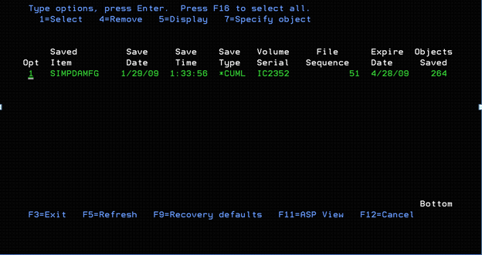

Take F9 Recovery defaults and change the parameters as shown below.

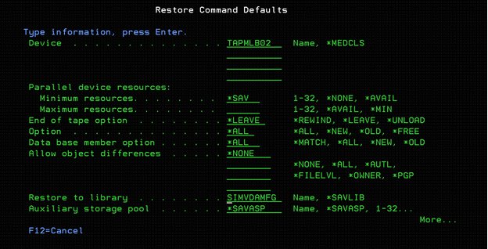

Now hit enter you will be back to previous page and again.



Now take option F14=Submit to batch

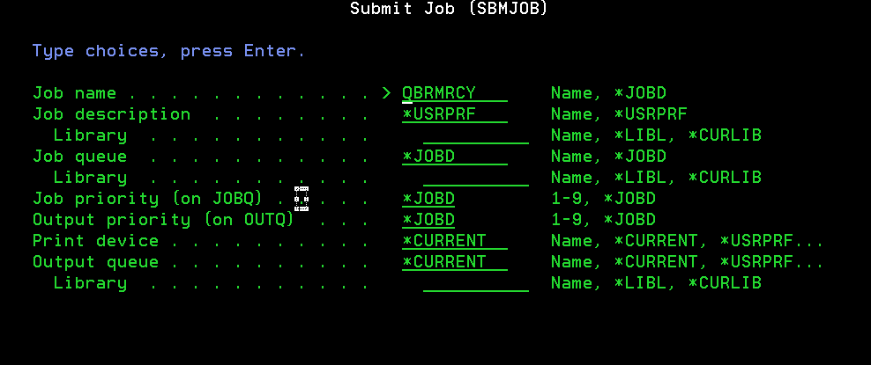

Fill the Job name, Job queue, Library as per restoration request and hit ENTER.

Now use command WRKJOB <JOB NAME> to monitor the job progress.
Once the job is completed make sure there is no not restored objects other than object types like *DATAQ, *JRNRCV. If found then take action as per the job log details.

SECTION B

Take OPT 7=Specify object and hit ENTER for the below screen.

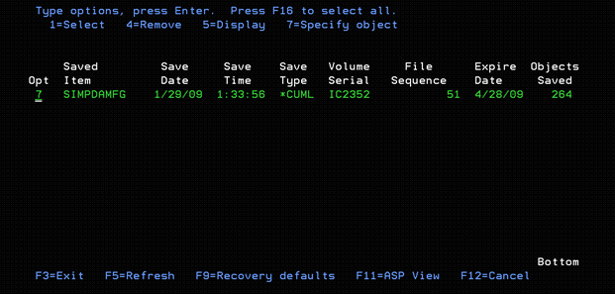

Specify the particular objects which have to be restored from the library and change the other parameters as given in the screenshot.

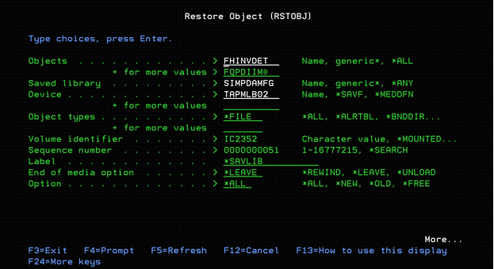

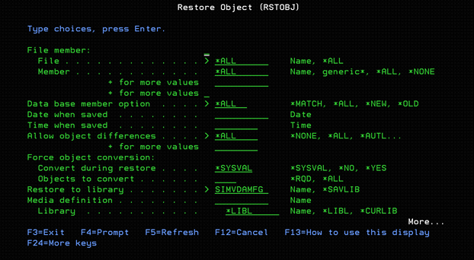

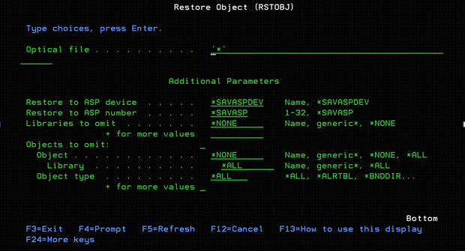

Now hit ENTER.

From the DSPLOGBRM command you can get the log for the restored object details and then email the details to the user for confirmation.

After getting confirmation from the user resolve or complete the Remedy case.

Make sure you change the move policy of the tape to IRONMTN and ship the tape(s) back to offsite.

Note: - Systems does not have BRMS installed use native commands RSTLIB and RSTOBJ.

