How to backup HMC data manually
Firstly login to HMC web link.
For e.g. we can use the link https://hwsusp01.merck.com
Click on the below link.
Log on and launch the Hardware Management Console web application.
You will be directed to the HMC login screen.
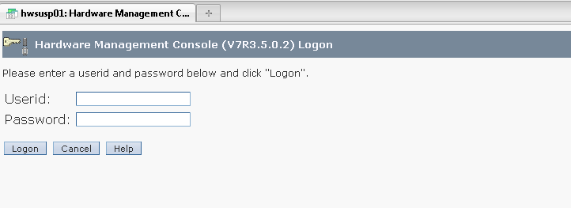
Provide the required credentials and click on Logon. Below screen appears.
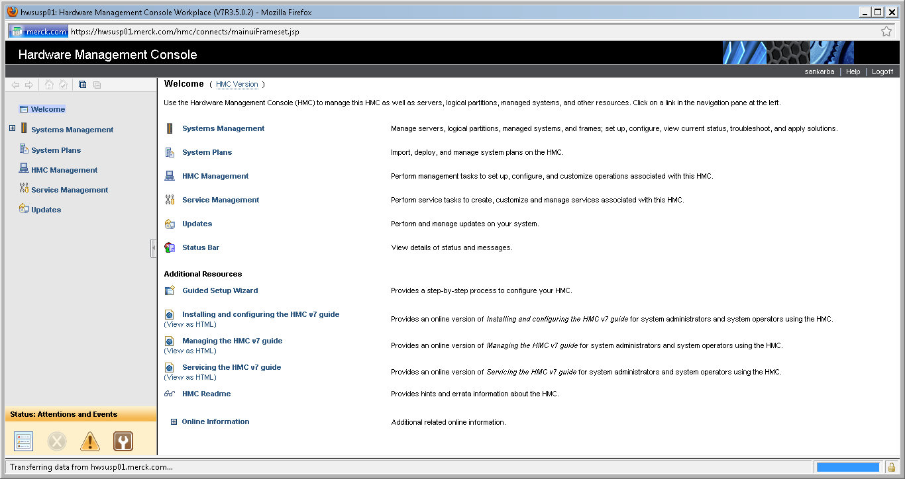
Now click on HMC Management on the left side of the screen.
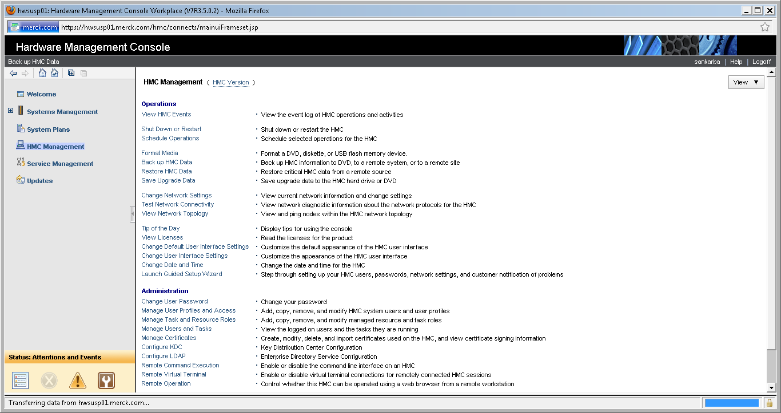
In the HMC management, now click on Backup HMC Data (Available on the right side of the screen).
By click the same, a new window will be seen as shown below.
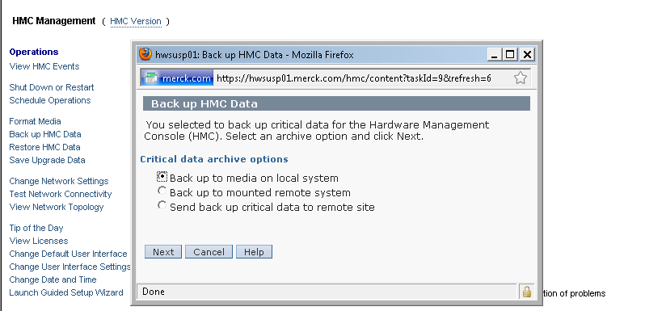
Here we have 3 options to backup the HMC data manually.
Generally we use the first option Back up to media on local system
Before proceeding with this option please make sure DVD is loaded in the HMC to perform the backup.

Note: For loading the DVD, raise an Incident request case to DATA_CENTER_OPERATIONS under infrastructure and relate the HMC details in the relationship tab and not the physical server details.
Once you click on the Next button you will be able to see whether the media (DVD) is loaded or not.
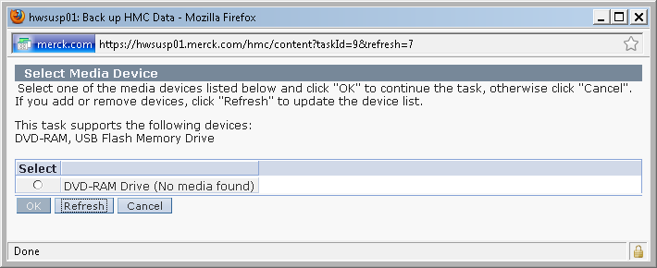
In the above e.g. there is no DVD loaded. Hence raise a request to data center team and have the DVD loaded.
In the below example you are able to view the DVD.
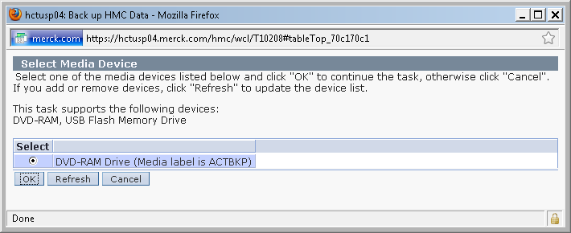
Now click on ok to commence the backup. Once the backup started another new window will pop up and once after the successful completion we will receive the completion notification.
If the backup fails then take necessary action to make the HMC backup as success one.

