Instruction to modify system startup program

Login to the AS/400 system.
Step 1: Locate the startup program for the system.
Use the below command to get the startup program details.
WRKSYSVAL QSTRUPPGM then take option 5 = Display.
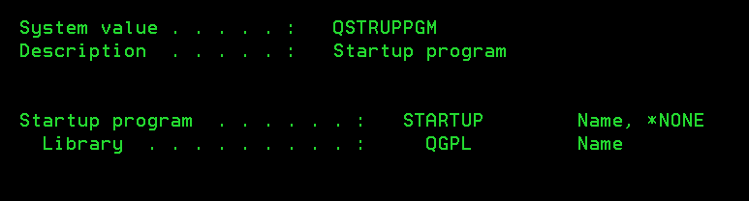
Step 2: Use the below command to know the source file, library and source member.
DSPOBJAUT OBJ(LIBRARY NAME/STARTUP PROGRAM NAME) OBJTYPE(*PGM) OUTPUT(*PRINT)
DSPPGM (LIBRARY NAME/STARTUP PROGRAM NAME)
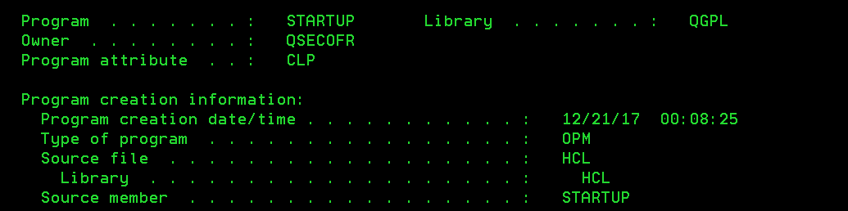
Step 3: Edit the member.
Use the below command to edit the member.
WRKMBRPDM FILE(LIBRARY /SOURCE FILE) MBR(SOURCE MEMBER)
Take option 6 = Print before modifying the member.
Now take option 2 = Edit

Now edit the member as per the requirement.
For inserting new line(s)
For inserting the new line see the below screen shit.
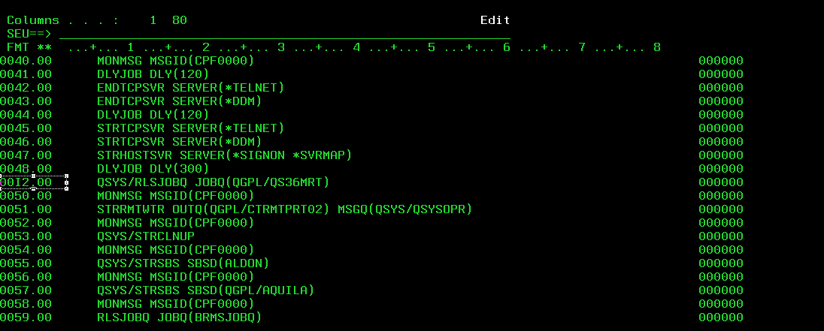
To insert 2 lines type I2 as shown in the above screen shot and hit enter.
2 lines will be inserted in the below.
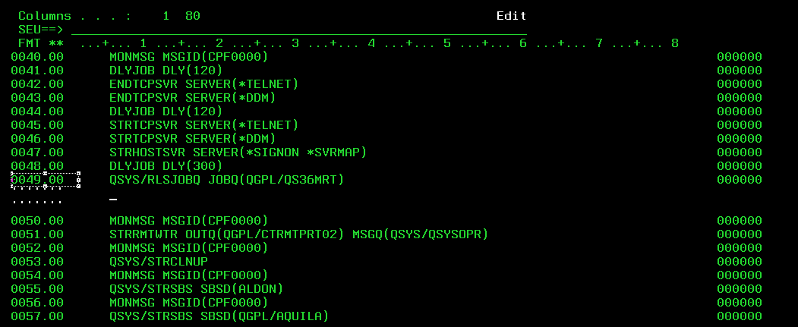

For deleting the existing line(s)
Similarly for deleting type D in the line exactly where do you want to delete and hit enter.
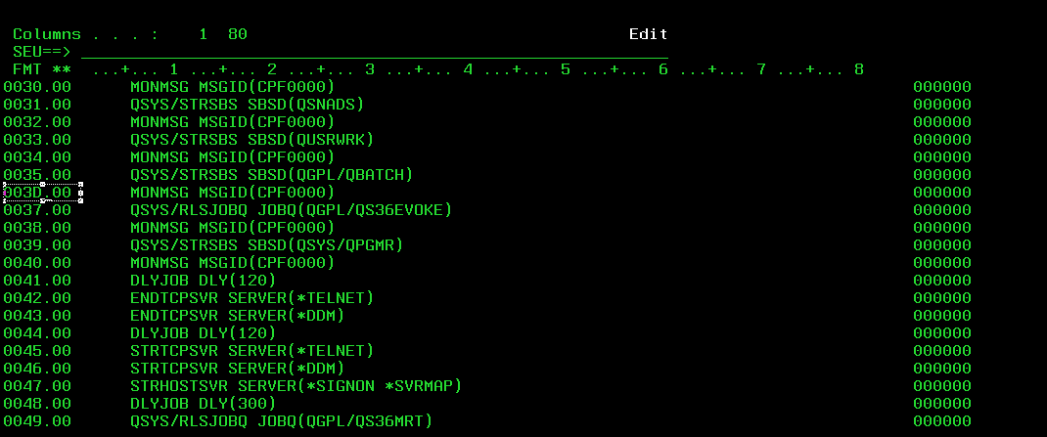
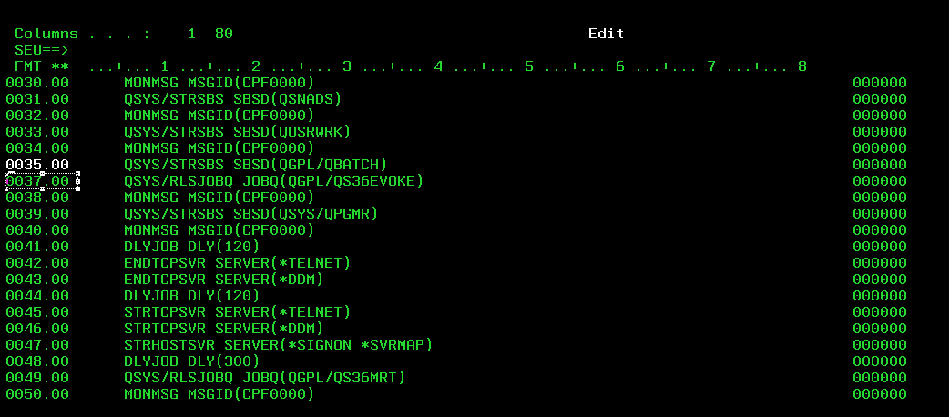
If you want to delete 2 continuous then you can type D2 in the required line and hit enter.
Once the required modifications were done then take F3 to exit.
You will be displayed with the below screen.

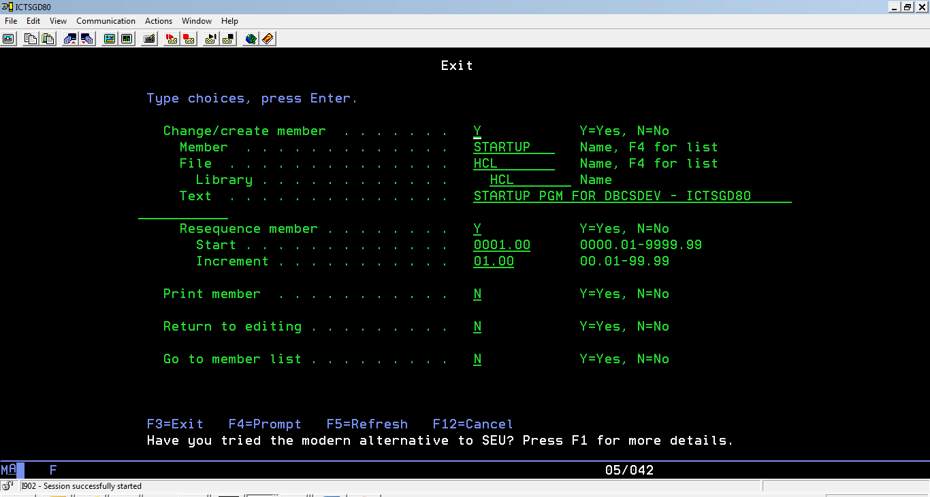
Again hit enter to confirm the modifications done.
Step 4: Compiling the modified member.
Now take option 14 = Compile and prompt it.
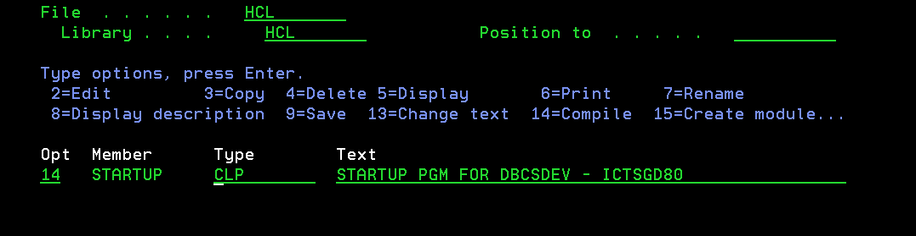
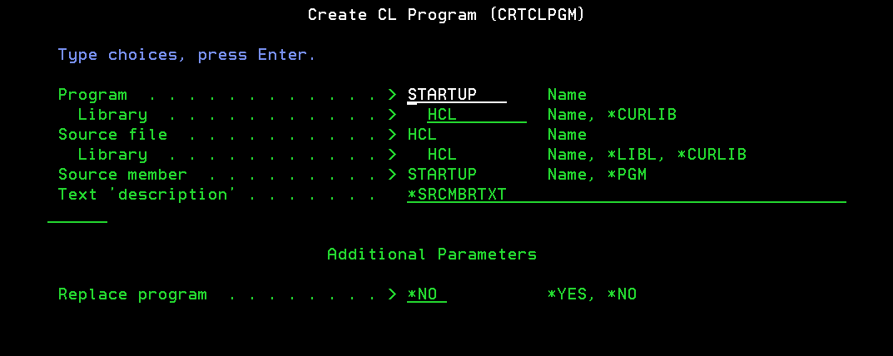
Very important step:
- Make sure you provide the correct library name. In this document, the program which is mentioned in system value QSTRUPPGM was found in QGPL library. This is important because while compiling you must provide the library name as QGPL as shown below.
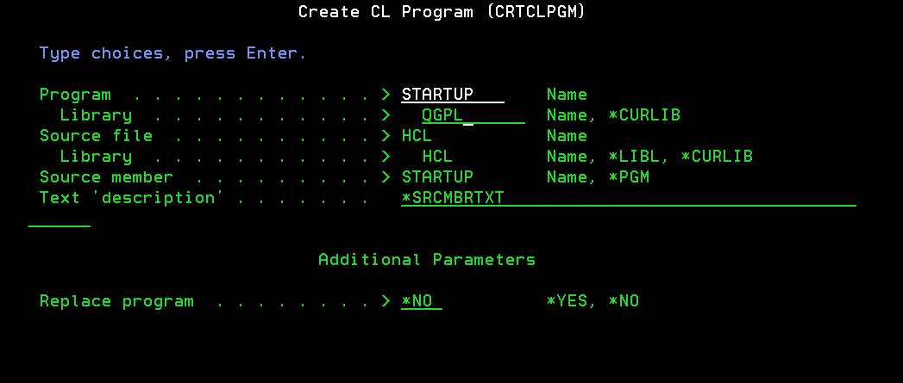

- The member can be saved in any library however during the compilation please make sure the program and library name is similar to the value mentioned in the system value QSTRUPPGM.
Step 5:
Revert the authority of the startup program as similar to the one which is taken in Step 2 (if required).

