Instruction to use QSECOFR and QSRV profile using PAM
Step 1: Login to the TPAM site.
Use the below link to access the TAPM.
https://tacs.merck.com/tpam
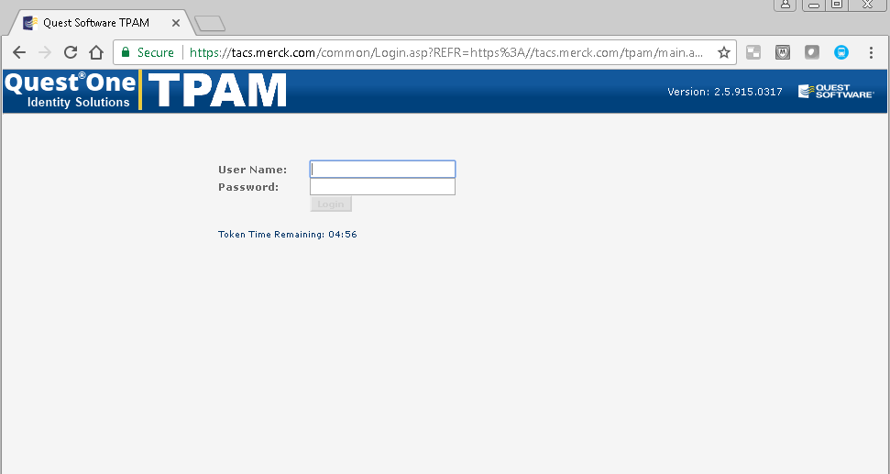
You need to provide your user name and password. Once entered, you will receive the below screen. Click on OK and proceed further.
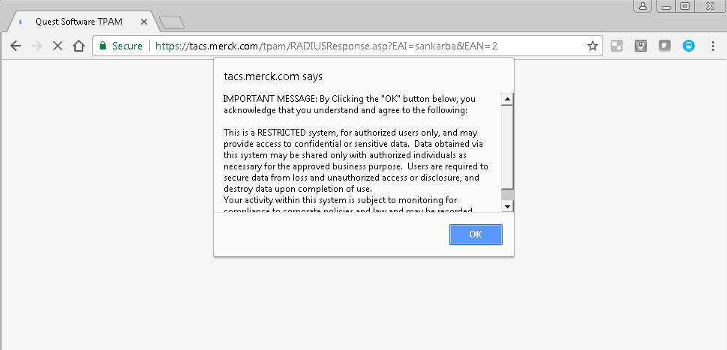
The n you will be requested to enter the passcode which can be obtained using VIP Access application.
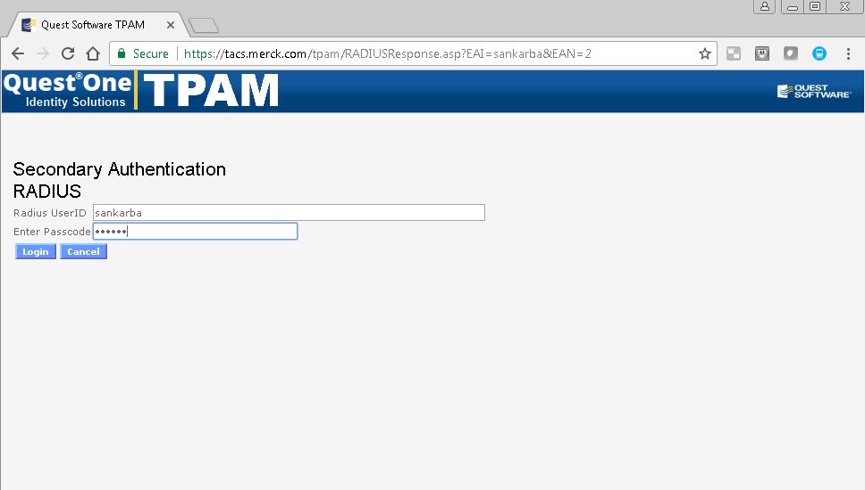

The VIP access application can be installed in your mobile or laptop or desktop.
Note: For configuration of VIP access – please login to the link https://tiea.merck.com
Then you will be routed to the below page.
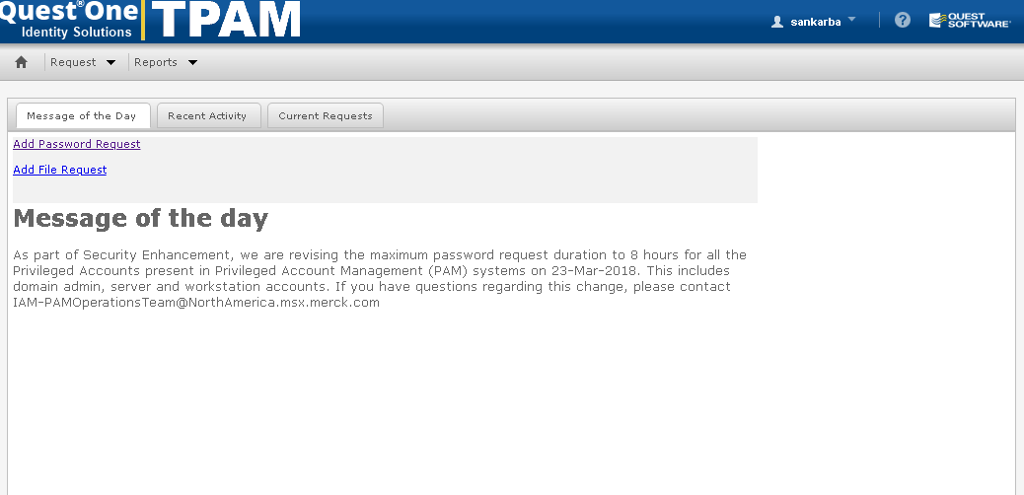
Step 2: Request for a new password.
For new request click on Request -> Password -> Add Request
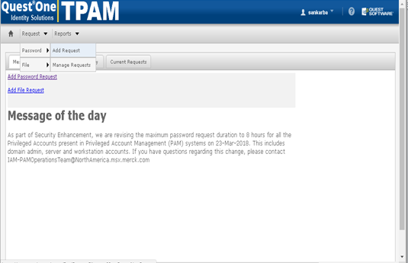
Then provide the system name for which you would require to extract the password for QSECOFR or QSRV or HSCROOT under Filter Tab.
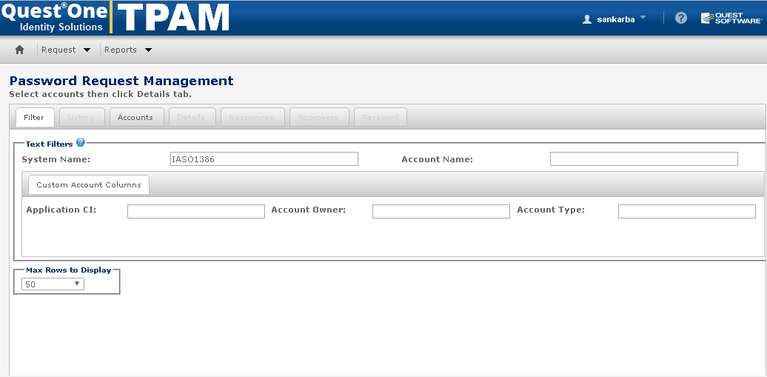

After updating the system name then click on Accounts Tab and select the check box for the profile for which you need to extract the password.
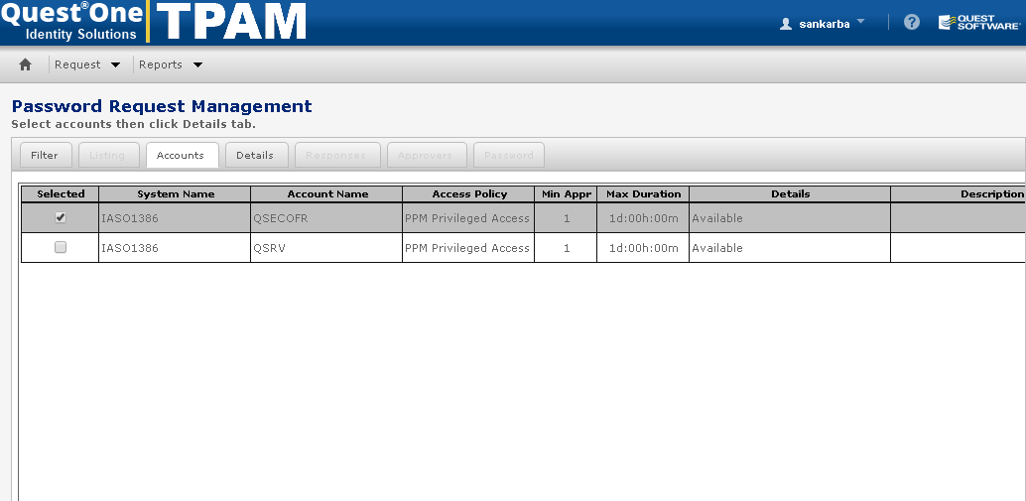

Then click on Details Tab and fill the below details.
- Select the duration for which you need the password of that particular profile.
- Mention the reason for obtaining the password of the profile. For. E.g. Backup monitoring or hardware maintenance, etc.

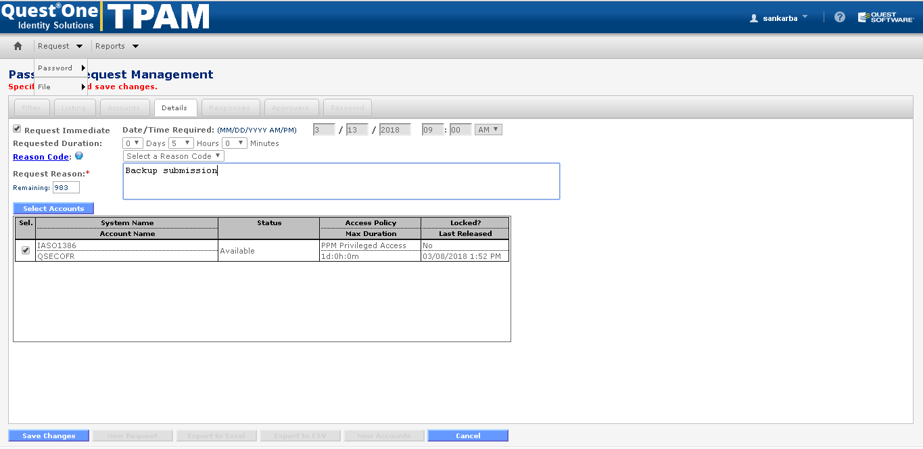
Once done then click on Save Changes button to obtain the password
Then you can view the password for the request profile in Password Tab.

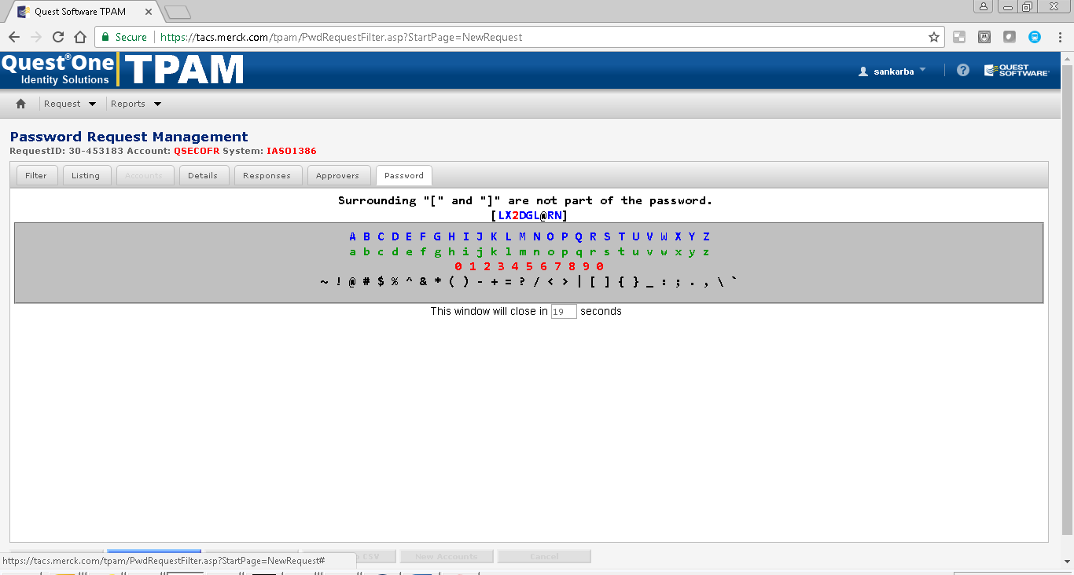
You will also receive an email confirmation for doing the same.
Step 3: For managing the existing the request.
For managing the request click on Request -> Password -> Manage Request
Then provide the system name.
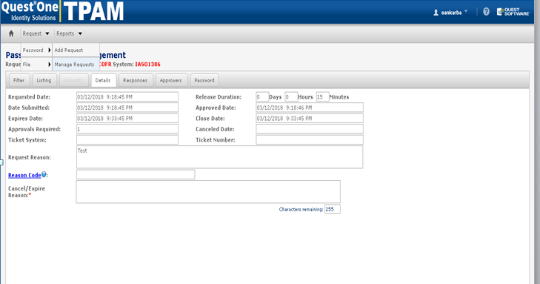

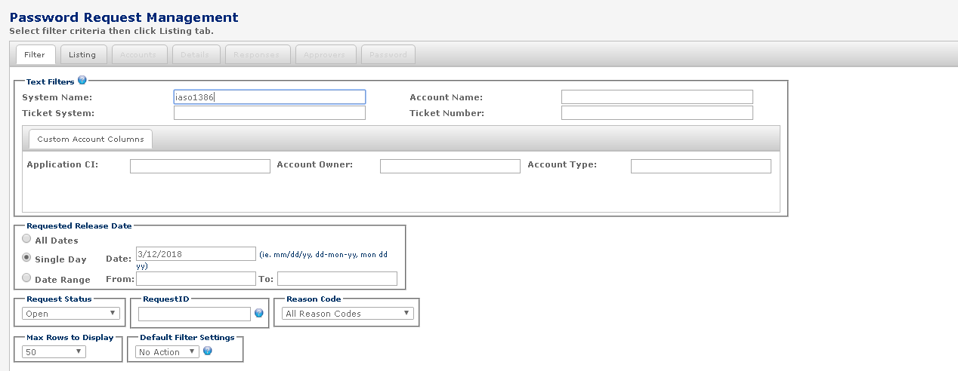

Once you enter the system name then click on List Tab you will see the existing request for that particular system.
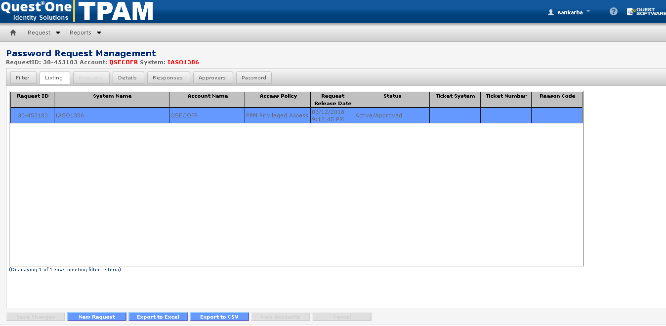
Now Click on Details Tab and provide the reason to cancel the existing request and click on Save Changes
Or
If you want see the password again then click on Password Tab.
