Password Setting/Reset Process for AS/400 user profiles

- Password setting/reset under any circumstance should undergo the following process without any deviation through a remedy request.
- DSPUSRPRF USRPRF(user profile name) OUTPUT(*PRINT) – Before evidence to be attached in remedy request.
- Check if the user has requested for password reset or just to enable the user profile.
- If the user has requested for enabling the profile, then use command WRKUSRPRF USRPRF(PROFILE) – Option 2 - change status parameter to *ENABLED and go to step 9.
- If the user has requested for password reset, we have to make sure, passwords are Random/Unique to each request that we execute.

Ex: buhnw6y,
jxku3siz,
nm249hsg,
kh2Zwr8y

This way we will ensure that, user profile default passwords are not guessable.

- If the user has requested for a password reset, then initially check the “Previous sign on “parameter. If it is more than 90 days then we need to email user and request for justification as to why the profile was not accessed for a long time.
- While resetting the password, make sure the status is *ENABLED and Set password to expired is *YES to ensure that the user can change the temporary password on first login.
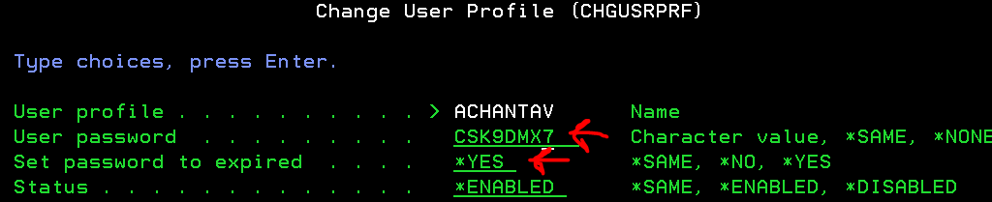

This way we will ensure that, no user use his/her profile with default password to work on systems.
- DSPUSRPRF USRPRF(user profile name) OUTPUT(*PRINT) – After evidence to be attached in remedy request.
- DSPAUDJRNE ENTTYP(CP) FROMTIME(“date and time of password reset”) OUTPUT(*PRINT) - evidence
- Find and display the audit spool file using the command WRKSPLF.
- Take print screen of the entry details
- Download the print screen spool file for after evidence, which needs to be attached in remedy request.
- Email user about the password reset completion and share the credential only to the owner of the profile even if it is group profile or service profile.

Exception case:

In S44AC211 system, While resetting the password / enabling the profile, make sure the initial menu is not *SIGNOFF. This happens when the user has not accessed the system for more than 90 days.

Reset the password as mentioned above and in order to find the user’s initial menu or program, use command GO MENU10AH – option 5 – Option 6. Enter the fields as shown below and hit enter
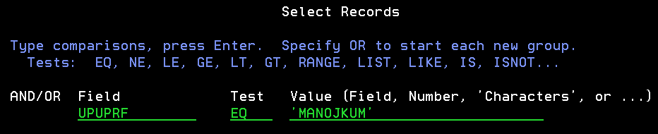

Scroll to the right side using shift +F8 to find out the user’s initial menu and program, then assign the same to the profile.

