AS/400 Account administration

Profile Creation:
- When we receive a case for profile creation, make sure the approved user access form is attached (form duly signed by the manager and the user) and the approved form must contain the following details, profile to be created (ISID), copy profile and the system name(s).
Important Note: - For a user access form only one user ID creation is allowed. It may contain many AS/400 system names. User access form containing more than 1 profile is NOT VALID.
- Check if profile to be created already exists in the mentioned system(s). If no, proceed with profile creation. If the profile already found in the system(s), then email user stating the same and act accordingly.
- Check if given copy profile exists in the system. If no, then request the user to provide another existing copy profile. If yes, please proceed with the next steps.
- Check if copy profile has special authorities or privileged access. If Yes, check with senior members before creating the profile. If no, you can directly start creating the profile.
How does the special authorities are defined?
If the copy profile has the below parameters, then it is called has privileged account.

Parameters | Special Authorities
Special Authorities (SPCAUT)  Note: - If the copy profile possesses any one of these authorities, then it should be discussed with the senior members | *ALLOBJ  *AUDIT  *IOSYSCFG  *SAVSYS  *SECADM  *SERVICE
User Class (USRCLS) | *PGMR  *SECADM  *SECOFR
Limit capabilities (LMTCPB) | *NO
Limit device sessions (LMTDEVSSN) | *NO
Password expiration interval (PWDEXPITV) | *NOMAX

- Check if the copy profile has an individual JOBD (not a generic JOBD), If yes, copy the individual JOBD in the ID of new user. To create a new JOBD use the below command.
WRKJOBD JOBD(copy profile) – take option 3=Copy and prompt it using F4 key.
Give the new ID against the New object as shown below in the screen shot.
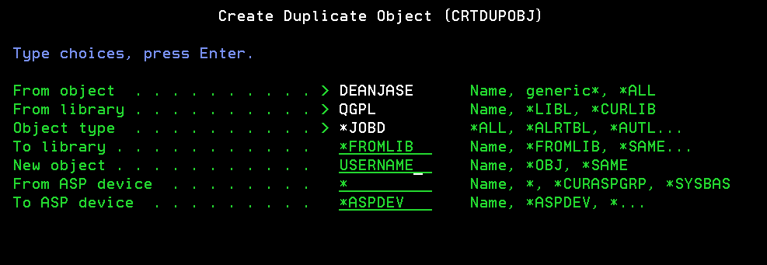
Once the JOBD is created then provide the authority to the created JOBD.
EDTOBJAUT OBJ(XXXXX) OBJTYPE(*JOBD) and then take F6= Add new users.
Then furnish the user id as shown below.

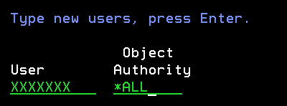
- Now create the user profile by using the command
WRKUSRPRF USRPRF(Copy profile) and take option 3 to copy the profile and key in the required parameters as given below
USRPRF - New profile name
PASSWORD – New password
PWDEXP - Set password to expired - *YES
STATUS – Status of the profile - *ENABLED
TEXT - Text description
JOBD – Job description – If newly created as mentioned in the previous step.
- Once the profile has been created you need to take a print of it using the command.
DSPUSRPRF USRPRF(XXXXXXX) TYPE(*ALL) OUTPUT(*PRINT)
- Send an email notification to the user for whom the profile has been created by copying HCL AS/400 support team and the password MUST be shared to the user in a separate email.
- Upon receiving confirmation from the user proceed to complete the case. Also make sure all the evidences have been attached to the case. This includes emails if any.
- Important note:
  - For system IASO1328, once the profile has been created from our end then raise a separate Remedy case to HCL JDE team (AMS Finance CIT under application).
  - For system S44AC211, once the profile has been created from end, notify the customer and complete the case. Follow the instruction as given in the email attachment.

Profile Modification:
- When we receive a case for profile modification, make sure the approved user modification form is attached (form duly signed by the manager and the user) and the approved form must contain the following details, profile to be modified, given any instruction to modify or copy profile and system name(s).
- Check if the profile to be modified exists in system using WRKUSRPRF/DSPUSRPRF command. If not found, notify the user and act accordingly.
- Before proceeding with profile modification, take a full print of the profile using command DSPUSRPRF USRPRF(XXXXX) TYPE(*ALL) OUTPUT(*PRINT). Download the report from the navigator to attach it in the case notes.
- Modify the parameters as requested (given instruction or copy profile) by the user and then inform the same to the user through email.
- After modifying the profile, take a full print of the profile using command DSPUSRPRF USRPRF(XXXXX) TYPE(*ALL) OUTPUT(*PRINT). Download the report from the navigator to attach it in the case notes.
- Upon receiving confirmation from the user proceed to complete the case. Also make sure all the before and after evidences has been attached to the case. This includes emails if any.
Profile Deletion:
- When we receive a case for profile deletion, make sure the approved user deletion form is attached (form duly signed by the manager) and the approved form must contain the following details, profile to be deleted and system name(s).
- Check if the profile to be deleted exists in system using WRKUSRPRF/DSPUSRPRF command. If yes, check if the user had logged in recently. If there is a recent sign on, then confirm with the requestor explaining the same and get approval to process further. This email evidence must be attached in the case notes for Audit purpose.
- Before proceeding with profile modification, take a full print of the profile using command DSPUSRPRF USRPRF(XXXXX) TYPE(*ALL) OUTPUT(*PRINT). Download the report from the navigator to attach it in the case notes.
- Then check if there is any job scheduled in user's name by using command WRKJOBSCDE OUTPUT(*PRINT) PRTFMT(*FULL). Then use command WRKJOB and take option 4 to view the generated spool files and take option 5 against QSYSPRT. In find column mention the profile name and press Shift+F4 to find if there is any job running under user profile parameter. If yes, change the job to run under QSECOFR profile. Ignore, if you find the name against the parameter scheduled by.
- Now delete the profile using the command
DLTUSRPRF USRPRF(XXXXXXXX) OWNOBJOPT (*CHGOWN QSECOFR)
- Take a host print by doing a right click on your mouse and having the radio button pointing to Pad 2. You can view the evidence as a spool file. The same can be downloaded from Navigator and attach it in the case notes as evidence.
- Inform user about completion of profile deletion and complete the case by attaching the necessary evidence(s). This includes emails if any.

