Instruction to check life time of the cache battery using Service Tool (SST)

There are 2 ways to check the life time of the cache battery using service tool (SST).
Step 1:
Login to the system using profile having special authority *SERVICE
In the command line issue the command STRSST. Provide the SST ID and password.
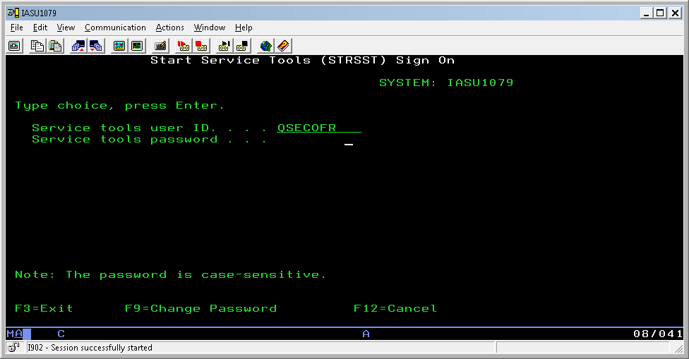
Then take OPTION 1 = Start a service tool 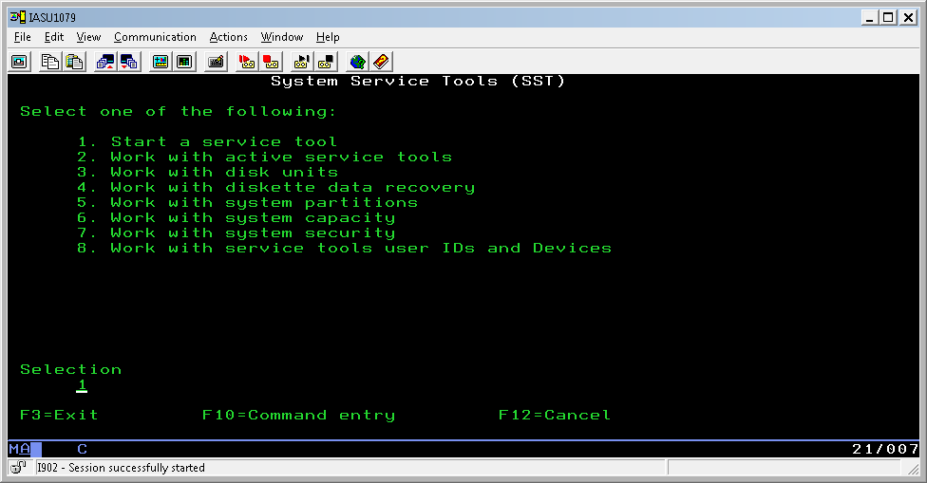
OPTION 7 = Hardware service manager
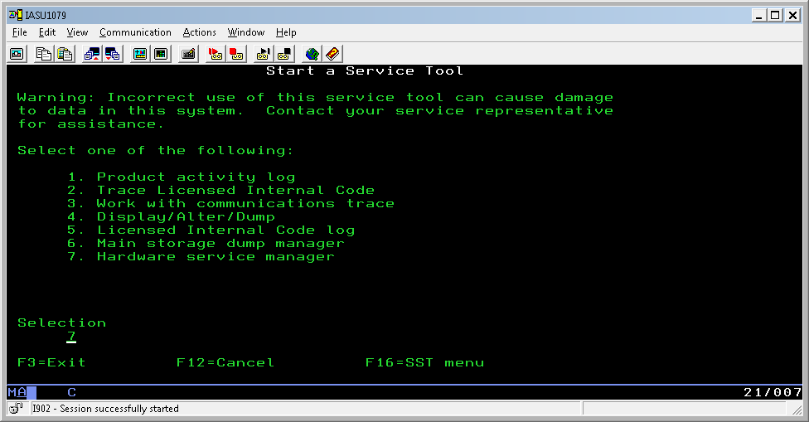
OPTION 9 = Work with resources containing cache battery packs
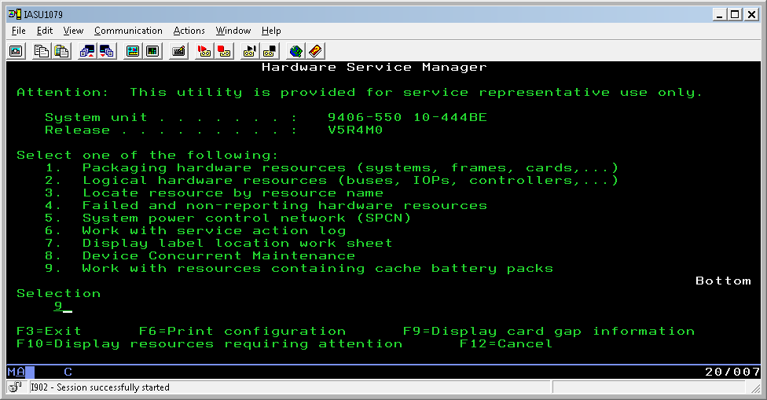

Option 5 = Display battery information
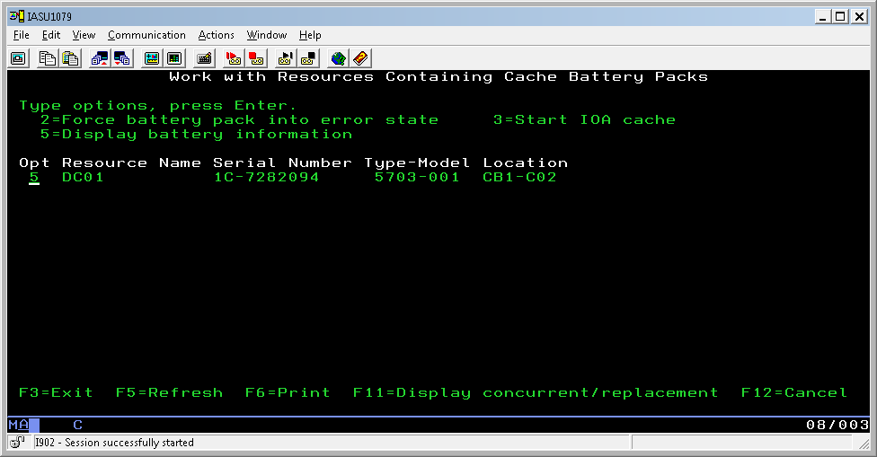
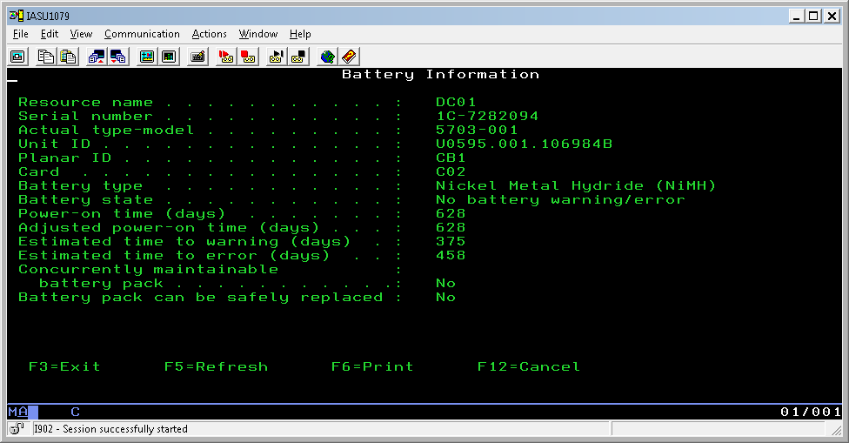

Step 2:
In the command line issue the command STRSST. Provide the SST ID and password.

Then take OPTION 1 = Start a service tool 

OPTION 4 = Display/Alter/Dump
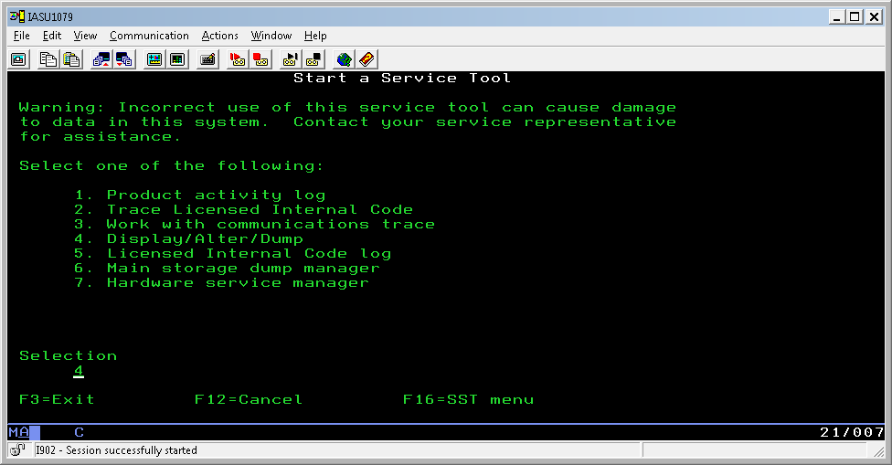
OPTION 1 = Display/Alter storage
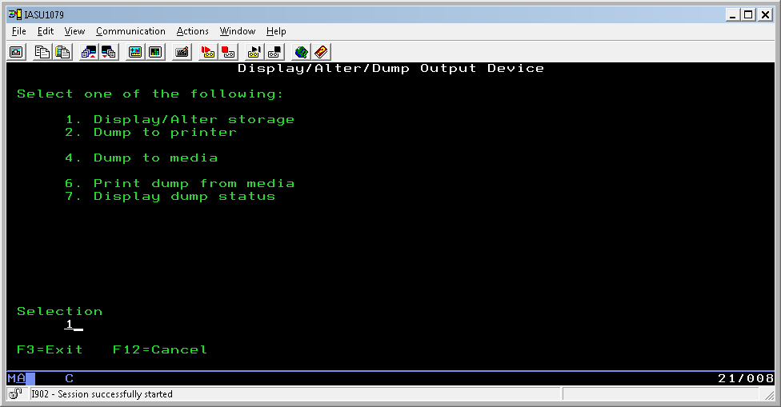

OPTION 2 = Licensed Internal Code (LIC) data
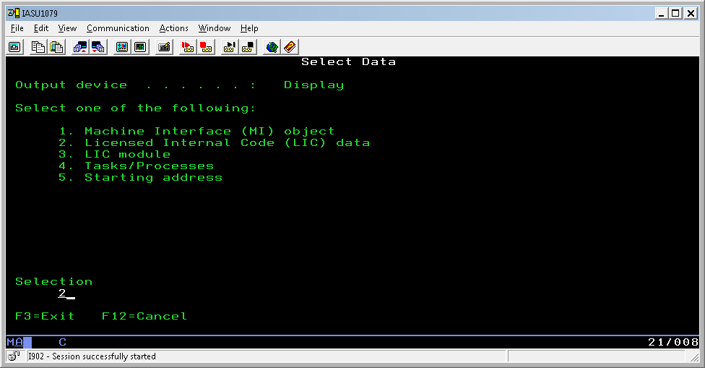
OPTION 14 = Advanced analysis
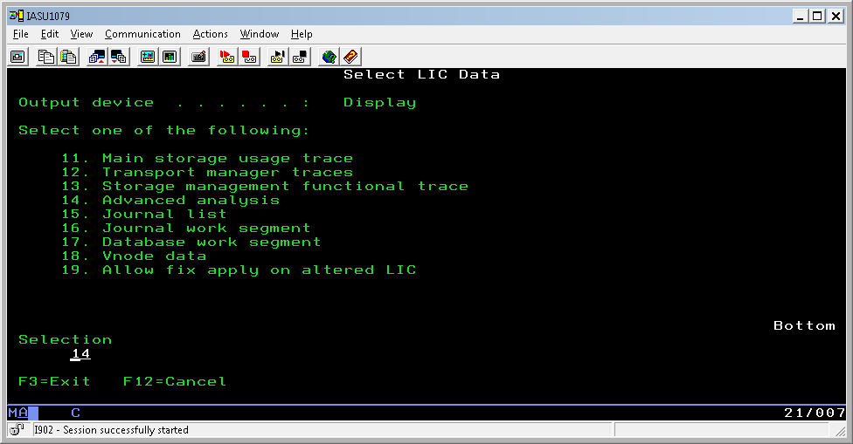

Take 1 against BATTERYINFO
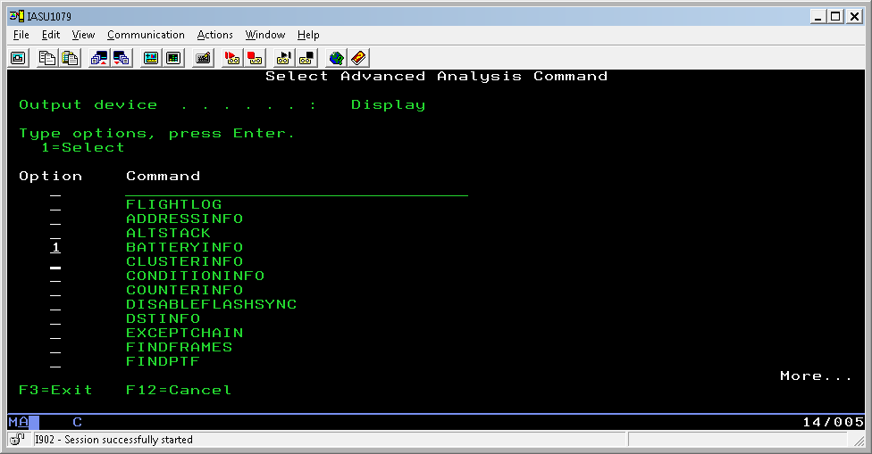
In the options type -INFO -ALL
