

MSc Data Science Project
7PAM2002-0901-2025
Department of Physics, Astronomy and Mathematics

Data Science FINAL PROJECT REPORT

Project Title: Comparative Analysis of Logistic Regression, Random Forest, and Deep Neural Networks for Diabetes Prediction

Student Name: Jagan satwik pinnam reddy
SRN: 23091055
Supervised by: Shree Hari Mittal
GitHub Repo: https://github.com/jaganSatwik7/diabetes_project.git
Table of Contents
Abstract 3
Acknowledgements 4
Chapter 1: Introduction 5
I. Overview 5
II. Problem Statement 5
III. Research Questions 6
Chapter 2: Background 7
I. Dataset 7
II. Data collection & GDPR 7
III. Literature Review 8
IV. Research Gap 9
Chapter 3: Methodology 11
I. Tools and Techniques 11
II. Algorithms 11
a. Logistic Regression 11
b. Random Forest 11
c. Artificial Neural Network 12
III. EDA and Visualization 13
Chapter 4: Results and Conclusion 19
I. Critical Discussion 19
II. Conclusion 20
III. Future Work 23
Chapter 5: Legal, Ethical and Professional Issues 24
References 24
Appendices 25
I. EDA 25
II. Model Building 34

Abstract
Diabetes is one of the chronic metabolic conditions which is a major burden to the health globally thus early detection and prediction of risk is paramount in effective intervention. This paper will compare three machine learning models namely: Logistic Regression, random forest, and Deep Neural Networks to predict hospital readmission due to diabetes based on a real-world clinical dataset found in the UCI machine learning repository. Extensive data pre-processing was undertaken and it included missing value treatment, feature encoding, normalization and correction of class imbalance. Exploratory data analysis was done to establish some important patterns and relationships in the data. The model was assessed based on the accuracy, precision and recall over training and testing data sets. They have shown that the results are that the Random Forest is significantly better than the Logistic Regression and Deep Neural Network, and the generalization and the strength of the model it produces are strong and effective in describing complex and non-linear clinical relationships. The results show that the Random Forest model achieved the best predictive performance, obtaining 0.959 accuracy, 0.942 precision, and 0.978 recall on the test dataset, significantly outperforming Logistic Regression and the Deep Neural Network. The results demonstrate the significance of model selection and preprocessing in constructing effective clinical decision-support systems to manage diabetes.

Acknowledgements
I also wish to admit that my project supervisor has greatly helped me, provided me with constructive criticism and support during the entire period of this project, which is why I would like to thank him. Their experience and support played a great role in influencing the course and quality of this study.
I also appreciate the faculty members and department in making the academic materials and learning environment that I need to complete this study. Their instruction formed the basis of machine learning concepts and the way they can be used in the medical field.
The contributors of the publicly available datasets and research repositories, and especially the UCI machine learning repository, are thanked in particular because they made it possible to conduct this research. Lastly, I would like to give a credit of the support made by my peers and family, whose encouragement and support were invaluable when this project was successfully completed.

Chapter 1: Introduction

Overview
Diabetes mellitus is a persistent metabolic condition that is associated with a high level of glucose in the blood due to the inability of the insulin secretion, insulin activity, or a combination of the two. It is a significant worldwide social health issue because of its increasing incidence and its correlation with serious complications that involve cardiovascular disease, neuropathy, retinopathy, and renal failure. It is critical to identify people who are at high risk early in order to implement timely preventive and clinical intervention that can decrease the burden and cost incurred in healthcare.
The development of machine learning has posed new possibilities in predictive modelling in healthcare because it allows the analysis of massive clinical and lifestyle data. Unlike standard statistical methods, contemporary machine learning models have the ability to follow non-linear and complicated associations between predictors and outcomes, and may enhance predictive quality. The proposed project is aimed at the formulation and testing of predictive models of diabetes based on clinical and demographic variables, such as age, body mass index (BMI), blood sugar, blood pressure, physical activity, and smoking.
This paper is a comparative analysis of three popular predictive methods, which include Logistic Regression, Random Forest, and Deep Neural Networks (DNNs) using a structured dataset provided in the UCI machine learning repository. The Logistic Regression is a good baseline model because it is understandable and is already applied in medical studies. Random Forest is one of the ensemble methods that can be used to deal with non-linear interactions and high-dimensional data. Deep Neural Networks are researched on their outstanding capacity to capture and model complicated interactions of features which would otherwise not be defined, through simpler methods.
Through a systematic comparison of these models, this project will determine the most useful model of predicting the outcome in diabetes and also measure the effect of preprocessing data and feature selection in model performance. The results are supposed to formulate useful information to apply in the early-stage detection and prevention measures in the management of diabetes.

Problem Statement
Although authorities have accumulated a lot of clinical data on the risk factors of diabetes there has always been a challenge in precisely determining the onset and prognosis of diabetes. Conventional diagnostic procedures and risk rating systems can tend to be based on fewer assumptions regarding the linearity of relationships among variables and may not utilize an increasing amount of clinical and lifestyle data. Consequently, the high-risk people might not be detected in time to undergo preventive measures.
The machine learning methods can be used to achieve better predictive performance by taking advantage of the multi-faceted patterns in data, yet, there is no agreement concerning the best models to be used in predicting diabetes using table-like clinical data. Although it is recognized that Logistic Regression is appreciated due to its transparency and interpretability, it can be ineffective in the predictive scope in case of non-linear relations between variables. Random Forest models are capable of addressing some of this limitation at the expense of interpretability. Powerful but still requiring careful preprocessing and tuning, Deep Neural Networks are not always more effective than simpler models, especially in cases where the quality and volume of data are small.
The second important problem is the clarity of the relationship between preprocessing of data and selection of features as it is applied to the model results. Clinical data usually have missing values, noise, and predictors correlated with one another, and all of these may have a considerable impact on the performance of the model. Also, despite the numerous clinical characteristics of diabetes, their comparative values and prediction power are not identified, using various modelling methods.
Consequently, the main issue that needs to be examined in the given study is the absence of a transparent, comparative vision of the way various machine learning models can predict the results of diabetes based on the same clinical data. This issue should be addressed to establish whether more complex models like DNNs have any value over traditional and ensemble models, and to make sure that predictive models can be successfully implemented in the actual clinical decision-making.

Research Questions
- How does the predictive performance of a Deep Neural Network compare with Logistic Regression and Random Forest models in predicting diabetes outcomes using clinical features?
- What is the impact of data preprocessing and feature selection on the performance of each predictive model?
- Which clinical and lifestyle features contribute most significantly to accurate diabetes prediction across different modelling techniques?

Chapter 2: Background

Dataset
The data used in the research is provided in the UCI Machine Learning Repository and is known as the data that consists of Diabetes 130 -US hospitals during the years 1999-2008 (Clore et al., 2014). It contains more than 101,000 patient encounter data, which consists of more than 50 attributes describing demographic, clinical, and lifestyle factors. Though artificial, the data has been designed to resemble the actual clinical documentation in various hospitals of the United States within the given period (Strack et al., 2014).
The most important patient-related characteristics include age, sex, and ethnicity as well as such crucial clinical parameters as a body mass index (BMI), blood glucose, and blood pressure. Additional information on medical history, including comorbidities, medication use, and previous visits to hospitals, is included to provide contextual information on the disease progression and management. The dataset is further enhanced with lifestyle indicators, especially physical activity and smoking status that confirm predictive modelling. The primary variable of interest is a binary yes or no of diabetes presence, thus making it easy to conduct a supervised learning framework to train and evaluate the model.
To ensure compliance with data privacy and ethical standards, the dataset has been completely anonymized, and no personally identifiable data is included in it to provide compliance with the General Data Protection Regulation (GDPR) and other privacy laws (Clore et al., 2014). This cross-sectional table dataset provides a strong start point of implementing and evaluating machine learning models, including, but not limited to, Logistic Regression, Random Forest, and Deep Neural Networks, to predict diabetes outcomes. Combining patient demographics with clinical measures and lifestyle factors give a more subtle view of the patterns of risks, which can help in the context of early detection and intervention during diabetes management (Strack et al., 2014).
Link here

Data collection & GDPR
The dataset, though synthetic, has been developed to reflect realistic clinical data of diabetes patients in various hospitals of the United States in the 1999- 2008 period. It is openly accessible through UCI Machine Learning Repository in research activities.
Data Collection: The data set was compiled out of publicly available sources and artificially created clinical records, which ensured that no personally identifiable information (PII) was included during the time of gathering.
Data Anonymization: All patient data in the dataset have been anonymized and personally identifiable information (PII) has been removed to ensure that people cannot be identified either directly or indirectly.
Data Minimisation: All the redundant data not necessary to accomplish a diabetes prediction are excluded, including any clinical measurements collected or demographic traits, which complies with the GDPR principle of data minimisation.
Ethical Usage: The data is openly published to allow its use in research, which by definition makes the use of this data ethical, transparent, and in line with the GDPR standards.

Literature Review
The given paper compares Logistic Regression (LR) and K-Nearest Neighbors (KNN) to predict diabetes in the Pima Indians Diabetes Dataset which is an elegant benchmark that has been used in medical machine learning studies. The research employs a typical supervised learning cycle that includes data preparation, training, and testing of the model. The dataset is however relatively low dimensional and small (only 768 instances with eight clinical features) and therefore not as representative as the current electronic health record datasets.
One of the major preprocessing steps is that of known limitation in the Pima dataset, where the zero values (i.e. glucose, BMI, insulin, blood pressure, etc.) that are physiologically implausible are taken as a missing value and imputed by the column means. Although this prevents the distortion of model learning, mean imputation assumes data symmetry in the feature distribution and can decrease variance, which can influence the model performance (Little and Rubin, 2019). Min-max normalization is used to carry out feature scaling since distance-based algorithms such as KNN are sensitive to the magnitude of its features (Han et al., 2022). Nevertheless, it does not choose or reduce the features, although the use of these methods has been shown to enhance the prediction of diabetes (Kavakiotis et al., 2017).
LR and KNN are restricted to the modelling stage. Logistic Regression is regularized and cross-validated, which is in line with healthcare best practices (Hosmer et al., 2013), with k=5 in KNN. The measures of performance are accuracy, precision, and recall, but the missing measures of F1-score or ROC-AUC do not allow seeing clinically significant sensitivity-specificity trade-offs (Saito and Rehmsmeier, 2015).

Refat et al. provide a comparative analysis of the machine learning (ML) and deep learning (DL) approaches on the detection of diabetes at an early stage using a UCI benchmark dataset consisting of 520 examples and 16 attributes as questionnaire items (Refat et al., 2022). The approach of the study is wider than most of the previous works by pitting six ML models (Logistic Regression, KNN, Decision Tree, Random Forest, SVM, and XGBoost) against three DL models (ANN, MLP, and LSTM), which makes the study more comparative.
Preprocessing entails transformation of categorical variables to binary numerical values, which are suitable in questionnaire data. Nevertheless, the pipeline is still quite straightforward, so there is no reason to scale features in distance-based models and no feature selection or dimensionality reduction. Variability between folds and statistical significance are not mentioned, even though a tenfold cross-validation is applied.
One of the strengths is the evaluation framework that consists of accuracy, precision, recall, F1-score, ROC-AUC, execution time, and loss. Although XGBoost has close to perfect accuracy, the small size of the data is a cause of concern on overfitting. Also, the discussion of deep learning structures and optimization is not as significant, and it is hard to determine whether the failure of DL is attributable to data constraints or to the model architecture.

Kaushal and Bartwal provide a detailed comparative analysis in an attempt to create useful diabetes prediction models that utilize machine learning and deep learning frameworks on PIMA Indians Diabetes Dataset and 130 US Clinical Hospitals dataset (Kaushal and Bartwal, 2022). The approach to the study is methodologically strong as it combines exploratory data analysis, sophisticated feature engineering, feature selection, and the use of SMOTE to address class imbalances, as well as a massive hyperparameter optimization. Model analysis is performed to a high level, using the K-Fold cross-validation tool with various measures, such as accuracy, precision, recall, F1-score, and confusion matrices, which are used to examine bias-variance trade-offs. Nonetheless, the comparison to be made is based more on internal validation as compared to external and temporal validation to measure generalizability. Also, there are architectural and capacity-scale issues that appear unexplained by the reported challenges in vanishing gradients in deep learning models.

Rethik et al. provide a comparative analysis of various models of machine learning to predict heart disease based on structured clinical data (Rethik et al., 2025). The given study is methodologically applicable despite the fact that its focus is on cardiovascular disease, not on diabetes because they both are based on the same risk factors and tabular clinical datasets. The study employs the UCI Heart Disease data provided by Kaggle which comprises 1025 cases and 14 features. Exploration analysis is done through correlation heatmaps and histograms, but the analysis is generally descriptive with little information on feature selection, multicollinearity and class imbalance management.
There are five machine learning models which include the random forest, logistic regression, naive bayes, decision tree and K-nearest neighbors that are tested using different train test splits with the 20 percent test split showing the best results. Lack of k-fold cross-validation/resampling e.g. SMOTE constrains robustness and can result in optimistic estimates. Accuracy, precision, and F1-score are used to measure the performance. Random Forest this time has the best performance, as with previous healthcare machine learning experiments, although recall does not get much attention, which lower clinical values when false negative counts matter.

Research Gap
Despite the fact that several research studies have used machine learning methods in predicting diabetes, there are a number of limitations. Most of the available literature is based on relatively small datasets like the Pima Indians Diabetes dataset and this restricts the applicability of the findings to actual healthcare settings. The questionnaire based datasets in other studies fail to reflect the complexity of the hospital records and clinical utilization pattern. Moreover, the comparison of classical machine learning models and deep learning approaches frequently proves inconsistent because it involves varying preprocessing pipeline, evaluating metrics, and imbalancing treatment approaches.
Moreover, deep learning models are often inserted without any optimization, which is why it is challenging to define whether it is the features of the data or the model configuration that limits its performance. Little emphasis is also given to formal hospital data that serves to measure actual clinical processes and patient readmission rates.
Thus, this research fills these gaps by comparing the Logistic Regression, the Random Forest, and the Deep Neural Networks on the basis of a massive real-world hospital data point of the UCI Machine Learning Repository. The models are tested based on a standard preprocessing pipeline and are measured on clinically important measures like accuracy, precision, and recall in order to understand which model is most appropriate in predicting diabetes-related hospital readmission.

Chapter 3: Methodology

Tools and Techniques
The Python programming environment has been adopted in this project because it provides powerful data science and machine learning environments. Pandas and NumPy are essential to carry out core manipulation and analysis by providing efficient implementation of manipulation and analysis of large tabular data and numerical operations. To perform statistical processing and identify outliers, Scipy is used, especially by using the z-score filtering the extreme values.
Exploratory data analysis and visualization are conducted with the help of Matplotlib and Seaborn, and they can be easily used to examine the distributions, relationships, and class imbalance. The development of the models is based on scikit-learn that provides classical machine learning algorithms, such as Logistic Regression and Random Forest, and preprocessing, train-test split, evaluation metrics, and resampling that enhance class imbalance.
In the case of deep learning, the Artificial Neural Network is constructed and trained with TensorFlow (Keras) which has flexibility in network architecture, optimization and regularization. The metrics of evaluation include accuracy, precision, and recall, to provide performance under class imbalance, especially the significance of correctly reporting readmission patients. All these tools together aid a strong and repeatable data pipeline between raw data preprocessing and comparative model assessment.

Algorithms

Logistic Regression
Logistic Regression is an old-fashioned statistical learning algorithm that is common in binary classification tasks especially in medical and epidemiological studies. Logistic Regression models the probability of a binary outcome using the logistic (sigmoid) function. For a feature vector $X=(x_{1},x_{2},...,x_{n})$, the probability that the target variable $y$equals 1 is given by:
$$P(y=1∣X)=\frac{1}{1+e^{-(β_{0}+β_{1}x_{1}+β_{2}x_{2}+...+β_{n}x_{n})}}$$
Overall, it provides a model of the probability of an outcome estimating a linear modulation between input features and the log-odds of the target variable. Its key advantages are simplicity, computational effectiveness and interpretability. Every coefficient is a direct reflection of the direction and strength of the role that a feature plays in the result, which is particularly useful with a clinical setting where clarity and elucidation of results are extremely important.

Random Forest
Random Forest is an ensemble learning algorithm that involves the use of several decision trees and combining their predictions. The training of each tree is done on a random subset of data and features and thus variance is minimized and the generalization is enhanced. Random Forest is a collection of learning algorithms based on the combination of several decision trees and provides a better predictive accuracy and decreases overfitting. All the trees are trained on a random sample of the data and features, which enhances diversity in the models. The majority voting is used to average the predictions of all the trees where the final prediction is obtained:
$$\hat{y}=\text{mode}(T_{1}(x),T_{2}(x),...,T_{n}(x))$$
Overall, Random Forests are known to cope with non-linear relationships, interaction of features and high-dimensional data with no strong assumptions with respect to data distributions.
In this project, Random Forest may be very handy since non-linear relationships between clinical and lifestyle variables are quite common. E.g. the joint impact of age, BMI, and physical activity on the risk of diabetes might not be complete as measured by linear models. Random Forest is capable of modeling these interactions in an automatic way without being sensitive to noise and outliers. The other benefit is that it has inbuilt features of importance measures, which can be used to determine the most significant predictors of diabetes to aid clinical interpretation.

Artificial Neural Network
Artificial Neural Networks and especially Deep Neural Networks are based on the design of the human brain and can be seen as a series of several interconnected layers of neurons. Overall, ANNs are very effective at learning non-linear mappings between inputs and outputs that are complex and have been very effective in a wide range of domains, including healthcare prediction applications. Their adaptability enables them to estimate very complex relationships which might not be modeled by the traditional models.
During forward propagation, each neuron computes a weighted sum of inputs followed by a non-linear activation function:
$z=\sum_{i=1}^{n}{w_{i}}x_{i}+b$, $a=f(z)$
For binary classification tasks, the model is trained by minimizing the binary cross-entropy loss function:
$$L=-\frac{1}{N}\sum_{i=1}^{N}{[}y_{i}log⁡(\hat{y_{i}})+(1-y_{i})log⁡(1-\hat{y_{i}})]$$
The model parameters are updated during backpropagation using gradient descent:
$$w=w-η\frac{∂L}{∂w}$$
The ANN is used in this project to assess whether the advanced deep learning techniques have a significant increase in predicting diabetes outcomes using tabular clinical data. ANNs have the capability to learn how many features interact (e.g., glucose, BMI, lifestyle factors) which may result in improved predictive accuracy. This renders them desirable in the detection of subtle patterns suggestive of risk of diabetes in early adulthood.
Nevertheless, ANNs have significant challenges as well. They also need a large amount of preprocessing, feature scaling and hyperparameter tuning and are more susceptible to overfitting particularly when using small datasets. Also, they are black-box, which makes them less interpretable, and thus prediction to clinicians is more difficult. The performance of the ANN is thus not merely considered in terms of accuracy in this study but also in comparison with simpler models to determine whether the ANN is as complex as it needs to be.

EDA and Visualization
Exploratory Data Analysis was used to comprehend the structure, quality and nature of diabetes data before developing the model. The data is a set of more than 100,000 interactions between the patient and the hospital with both numerical and categorical variables such as demographic data, hospital admissions, clinical measurements, and medication use.
The patients were distributed unevenly in terms of the target variable, the number of patients who were not readmitted was the highest according to the distribution, and then there were the patients who were readmitted after 30 days and then the fewest patients who readmission happened after 30 days.
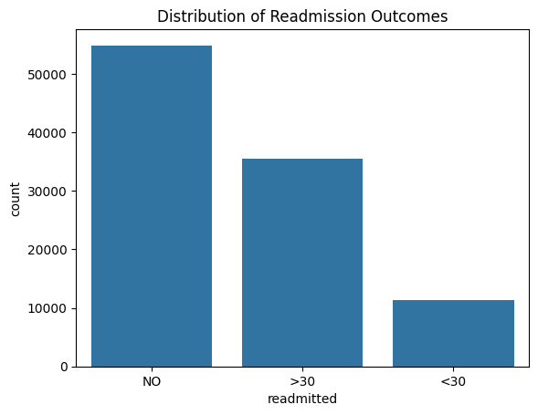
Figure 1 Target Variable
The demographic analysis showed that the proportion of female patients was bigger, as well as most of the people in the dataset were Caucasian. Analysis of age distribution revealed that the majority of patients were in the age brackets that are older as expected based on prevalence patterns of diabetes.
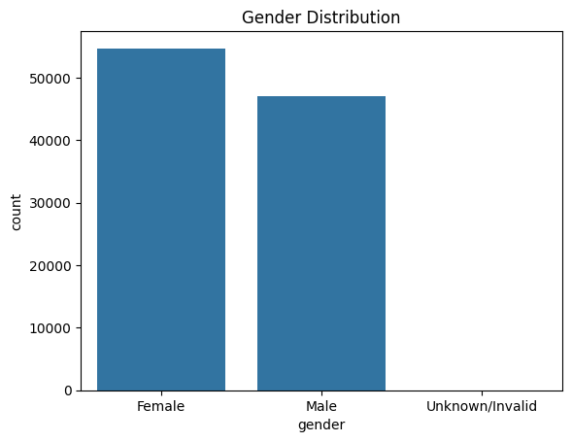
Figure 2 Gender Distribution
This imbalance indicates the possibility of having demographic variation in the hospital records, and it brings to the fore the need to ensure that predictive models are not trained to acquire gender-related biases.
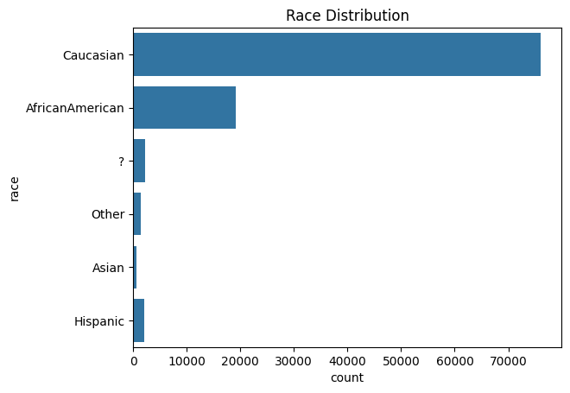
Figure 3 Race Distribution
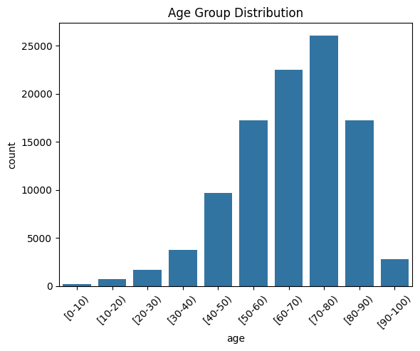
Figure 4 Bucketed age distribution
The larger proportion of patients in the older age brackets is in line with established clinical trends on diabetes prevalence. This is an indication that age is bound to play a significant role in the hospital readmission risk modelling.
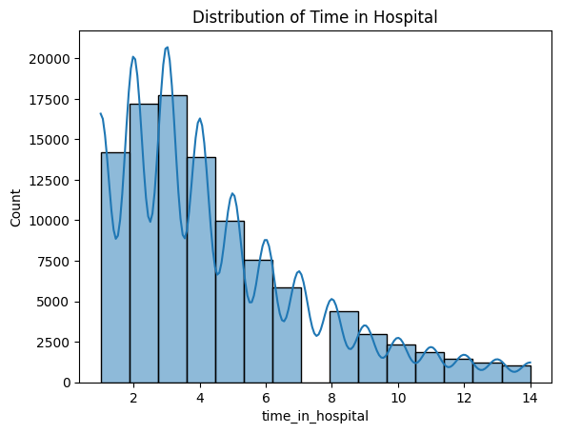
Figure 5 Time in Hospital
The skewed right distribution also shows that the majority of patients spend relatively short durations of time at the hospital whereas a few spend longer durations in the hospital. The increased hospital stays can also be a sign of more serious health conditions and thus may be related to the increased risk of readmission.
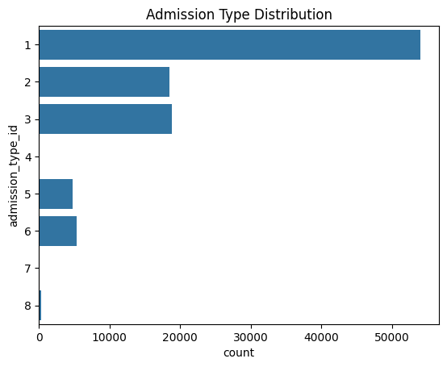
Figure 6 Admission Type
Medication variables showed that a big percentage of patients took diabetes medication, and the amount of insulin fluctuation and medication alternation at the hospital were different.
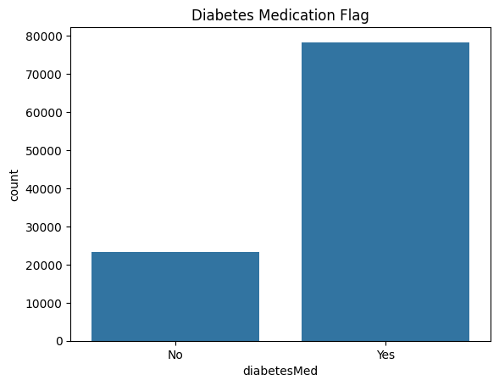
Figure 7 Diabetes Distribution
The use of insulin variability and changes of medication could indicate a difference in the severity of disease or response to treatment, thus the variables could be potentially useful as predictors of readmission.
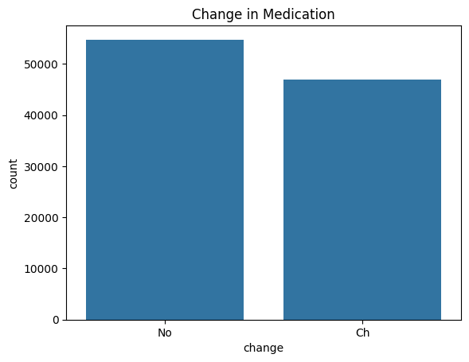
Figure 8 Change in Medication
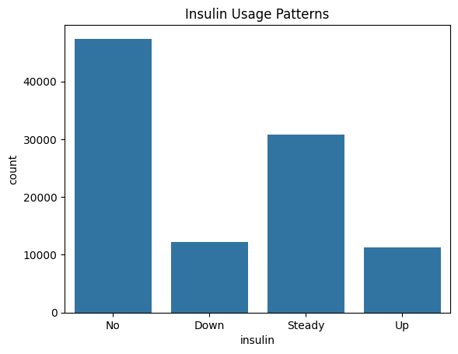
Figure 9 Insulin Distribution
The analysis of correlations between numerical variables exhibited weak to moderate correlations, indicating the lack of multicollinearity, but showing the presence of the correlation between the increased hospital stay and additional procedures and medications. 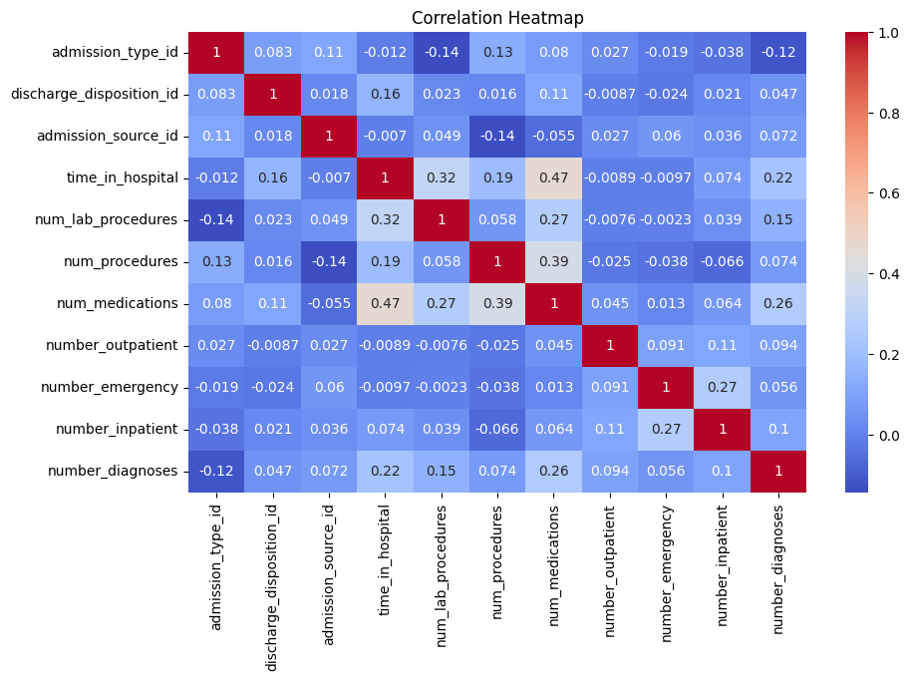
Figure 10 Correlation Plot
Lastly, the readmission and the key predictors were investigated. The readmission rates were high among patients who have extended hospitalization and those who are old.
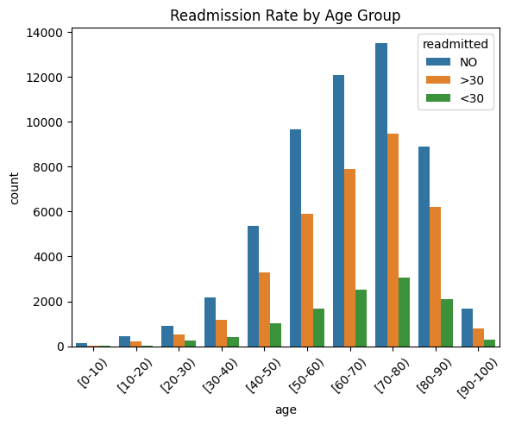
Figure 11 Multivariate Correlation Distribution

Chapter 4: Results and Conclusion

Critical Discussion
The comparison of the Logistic Regression, Random Forest, and the Deep Neural Network indicates the apparent differences between the three algorithms in terms of their applicability to tabular clinical data. The random forest had a much higher accuracy, precision, and recall in the training and test set as compared to the other models. This means that it has a high potential to capture the non-linear relationships between clinical variables including hospitalization history, medication use, and the number of times a certain diagnostic was made. The gap between training and testing performance is relatively small indicating good generalization although the model is complex.
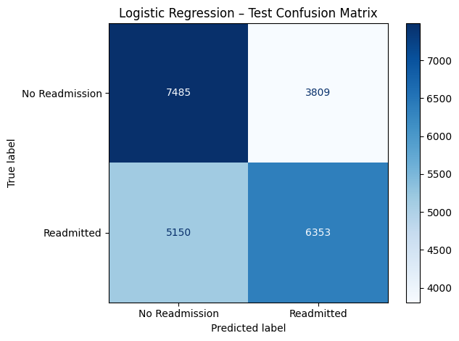
Figure 12 Logistic Regression CM
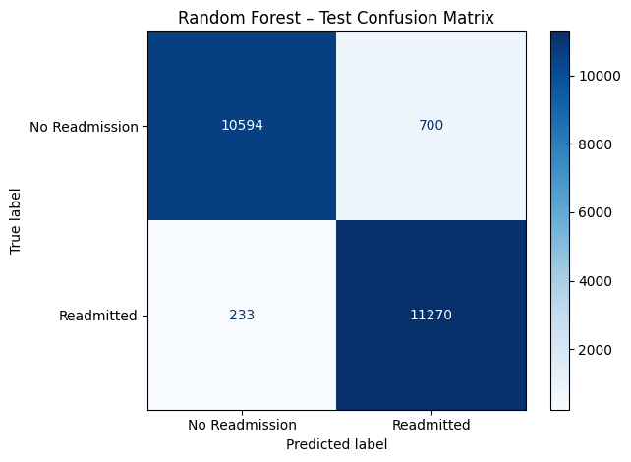
Figure 13 Random Forest CM
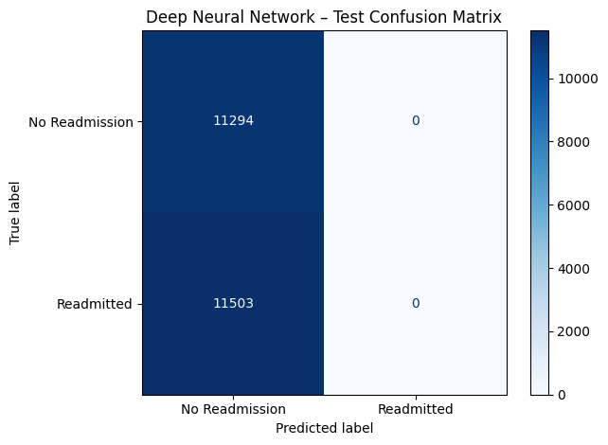
Figure 14 Deep Neural Networks CM
Logistic Regression was moderately and consistently acceptable. Its findings suggest that the predictors have linear relationships with the readmission risks, but they cannot be used to explain the underlying patterns in detail. Nevertheless, its interpretability has been a significant strength because the explanations are more focused on clinical reasoning as the explanations are based on the coefficients. This renders Logistic Regression practical as a test case and where the goal is to be open and transparent, despite poor predictive accuracy.
The Deep Neural Network was very inaccurate and imprecise whereas attaining a perfect recall, implying that it categorized most of the cases as positive. Further experiments were aimed at enhancing the depth neural network performance by trying various learning rates (0.1, 0.01 and 0.001), increasing the number of training epochs (100 and 200), and trying various network structures by varying the number of hidden layers and neurons. In spite of these modifications, the model had always converged to a unstable solution resulting in an accuracy of about 0.5 with extreme accuracy-recall behaviour in which a prediction was biased towards one of the classes. This implies that the neural network was unable to generalize meaningful decision boundaries using the structured tabular data, which supports earlier studies that deep learning networks might not be more effective than tree-based predictive control algorithms on tabular clinical data.

Conclusion
The purpose of this project was to assess and compare the performance of Logistic Regression, Rand Forest, and a Deep Neural Network to predict hospital readmission due to diabetes with the help of clinical and demographic data. Meaningful insights in terms of predictive performance and methodological appropriateness were derived through systematic preprocessing and exploratory analysis and model evaluation.
Exploratory Data Analysis found that there were serious issues in the data quality, such as the high missingness of laboratory variables, high reliance on categorical features, and the unequal representation of classes in the outcome of the readmission. These are the problems, which were solved by removing features, encoding, normalization and oversampling to ensure that the models could be trained successfully. The visualization also pointed out the relationships between age, the duration of hospitalization, and the risk of readmission, thus supporting the clinical significance of the chosen characteristics.
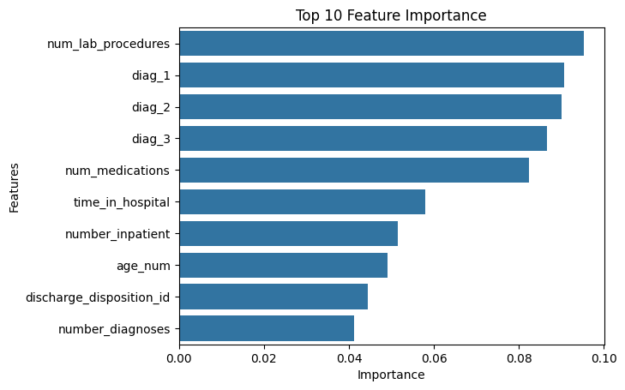
Figure 15 Feature Importances
In order to respond to Research Question 3, the feature importance of the Random Forest model was examined. These findings indicate that the most significant predictors of readmission were numlabprocedures, primary diagnosis codes (diag1, diag2, diag-3) and the number of medications. This indicates that the intensity of clinical testing, history of diagnosis, and complexity of treatment are significant factors of predicting hospital rehospitalization in diabetes.
Random Forest was the best model that was evaluated. It had the best accuracy, precision and recall on unseen data and this indicates its robustness and good generalization. The ability of its ensemble structure to capture complex, non-linear interactions that are typical of clinical datasets was enabled by its ensemble structure. Logistic Regression, which is less accurate, gave consistent and readable results, which could be useful in the interpretation of the baseline risk factors. On the contrary, the Deep Neural Network was not as performing, suggesting that deep learning is not necessarily more effective on tabular medical data without much tuning and architectural optimization.
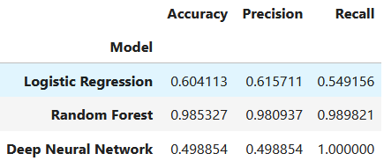
Figure 16 Train Performance
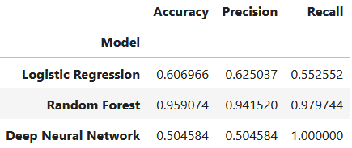
Figure 17 Test Performance
The results imply the necessity to match model choice to the data characteristics. Although more sophisticated algorithms, like DNNs, are more effective, simpler or ensemble-based algorithms might be more effective, stable, and feasible in a healthcare environment. Notably, the good recall of Random Forest implies that there is high potential of predicting at-risk patients who can be targeted with regard to preventing readmission, which is essential in early intervention.
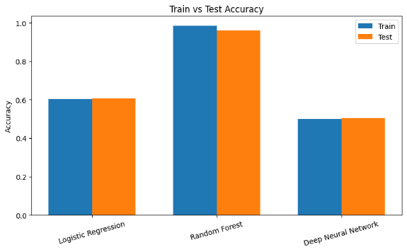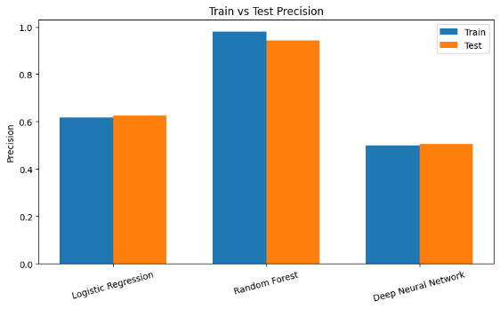
Figure 18 Train Test Accuracy plots

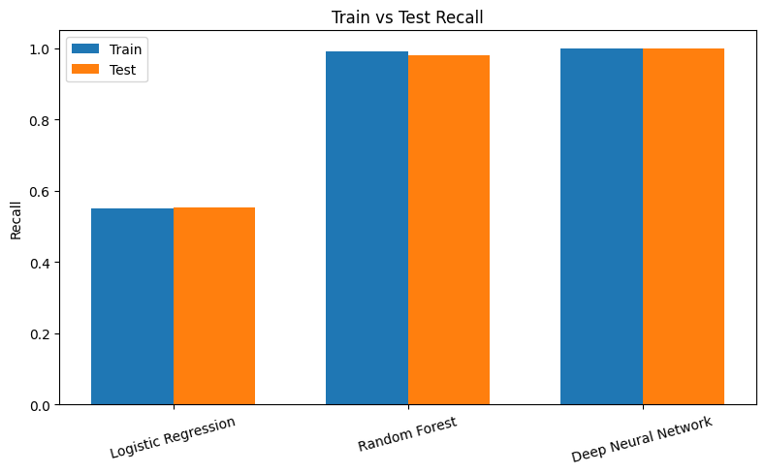
Figure 19 Train Test Recall plot
To summarize, the present work illustrates that Random Forest is the most appropriate model in this set of data that can be used to predict diabetes readmission because it has both high predictive performance and strength. The findings justify the application of machine learning as a decision-support tool in the management of diabetes whereas it underlines the importance of preprocessing and model selection to achieve clinically meaningful results.

Future Work
The present research can be developed in a number of ways in the future. First, more sophisticated methods of imbalance-handling can be considered, e.g. SMOTE or cost-sensitive learning would help minimize the possible bias produced by random oversampling. Second, it is possible that hyperparameter optimization and other neural network architectures can enhance Deep Neural Network performance. Predictive accuracy could also be increased by incorporating temporal data, including the previous admissions or longitudinal lab results. Also, the Random Forest model can be subjected to explainability techniques, including SHAP or LIME, in order to enhance clinical interpretability. Lastly, it would be important to validate the models using external data to determine generalizability and applicability of the models in various healthcare environments.

Chapter 5: Legal, Ethical and Professional Issues
Machine learning in the medical field brings significant legal, ethical, and professional concerns. Predictive models that utilize clinical data are legally required to abide by the regulations of data protection laws including the HIPAA in the United States and the GDPR in the European Union. These models demand stringent protection of the privacy of patients, secure storage of data, informed consent and legal processing of the data. Further, predictive devices employed in clinical practice can also be considered medical devices, which must be approved, validated and held responsible in instances where they offer wrong predictions.
Issues of integrity, openness, and autonomy of the patient are ethical in nature. Demographic biases may be included in clinical datasets, and models can learn them by default, further strengthening healthcare inequalities. In addition to that, non-transparent models like the Random Forests and Deep Neural Networks require the use of explainability methods. Clinical judgment should not be overly relied upon because machine learning results ought to support, rather than substitute it.
Professionally, developers need to guarantee methodological rigor, reproducibility, documentation, and interdisciplinary collaboration in order to develop clinically reliable and responsible predictive systems.

References
Han, J., Kamber, M. and Pei, J. (2022) Data Mining: Concepts and Techniques. 4th edn. Morgan Kaufmann.
Hosmer, D.W., Lemeshow, S. and Sturdivant, R.X. (2013) Applied Logistic Regression. 3rd edn. Wiley.
Kavakiotis, I. et al. (2017) ‘Machine learning and data mining methods in diabetes research’, Computational and Structural Biotechnology Journal, 15, pp. 104–116.
Little, R.J.A. and Rubin, D.B. (2019) Statistical Analysis with Missing Data. 3rd edn. Wiley.
Saito, T. and Rehmsmeier, M. (2015) ‘The precision–recall plot is more informative than the ROC plot when evaluating binary classifiers on imbalanced datasets’, PLoS ONE, 10(3), e0118432.
Shukla, A., Kumar, R., Chole, V., Moolchandani, J., Sahu, S. and Kumar, A. ‘Comparative analysis of machine learning models for diabetes prediction’, Proceedings of the IEEE, IEEE.
Refat, M.A.R., Al Amin, M., Kaushal, C., Yeasmin, M.N. and Islam, M.K. ‘A comparative analysis of early stage diabetes prediction using machine learning and deep learning approach’, Proceedings of the IEEE, IEEE.
Saito, T. and Rehmsmeier, M. (2015) ‘The precision–recall plot is more informative than the ROC plot when evaluating binary classifiers on imbalanced datasets’, PLoS ONE, 10(3), e0118432.
Kaushal, C. and Bartwal, K.S. (2022) ‘A comprehensive analysis and comparative insights for developing diabetes prediction models’, Proceedings of the IEEE, IEEE.
Kavakiotis, I., Tsave, O., Salifoglou, A., Maglaveras, N., Vlahavas, I. and Chouvarda, I. (2017) ‘Machine learning and data mining methods in diabetes research’, Computational and Structural Biotechnology Journal, 15, pp. 104–116.
Rethik, K., Singh, A., Singh, D. and Rakhra, M. (2025) ‘Comparative analysis of different heart disease prediction models’, Proceedings of the IEEE, IEEE.
Kavakiotis, I., Tsave, O., Salifoglou, A., Maglaveras, N., Vlahavas, I. and Chouvarda, I. (2017) ‘Machine learning and data mining methods in diabetes research’, Computational and Structural Biotechnology Journal, 15, pp. 104–116.
American Diabetes Association, 2023. Standards of Medical Care in Diabetes—2023. Diabetes Care, 46(Supplement 1), pp. S1–S216.
Breiman, L., 2001. Random Forests. Machine Learning, 45(1), pp. 5–32.
Choudhury, A., Asan, O. and Le, T., 2020. Comparative Analysis of Machine Learning Approaches for Diabetes Prediction. Health Informatics Journal, 26(3), pp. 1982–1996.
Clore, J., Cios, K., DeShazo, J., Strack, B., Gennings, C., Olmo, J. and Ventura, S., 2014. Diabetes 130-US hospitals for years 1999–2008. UCI Machine Learning Repository.
Hosmer, D.W., Lemeshow, S. and Sturdivant, R.X., 2013. Applied Logistic Regression. 3rd ed. Hoboken: Wiley.
Kavakiotis, I., Tsave, O., Salifoglou, A., Maglaveras, N., Vlahavas, I. and Chouvarda, I., 2017. Machine Learning and Data Mining Methods in Diabetes Research. Computational and Structural Biotechnology Journal, 15, pp. 104–116.
Strack, B., DeShazo, J., Gennings, C., Olmo, J., Ventura, S., Cios, K. and Clore, J., 2014. Impact of HbA1c measurement on hospital readmission rates: Analysis of 70,000 clinical database patient records. BioMed Research International, 2014, Article ID 767340.
World Health Organization, 2021. Global report on diabetes. Geneva: WHO.

Appendices

EDA
import pandas as pd

df = pd.read_csv('diabetic_data.csv')

df.head()

# Basic info about data
df.shape
df.info()

df.dtypes

df.describe()

df.describe(include='object')

df.isnull().sum().sort_values(ascending=False)

(df == '?').sum()

df.duplicated().sum()

import matplotlib.pyplot as plt
import seaborn as sns

sns.countplot(x='readmitted', data=df)
plt.title('Distribution of Readmission Outcomes')
plt.show()

df['readmitted'].value_counts(normalize=True) * 100

sns.countplot(x='gender', data=df)
plt.title('Gender Distribution')
plt.show()

sns.countplot(y='race', data=df)
plt.title('Race Distribution')
plt.show()

sns.countplot(x='age', data=df, order=sorted(df['age'].unique()))
plt.title('Age Group Distribution')
plt.xticks(rotation=45)
plt.show()

sns.histplot(df['time_in_hospital'], bins=15, kde=True)
plt.title('Distribution of Time in Hospital')
plt.show()

sns.countplot(y='admission_type_id', data=df)
plt.title('Admission Type Distribution')
plt.show()

sns.countplot(y='discharge_disposition_id', data=df)
plt.title('Discharge Disposition Distribution')
plt.show()

sns.countplot(x='diabetesMed', data=df)
plt.title('Diabetes Medication Flag')
plt.show()

sns.countplot(x='change', data=df)
plt.title('Change in Medication')
plt.show()

sns.countplot(x='insulin', data=df,
order=['No', 'Down', 'Steady', 'Up'])
plt.title('Insulin Usage Patterns')
plt.show()

corr = df.select_dtypes(include=['int64', 'float64']).corr()
plt.figure(figsize=(10, 6))
sns.heatmap(corr, annot=True, cmap='coolwarm')
plt.title('Correlation Heatmap')
plt.show()

sns.boxplot(x='readmitted', y='time_in_hospital', data=df)
plt.title('Time in Hospital vs Readmission')
plt.show()

sns.countplot(x='age', hue='readmitted', data=df,
order=sorted(df['age'].unique()))
plt.title('Readmission Rate by Age Group')
plt.xticks(rotation=45)
plt.show()

df.nunique().sort_values(ascending=True)

df['weight'].value_counts(dropna=False).head(10)

missing_ratio = df.isnull().mean()
missing_ratio[missing_ratio > 0.4]

import numpy as np
df.replace('?', np.nan, inplace=True)

missing_ratio = df.isnull().mean()
cols_to_drop = missing_ratio[missing_ratio > 0.4].index
df.drop(columns=cols_to_drop, inplace=True)

for col in df.select_dtypes(include='object').columns:
df[col].fillna(df[col].mode()[0], inplace=True)

for col in df.select_dtypes(include=['int64','float64']).columns:
df[col].fillna(df[col].median(), inplace=True)

df.drop_duplicates(inplace=True)

df.reset_index(drop=True, inplace=True)

df['readmitted_binary'] = df['readmitted'].apply(lambda x: 0 if x == 'NO' else 1)

df['age_num'] = df['age'].str.extract(r'(\d+)').astype(int) + 5 # midpoint of each range

df_model = df.drop(columns=['encounter_id', 'patient_nbr', 'readmitted', 'age'])

from sklearn.preprocessing import LabelEncoder

cat_cols = df_model.select_dtypes(include='object').columns
le = LabelEncoder()
for col in cat_cols:
df_model[col] = le.fit_transform(df_model[col])

from sklearn.model_selection import train_test_split

X = df_model.drop('readmitted_binary', axis=1)
y = df_model['readmitted_binary']

X_train, X_test, y_train, y_test = train_test_split(X, y, test_size=0.2, random_state=42, stratify=y)

from sklearn.ensemble import RandomForestClassifier
from sklearn.metrics import accuracy_score, classification_report, confusion_matrix

rf = RandomForestClassifier(n_estimators=100, random_state=42)
rf.fit(X_train, y_train)

y_pred = rf.predict(X_test)
print("Accuracy:", accuracy_score(y_test, y_pred))
print("\nClassification Report:\n", classification_report(y_test, y_pred))
print("\nConfusion Matrix:\n", confusion_matrix(y_test, y_pred))

from sklearn.linear_model import LogisticRegression

log_reg = LogisticRegression(max_iter=1000, solver='liblinear', class_weight='balanced')
log_reg.fit(X_train, y_train)

y_pred_lr = log_reg.predict(X_test)

print("Logistic Regression Accuracy:", accuracy_score(y_test, y_pred_lr))
print("\nLogistic Regression Classification Report:\n", classification_report(y_test, y_pred_lr))
print("\nLogistic Regression Confusion Matrix:\n", confusion_matrix(y_test, y_pred_lr))

import pandas as pd
import numpy as np
from sklearn.metrics import accuracy_score, precision_score, recall_score, f1_score

def compute_metrics(y_true, y_pred):
return {
'accuracy': accuracy_score(y_true, y_pred),
'precision': precision_score(y_true, y_pred, zero_division=0),
'recall': recall_score(y_true, y_pred, zero_division=0),
'f1': f1_score(y_true, y_pred, zero_division=0)
}

results_df = pd.DataFrame(columns=['model', 'variant', 'accuracy', 'precision', 'recall', 'f1'])
results_df

from sklearn.ensemble import RandomForestClassifier

rf = RandomForestClassifier(n_estimators=100, random_state=42)
rf.fit(X_train, y_train)

y_pred = rf.predict(X_test)
m = compute_metrics(y_test, y_pred)

results_df.loc[len(results_df)] = ['RandomForest', 'baseline', m['accuracy'], m['precision'], m['recall'], m['f1']]
results_df

from sklearn.linear_model import LogisticRegression

log_reg = LogisticRegression(max_iter=1000, solver='liblinear', class_weight='balanced')
log_reg.fit(X_train, y_train)

y_pred = log_reg.predict(X_test)
m = compute_metrics(y_test, y_pred)

results_df.loc[len(results_df)] = ['LogisticRegression', 'baseline', m['accuracy'], m['precision'], m['recall'], m['f1']]
results_df

from sklearn.model_selection import RandomizedSearchCV

param_dist = {
'n_estimators': [50, 100, 200],
'max_depth': [None, 8, 16],
'min_samples_split': [2, 5],
'min_samples_leaf': [1, 2],
}

rs = RandomizedSearchCV(
estimator=RandomForestClassifier(random_state=42),
param_distributions=param_dist,
n_iter=5,
cv=3,
scoring='f1',
random_state=42,
n_jobs=-1
)

rs.fit(X_train, y_train)
best_rf = rs.best_estimator_

y_pred = best_rf.predict(X_test)
m = compute_metrics(y_test, y_pred)

results_df.loc[len(results_df)] = ['RandomForest', 'optimized', m['accuracy'], m['precision'], m['recall'], m['f1']]
results_df

from sklearn.preprocessing import StandardScaler
from sklearn.utils.class_weight import compute_class_weight
import numpy as np

y_train = np.array(y_train).astype(int)
y_test = np.array(y_test).astype(int)

print("Train class distribution:", np.bincount(y_train))
print("Test class distribution:", np.bincount(y_test))

if hasattr(X_train, "columns"):
numeric_cols = X_train.select_dtypes(include=['int64','float64']).columns
scaler = StandardScaler()
X_train_scaled = X_train.copy()
X_test_scaled = X_test.copy()
X_train_scaled[numeric_cols] = scaler.fit_transform(X_train[numeric_cols])
X_test_scaled[numeric_cols] = scaler.transform(X_test[numeric_cols])
else:
scaler = StandardScaler()
X_train_scaled = scaler.fit_transform(X_train)
X_test_scaled = scaler.transform(X_test)

classes = np.unique(y_train)
class_weights = dict(zip(classes, compute_class_weight(class_weight='balanced', classes=classes, y=y_train)))
print("Class weights:", class_weights)

print("X_train shape:", X_train_scaled.shape, "y_train shape:", y_train.shape)

import tensorflow as tf
from tensorflow.keras.models import Sequential
from tensorflow.keras.layers import Dense, Dropout
from sklearn.metrics import accuracy_score, precision_score, recall_score, f1_score
import numpy as np

tf.random.set_seed(42)
np.random.seed(42)

input_dim = X_train_scaled.shape[1]

dnn = Sequential([
Dense(64, activation='relu', input_shape=(input_dim,)),
Dropout(0.3),
Dense(32, activation='relu'),
Dropout(0.3),
Dense(1, activation='sigmoid')
])
dnn.compile(optimizer='adam', loss='binary_crossentropy', metrics=['accuracy'])

dnn.fit(X_train_scaled, y_train, epochs=20, batch_size=32, validation_split=0.1, class_weight=class_weights, verbose=0)

y_proba_test = dnn.predict(X_test_scaled).ravel()
y_pred_test = (y_proba_test > 0.5).astype(int)

print("Predicted class counts (test):", np.bincount(y_pred_test))
print("Predicted probabilities sample:", np.round(y_proba_test[:10], 3))

acc = accuracy_score(y_test, y_pred_test)
prec = precision_score(y_test, y_pred_test, zero_division=0)
rec = recall_score(y_test, y_pred_test, zero_division=0)
f1 = f1_score(y_test, y_pred_test, zero_division=0)

results_df.loc[len(results_df)] = ['DNN', 'baseline_scaled', acc, prec, rec, f1]
print("DNN (scaled) f1_test:", f1)
results_df

from tensorflow.keras.optimizers import Adam
import tensorflow as tf
import numpy as np

configs = [
{'units1':64, 'units2':32, 'dropout':0.3, 'lr':1e-3, 'epochs':12, 'name':'dnn_opt1_scaled'},
{'units1':128, 'units2':64, 'dropout':0.4, 'lr':5e-4, 'epochs':15, 'name':'dnn_opt2_scaled'}
]

for cfg in configs:
tf.keras.backend.clear_session()
tf.random.set_seed(42)
np.random.seed(42)

model = Sequential([
Dense(cfg['units1'], activation='relu', input_shape=(input_dim,)),
Dropout(cfg['dropout']),
Dense(cfg['units2'], activation='relu'),
Dropout(cfg['dropout']),
Dense(1, activation='sigmoid')
])
model.compile(optimizer=Adam(cfg['lr']), loss='binary_crossentropy', metrics=['accuracy'])
model.fit(X_train_scaled, y_train, epochs=cfg['epochs'], batch_size=32, validation_split=0.1, class_weight=class_weights, verbose=0)

y_proba_test = model.predict(X_test_scaled).ravel()
y_pred_test = (y_proba_test > 0.5).astype(int)

acc = accuracy_score(y_test, y_pred_test)
prec = precision_score(y_test, y_pred_test, zero_division=0)
rec = recall_score(y_test, y_pred_test, zero_division=0)
f1 = f1_score(y_test, y_pred_test, zero_division=0)

results_df.loc[len(results_df)] = ['DNN', cfg['name'], acc, prec, rec, f1]
print(f"{cfg['name']} f1_test: {f1:.4f} predicted_counts: {np.bincount(y_pred_test)}")

results_df

import matplotlib.pyplot as plt
import numpy as np

metrics = ["accuracy", "precision", "recall", "f1"]

labels = results_df["model"] + " - " + results_df["variant"]

x = np.arange(len(results_df))
width = 0.2

plt.figure(figsize=(14, 7))

for i, metric in enumerate(metrics):
plt.bar(x + i*width, results_df[metric], width, label=metric)

plt.xticks(x + width*1.5, labels, rotation=45, ha='right')
plt.ylabel("Score")
plt.title("Model Performance Comparison")
plt.legend()

plt.tight_layout()
plt.show()

Model Building
import pandas as pd
import numpy as np
import scipy as sp
from sklearn.model_selection import train_test_split
from sklearn.metrics import accuracy_score, precision_score, recall_score
from sklearn.utils import resample
from sklearn.ensemble import RandomForestClassifier
from tensorflow.keras.models import Sequential
from tensorflow.keras.layers import Dense, Dropout
from tensorflow.keras.optimizers import Adam
import matplotlib.pyplot as plt

df = pd.read_csv("diabetic_data.csv")

mask = (
(df[["diag_1", "diag_2", "diag_3"]] == "?").any(axis=1)
| (df["race"] == "?")
| (df["discharge_disposition_id"] == 11)
| (df["gender"] == "Unknown/Invalid")
)
df = df[~mask]

df["admission_type_id"] = df["admission_type_id"].replace({2:1, 7:1, 6:5, 8:5})

df["discharge_disposition_id"] = df["discharge_disposition_id"].replace({
6:1, 8:1, 9:1, 13:1,
3:2, 4:2, 5:2, 14:2, 22:2, 23:2, 24:2,
12:10, 15:10, 16:10, 17:10,
25:18, 26:18
})

df["admission_source_id"] = df["admission_source_id"].replace({
2:1, 3:1,
5:4, 6:4, 10:4, 22:4, 25:4,
15:9, 17:9, 20:9, 21:9,
13:11, 14:11
})

df["change"] = df["change"].replace({"Ch":1, "No":0})
df["gender"] = df["gender"].replace({"Male":1, "Female":0})
df["diabetesMed"] = df["diabetesMed"].replace({"Yes":1, "No":0})
df["A1Cresult"] = df["A1Cresult"].replace({">7":1, ">8":1, "Norm":0, "None":-99})
df["max_glu_serum"] = df["max_glu_serum"].replace({">200":1, ">300":1, "Norm":0, "None":-99})
df["readmitted"] = df["readmitted"].replace({">30":0, "<30":1, "NO":0})

age_mapping = {f"[{i*10}-{(i+1)*10})": i+1 for i in range(10)}
df["age"] = df["age"].replace(age_mapping)

df = df.drop_duplicates(subset=["patient_nbr"], keep="first")
df = df.drop(["weight", "payer_code", "medical_specialty"], axis=1)

med_columns = [
"metformin","repaglinide","nateglinide","chlorpropamide","glimepiride",
"acetohexamide","glipizide","glyburide","tolbutamide","pioglitazone",
"rosiglitazone","acarbose","miglitol","troglitazone","tolazamide",
"insulin","glyburide-metformin","glipizide-metformin",
"glimepiride-pioglitazone","metformin-rosiglitazone",
"metformin-pioglitazone","change","diabetesMed"
]

categorical_cols = [
"gender","admission_type_id","discharge_disposition_id",
"admission_source_id","max_glu_serum","A1Cresult","race"
] + med_columns

numeric_cols = [
"age","time_in_hospital","num_procedures","num_medications",
"number_outpatient","number_emergency",
"number_inpatient","number_diagnoses"
]

df[numeric_cols] = df[numeric_cols].astype(float)
df[numeric_cols] = (df[numeric_cols] - df[numeric_cols].mean()) / df[numeric_cols].std()

df = df[(np.abs(sp.stats.zscore(df[numeric_cols])) < 3).all(axis=1)]

df_encoded = pd.get_dummies(df, columns=categorical_cols, drop_first=True)

numeric_features = [
"age",
"time_in_hospital",
"num_procedures",
"num_medications",
"number_outpatient",
"number_emergency",
"number_inpatient",
"number_diagnoses",
]

dummy_features = [
col for col in df_encoded.columns
if col not in numeric_features + ["readmitted"]
and df_encoded[col].dtype != "object"
]

X = df_encoded[numeric_features + dummy_features]
y = df_encoded["readmitted"]

X_majority = X[y == 0]
X_minority = X[y == 1]

X_minority_upsampled = resample(
X_minority, replace=True, n_samples=len(X_majority), random_state=20
)

X_balanced = pd.concat([X_majority, X_minority_upsampled])
y_balanced = pd.Series([0]*len(X_majority) + [1]*len(X_minority_upsampled))

X_train, X_test, y_train, y_test = train_test_split(
X_balanced, y_balanced, test_size=0.2, random_state=0
)

rf = RandomForestClassifier(
n_estimators=10, max_depth=25, min_samples_split=10, random_state=0
)
rf.fit(X_train, y_train)
rf_pred = rf.predict(X_test)

print("\n--- Random Forest ---")
print("Accuracy:", accuracy_score(y_test, rf_pred))
print("Precision:", precision_score(y_test, rf_pred))
print("Recall:", recall_score(y_test, rf_pred))

dnn = Sequential([
Dense(128, activation="relu", input_shape=(X_train.shape[1],)),
Dropout(0.3),
Dense(64, activation="relu"),
Dropout(0.3),
Dense(1, activation="sigmoid")
])

dnn.compile(
optimizer=Adam(learning_rate=0.001),
loss="binary_crossentropy",
metrics=["accuracy"]
)

dnn.fit(
X_train, y_train,
epochs=20,
batch_size=64,
validation_split=0.2,
verbose=0
)

dnn_pred = (dnn.predict(X_test) > 0.5).astype(int).ravel()

print("\n--- Deep Neural Network ---")
print("Accuracy:", accuracy_score(y_test, dnn_pred))
print("Precision:", precision_score(y_test, dnn_pred))
print("Recall:", recall_score(y_test, dnn_pred))

dnn_final = Sequential([
Dense(128, activation="relu", input_shape=(X_train.shape[1],)),
Dropout(0.3),
Dense(64, activation="relu"),
Dropout(0.3),
Dense(1, activation="sigmoid")
])

dnn_final.compile(
optimizer=Adam(learning_rate=0.01),
loss="binary_crossentropy",
metrics=["accuracy"]
)

dnn_final.fit(
X_train, y_train,
epochs=20,
batch_size=64,
validation_split=0.2,
verbose=1
)

dnn_pred = (dnn_final.predict(X_test) > 0.5).astype(int).ravel()

print("\n--- Deep Neural Network ---")
print("Accuracy:", accuracy_score(y_test, dnn_pred))
print("Precision:", precision_score(y_test, dnn_pred))
print("Recall:", recall_score(y_test, dnn_pred))

dnn_small = Sequential([
Dense(64, activation="relu", input_shape=(X_train.shape[1],)),
Dropout(0.2),
Dense(32, activation="relu"),
Dense(1, activation="sigmoid")
])

dnn_small.compile(
optimizer=Adam(learning_rate=0.005),
loss="binary_crossentropy",
metrics=["accuracy"]
)

dnn_small.fit(
X_train, y_train,
epochs=20,
batch_size=64,
validation_split=0.2,
verbose=1
)

pred_small = (dnn_small.predict(X_test) > 0.5).astype(int).ravel()

print("\n--- DNN Small ---")
print("Accuracy:", accuracy_score(y_test, pred_small))
print("Precision:", precision_score(y_test, pred_small))
print("Recall:", recall_score(y_test, pred_small))

dnn_medium = Sequential([
Dense(128, activation="relu", input_shape=(X_train.shape[1],)),
Dropout(0.3),
Dense(64, activation="relu"),
Dropout(0.3),
Dense(32, activation="relu"),
Dense(1, activation="sigmoid")
])

dnn_medium.compile(
optimizer=Adam(learning_rate=0.001),
loss="binary_crossentropy",
metrics=["accuracy"]
)

dnn_medium.fit(
X_train, y_train,
epochs=20,
batch_size=64,
validation_split=0.2,
verbose=0
)

pred_medium = (dnn_medium.predict(X_test) > 0.5).astype(int).ravel()

print("\n--- DNN Medium ---")
print("Accuracy:", accuracy_score(y_test, pred_medium))
print("Precision:", precision_score(y_test, pred_medium))
print("Recall:", recall_score(y_test, pred_medium))

dnn_deep = Sequential([
Dense(256, activation="relu", input_shape=(X_train.shape[1],)),
Dropout(0.4),
Dense(128, activation="relu"),
Dropout(0.3),
Dense(64, activation="relu"),
Dense(32, activation="relu"),
Dense(1, activation="sigmoid")
])

dnn_deep.compile(
optimizer=Adam(learning_rate=0.0005),
loss="binary_crossentropy",
metrics=["accuracy"]
)

dnn_deep.fit(
X_train, y_train,
epochs=200,
batch_size=64,
validation_split=0.2,
verbose=0
)

pred_deep = (dnn_deep.predict(X_test) > 0.5).astype(int).ravel()

print("\n--- DNN Deep ---")
print("Accuracy:", accuracy_score(y_test, pred_deep))
print("Precision:", precision_score(y_test, pred_deep))
print("Recall:", recall_score(y_test, pred_deep))

dnn_final = Sequential([
Dense(128, activation="relu", input_shape=(X_train.shape[1],)),
Dropout(0.3),
Dense(64, activation="relu"),
Dropout(0.3),
Dense(1, activation="sigmoid")
])

dnn_final.compile(
optimizer=Adam(learning_rate=0.01),
loss="binary_crossentropy",
metrics=["accuracy"]
)

dnn_final.fit(
X_train, y_train,
epochs=20,
batch_size=64,
validation_split=0.2,
verbose=1
)

dnn_pred = (dnn_final.predict(X_test) > 0.5).astype(int).ravel()

print("\n--- Deep Neural Network ---")
print("Accuracy:", accuracy_score(y_test, dnn_pred))
print("Precision:", precision_score(y_test, dnn_pred))
print("Recall:", recall_score(y_test, dnn_pred))

from sklearn.linear_model import LogisticRegression

lr = LogisticRegression(
penalty="l1",
solver="liblinear",
fit_intercept=True,
max_iter=1000
)

lr.fit(X_train, y_train)
lr_pred = lr.predict(X_test)

print("\n--- Logistic Regression ---")
print("Accuracy:", accuracy_score(y_test, lr_pred))
print("Precision:", precision_score(y_test, lr_pred))
print("Recall:", recall_score(y_test, lr_pred))

models_preds = {
"Logistic Regression": (lr, lr.predict(X_train), lr.predict(X_test)),
"Random Forest": (rf, rf.predict(X_train), rf.predict(X_test)),
"Deep Neural Network": (
dnn,
(dnn.predict(X_train) > 0.5).astype(int).ravel(),
(dnn.predict(X_test) > 0.5).astype(int).ravel(),
),
}

metrics = {"accuracy": accuracy_score, "precision": precision_score, "recall": recall_score}

results = {}

for model_name, (_, y_train_pred, y_test_pred) in models_preds.items():
results[model_name] = {
"train": {m: metrics[m](y_train, y_train_pred) for m in metrics},
"test": {m: metrics[m](y_test, y_test_pred) for m in metrics},
}

import numpy as np
import matplotlib.pyplot as plt

for metric in ["accuracy", "precision", "recall"]:
plt.figure(figsize=(8, 5))
x = np.arange(len(results))
width = 0.35

train_scores = [results[m]["train"][metric] for m in results]
test_scores = [results[m]["test"][metric] for m in results]

plt.bar(x - width/2, train_scores, width, label="Train")
plt.bar(x + width/2, test_scores, width, label="Test")

plt.xticks(x, results.keys(), rotation=15)
plt.ylabel(metric.capitalize())
plt.title(f"Train vs Test {metric.capitalize()}")
plt.legend()
plt.tight_layout()
plt.show()

train_table = pd.DataFrame({
"Model": results.keys(),
"Accuracy": [results[m]["train"]["accuracy"] for m in results],
"Precision": [results[m]["train"]["precision"] for m in results],
"Recall": [results[m]["train"]["recall"] for m in results],
})

train_table = train_table.set_index("Model")
print("\nTrain Performance")
display(train_table)

test_table = pd.DataFrame({
"Model": results.keys(),
"Accuracy": [results[m]["test"]["accuracy"] for m in results],
"Precision": [results[m]["test"]["precision"] for m in results],
"Recall": [results[m]["test"]["recall"] for m in results],
})

test_table = test_table.set_index("Model")
print("\nTest Performance")
display(test_table)

