Google Data Engineering Cheatsheet

Compiled by Maverick Lin (http://mavericklin.com)

Last Updated August 4, 2018

# ~~What is Data Engineering?~~

**~~Hadoop Overview~~**

**~~Hadoop Ecosystem~~**

Data engineering enables data-driven decision making by collecting, transforming, and visualizing data. A data engineer designs, builds, maintains, and troubleshoots data processing systems with a particular emphasis on the security, reliability, fault-tolerance, scalability, fidelity, and efficiency of such systems.

A data engineer also analyzes data to gain insight into business outcomes, builds statistical models to support decision-making, and creates machine learning models to automate and simplify key business processes.

Key Points

* Build/maintain data structures and databases
* Design data processing systems
* Analyze data and enable machine learning
* Design for reliability
* Visualize data and advocate policy
* Model business processes for analysis
* Design for security and compliance

# ~~Google Compute Platform (GCP)~~

**Hadoop**

Data can no longer fit in memory on one machine (mo- nolithic), so a new way of computing was devised using many computers to process the data (distributed). Such a group is called a cluster, which makes up server farms. All of these servers have to be coordinated in the following ways: partition data, coordinate computing tasks, handle fault tolerance/recovery, and allocate capacity to process.

Hadoop is an open source *distributed* processing fra- mework that manages data processing and storage for big data applications running in clustered systems. It is com- prised of 3 main components:

* **Hadoop Distributed File System (HDFS)**: a distributed file system that provides high-

throughput access to application data by partitio- ning data across many machines

* **YARN**: framework for job scheduling and cluster resource management (task coordination)
* **MapReduce**: YARN-based system for parallel processing of large data sets on multiple machines

An entire ecosystem of tools have emerged around Hadoop, which are based on interacting with HDFS.

**Hive**: data warehouse software built o top of Hadoop that facilitates reading, writing, and managing large datasets residing in distributed storage using SQL-like queries (Hi- veQL). Hive abstracts away underlying MapReduce jobs and returns HDFS in the form of tables (not HDFS).

**Pig**: high level scripting language (Pig Latin) that enables writing complex data transformations. It pulls unstructu- red/incomplete data from sources, cleans it, and places it in a database/data warehouses. Pig performs ETL into data warehouse while Hive queries from data warehouse to perform analysis (GCP: DataFlow).

**Spark**: framework for writing fast, distributed programs for data processing and analysis. Spark solves similar pro- blems as Hadoop MapReduce but with a fast in-memory approach. It is an unified engine that supports SQL que- ries, streaming data, machine learning and graph proces- sing. Can operate separately from Hadoop but integrates well with Hadoop. Data is processed using Resilient Dis- tributed Datasets (RDDs), which are immutable, lazily

**HDFS** evaluated, and tracks lineage. ;

GCP is a collection of Google computing resources, which

are offered via *services*. Data engineering services include Compute, Storage, Big Data, and Machine Learning.

The 4 ways to interact with GCP include the console, command-line-interface (CLI), API, and mobile app.

The GCP resource hierarchy is organized as follows. All resources (VMs, storage buckets, etc) are organized into **projects**. These projects *may* be organized into **folders**, which can contain other folders. All folders and projects; can be brought together under an organization node. Project folders and organization nodes are where policies can be defined. Policies are inherited downstream and dictate who can access what resources. Every resource must belong to a project and every must have a billing account associated with it.

**Advantages**: Performance (fast solutions), Pricing (sub- hour billing, sustained use discounts, custom machine ty- pes), PaaS Solutions, Robust Infrastructure

Each disk on a different machine in a cluster is comprised of 1 master node; the rest are data nodes. The **master**;

**node** manages the overall file system by storing the

directory structure and metadata of the files. The **data nodes** physically store the data. Large files are broken up/distributed across multiple machines, which are replicated across 3 machines to provide fault tolerance.

# MapReduce

Parallel programming paradigm which allows for proces- sing of huge amounts of data by running processes on mul- tiple machines. Defining a MapReduce job requires two stages: map and reduce.

* + **Map**: operation to be performed in parallel on small portions of the dataset. the output is a key-value

pair *< K, V >*

* + **Reduce**: operation to combine the results of Map

**YARN- Yet Another Resource Negotiator** Coordinates tasks running on the cluster and assigns new nodes in case of failure. Comprised of 2 subcomponents: the resource manager and the node manager. The **re- source manager** runs on a single master node and sche- dules tasks across nodes. The **node manager** runs on all other nodes and manages tasks on the individual node.

**Hbase**: non-relational, NoSQL, column-oriented data- base management system that runs on top of HDFS. Well suited for sparse data sets (GCP: BigTable) **Flink/Kafka**: stream processing framework. Batch stre- aming is for bounded, finite datasets, with periodic up- dates, and delayed processing. Stream processing is for unbounded datasets, with continuous updates, and imme- diate processing. Stream data and stream processing must be decoupled via a message queue. Can group streaming data (windows) using tumbling (non-overlapping time), sliding (overlapping time), or session (session gap) win- dows.

**Beam**: programming model to define and execute data

processing pipelines, including ETL, batch and stream (continuous) processing. After building the pipeline, it is executed by one of Beam’s distributed processing back- ends (Apache Apex, Apache Flink, Apache Spark, and Google Cloud Dataflow). Modeled as a Directed Acyclic Graph (DAG).

**Oozie**: workflow scheduler system to manage Hadoop jobs **Sqoop**: transferring framework to transfer large amounts of data into HDFS from relational databases (MySQL)

**~~IAM~~**

# Identity Access Management (IAM)

Access management service to manage different members of the platform- who has what access for which resource.

Each member has roles and permissions to allow them access to perform their duties on the platform. 3 member

# ~~Key Concepts~~ OLAP vs. OLTP

**Online Analytical Processing (OLAP)**: primary

objective is data analysis. It is an online analysis and data retrieving process, characterized by a large volume of data and complex queries, uses data warehouses.

**Online Transaction Processing (OLTP)**: primary

# ~~Compute Choices~~ Google App Engine

Flexible, serverless platform for building highly available

applications. Ideal when you want to focus on writing and developing code and do not want to manage servers, clusters, or infrastructures.

**Use Cases:** web sites, mobile app and gaming backends,

types: Google account (single person, gmail account), service account (non-person, application), and Google Group (multiple people). Roles are a set of specific permissions for members. Cannot assign permissions to user directly, must grant roles.

If you grant a member access on a higher hierarchy level, that member will have access to all levels below that hierarchy level as well. You cannot be restricted a lower level. The policy is a union of assigned and inherited policies.

**Primitive Roles**: Owner (full access to resources, manage roles), Editor (edit access to resources, change or add), Viewer (read access to resources)

**Predefined Roles**: finer-grained access control than primitive roles, predefined by Google Cloud

# Custom Roles

**Best Practice**: use predefined roles when they exist (over primitive). Follow the principle of least privileged favors.

**~~Stackdriver~~**

GCP’s monitoring, logging, and diagnostics solution. Pro- vides insights to health, performance, and availability of applications.

Main Functions

* + **Debugger**: inspect state of app in real time without stopping/slowing down e.g. code behavior
  + **Error Reporting**: counts, analyzes, aggregates crashes in cloud services
  + **Monitoring**: overview of performance, uptime and heath of cloud services (metrics, events, metadata)
  + **Alerting**: create policies to notify you when health and uptime check results exceed a certain limit
  + **Tracing**: tracks how requests propagate through applications/receive near real-time performance re- sults, latency reports of VMs
  + **Logging**: store, search, monitor and analyze log data and events from GCP

objective is data processing, manages database modifi- cation, characterized by large numbers of short online transactions, simple queries, and traditional DBMS.

**Row vs. Columnar Database Row Format**: stores data by row

**Column Format**: stores data tables by column rather than by row, which is suitable for analytical query proces- sing and data warehouses

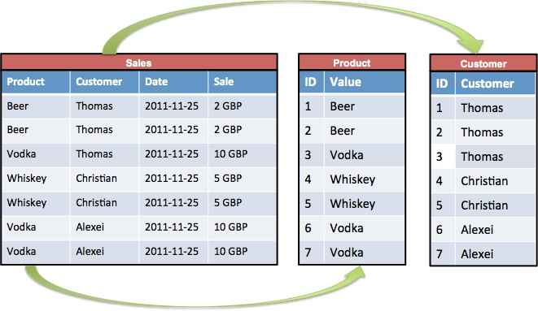

# IaaS, Paas, SaaS

**IaaS**: gives you the infrastructure pieces (VMs) but you have to maintain/join together the different infrastructure pieces for your application to work. Most flexible option. **PaaS**: gives you all the infrastructure pieces already joined so you just have to deploy source code on the platform for your application to work. PaaS solutions are managed services/no-ops (highly available/reliable) and serverless/autoscaling (elastic). Less flexible than IaaS

# Fully Managed, Hotspotting

RESTful APIs, IoT apps.

# Google Kubernetes (Container) Engine

Logical infrastructure powered by Kubernetes, an open- source container orchestration system. Ideal for managing containers in production, increase velocity and operatabi- lity, and don’t have OS dependencies.

**Use Cases:** containerized workloads, cloud-native distributed systems, hybrid applications.

**Google Compute Engine** (IaaS)

Virtual Machines (VMs) running in Google’s global data center. Ideal for when you need complete control over your infrastructure and direct access to high-performance hardward or need OS-level changes.

**Use Cases:** any workload requiring a specific OS or OS configuration, currently deployed and on-premises software that you want to run in the cloud.

**Summary**: AppEngine is the PaaS option- serverless and ops free. ComputeEngine is the IaaS option- fully controllable down to OS level. Kubernetes Engine is in the middle- clusters of machines running Kuberenetes and hosting containers.

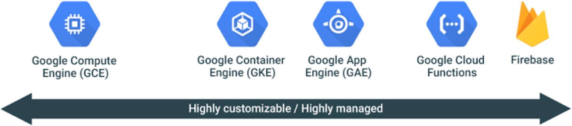

# Additional Notes

You can also mix and match multiple compute options. **Preemptible Instances**: instances that run at a much lower price but may be terminated at any time, self- terminate after 24 hours. ideal for interruptible workloads **Snapshots**: used for backups of disks

**Images**: VM OS (Ubuntu, CentOS)

**~~Storage~~**

**Persistent Disk** Fully-managed block storage (SSDs) that is suitable for VMs/containers. Good for snapshots of data backups/sharing read-only data across VMs.

**Cloud Storage** Infinitely scalable, fully-managed and highly reliable object/blob storage. Good for data blobs: images, pictures, videos. Cannot query by content.

To use Cloud Storage, you create buckets to store data and the location can be specified. Bucket names are globally unique. There a 4 storage classes:

* + **Multi-Regional**: frequent access from anywhere in the world. Use for ”hot data”
  + **Regional**: high local performance for region
  + **Nearline**: storage for data accessed less than once a month (archival)
  + **Coldline**: less than once a year (archival)

**~~CloudSQL and Cloud Spanner- Relational DBs~~**

# Cloud SQL

Fully-managed relational database service (supports MySQL/PostgreSQL). Use for relational data: tables, rows and columns, and super structured data. SQL compatible and can update fields. Not scalable (small storage- GBs). Good for web frameworks and OLTP wor- kloads (not OLAP). Can use **Cloud Storage Transfer Service** or **Transfer Appliance** to data into Cloud Storage (from AWS, local, another bucket). Use gsutil if copying files over from on-premise.

# Cloud Spanner

Google-proprietary offering, more advanced than Cloud SQL. Mission-critical, relational database. Supports ho- rizontal scaling. Combines benefits of of relational and non-relational databases.

* + **Ideal**: relational, structured, and semi-structured data that requires high availability, strong consis-

tency, and transactional reads and writes

* + **Avoid**: data is not relational or structured, want an open source RDBMS, strong consistency and high availability is unnecessary

# Cloud Spanner Data Model

A database can contain 1+ tables. Tables look like relati- onal database tables. Data is strongly typed: must define a schema for each database and that schema must specify the data types of each column of each table.

**Parent-Child Relationships**: Can optionally define re- lationships between tables to physically co-locate their rows for efficient retrieval (data locality: physically sto- ring 1+ rows of a table with a row from another table.

**~~BigTable~~**

Columnar database ideal applications that need high throughput, low latencies, and scalability (IoT, user analy- tics, time-series data, graph data) for non-structured key/value data (each value is *<* 10 MB). A single value in each row is indexed and this value is known as the row key. Does not support SQL queries. Zonal service. Not good for data less than 1TB of data or items greater than 10MB. Ideal at handling large amounts of data (TB/PB) for long periods of time.

# Data Model

1. Dimensional: row key, column family (table name), co- lumn name, timestamp.
   * Row key uniquely identifies an entity and columns contain individual values for each row.
   * Similar columns are grouped into column families.
   * Each column is identified by a combination of the column family and a column qualifier, which is a

unique name within the column family.

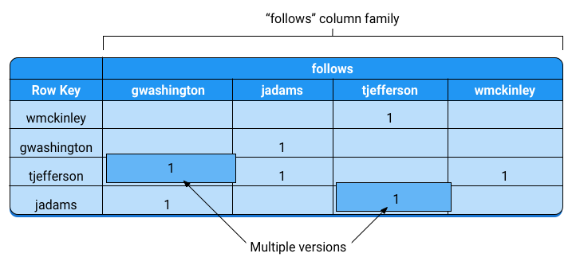

**Load Balancing** Automatically manages splitting, merging, and rebalancing. The master process balances workload/data volume within clusters. The master splits busier/larger tablets in half and merges less- accessed/smaller tablets together, redistributing them between nodes.

Best write performance can be achieved by using row keys that do not follow a predictable order and grouping related rows so they are adjacent to one another, which re- sults in more efficient multiple row reads at the same time.

**Security** Security can be managed at the project and instance level. Does not support table-level, row-level, column-level, or cell-level security restrictions.

# Other Storage Options

* Need SQL for OLTP: CloudSQL/Cloud Spanner.
* Need interactive querying for OLAP: BigQuery.
* Need to store blobs larger than 10 MB: Cloud Storage.
* Need to store structured objects in a document database, with ACID and SQL-like queries: Cloud Datastore.

# ~~BigTable Part II~~ Designing Your Schema

Designing a Bigtable schema is different than designing a

schema for a RDMS. Important considerations:

* + Each table has only one index, the row key (4 KB)
  + Rows are **sorted lexicographically by row key**.
  + All operations are **atomic** (ACID) at row level.
  + Both reads and writes should be distributed evenly
  + Try to keep all info for an entity in a single row
  + Related entities should be stored in adjacent rows
  + Try to store **10 MB in a single cell** (max 100 MB) and **100 MB in a single row** (256 MB)
  + Supports max of 1,000 tables in each instance.
  + Choose row keys that don’t follow predictable order
  + Can use up to around 100 column families
  + Column Qualifiers: can create as many as you need in each row, but should avoid splitting data across

more column qualifiers than necessary (16 KB)

* + **Tables are sparse**. Empty columns don’t take up any space. Can create large number of columns, even if most columns are empty in most rows.
  + Field promotion (shift a column as part of the row key) and salting (remainder of division of hash of

timestamp plus row key) are ways to help design row keys.

For time-series data, use tall/narrow tables. Denormalize- prefer multiple tall and narrow tables

**~~BigQuery~~**

Scalable, fully-managed Data Warehouse with extremely fast SQL queries. Allows querying for massive volumes

# ~~BigQuery Part II~~ Partitioned tables

Special tables that are divided into partitions based on

# ~~Optimizing BigQuery~~ Controlling Costs

* Avoid SELECT * (full scan), select only columns needed

of data at fast speeds. Good for OLAP workloads (petabyte-scale), Big Data exploration and processing, and reporting via Business Intelligence (BI) tools. Sup- ports SQL querying for non-relational data. Relatively cheap to store, but costly for querying/processing. Good for analyzing historical data.

# Data Model

Data tables are organized into units called datasets, which are sets of tables and views. A table must belong to da- taset and a datatset must belong to a porject. Tables contain records with rows and columns (fields).

You can load data into BigQuery via two options: batch loading (free) and streaming (costly).

# Security

BigQuery uses IAM to manage access to resources. The three types of resources in BigQuery are organizations, projects, and datasets. Security can be applied at the project and dataset level, but not table or view level.

# Views

A view is a virtual table defined by a SQL query. When you create a view, you query it in the same way you query a table. **Authorized views allow you to share query results with particular users/groups without giving them access to underlying data.** When a user queries the view, the query results contain data only from the tables and fields specified in the query that defines the view.

# Billing

Billing is based on **storage** (amount of data stored), **querying** (amount of data/number of bytes processed by query), and **streaming inserts**. Storage options are ac- tive and long-term (modified or not past 90 days). Query options are on-demand and flat-rate.

Query costs are based on how much data you read/process, so if you only read a section of a table (partition), your costs will be reduced. Any charges occurred are billed to the attached billing account. Expor- ting/importing/copying data is free.

a column or partition key. Data is stored on different directories and specific queries will only run on slices of data, which improves query performance and reduces costs. Note that the partitions will not be of the same size. BigQuery automatically does this.

Each partitioned table can have up to 2,500 partitions (2500 days or a few years). The daily limit is 2,000 partition updates per table, per day. The rate limit: 50 partition updates every 10 seconds.

Two types of partitioned tables:

* **Ingestion Time**: Tables partitioned based on the data’s ingestion (load) date or arrival date. Each partitioned table will have pseudocolumn PARTITIONTIME, or time data was loaded into table. Pseudocolumns are reserved for the table and

cannot be used by the user.

* **Partitioned Tables**: Tables that are partitioned based on a TIMESTAMP or DATE column.

**Windowing**: window functions increase the efficiency and reduce the complexity of queries that analyze partitions (windows) of a dataset by providing complex operations without the need for many intermediate calculations. They reduce the need for intermediate tables to store temporary data

# Bucketing

Like partitioning, but each split/partition should be the same size and is based on the hash function of a column. Each bucket is a separate file, which makes for more efficient sampling and joining data.

# Querying

After loading data into BigQuery, you can query using Standard SQL (preferred) or Legacy SQL (old). Query jobs are actions executed asynchronously to load, export, query, or copy data. Results can be saved to permanent (store) or temporary (cache) tables. 2 types of queries:

* **Interactive**: query is executed immediately, counts toward daily/concurrent usage (default)
* **Batch**: batches of queries are queued and the query starts when idle resources are available, only counts for daily and switches to interactive if idle for 24

hours

# Wildcard Tables

Used if you want to union all similar tables with similar names. ’*’ (e.g. project.dataset.Table*)

(SELECT * EXCEPT)

* Sample data using preview options for free
* Preview queries to estimate costs (dryrun)
* Use max bytes billed to limit query costs
* Don’t use LIMIT clause to limit costs (still full scan)
* Monitor costs using dashboards and audit logs
* Partition data by date
* Break query results into stages
* Use default table expiration to delete unneeded data
* Use streaming inserts wisely
* Set hard limit on bytes (members) processed per day

# Query Performance

Generally, queries that do less work perform better.

# Input Data/Data Sources

* Avoid SELECT *
* Prune partitioned queries (for time-partitioned table, use PARTITIONTIME pseudo column to filter partitions)
* Denormalize data (use nested and repeated fields)
* Use external data sources appropriately
* Avoid excessive wildcard tables

# SQL Anti-Patterns

* Avoid self-joins., use window functions (perform calcu- lations across many table rows related to current row)
* Partition/Skew: avoid unequally sized partitions, or when a value occurs more often than any other value
* Cross-Join: avoid joins that generate more outputs than inputs (pre-aggregate data or use window function) Update/Insert Single Row/Column: avoid point-specific DML, instead batch updates and inserts

# Managing Query Outputs

* Avoid repeated joins and using the same subqueries
* Writing large sets has performance/cost impacts. Use filters or LIMIT clause. 128MB limit for cached results
* Use LIMIT clause for large sorts (Resources Exceeded)

# Optimizing Query Computation

* Avoid repeatedly transforming data via SQL queries
* Avoid JavaScript user-defined functions
* Use approximate aggregation functions (approx count)
* Order query operations to maximize performance. Use ORDER BY only in outermost query, push complex ope- rations to end of the query.
* For queries that join data from multiple tables, optimize join patterns. Start with the largest table.

**~~DataStore~~**

NoSQL document database that automatically handles sharding and replication (highly available, scalable and durable). Supports ACID transactions, SQL-like queries. Query execution depends on size of returned result, not size of dataset. Ideal for ”needle in a haystack”operation and applications that rely on highly available structured data at scale

**~~DataFlow~~**

Managed service for developing and executing data processing patterns (ETL) (based on Apache Beam) for **streaming** and **batch** data. Preferred for new Hadoop or Spark infrastructure development. Usually site between front-end and back-end storage solutions.

# Concepts

**~~Pub/Sub~~**

Asynchronous messaging service that decouples senders and receivers. Allows for secure and highly available com- munication between independently written applications. A publisher app creates and sends messages to a *to- pic*. Subscriber applications create a subscription to a topic to receive messages from it. Communication can be one-to-many (fan-out), many-to-one (fan-in), and

# Data Model

Data objects in Datastore are known as entities. An entity has one or more named properties, each of which can have one or more values. Each entity in has a key that uniquely identifies it. You can fetch an individual entity using the entity’s key, or query one or more entities based on the entities’ keys or property values.

Ideal for highly structured data at scale: product catalogs, customer experience based on users past acti- vities/preferences, game states. Don’t use if you need extremely low latency or analytics (complex joins, etc).

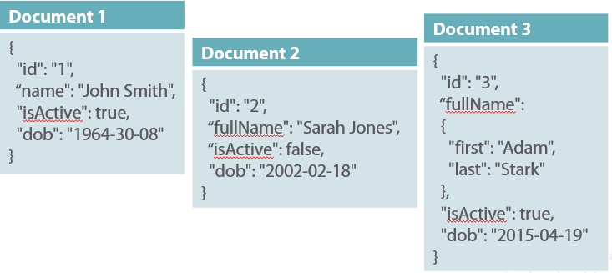

**~~DataProc~~**

Fully-managed cloud service for running Spark and Hadoop clusters. Provides access to Hadoop cluster on GCP and Hadoop-ecosystem tools (Pig, Hive, and Spark). Can be used to implement ETL warehouse solution.

Preferred if migrating existing on-premise Hadoop or Spark infrastructure to GCP without redevelopment ef- fort. Dataflow is preferred for a new development.

**Pipeline**: encapsulates series of computations that

accepts input data from external sources, transforms data to provide some useful intelligence, and produce output **PCollections**: abstraction that represents a potentially distributed, multi-element data set, that acts as the pipeline’s data. PCollection objects represent input, intermediate, and output data. The edges of the pipeline. **Transforms**: operations in pipeline. A transform takes a PCollection(s) as input, performs an operation that you specify on each element in that collection, and produces a new output PCollection. Uses the ”what/where/when/how”model. Nodes in the pipeline. Composite transforms are multiple transforms: combi- ning, mapping, shuffling, reducing, or statistical analysis. **Pipeline I/O**: the source/sink, where the data flows in and out. Supports read and write transforms for a number of common data storage types, as well as custom.

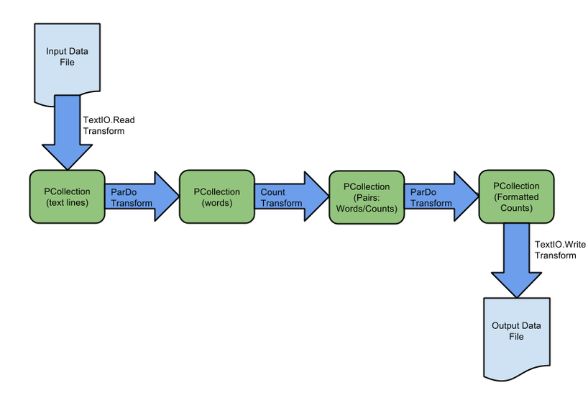

# Windowing

Windowing a PCollection divides the elements into win- dows based on the associated event time for each element. Especially useful for PCollections with unbounded size, since it allows operating on a sub-group (mini-batches).

many-to-many. Gaurantees at least once delivery before deletion from queue.

# Scenarios

* + Balancing workloads in network clusters- queue can efficiently distribute tasks
  + Implementing asynchronous workflows
  + Data streaming from various processes or devices
  + Reliability improvement- in case zone failure
  + Distributing event notifications
  + Refreshing distributed caches
  + Logging to multiple systems

# Benefits/Features

Unified messaging, global presence, push- and pull-style subscriptions, replicated storage and guaranteed at-least- once message delivery, encryption of data at rest/transit, easy-to-use REST/JSON API

# Data Model

**Topic**, **Subscription**, **Message** (combination of data and attributes that a publisher sends to a topic and is eventually delivered to subscribers), **Message Attribute** (key-value pair that a publisher can define for a message)

# Message Flow

* + Publisher creates a topic in the Cloud Pub/Sub ser- vice and sends messages to the topic.
  + Messages are persisted in a message store until they are delivered and acknowledged by subscribers.
  + The Pub/Sub service forwards messages from a topic to all of its subscriptions, individually. Each subs- cription receives messages either by pushing/pulling.
  + The subscriber receives pending messages from its subscription and acknowledges message.
  + When a message is acknowledged by the subscriber, it is removed from the subscription’s message queue.

# Triggers

Allows specifying a trigger to control when (in processing time) results for the given window can be produced. If unspecified, the default behavior is to trigger first when the watermark passes the end of the window, and then trigger again every time there is late arriving data.

**~~ML Engine~~**

**Features**: input data used by the ML model

**Feature Engineering**: transforming input features to be more useful for the models. e.g. mapping categories to buckets, normalizing between -1 and 1, removing null **Train/Eval/Test**: training is data used to optimize the model, evaluation is used to asses the model on new data during training, test is used to provide the final result **Classification/Regression**: regression is prediction a number (e.g. housing price), classification is prediction from a set of categories(e.g. predicting red/blue/green) **Linear Regression**: predicts an output by multiplying and summing input features with weights and biases **Logistic Regression**: similar to linear regression but predicts a probability

**Neural Network**: composed of neurons (simple building

blocks that actually “learn”), contains activation functi- ons that makes it possible to predict non-linear outputs **Activation Functions**: mathematical functions that in- troduce non-linearity to a network e.g. RELU, tanh **Sigmoid Function**: function that maps very negative numbers to a number very close to 0, huge numbers close to 1, and 0 to .5. Useful for predicting probabilities **Gradient Descent/Backpropagation**: fundamental loss optimizer algorithms, of which the other optimizers are usually based. Backpropagation is similar to gradient descent but for neural nets

**Optimizer**: operation that changes the weights and bia-

ses to reduce loss e.g. Adagrad or Adam

**Weights / Biases**: weights are values that the input fea- tures are multiplied by to predict an output value. Biases are the value of the output given a weight of 0.

**Converge**: algorithm that converges will eventually re- ach an optimal answer, even if very slowly. An algorithm that doesn’t converge may never reach an optimal answer. **Learning Rate**: rate at which optimizers change weights and biases. High learning rate generally trains faster but risks not converging, whereas a lower rate trains slower **Overfitting**: model performs great on the input data but poorly on the test data (combat by dropout, early stop- ping, or reduce # of nodes or layers)

**Bias/Variance**: how much output is determined by the features. more variance often can mean overfitting, more bias can mean a bad model

**Regularization**: variety of approaches to reduce over- fitting, including adding the weights to the loss function, randomly dropping layers (dropout)

**Ensemble Learning**: training multiple models with dif- ferent parameters to solve the same problem **Embeddings**: mapping from discrete objects, such as words, to vectors of real numbers. useful because classifi- ers/neural networks work well on vectors of real numbers

**ML Concepts/Terminology**

**TensorFlow**

Tensorflow is an open source software library for numeri- cal computation using data flow graphs. Everything in TF is a graph, where nodes represent operations on data and edges represent the data. Phase 1 of TF is building up a computation graph and phase 2 is executing it. It is also distributed, meaning it can run on either a cluster of machines or just a single machine.

**Tensors**

In a graph, tensors are the edges and are multidimensional data arrays that flow through the graph. Central unit of data in TF and consists of a set of primitive values shaped into an array of any number of dimensions.

A tensor is characterized by its rank (# dimensions in tensor), shape (# of dimensions and size of each di- mension), data type (data type of each element in tensor).

**Placeholders and Variables**

**Variables**: best way to represent shared, persistent state manipulated by your program. These are the parameters of the ML model are altered/trained during the training process. Training variables.

**Placeholders**: way to specify inputs into a graph that hold the place for a Tensor that will be fed at runtime. They are assigned once, do not change after. Input nodes

**Popular Architectures**

**Linear Classifier**: takes input features and combines them with weights and biases to predict output value **DNNClassifier**: deep neural net, contains intermediate layers of nodes that represent “hidden features” and activation functions to represent non-linearity **ConvNets**: convolutional neural nets. popular for image classification.

**Transfer Learning**: use existing trained models as starting points and add additional layers for the specific use case. idea is that highly trained existing models know general features that serve as a good starting point for training a small network on specific examples

**RNN**: recurrent neural nets, designed for handling a sequence of inputs that have “memory” of the sequence. LSTMs are a fancy version of RNNs, popular for NLP **GAN**: general adversarial neural net, one model creates fake examples, and another model is served both fake example and real examples and is asked to distinguish **Wide and Deep**: combines linear classifiers with deep neural net classifiers, ”wide”linear parts represent memorizing specific examples and “deep” parts represent understanding high level features

Managed infrastructure of GCP with the power and flexibility of TensorFlow. Can use it to train ML models

at scale and host trained models to make predictions about new data in the cloud. Supported frameworks include Tensorflow, scikit-learn and XGBoost.

# ML Workflow

Evaluate Problem: What is the problem and is ML the best approach? How will you measure model’s success? **Choosing Development Environment**: Supports Python 2 and 3 and supports TF, scikit-learn, XGBoost as frameworks.

**Data Preparation and Exploration**: Involves gathe- ring, cleaning, transforming, exploring, splitting, and preprocessing data. Also includes feature engineering.

**Model Training/Testing**: Provide access to train/test data and train them in batches. Evaluate progress/results and adjust the model as needed. Export/save trained model (250 MB or smaller to deploy in ML Engine).

**Hyperparameter Tuning**: hyperparameters are varia- bles that govern the training process itself, not related to the training data itself. Usually constant during training. **Prediction**: host your trained ML models in the cloud and use the Cloud ML prediction service to infer target values for new data

# ML APIs

**Speech-to-Text**: speech-to-text conversion

**Text-to-Speech**: text-to-speech conversion **Translation**: dynamically translate between languages **Vision**: derive insight (objects/text) from images **Natural Language**: extract information (sentiment, intent, entity, and syntax) about the text: people, places.. **Video Intelligence**: extract metadata from videos

# Cloud Datalab

Interactive tool (run on an instance) to explore, analyze, transform and visualize data and build machine learning models. Built on Jupyter. Datalab is free but may incus costs based on usages of other services.

# Data Studio

Turns your data into informative dashboards and reports. Updates to data will automatiaclly update in dashbaord. **Query cache** remembers the queries (requests for data) issued by the components in a report (lightning bolt)- turn off for data that changes frequently, want to prio- ritize freshness over performance, or using a data source that incurs usage costs (e.g. BigQuery). **Prefetch cache** predicts data that could be requested by analyzing the di- mensions, metrics, filters, and date range properties and controls on the report.

# ~~Case Study: Flowlogistic I~~ Company Overview

Flowlogistic is a top logistics and supply chain provider.

They help businesses throughout the world manage their resources and transport them to their final destination. The company has grown rapidly, expanding their offerings to include rail, truck, aircraft, and oceanic shipping.

# Company Background

The company started as a regional trucking company, and then expanded into other logistics markets. Because they have not updated their infrastructure, managing and tracking orders and shipments has become a bottleneck. To improve operations, Flowlogistic developed proprie- tary technology for tracking shipments in real time at the parcel level. However, they are unable to deploy it because their technology stack, based on Apache Kafka, cannot support the processing volume. In addition, Flowlogistic wants to further analyze their orders and shipments to determine how best to deploy their resources.

# Solution Concept

Flowlogistic wants to implement two concepts in the cloud:

* + Use their proprietary technology in a real-time inventory-tracking system that indicates the loca- tion of their loads.
  + Perform analytics on all their orders and shipment logs (structured and unstructured data) to deter-

mine how best to deploy resources, which customers to target, and which markets to expand into. They also want to use predictive analytics to learn earlier when a shipment will be delayed.

# Business Requirements

-Build a reliable and reproducible environment with scaled parity of production

-Aggregate data in a centralized Data Lake for analysis

-Perform predictive analytics on future shipments

-Accurately track every shipment worldwide

-Improve business agility and speed of innovation through rapid provisioning of new resources

-Analyze/optimize architecture cloud performance

-Migrate fully to the cloud if all other requirements met

# Technical Requirements

-Handle both streaming and batch data

-Migrate existing Hadoop workloads

-Ensure architecture is scalable and elastic to meet the changing demands of the company

-Use managed services whenever possible

-Encrypt data in flight and at rest

-Connect a VPN between the production data center and cloud environment

# ~~Case Study: Flowlogistic II~~ Existing Technical Environment

Flowlogistic architecture resides in a single data center:

* + Databases:
    - 8 physical servers in 2 clusters

∗ SQL Server: inventory, user/static data

* + - 3 physical servers

∗ Cassandra: metadata, tracking messages

* + - 10 Kafka servers: tracking message aggregation

and batch insert

* + Application servers: customer front end, middleware for order/customs
    - 60 virtual machines across 20 physical servers

∗ Tomcat: Java services

∗ Nginx: static content

∗ Batch servers

* + Storage appliances
    - iSCSI for virtual machine (VM) hosts
    - Fibre Channel storage area network (FC SAN): SQL server storage
    - Network-attached storage (NAS): image sto- rage, logs, backups
  + 10 Apache Hadoop / Spark Servers
    - Core Data Lake
    - Data analysis workloads
  + 20 miscellaneous servers
    - Jenkins, monitoring, bastion hosts, security

scanners, billing software

# CEO Statement

We have grown so quickly that our inability to up- grade our infrastructure is really hampering further growth/efficiency. We are efficient at moving shipments around the world, but we are inefficient at moving data around. We need to organize our information so we can more easily understand where our customers are and what they are shipping.

# CTO Statement

IT has never been a priority for us, so as our data has grown, we have not invested enough in our tech- nology. I have a good staff to manage IT, but they are so busy managing our infrastructure that I cannot get them to do the things that really matter, such as organizing our data, building the analytics, and figu- ring out how to implement the CFO’s tracking technology.

# CFO Statement

Part of our competitive advantage is that we penalize our- selves for late shipments/deliveries. Knowing where our shipments are at all times has a direct correlation to our bottom line and profitability. Additionally, I don’t want to commit capital to building out a server environment.

# ~~Flowlogistic Potential Solution~~

1. Cloud Dataproc handles the existing workloads and produces results as before (using a VPN).
2. At the same time, data is received through the data center, via either stream or batch, and sent to Pub/Sub.
3. Pub/Sub encrypts the data in transit and at rest.
4. Data is fed into Dataflow either as stream/batch data.
5. Dataflow processes the data and sends the cleaned data to BigQuery (again either as stream or batch).
6. Data can then be queried from BigQuery and pre- dictive analysis can begin (using ML Engine, etc..)

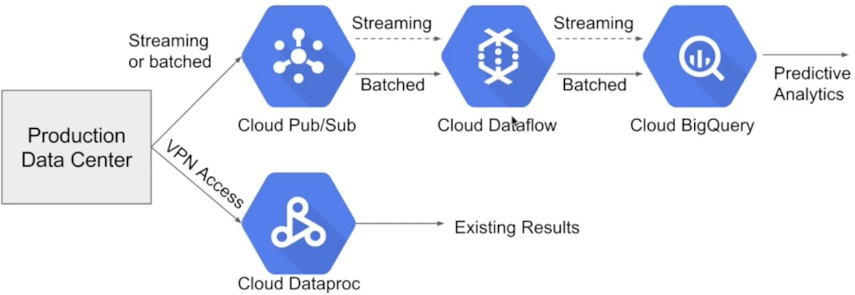

***Note***: All services are fully managed., easily scalable, and can handle streaming/batch data. All technical require- ments are met.

# ~~Case Study: MJTelco I~~ Company Overview

MJTelco is a startup that plans to build networks

in rapidly growing, underserved markets around the world. The company has patents for innovative optical communications hardware. Based on these patents, they can create many reliable, high-speed backbone links with inexpensive hardware.

# Company Background

Founded by experienced telecom executives, MJTelco uses technologies originally developed to overcome communica- tions challenges in space. Fundamental to their operation, they need to create a distributed data infrastructure that drives real-time analysis and incorporates machine lear-

# ~~Case Study: MJTelco II~~ Technical Requirements

-Ensure secure and efficient transport and storage of

telemetry data.

-Rapidly scale instances to support between 10,000 and 100,000 data providers with multiple flows each.

-Allow analysis and presentation against data tables tracking up to 2 years of data storing approximately 100m records/day. Support rapid iteration of monitoring infrastructure focused on awareness of data pipeline problems both in telemetry flows and in production learning cycles.

# CEO Statement

Our business model relies on our patents, analytics and

# ~~Choosing a Storage Option~~

ning to continuously optimize their topologies. Because their hardware is inexpensive, they plan to overdeploy the network allowing them to account for the impact of dynamic regional politics on location availability and cost.

Their management and operations teams are situated all around the globe creating many-to-many relationship between data consumers and providers in their system. After careful consideration, they decided public cloud is the perfect environment to support their needs.

# Solution Concept

MJTelco is running a successful proof-of-concept (PoC) project in its labs. They have two primary needs:

* + Scale and harden their PoC to support significantly more data flows generated when they ramp to more

than 50,000 installations.

* + Refine their machine-learning cycles to verify and improve the dynamic models they use to control topology definitions. MJTelco will also use three se- parate operating environments – development/test, staging, and production – to meet the needs of

running experiments, deploying new features, and serving production customers.

# Business Requirements

-Scale up their production environment with minimal cost, instantiating resources when and where needed in an un- predictable, distributed telecom user community.

-Ensure security of their proprietary data to protect their leading-edge machine learning and analysis.

-Provide reliable and timely access to data for analysis from distributed research workers.

-Maintain isolated environments that support rapid ite- ration of their machine-learning models without affecting their customers.

dynamic machine learning. Our inexpensive hardware is organized to be highly reliable, which gives us cost advantages. We need to quickly stabilize our large distributed data pipelines to meet our reliability and capacity commitments.

# CTO Statement

Our public cloud services must operate as advertised. We need resources that scale and keep our data secure. We also need environments in which our data scientists can carefully study and quickly adapt our models. Because we rely on automation to process our data, we also need our development and test environments to work as we iterate.

# CFO Statement

This project is too large for us to maintain the hardware and software required for the data and analysis. Also, we cannot afford to staff an operations team to monitor so many data feeds, so we will rely on automation and infrastructure. Google Cloud’s machine learning will al- low our quantitative researchers to work on our high-value problems instead of problems with our data pipelines.

**Cloud Storage**: unstructured data (blob)

**CloudSQL**: OLTP, SQL, structured and relational data, no need for horizontal scaling

|  |  |  |
| --- | --- | --- |
| **Need** | **Open Source** | **GCP Solution** |
| Compute,  Block Storage | Persistent Disks,  SSD | Persistent Disks,  SSD |
| Media, Blob  Storage | Filesystem,  HDFS | Cloud Storage |
| SQL Interface  on File Data | Hive | BigQuery |
| Document  DB, NoSQL | CouchDB, Mon-  goDB | DataStore |
| Fast Scanning  NoSQL | HBase, Cassan-  dra | BigTable |
| OLTP | RDBMS-  MySQL | CloudSQL,  Cloud Spanner |
| OLAP | Hive | BigQuery |

**Cloud Spanner**: OLTP, SQL, structured and relational data, need for horizontal scaling, between RDBMS/big data

**Cloud Datastore**: NoSQL, document data, key-value structured but non-relational data (XML, HTML, query depends on size of result (not dataset), fast to read/slow to write

**BigTable**: NoSQL, key-value data, columnar, good for sparse data, sensitive to hot spotting, high throughput and scalability for non-structured key/value data, where each value is typically no larger than 10 MB

# ~~Solutions~~ Data Lifecycle

At each stage, GCP offers multiple services to manage

your data.

1. **Ingest**: first stage is to pull in the raw data, such as streaming data from devices, on-premises batch data, application logs, or mobile-app user events and analytics
2. **Store**: after the data has been retrieved, it needs to be stored in a format that is durable and can be easily accessed
3. **Process and Analyze**: the data is transformed from raw form into actionable information
4. **Explore and Visualize**: convert the results of the analysis into a format that is easy to draw insights from and to share with colleagues and peers

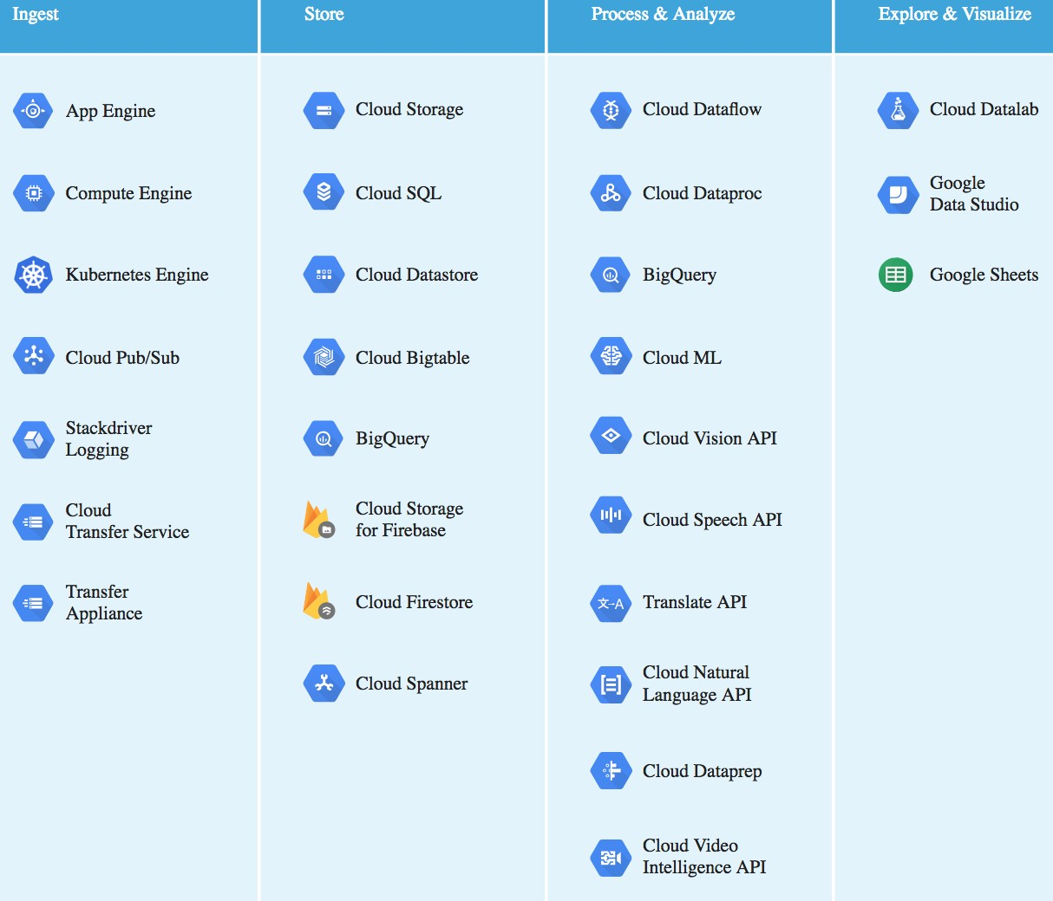

# Ingest

There are a number of approaches to collect raw data, based on the data’s size, source, and latency.

* + **Application**: data from application events, log fi- les or user events, typically collected in a push mo-

del, where the application calls an API to send the data to storage (Stackdriver Logging, Pub/Sub, CloudSQL, Datastore, Bigtable, Spanner)

* + **Streaming**: data consists of a continuous stream of small, asynchronous messages. Common uses in-

clude telemetry, or collecting data from geographi- cally dispersed devices (IoT) and user events and analytics (Pub/Sub)

* + **Batch**: large amounts of data are stored in a set of files that are transferred to storage in bulk. com-

mon use cases include scientific workloads, backups, migration (Storage, Transfer Service, Appliance)

# ~~Solutions- Part II~~ Storage

**Cloud Storage**: durable and highly-available object sto-

rage for structured and unstructured data

**Cloud SQL**: fully managed, cloud RDBMS that offers both MySQL and PostgreSQL engines with built-in sup- port for replication, for low-latency, transactional, relati- onal database workloads. supports RDBMS workloads up to 10 TB (storing financial transactions, user credentials, customer orders)

**BigTable**: managed, high-performance NoSQL database service designed for terabyte- to petabyte-scale workloads. suitable for large-scale, high-throughput workloads such as advertising technology or IoT data infrastructure. does not support multi-row transactions, SQL queries or joins, consider Cloud SQL or Cloud Datastore instead

**Cloud Spanner**: fully managed relational database ser- vice for mission-critical OLTP applications. horizontally scalable, and built for strong consistency, high availability, and global scale. supports schemas, ACID transactions, and SQL queries (use for retail and global supply chain, ad tech, financial services)

**BigQuery**: stores large quantities of data for query and analysis instead of transactional processing

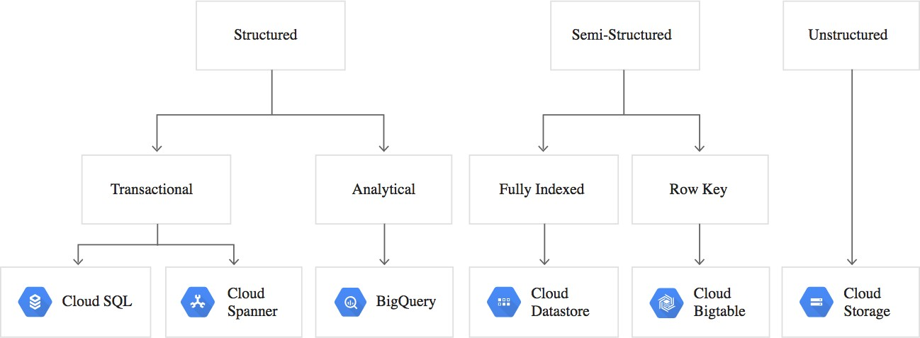

**Exploration and Visualization** Data exploration and visualization to better understand the results of the pro- cessing and analysis.

* + **Cloud Datalab**: interactive web-based tool that you can use to explore, analyze and visualize data

built on top of Jupyter notebooks. runs on a VM and automatically saved to persistent disks and can be stored in GC Source Repo (git repo)

* + **Data Studio**: drag-and-drop report builder that you can use to visualize data into reports and dash-

boards that can then be shared with others, bac- ked by live data, that can be shared and updated easily. data sources can be data files, Google She- ets, Cloud SQL, and BigQuery. supports **query** and **prefetch cache**: query remembers previous queries and if data not found, goes to prefetch cache, which predicts data that could be requested (disable if data changes frequently/using data source incurs charges)

# ~~Solutions- Part III~~ Process and Analyze

In order to derive business value and insights from data,

you must transform and analyze it. This requires a proces- sing framework that can either analyze the data directly or prepare the data for downstream analysis, as well as tools to analyze and understand processing results.

* + **Processing**: data from source systems is cleansed, normalized, and processed across multiple machines,

and stored in analytical systems

* + **Analysis**: processed data is stored in systems that allow for ad-hoc querying and exploration
  + 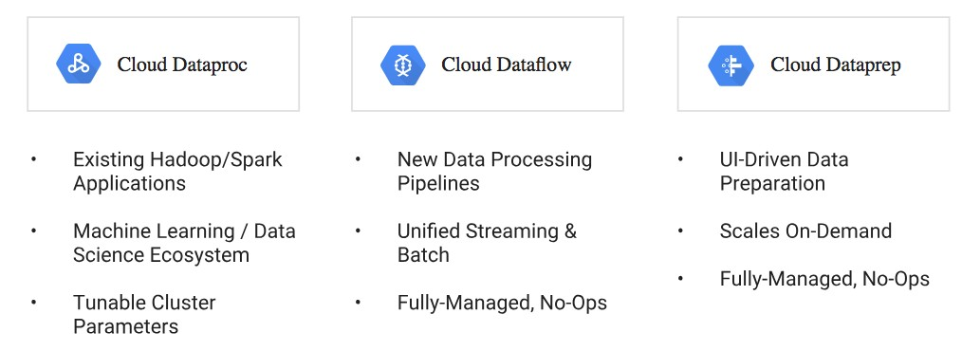**Understanding**: based on analytical results, data is used to train and test automated machine-learning models

# Processing

* + **Cloud Dataproc**: migrate your existing Hadoop or Spark deployments to a fully-managed service that automates cluster creation, simplifies configuration and management of your cluster, has built-in moni- toring and utilization reports, and can be shutdown

when not in use

* + **Cloud Dataflow**: designed to simplify big data for both streaming and batch workloads, focus on filte- ring, aggregating, and transforming your data
  + **Cloud Dataprep**: service for visually exploring, cleaning, and preparing data for analysis. can

transform data of any size stored in CSV, JSON, or relational-table formats

# Analyzing and Querying

* + **BigQuery**: query using SQL, all data encrypted, user analysis, device and operational metrics, busi- ness intelligence
  + **Task-Specific ML**: Vision, Speech, Natural Lan- guage, Translation, Video Intelligence
  + **ML Engine**: managed platform you can use to run custom machine learning models at scale

streaming data: use Pub/Sub and Dataflow in combination