**GIT BASH**

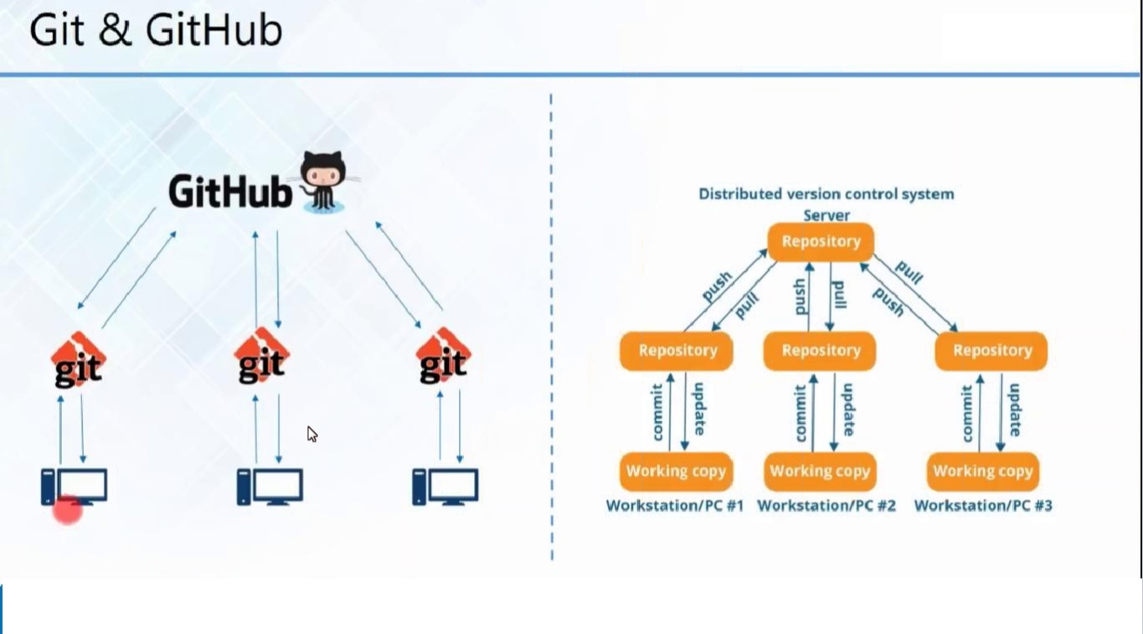

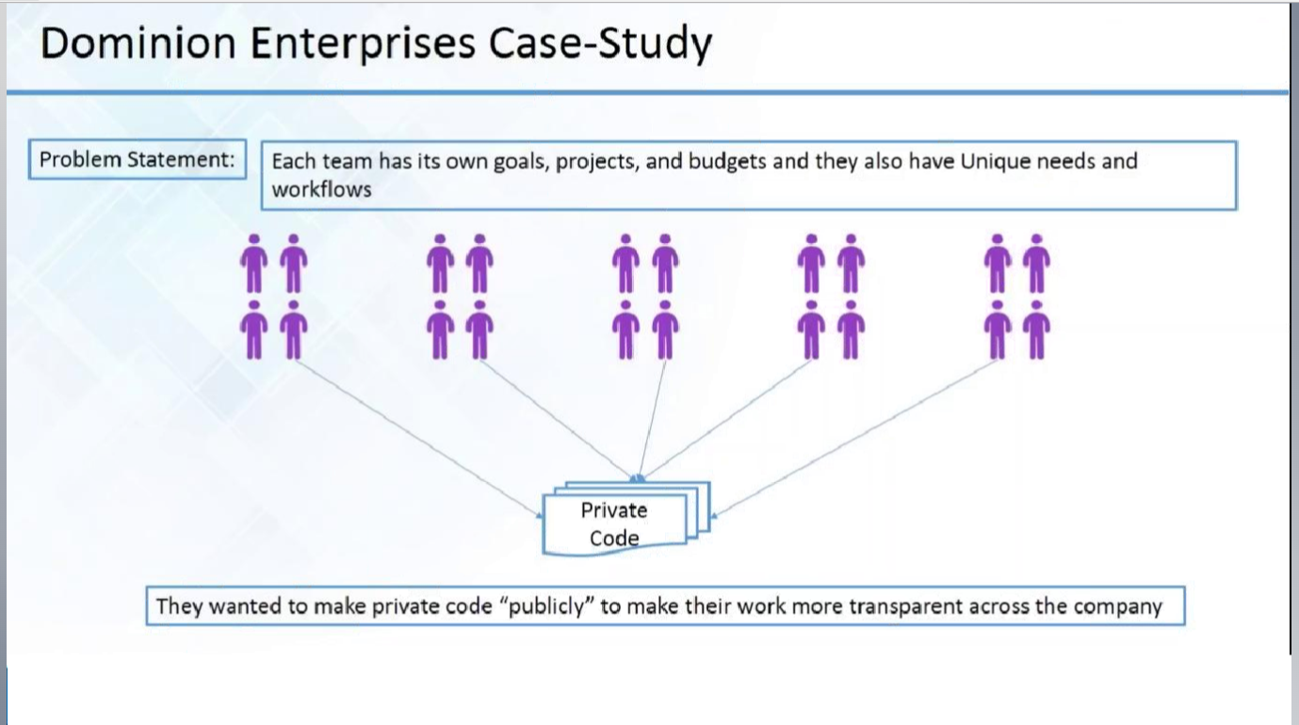

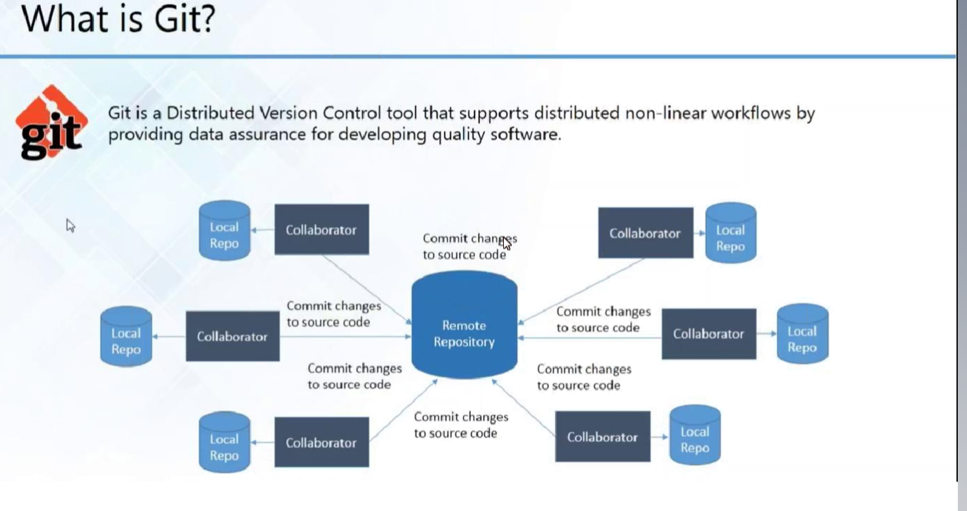

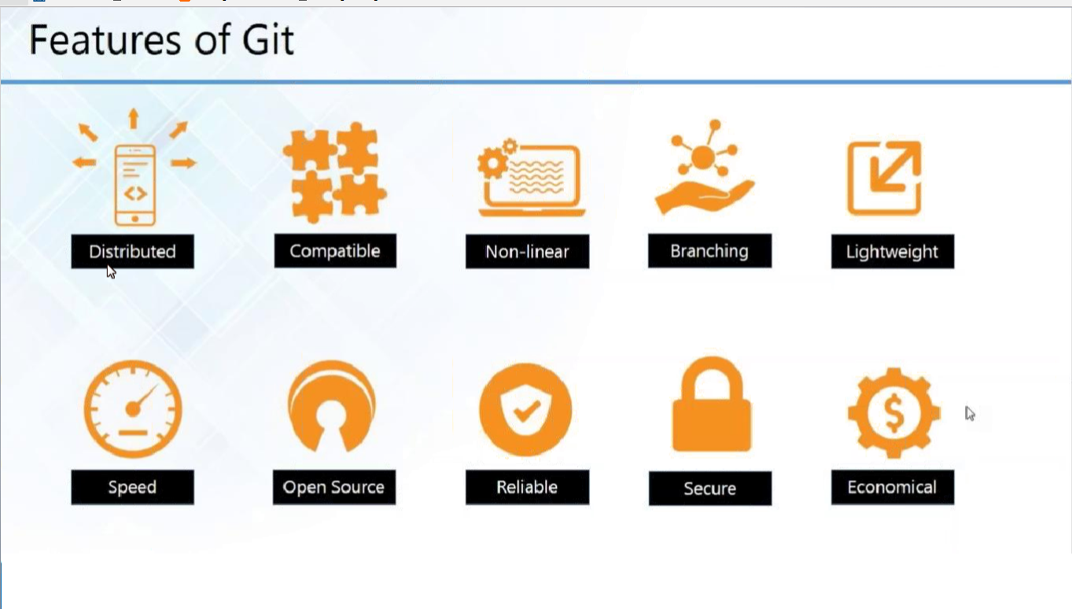

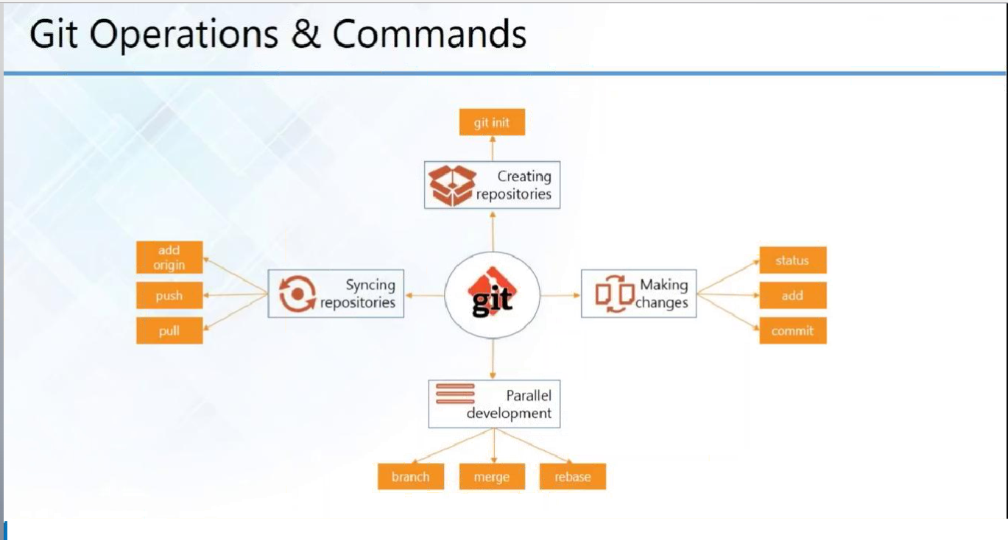

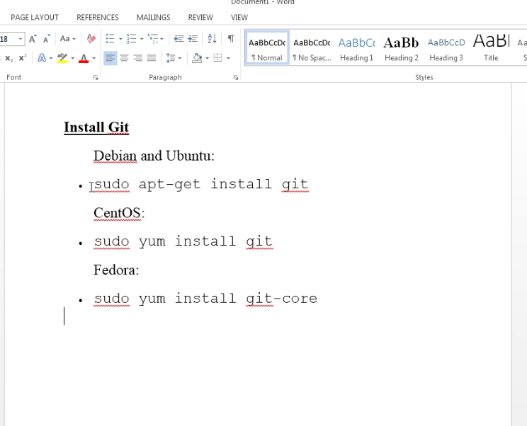

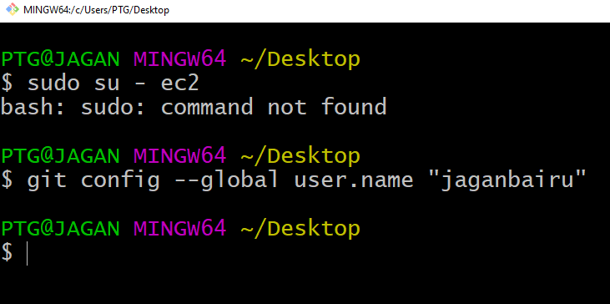

User name—GIT HUB name

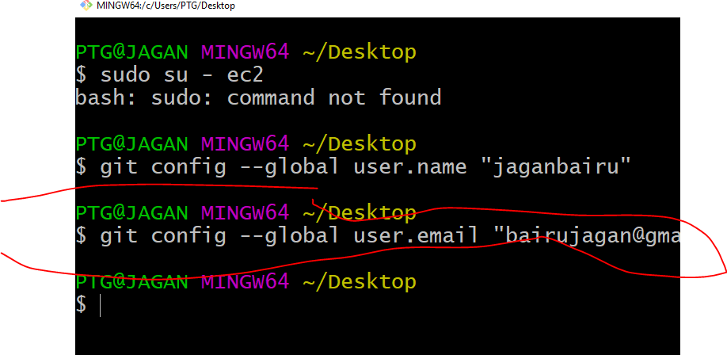

Hecking the git

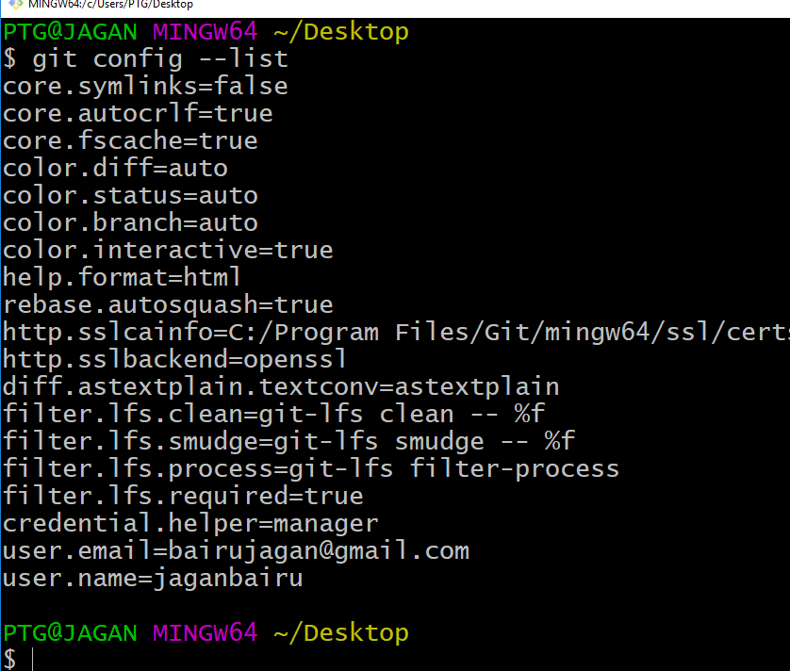

**$ git config --global user.name "jaganbairu"**

**$** **git config --global user.mail** [**bairujagan@gmail.com**](mailto:bairujagan@gmail.com)

**$git config –-list (to see list)**

PTG@JAGAN MINGW64 ~/Desktop/GIT-ONLINECLASS-LOCALREPO

**$ git init (create .git folder in the local repo)**

**$ git remote add origin "git@github.com:jaganbairu/jagan1.git"**

**(from online git hub copy the link)**

**$ git clone** [**https://github.com/jaganbairu/jagan2.git**](https://github.com/jaganbairu/jagan2.git) **(create copy)**

**$git status**

**$git On branch master -created file in the local repo will come**

**$ git add 1.txt**

**$ git add –A (all file will be pushed to site)**

**$ git commit 1.txt -m "my first commit done success" (commit)**

**$ git commit –a 1.txt -m "my first commit done success" (all files will be committed)**

**$ git commit -a -m "my all committs done success"**

**-a all commits**

**$ git log (all details committed )**

**$GIT RESET (DELETE THE COMMIT OLD)**

**$ git branch brr (any branch)**

**$ git checkout master (old file seen)**

**$ git checkout brr (shows branch latest file)**

$git merge brr (bee in master $git checkout master)

Modifying /creating files in branch or master:::

PTG@JAGAN MINGW64 ~/Desktop/GIT-ONLINECLASS-LOCALREPO (brr)--LOCAL

$ touch 11.txt --(new file Created)

PTG@JAGAN MINGW64 ~/Desktop/GIT-ONLINECLASS-LOCALREPO (brr)

$ ls

1.txt 2.txt First_SRC_TELANGANA.pdf j2.txt jagan2/

**11.txt** 3.txt j1.txt j3.txt

PTG@JAGAN MINGW64 ~/Desktop/GIT-ONLINECLASS-LOCALREPO (brr)

$ git status --check status

On branch brr

Untracked files:

(use "git add <file>..." to include in what will be committed)

11.txt --untracked

nothing added to commit but untracked files present (use "git add" to track)

PTG@JAGAN MINGW64 ~/Desktop/GIT-ONLINECLASS-LOCALREPO (brr)

$ git add –A (add file)

PTG@JAGAN MINGW64 ~/Desktop/GIT-ONLINECLASS-LOCALREPO (brr)

$ git status

On branch brr

Changes to be committed:

(use "git reset HEAD <file>..." to unstage)

new file:11.txt --Added file

PTG@JAGAN MINGW64 ~/Desktop/GIT-ONLINECLASS-LOCALREPO (brr)

$ git commit -a -m "committed**" --Committed**

[brr 38b7704] committed

1 file changed, 0 insertions(+), 0 deletions(-)

create mode 100644 11.txt --committed

PTG@JAGAN MINGW64 ~/Desktop/GIT-ONLINECLASS-LOCALREPO (brr)

$ ls

1.txt 2.txt First_SRC_TELANGANA.pdf j2.txt jagan2/

11.txt 3.txt j1.txt j3.txt

PTG@JAGAN MINGW64 ~/Desktop/GIT-ONLINECLASS-LOCALREPO (brr)

$ git checkout master **--changed to MASTER REPO**

Switched to branch 'master'

PTG@JAGAN MINGW64 ~/Desktop/GIT-ONLINECLASS-LOCALREPO (master)

$ ls

1.txt 2.txt 5.txt 7.txt 9.txt j1.txt j3.txt

10.txt 3.txt 6.txt 8.txt First_SRC_TELANGANA.pdf j2.txt jagan2/

PTG@JAGAN MINGW64 ~/Desktop/GIT-ONLINECLASS-LOCALREPO (master)

$ **git merge brr**  **(***merged branch to Master : brr to master**)

Merge made by the 'recursive' strategy.

**11.txt | 0**

1 file changed, 0 insertions(+), 0 deletions(-)

create mode 100644 11.txt

PTG@JAGAN MINGW64 ~/Desktop/GIT-ONLINECLASS-LOCALREPO (master)

$ ls

1.txt **11.txt** 3.txt 6.txt 8.txt First_SRC_TELANGANA.pdf j2.txt jagan2/

10.txt 2.txt 5.txt 7.txt 9.txt j1.txt j3.txt

PTG@JAGAN MINGW64 ~/Desktop/GIT-ONLINECLASS-LOCALREPO (master)

$ git checkout brr **--master to brr**

Switched to branch 'brr'

PTG@JAGAN MINGW64 ~/Desktop/GIT-ONLINECLASS-LOCALREPO (brr)

$ ls

1.txt 2.txt First_SRC_TELANGANA.pdf j2.txt jagan2/

**11.txt** 3.txt j1.txt j3.txt

PTG@JAGAN MINGW64 ~/Desktop/GIT-ONLINECLASS-LOCALREPO (brr)

$ git checkout master

Switched to branch 'master'

PTG@JAGAN MINGW64 ~/Desktop/GIT-ONLINECLASS-LOCALREPO (master)

$ git checkout brr

Switched to branch 'brr'

PTG@JAGAN MINGW64 ~/Desktop/GIT-ONLINECLASS-LOCALREPO (brr)

$ ls

1.txt 2.txt First_SRC_TELANGANA.pdf j2.txt jagan2/

11.txt 3.txt j1.txt j3.txt

PTG@JAGAN MINGW64 ~/Desktop/GIT-ONLINECLASS-LOCALREPO (brr)

-------------------------------------

$ git remote add origin "https://github.com/jaganbairu/jagan1.git"

fatal: not a git repository (or any of the parent directories): .git

PTG@JAGAN MINGW64 ~/Desktop

$ git init

Initialized empty Git repository in C:/Users/PTG/Desktop/.git/

PTG@JAGAN MINGW64 ~/Desktop (master)

$ git remote add origin "https://github.com/jagan

$ git clone "https://github.com/jaganbairu/jagan1.git"

$ ssh -T git@github.com

**KEY-GEN creation**

PTG@JAGAN MINGW64 ~/Desktop/GIT-ONLINECLASS-LOCALREPO (brr)

PTG@JAGAN MINGW64 ~/Desktop (master)

**$ ssh-keygen**

Generating public/private rsa key pair.

Enter file in which to save the key (/c/Users/PTG/.ssh/id_rsa):

/c/Users/PTG/.ssh/id_rsa already exists.

Overwrite (y/n)? **y**

Enter passphrase (empty for no passphrase): **ENTER**

Enter same passphrase again:

Your identification has been saved in **/c/Users/PTG/.ssh/id_rsa**. **---COPY THIS ENTER**

Your public key has been saved in /c/Users/PTG/.ssh/id_rsa.pub.

The key fingerprint is:

SHA256:47/CQhHVrflxX/gjB7P1Mrpc5fcCWKWUs4GB64OM9CM PTG@JAGAN

The key's randomart image is:

+---[RSA 2048]----+

| ..o.+ . |

| . . o * . |

| . . + * . |

| . . . o =oo..|

| . + +S + o=o+|

| E *.o.. ooo=+|

| o o.. o+o+|

| . o. .... o|

| . .o.o. ..|

+----[SHA256]-----+

PTG@JAGAN MINGW64 ~/Desktop (master)

**$ cat /c/Users/PTG/.ssh/id_rsa.pub**

**ssh-rsa** **AAAAB3NzaC1yc2EAAAADAQABAAABAQC8I9vgO4hJujKJspR4yVmmsMGnYsVrz/pr693SNOHU VV5gRZVRTFkUVa4Yodn+s46PomD8LoDQaQRUqeBbQQGflVLMuiPbHO8uABxvh7NcUb5ceVXXJad5T7/z ZuKbpviyIkXg7ZMstvHgDvzcVNkxdgjsDYbnrc1nLa8flK8sHzhpXQHYKfjjblXkjWGGvJfFrU2trrY+ MJuYBajoBxGryJtNkHTKuRARwwFkzeUhX/JEgr75guB4DbVFYaYtwuTykUA1nZCLvwuDDGqJhzi6OW78 CemYoJyHL62r+UMyWU1iywLTydnhZN9QevhS+eSaiDPX9lvt6vHyPM8jVnE/ PTG@JAGAN**

PTG@JAGAN MINGW64 ~/Desktop (master

ENTER-ABOVE KEY IN THE DOWN BELOW

