**TALLY_GET_USER_INFO :**

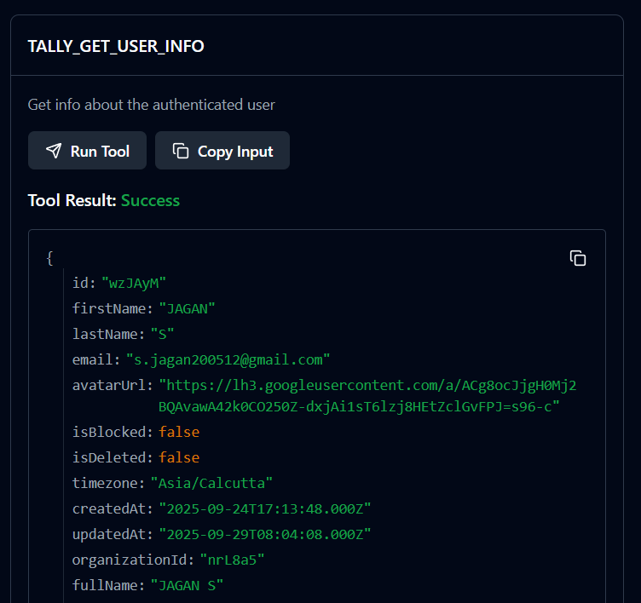

**TALLY_LIST_WORKSPACES**

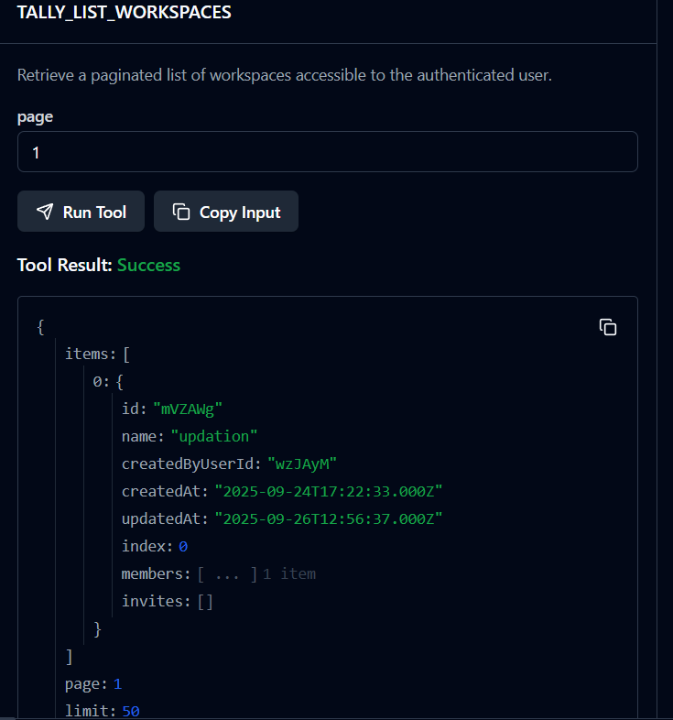

**TALLY_GET_WORKSPACE :**

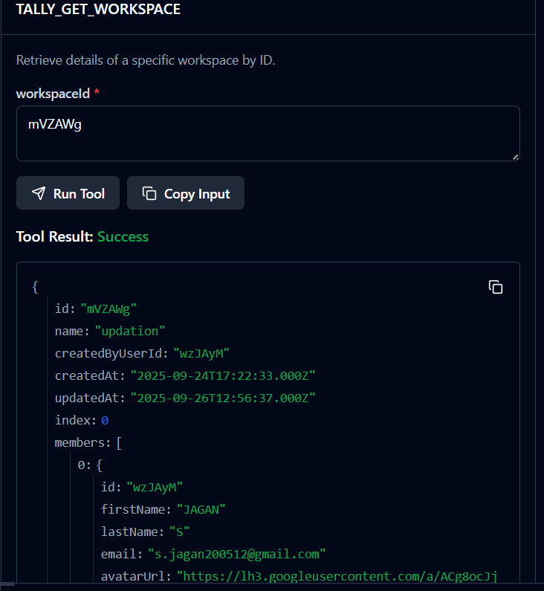

**TALLY_UPDATE_WORKSPACE**

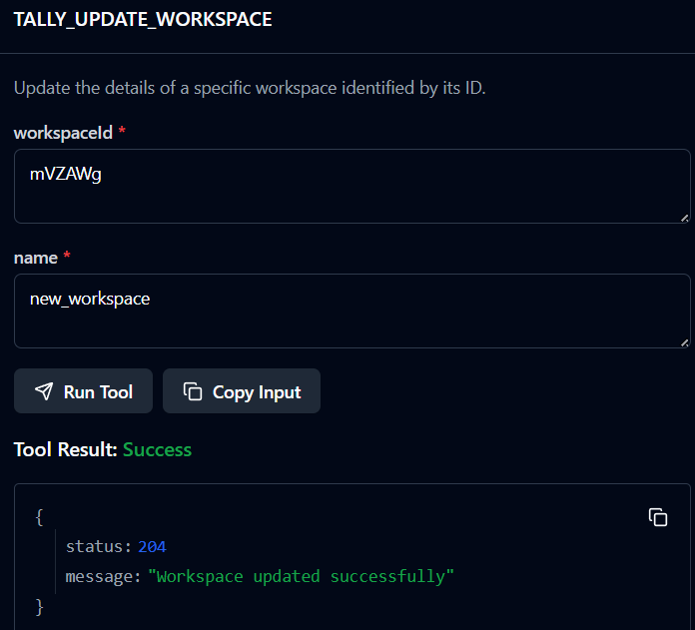

**TALLY_LIST_FORMS :**

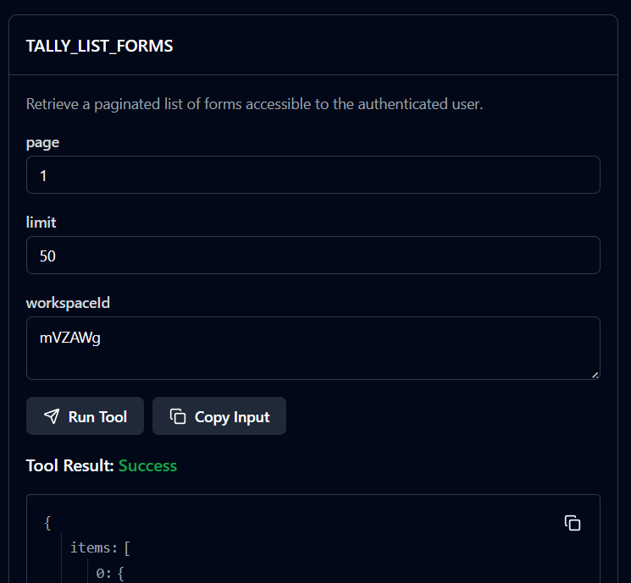

**TALLY_GET_FORM**

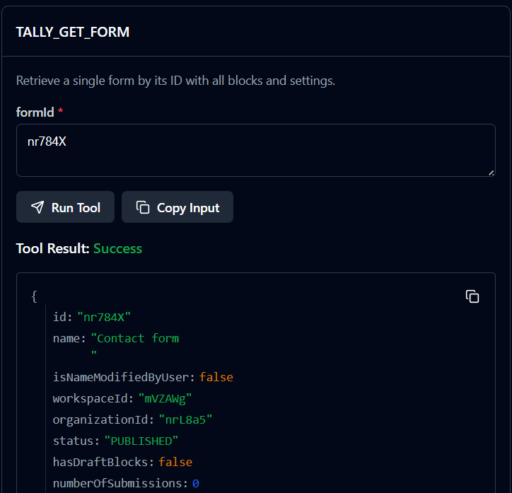

**TALLY_CREATE_FORM**

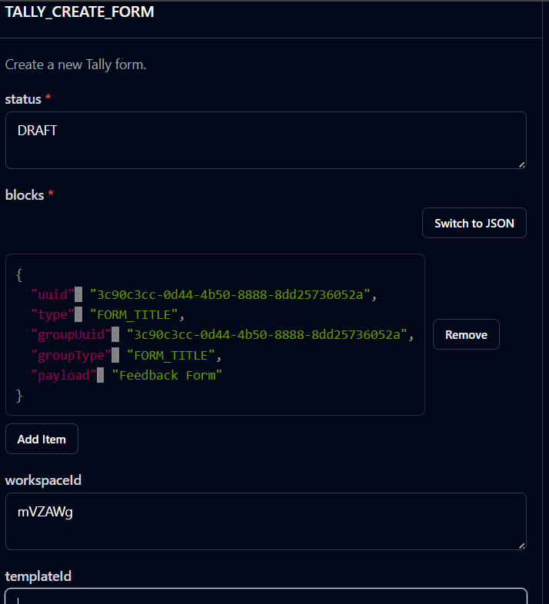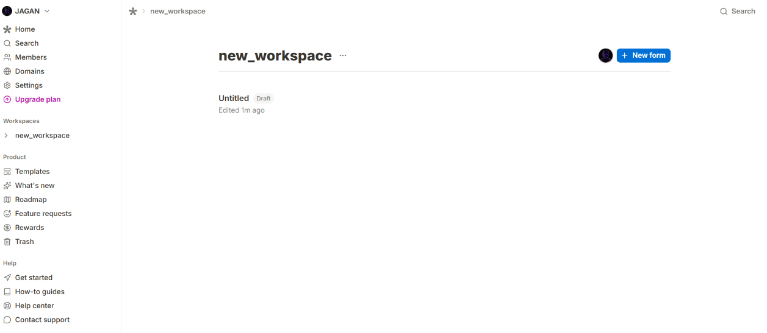

**TALLY_UPDATE_FORM**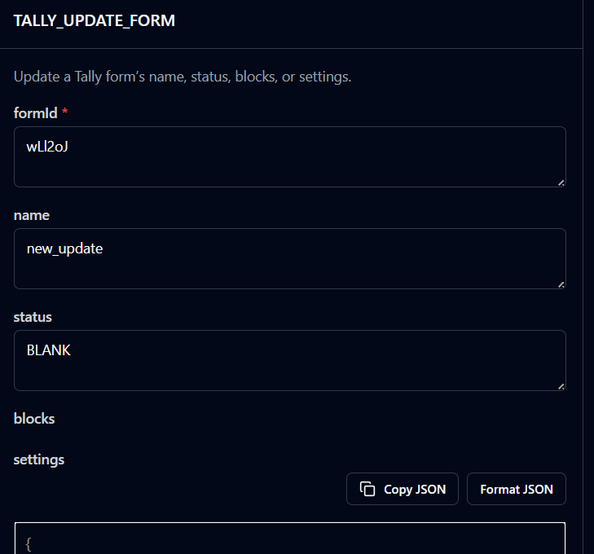

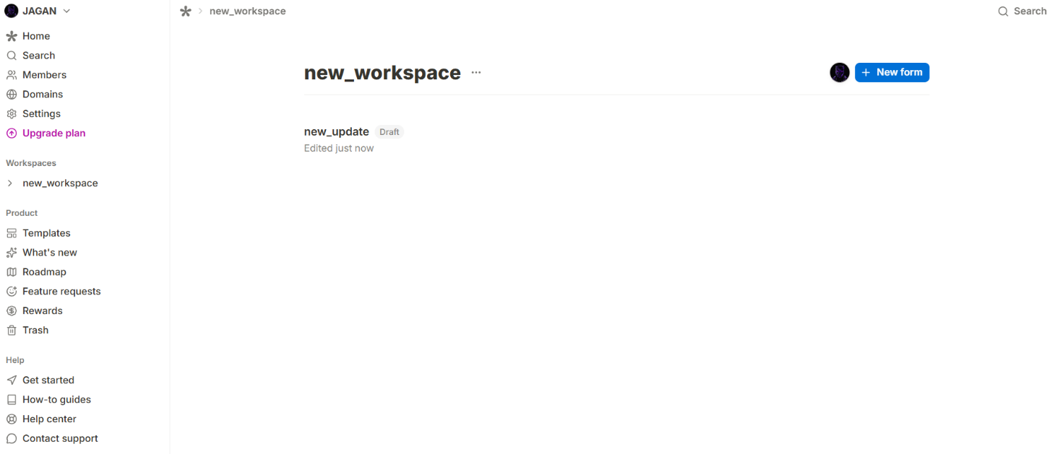

**TALLY_DELETE_FORM**

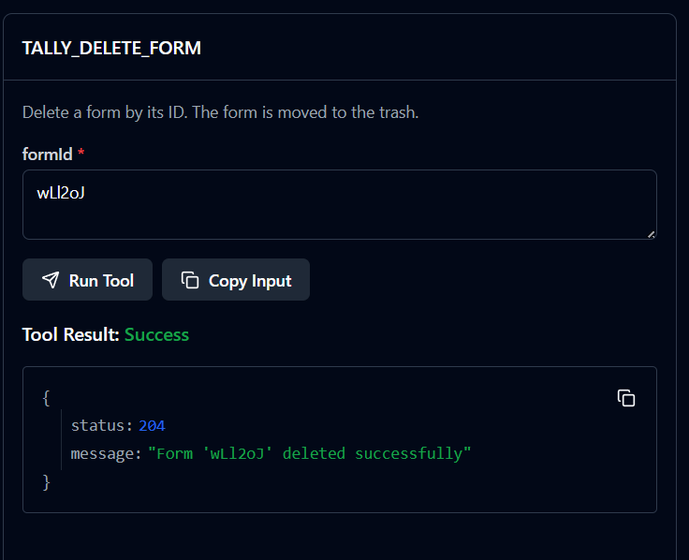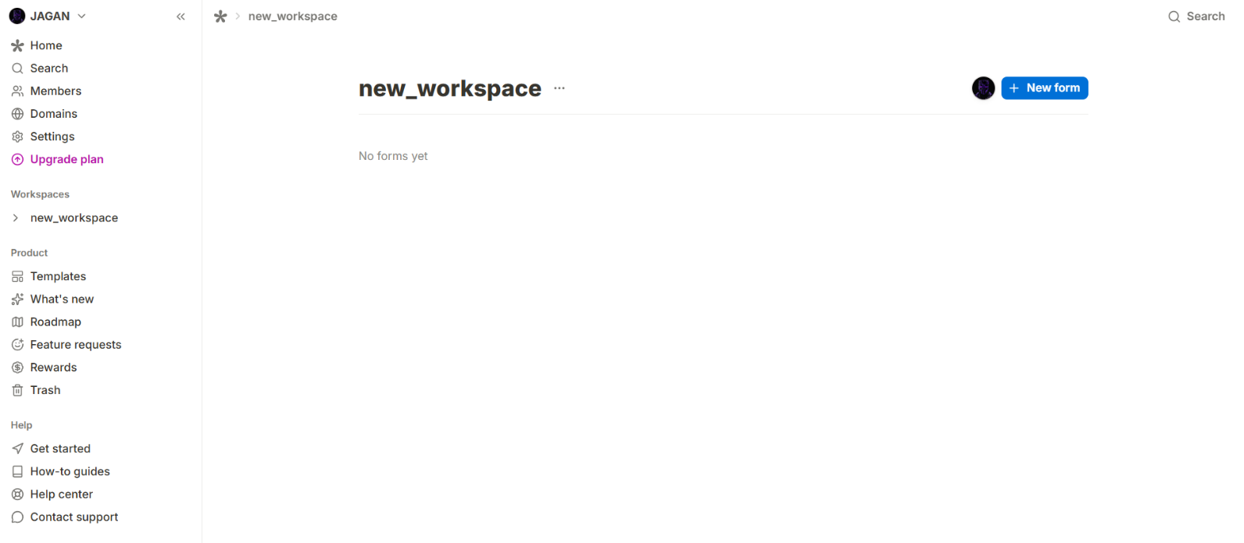

**TALLY_LIST_FORM_QUESTIONS**

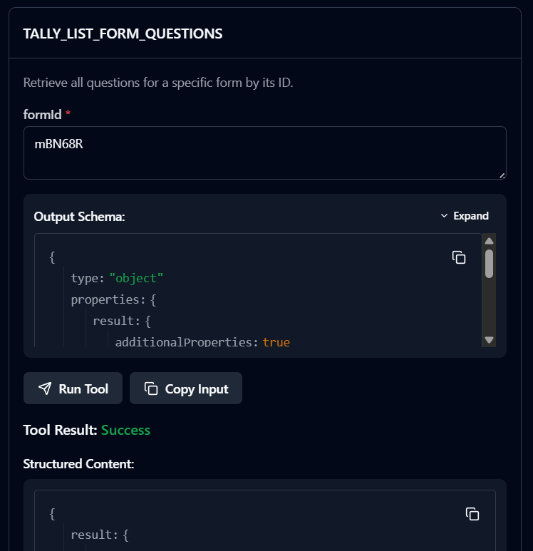

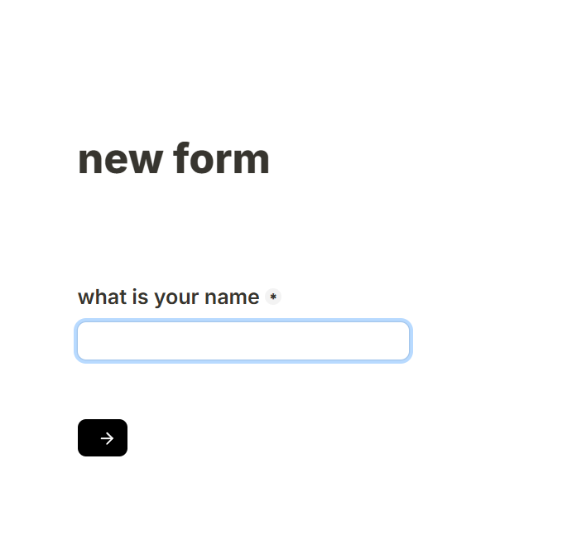

**TALLY_LIST_SUBMISSIONS**

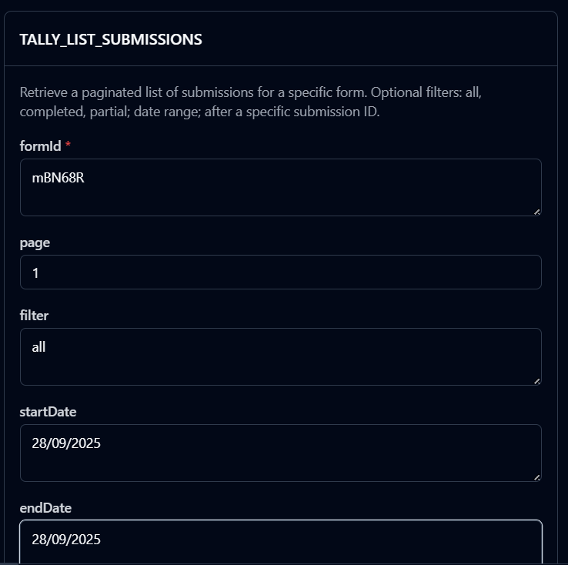

**TALLY_GET_SUBMISSION**

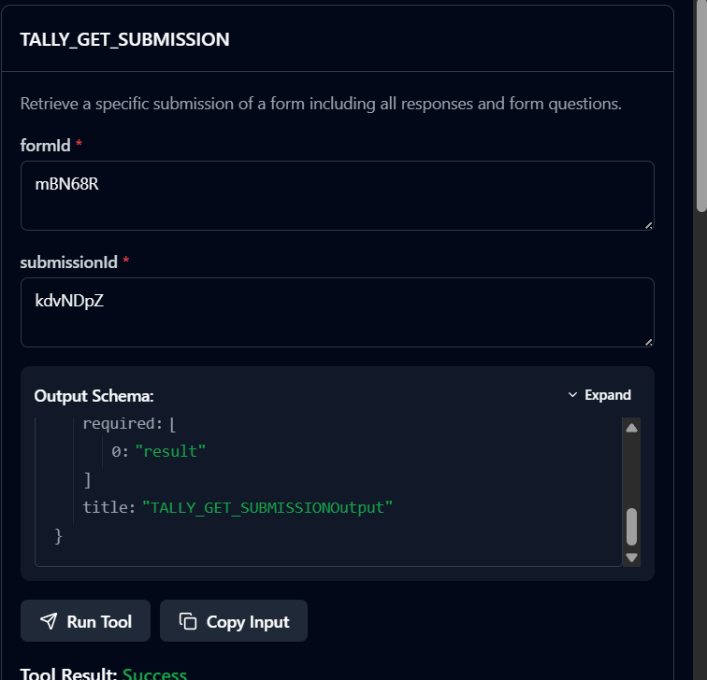

**TALLY_DELETE_SUBMISSION**

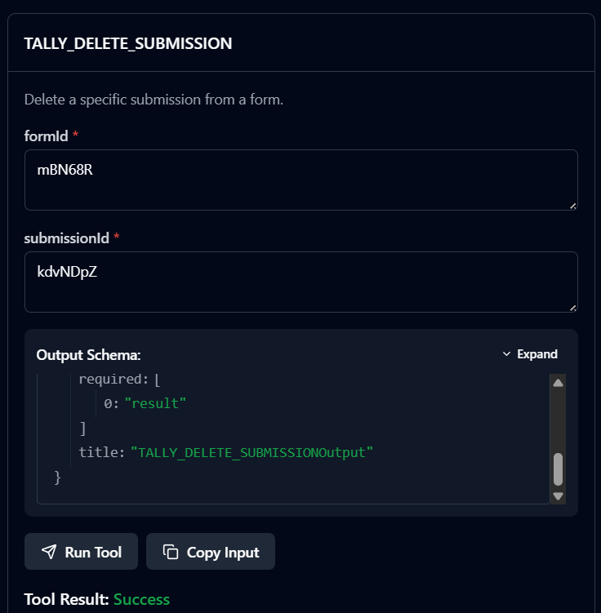

**TALLY_GET_FORM_SETTINGS**

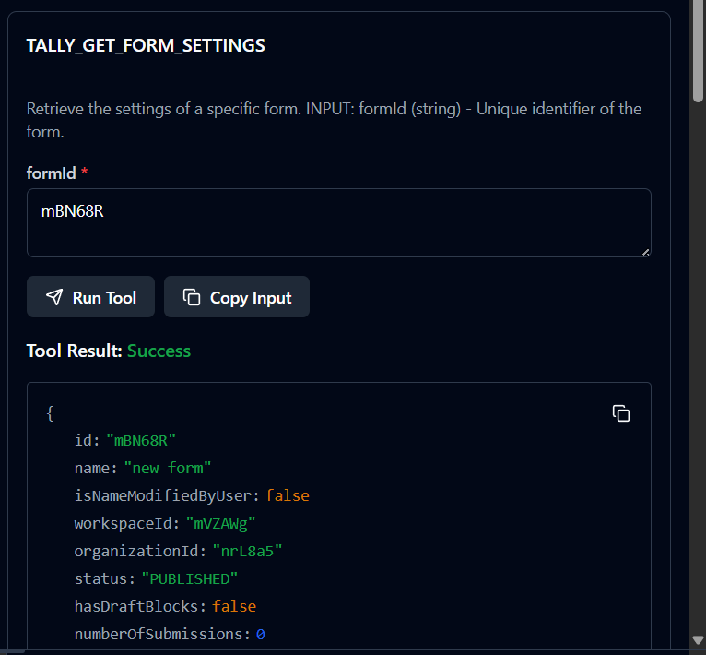

**TALLY_LIST_WEBHOOKS**

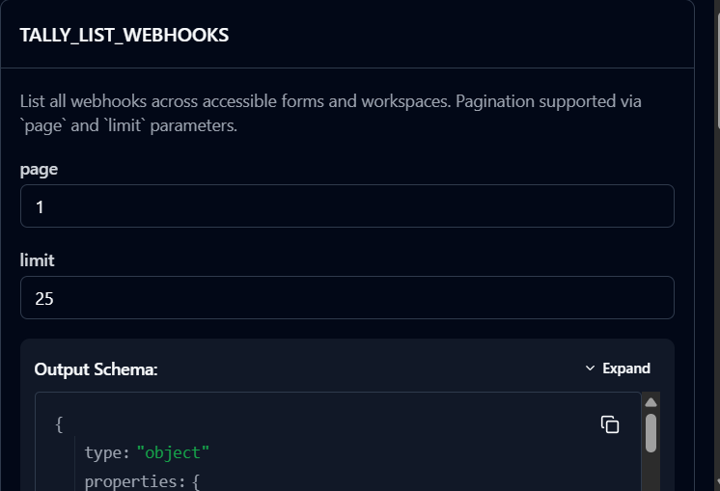

**TALLY_CREATE_WEBHOOK**

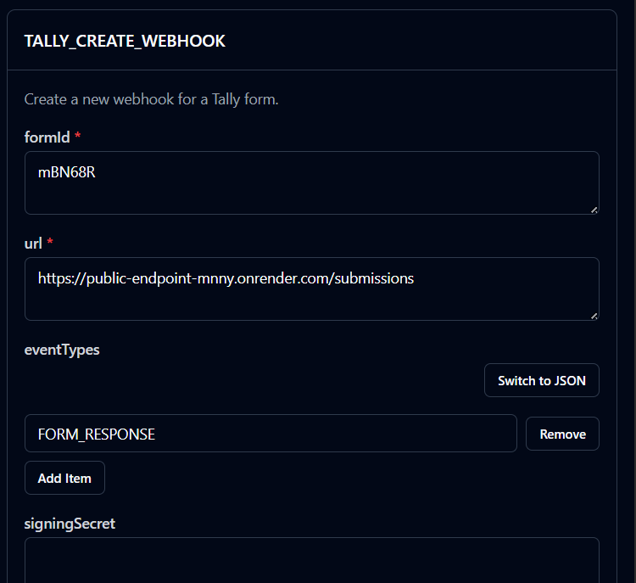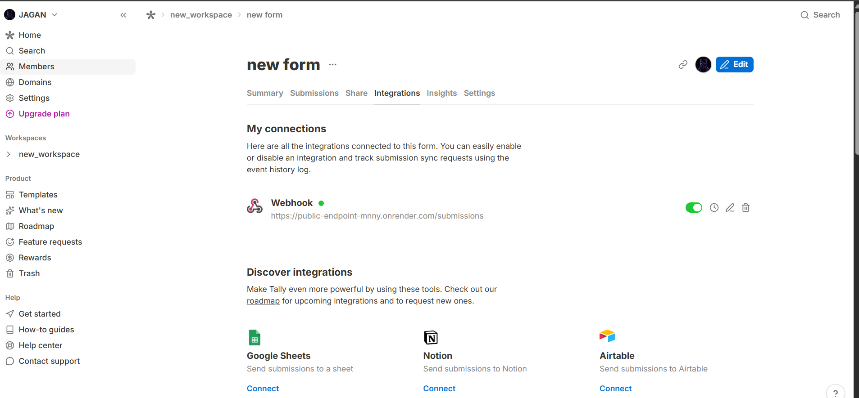

**TALLY_LIST_WEBHOOK_EVENTS**

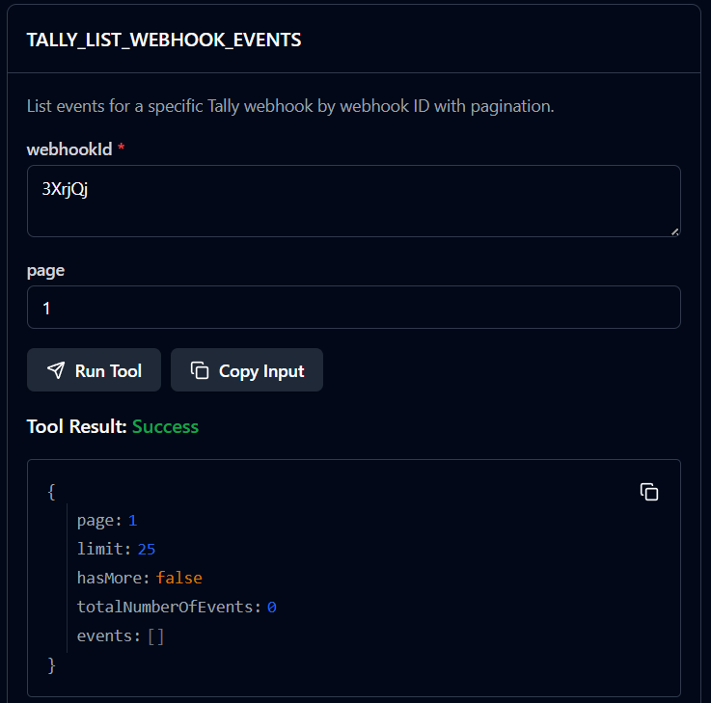

**TALLY_UPDATE_WEBHOOK**

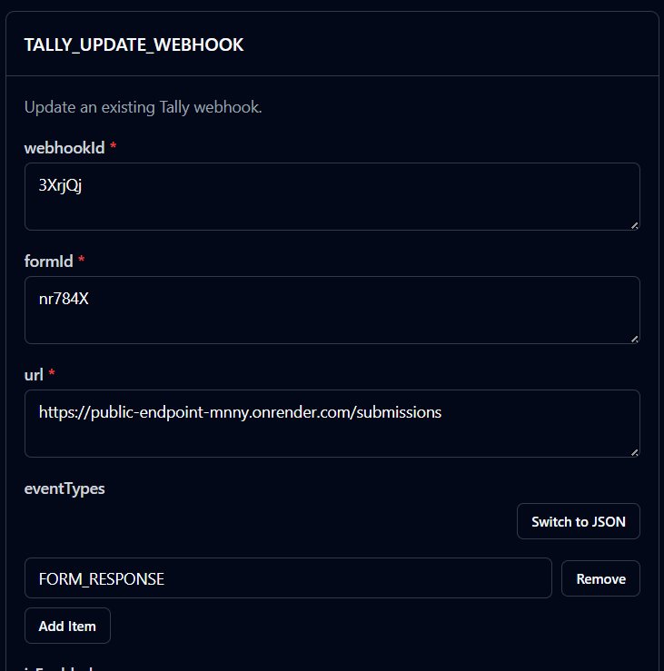

**TALLY_DELETE_WEBHOOK**

