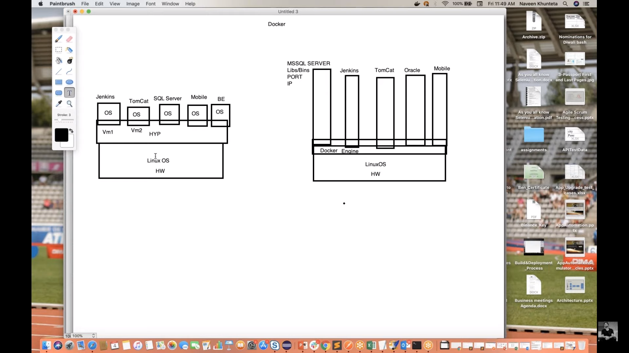

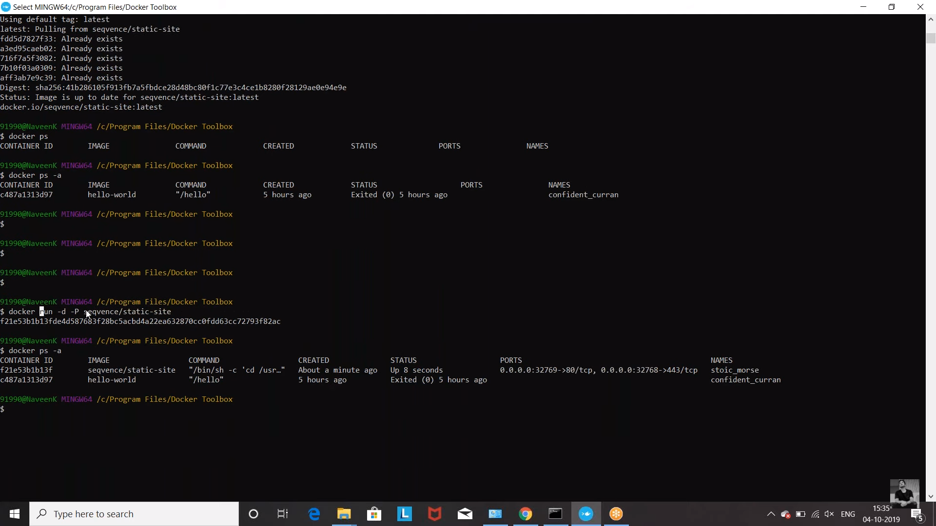

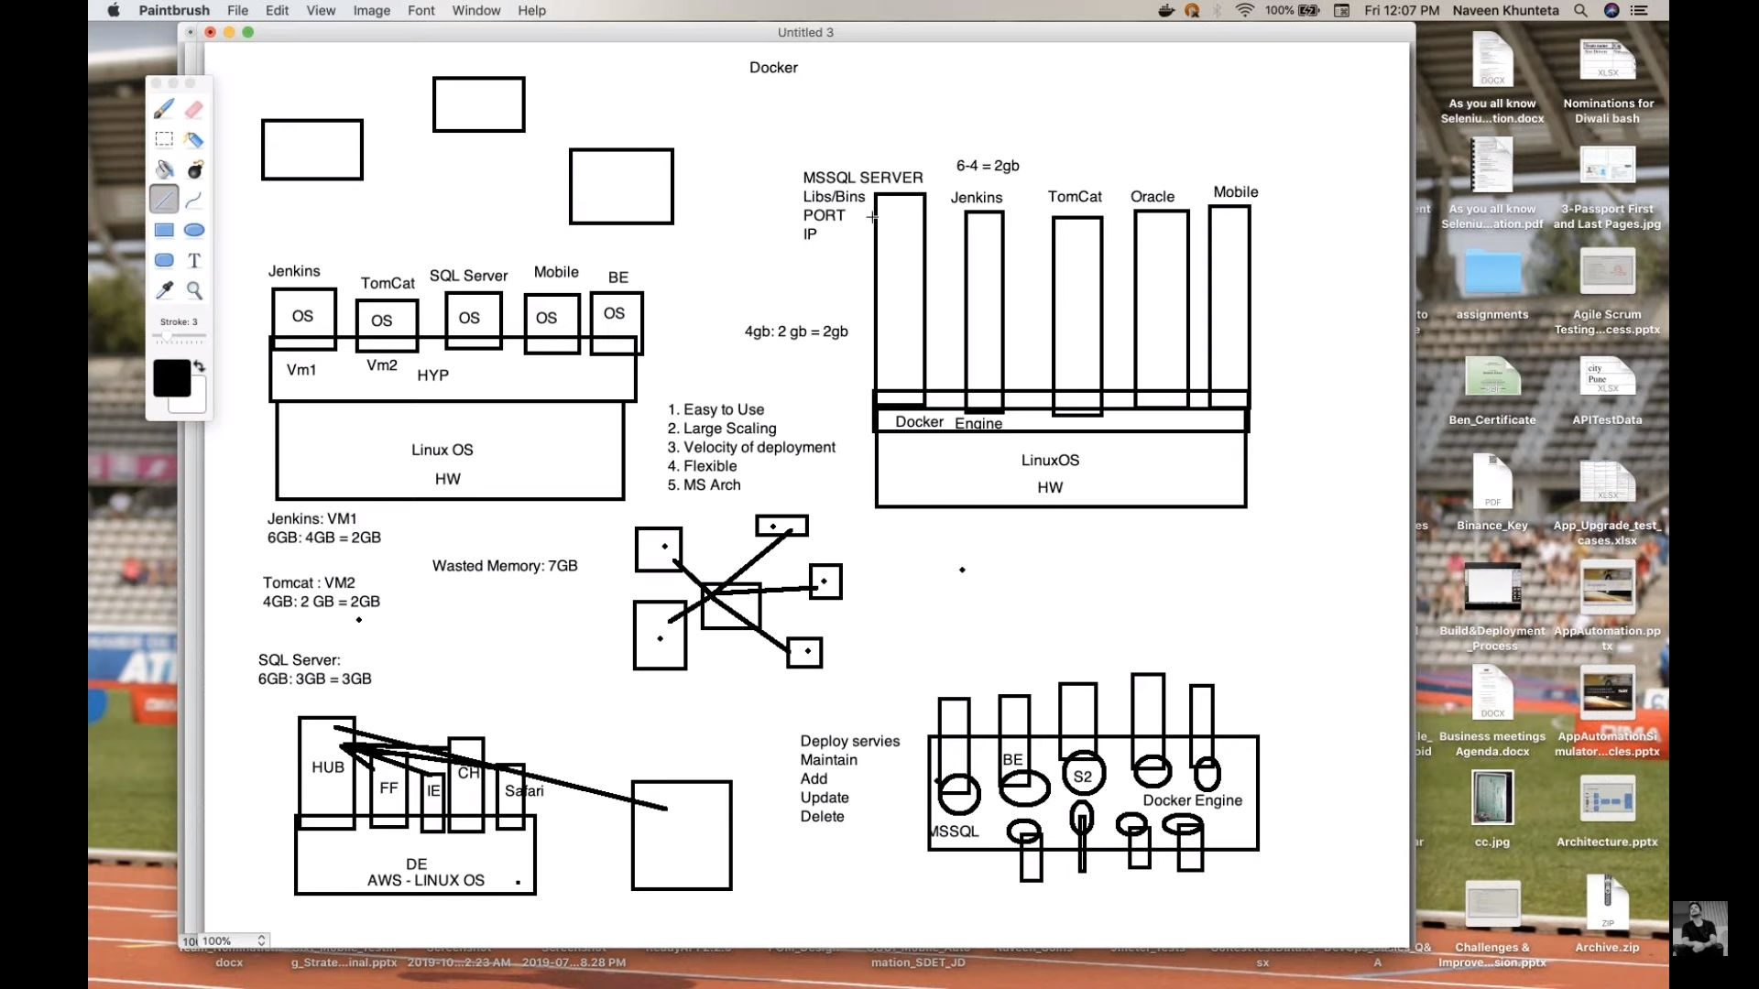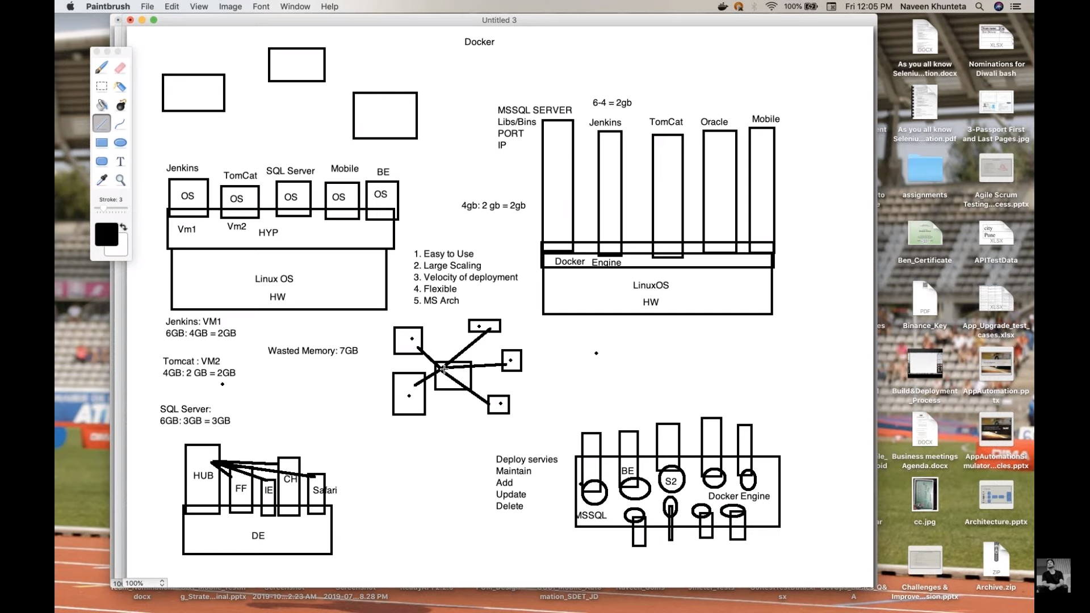

1. Docker pull
2. Docker images
3. Docker –version
4. Docker ps -a (status)
5. Docker run image path
6. Docker rm continerID
7. Docker stop containerID
8. Docker restart containerID
9. Docker kill containerID
10. Docker inspect containerID (inspect it will give json configuration)
11. Docker image ls (checking the image list)
12. Docker rmi imagename/imageID
13. Docker image prune -a ( It will remove image which is not associated with any container)
14. Docker start containerID
15. Docker ps (which are available)
16. Docker logs(we can see the logs)