Search for all conflicting files. grep -lr '<<<<<<<'

**Resolve easy/obvious conflicts**

At this point you may review each files. If solution is to accept local/our version, run:

git checkout --ours PATH/FILE

If solution is to accept remote/other-branch version, run:

git checkout --theirs PATH/FILE

If you have multiple files and you want to accept local/our version, run:

grep -lr '<<<<<<<' . | xargs git checkout --ours

If you have multiple files and you want to accept remote/other-branch version, run:

grep -lr '<<<<<<<' . | xargs git checkout --theirs

**For complex conflicts**

For files that needs manual review/edit, use vim or any text editor to resolve differences.

Make sure you run git add FILENAME for files edited using vim.

Finally, review if all files are ready for commit using  git status

And run git commit -am "MSG" followed by optional git push

Use git revert <ID> to revert back to a previous commit. each commit has an identifying code.

## Working with local repositories

### git init

This command turns a directory into an empty Git repository. This is the first step in creating a repository. After running git init, adding and committing files/directories is possible.

Usage:

# change directory to codebase

$ cd /file/path/to/code

# make directory a git repository

$ git init

In Practice:

# change directory to codebase

$ cd /Users/computer-name/Documents/website

# make directory a git repository

$ git init

Initialized empty Git repository in /Users/computer-name/Documents/website/.git/

### git add

Adds files in the to the staging area for Git. Before a file is available to commit to a repository, the file needs to be added to the Git index (staging area). There are a few different ways to use git add, by adding entire directories, specific files, or all unstaged files.

Usage:

$ git add <file or directory name>

In Practice:

# To add all files not staged:

$ git add .

# To stage a specific file:

$ git add index.html

# To stage an entire directory:

$ git add css

### git commit

Record the changes made to the files to a local repository. For easy reference, each commit has a unique ID.

It’s best practice to include a message with each commit explaining the changes made in a commit. Adding a commit message helps to find a particular change or understanding the changes.

Usage:

# Adding a commit with message

$ git commit -m "Commit message in quotes"

In Practice:

$ git commit -m "My first commit message"

[SecretTesting 0254c3d] My first commit message

1 file changed, 0 insertions(+), 0 deletions(-)

create mode 100644 homepage/index.html

### git status

This command returns the current state of the repository.

git status will return the current working branch. If a file is in the staging area, but not committed, it shows with git status. Or, if there are no changes it’ll return nothing to commit, working directory clean.

Usage:

$ git status

In Practice:

# Message when files have not been staged (git add)

$ git status

On branch SecretTesting

Untracked files:

(use "git add <file>..." to include in what will be committed)

homepage/index.html

# Message when files have been not been committed (git commit)

$ git status

On branch SecretTesting

Your branch is up-to-date with 'origin/SecretTesting'.

Changes to be committed:

(use "git reset HEAD <file>..." to unstage)

new file: homepage/index.html

# Message when all files have been staged and committed

$ git status

On branch SecretTesting

nothing to commit, working directory clean

### git config

With Git, there are many configurations and settings possible. git config is how to assign these settings. Two important settings are user user.name and user.email. These values set what email address and name commits will be from on a local computer. With git config, a --global flag is used to write the settings to all repositories on a computer. Without a --global flag settings will only apply to the current repository that you are currently in.

There are many other variables available to edit in git config. From editing color outputs to changing the behavior of git status. Learn about git config settings in the official [Git documentation](https://git-scm.com/docs/git-config).

Usage:

$ git config <setting> <command>

In Practice:

# Running git config globally

$ git config --global user.email "my@emailaddress.com"

$ git config --global user.name "Brian Kerr"

# Running git config on the current repository settings

$ git config user.email "my@emailaddress.com"

$ git config user.name "Brian Kerr"

### git branch

To determine what branch the local repository is on, add a new branch, or delete a branch.

Usage:

# Create a new branch

$ git branch <branch_name>

# List all remote or local branches

$ git branch -a

# Delete a branch

$ git branch -d <branch_name>

In Practice:

# Create a new branch

$ git branch new_feature

# List branches

$ git branch -a

* SecretTesting

new_feature

remotes/origin/stable

remotes/origin/staging

remotes/origin/master -> origin/SecretTesting

# Delete a branch

$ git branch -d new_feature

Deleted branch new_feature (was 0254c3d).

### git checkout

To start working in a different branch, use git checkout to switch branches.

Usage:

# Checkout an existing branch

$ git checkout <branch_name>

# Checkout and create a new branch with that name

$ git checkout -b <new_branch>

In Practice:

# Switching to branch 'new_feature'

$ git checkout new_feature

Switched to branch 'new_feature'

# Creating and switching to branch 'staging'

$ git checkout -b staging

Switched to a new branch 'staging'

### git merge

Integrate branches together. git merge combines the changes from one branch to another branch. For example, merge the changes made in a staging branch into the stable branch.

Usage:

# Merge changes into current branch

$ git merge <branch_name>

In Practice:

# Merge changes into current branch

$ git merge new_feature

Updating 0254c3d..4c0f37c

Fast-forward

homepage/index.html | 297 ++++++++++++++++++++++++++++++++++++++++++++++++++++++++

1 file changed, 297 insertions(+)

create mode 100644 homepage/index.html

## Working with remote repositories

### git remote

To connect a local repository with a remote repository. A remote repository can have a name set to avoid having to remember the URL of the repository.

Usage:

# Add remote repository

$ git remote <command> <remote_name> <remote_URL>

# List named remote repositories

$ git remote -v

In Practice:

# Adding a remote repository with the name of beanstalk

$ git remote add origin git@account_name.git.beanstalkapp.com:/acccount_name/repository_name.git

# List named remote repositories

$ git remote -v

origin git@account_name.git.beanstalkapp.com:/acccount_name/repository_name.git (fetch)

origin git@account_name.git.beanstalkapp.com:/acccount_name/repository_name.git (push)

Note: A remote repository can have any name. It’s common practice to name the remote repository ‘origin’.

### git clone

To create a local working copy of an existing remote repository, use git clone to copy and download the repository to a computer. Cloning is the equivalent of git init when working with a remote repository. Git will create a directory locally with all files and repository history.

Usage:

$ git clone <remote_URL>

In Practice:

$ git clone git@account_name.git.beanstalkapp.com:/acccount_name/repository_name.git

Cloning into 'repository_name'...

remote: Counting objects: 5, done.

remote: Compressing objects: 100% (3/3), done.

remote: Total 5 (delta 0), reused 0 (delta 0)

Receiving objects: 100% (5/5), 3.08 KiB | 0 bytes/s, done.

Checking connectivity... done.

### git pull

To get the latest version of a repository run git pull. This pulls the changes from the remote repository to the local computer.

Usage:

$ git pull <branch_name> <remote_URL/remote_name>

In Practice:

# Pull from named remote

$ git pull origin staging

From account_name.git.beanstalkapp.com:/account_name/repository_name

* branch staging -> FETCH_HEAD

* [new branch] staging -> origin/staging

Already up-to-date.

# Pull from URL (not frequently used)

$ git pull git@account_name.git.beanstalkapp.com:/acccount_name/repository_name.git staging

From account_name.git.beanstalkapp.com:/account_name/repository_name

* branch staging -> FETCH_HEAD

* [new branch] staging -> origin/staging

Already up-to-date.

### git push

Sends local commits to the remote repository. git push requires two parameters: the remote repository and the branch that the push is for.

Usage:

$ git push <remote_URL/remote_name> <branch>

# Push all local branches to remote repository

$ git push —all

In Practice:

# Push a specific branch to a remote with named remote

$ git push origin staging

Counting objects: 5, done.

Delta compression using up to 4 threads.

Compressing objects: 100% (3/3), done.

Writing objects: 100% (5/5), 734 bytes | 0 bytes/s, done.

Total 5 (delta 2), reused 0 (delta 0)

To git@account_name.git.beanstalkapp.com:/acccount_name/repository_name.git

ad189cb..0254c3d SecretTesting -> SecretTesting

# Push all local branches to remote repository

$ git push --all

Counting objects: 4, done.

Delta compression using up to 4 threads.

Compressing objects: 100% (4/4), done.

Writing objects: 100% (4/4), 373 bytes | 0 bytes/s, done.

Total 4 (delta 2), reused 0 (delta 0)

remote: Resolving deltas: 100% (2/2), completed with 2 local objects.

To git@account_name.git.beanstalkapp.com:/acccount_name/repository_name.git

0d56917..948ac97 master -> master

ad189cb..0254c3d SecretTesting -> SecretTesting

## Advanced Git Commands

### git stash

To save changes made when they’re not in a state to commit them to a repository. This will store the work and give a clean working directory. For instance, when working on a new feature that’s not complete, but an urgent bug needs attention.

Usage:

# Store current work with untracked files

$ git stash -u

# Bring stashed work back to the working directory

$ git stash pop

In Practice:

# Store current work

$ git stash -u

Saved working directory and index state WIP on SecretTesting: 4c0f37c Adding new file to branch

HEAD is now at 4c0f37c Adding new file to branch

# Bring stashed work back to the working directory

$ git stash pop

On branch SecretTesting

Your branch and 'origin/SecretTesting' have diverged,

and have 1 and 1 different commit each, respectively.

(use "git pull" to merge the remote branch into yours)

Changes not staged for commit:

(use "git add <file>..." to update what will be committed)

(use "git checkout -- <file>..." to discard changes in working directory)

modified: index.html

no changes added to commit (use "git add" and/or "git commit -a")

Dropped refs/stash@{0} (3561897724c1f448ae001edf3ef57415778755ec)

### git log

To show the chronological commit history for a repository. This helps give context and history for a repository. git log is available immediately on a recently cloned repository to see history.

Usage:

# Show entire git log

$ git log

# Show git log with date pameters

$ git log --<after/before/since/until>=<date>

# Show git log based on commit author

$ git log --<author>="Author Name"

In Practice:

# Show entire git log

$ git log

commit 4c0f37c711623d20fc60b9cbcf393d515945952f

Author: Brian Kerr <my@emailaddress.com>

Date: Tue Oct 25 17:46:11 2016 -0500

Updating the wording of the homepage footer

commit 0254c3da3add4ebe9d7e1f2e76f015a209e1ef67

Author: Ashley Harpp <my@emailaddress.com>

Date: Wed Oct 19 16:27:27 2016 -0500

My first commit message

# Show git log with date pameters

$ git log --before="Oct 20"

commit 0254c3da3add4ebe9d7e1f2e76f015a209e1ef67

Author: Ashley Harpp <my@emailaddress.com>

Date: Wed Oct 19 16:27:27 2016 -0500

My first commit message

# Show git log based on commit author

$ git log --author="Brian Kerr"

commit 4c0f37c711623d20fc60b9cbcf393d515945952f

Author: Brian Kerr <my@emailaddress.com>

Date: Tue Oct 25 17:46:11 2016 -0500

Updating the wording of the homepage footer

### git rm

Remove files or directories from the working index (staging area). With git rm, there are two options to keep in mind: force and cached. Running the command with force deletes the file. The cached command removes the file from the working index. When removing an entire directory, a recursive command is necessary.

Usage:

# To remove a file from the working index (cached):

$ git rm --cached <file name>

# To delete a file (force):

$ git rm -f <file name>

# To remove an entire directory from the working index (cached):

$ git rm -r --cached <directory name>

# To delete an entire directory (force):

$ git rm -r -f <file name>

In Practice:

# To remove a file from the working index:

$ git rm --cached css/style.css

rm 'css/style.css'

# To delete a file (force):

$ git rm -f css/style.css

rm 'css/style.css'

# To remove an entire directory from the working index (cached):

$ git rm -r --cached css/

rm 'css/style.css'

rm 'css/style.min.css'

# To delete an entire directory (force):

$ git rm -r -f css/

rm 'css/style.css'

rm 'css/style.min.css'

## **9. Git revert**

Sometimes we need to undo the changes that we've made. There are various ways to undo our changes locally or remotely (depends on what we need), but we must carefully use these commands to avoid unwanted deletions.

A safer way that we can undo our commits is by using **git revert**. To see our commit history, first we need to use **git log -- oneline:**

**commit history of my master branch**

Then we just need to specify the hash code next to our commit that we would like to undo:

git revert 3321844

After this, you will see a screen like below - just press **shift + q** to exit:

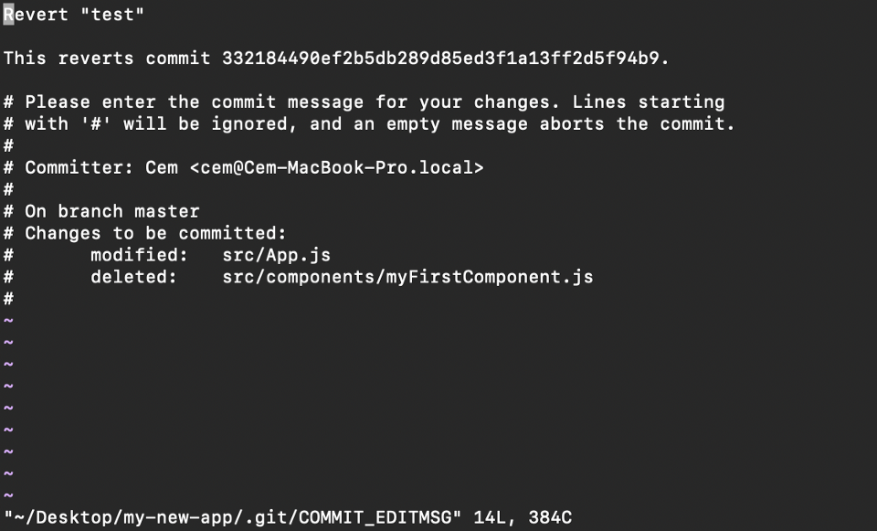

The Git revert command will undo the given commit, but will create a new commit without deleting the older one:

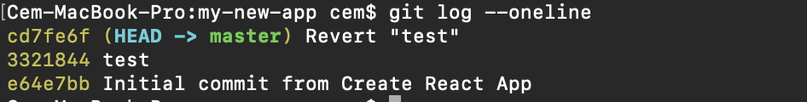**new "revert" commit**

The advantage of using **git revert** is that it doesn't touch the commit history. This means that you can still see all of the commits in your history, even the reverted ones.

Another safety measure here is that everything happens in our local system unless we push them to the remote repo. That's why git revert is safer to use and is the preferred way