| Severity | Priority |
| --- | --- |
| Severity is a parameter to denote the impact of a particular defect on the software. | Priority is a parameter to decide the order in which defects should be fixed. |
| Severity means how severe defect is affecting the functionality. | Priority means how fast defect has to be fixed. |
| Severity is related to the quality standard. | Priority is related to scheduling to resolve the problem. |
| Testing engineer decides the severity level of the defect. | Product manager decides the priorities of defects. |
| Its value is objective. | Its value is subjective. |
| Its value doesn’t change from time to time. | Its value changes from time to time. |
| Severity is of 5 types: Critical, Major, Moderate, Minor, and Cosmetic. | Priority is of 3 types: Low, Medium, and High. |

Life Cycle Defect:

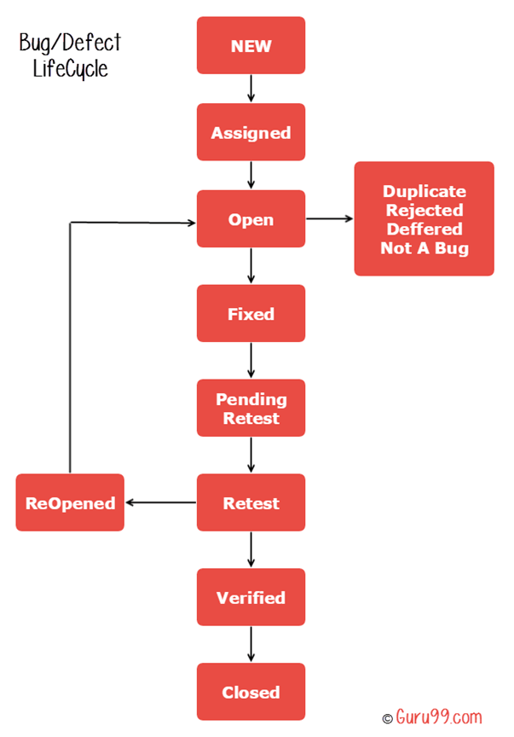

**Regression:**

Regression Testing is nothing but a full or partial selection of already executed test cases which are re-executed to ensure existing functionalities work fine

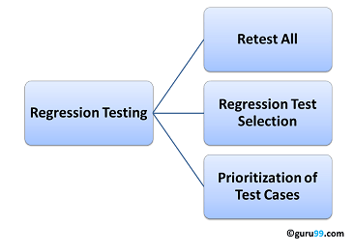

**Smoke Testing**

Smoke Testing is a software testing process that determines whether the deployed software build is stable or not. Smoke testing is a confirmation for QA team to proceed with further software testing. It consists of a minimal set of tests run on each build to test software functionalities. Smoke testing is also known as "Build Verification Testing" or “Confidence Testing.”

**Sanity Testing:**

* Sanity testing helps in quickly identify defects in the core functionality.
* It can be carried out in lesser time as no documentation is required for sanity testing.
* If the defects are found during sanity testing, project is rejected that is helpful in saving time for execution of regression tests.

|  |  |
| --- | --- |
| **Smoke Testing** | **Sanity Testing** |
| Smoke Testing is performed to ascertain that the critical functionalities of the program is working fine | Sanity Testing is done to check the new functionality/bugs have been fixed |
| The objective of this testing is to verify the "stability" of the system in order to proceed with more rigorous testing | The objective of the testing is to verify the "rationality" of the system in order to proceed with more rigorous testing |
| This testing is performed by the developers or testers | Sanity testing in software testing is usually performed by testers |
| Smoke testing is usually documented or scripted | Sanity testing is usually not documented and is unscripted |
| Smoke testing is a subset of Acceptance testing | Sanity testing is a subset of [Regression Testing](https://www.guru99.com/regression-testing.html) |
| Smoke testing exercises the entire system from end to end | Sanity testing exercises only the particular component of the entire system |
| Smoke testing is like General Health Check Up | Sanity Testing is like specialized health check up |