Reverse KT:

* JBehave: JBehave is support for Java
* Its support with BDD framework and Test Acceptance will be writing as stories and we can cover as scenarios with story
* We can install the jbehave plugins to write story files from eclipse/project/repository
* JBehave Template:

Always **story** starts with **Narrative keyword, we can write story line or module description**

**Then It will be** Scenario **keyword, here we will write test case with description what are we going to perform the actions using below keywords**

1. **Given** 🡪 Some precondition step
2. **When** 🡪 Some key actions
3. **Then** 🡪 To observe outcomes or validation
4. **And** 🡪 Repeat same steps above any then we are going to use
5. **Scenario**: Business rule through list of steps with arguments.

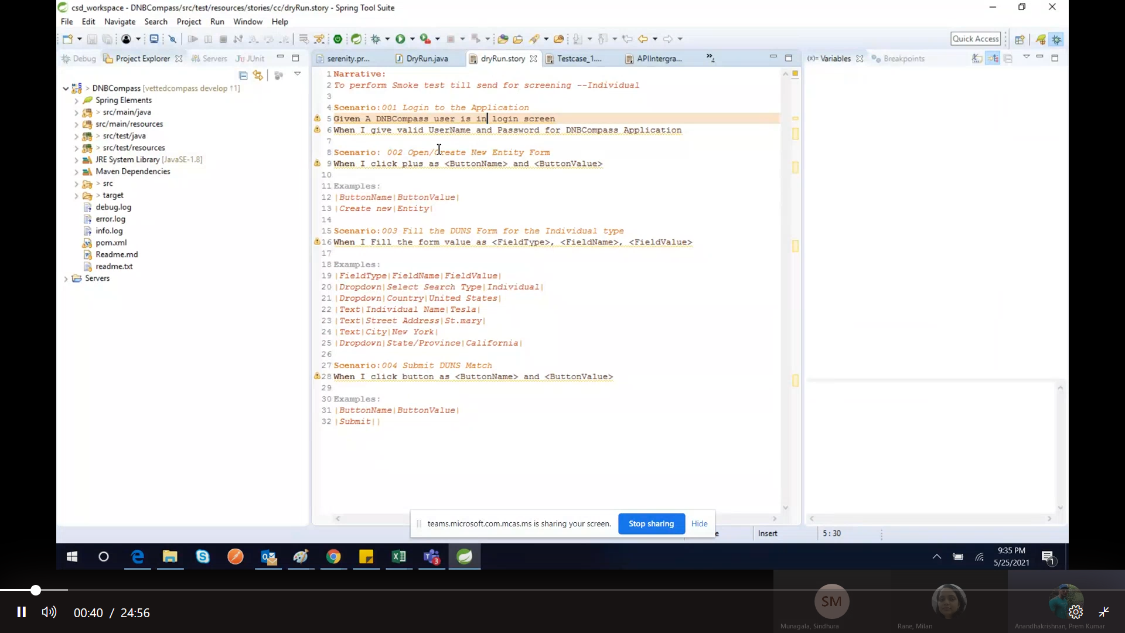

From Story file to redirect to Test class below:

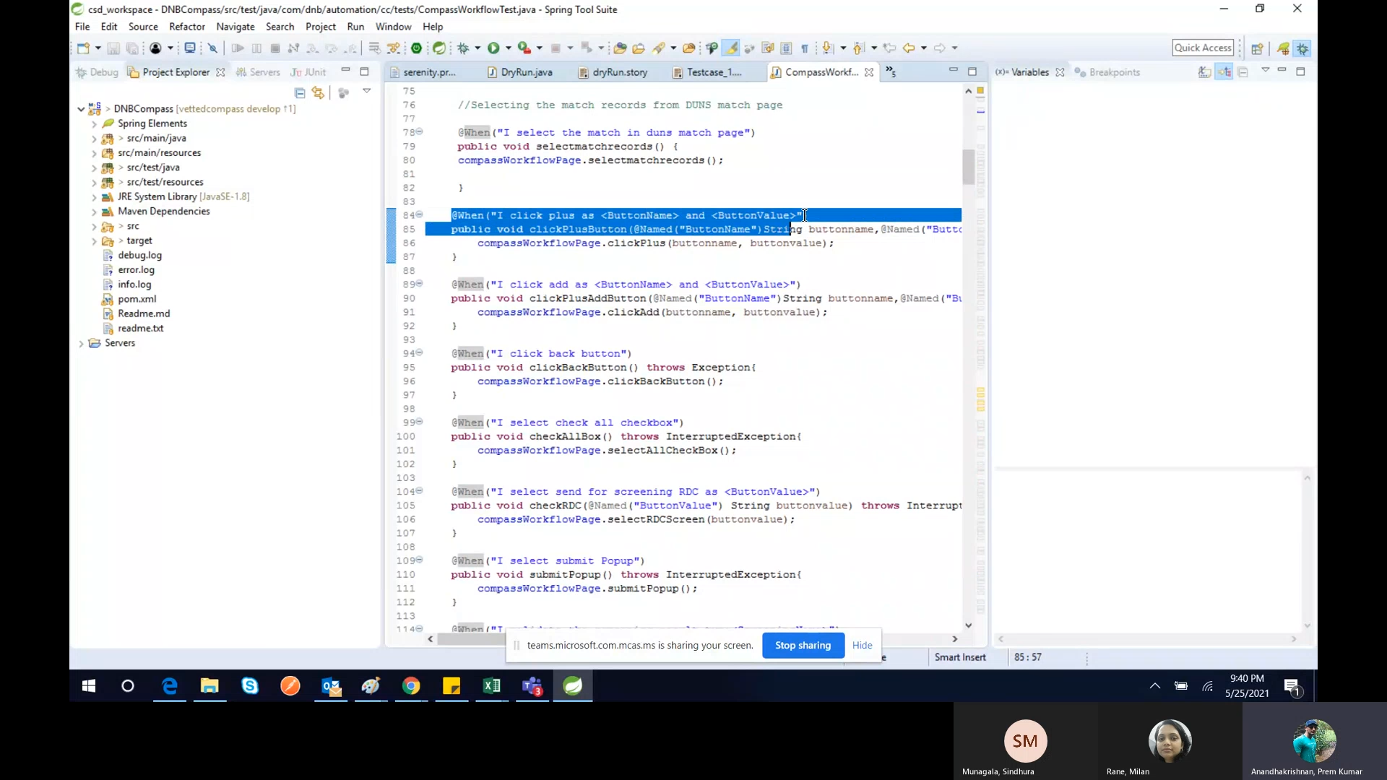

Importing Packages :

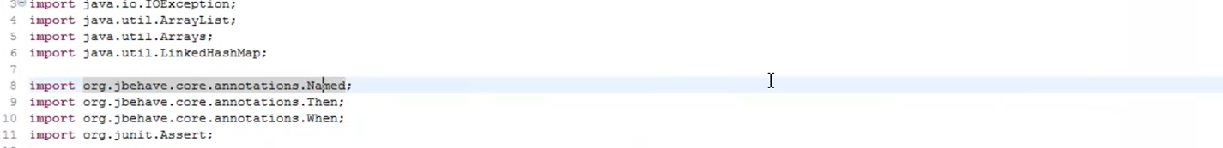

@Name Annotation :



@Name will be used for act as parameter and it converted to Variable

Example, <ButtonName> as parameter and @Name(“ButtonName”) then it will be converted to String buttonName variable

<ButtonName>,<ButtonValue> parameters are coming from .story file and it will pass the data from .story file

**Flow of Code :** Runner class file 🡨🡪Step class file 🡨🡪 Test class file 🡨🡪 PageObject class 🡨🡪 properties(Object repository all the xpaths) 🡨🡪 Then common utility class

Page Class file : Performing the actions(like buttons ,button text.data manipulations )

DNBCompassXpath.properties: all the xpath we have.

DNBcompassXpathLoader.java : it will be load the properties file then xpath methods from xpath properties file

Then we will perform the actions like button click or other actions

**DNBCompassUtilFile.java** : It has common util methods we have and we can use of it wherever required. Like JavaScriptExecutors,dropdown,webdriverwait,pageload common actions

Runner File : DryRun extends SerenityStory -🡪 This is runner file and it will be used serenity framework . Below is the command for run the application using Junit

/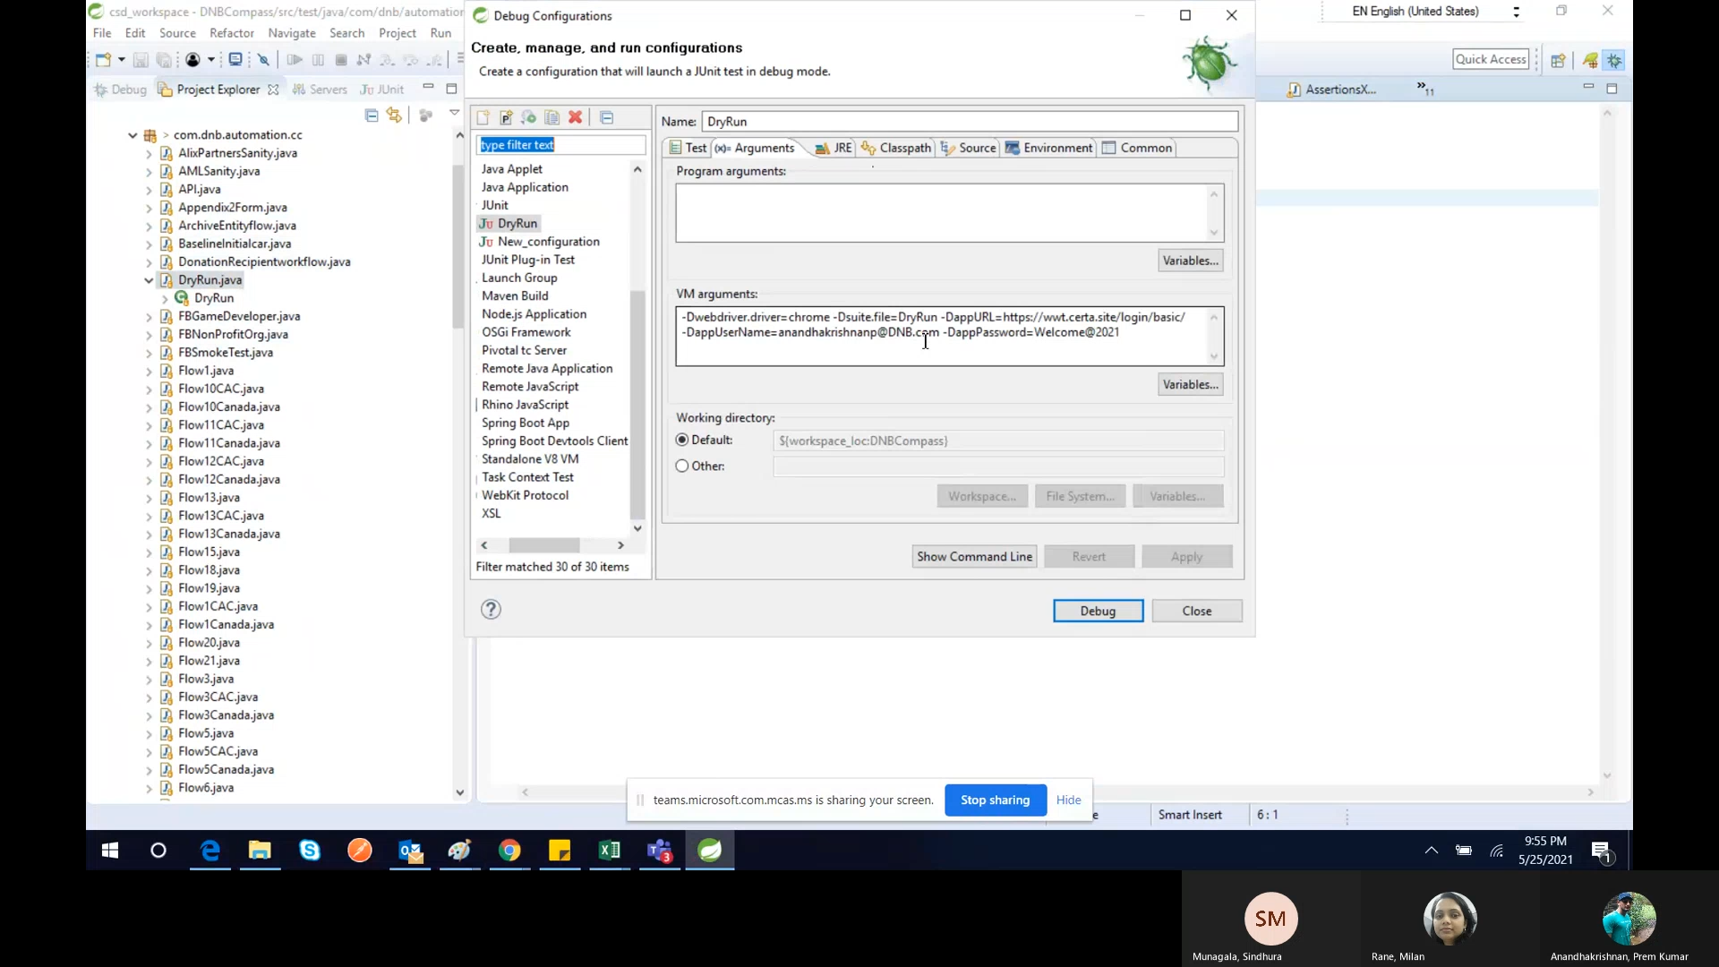

Note : story filename and Java file name should be same

-Dsuite.file=DryRun 🡪 it will start execute then it will call serenity frameworks calls then it will check the .story file name is available or not if yes then it will return it else it will be exceptions

This is our simple Behavioural Data Driven framework using JBehave framework.

Questions : Are we using only chrome browser support or multi browser support?

Question2 : where we are configuring browser software?