**Question 1: SQL Query to find the second highest salary of Employee**

Answer: There are many ways to find the second highest salary of an Employee in SQL, you can either use SQL Join or Subquery to solve this problem. Here is an SQL query using Subquery:

SELECT MAX(Salary)

FROM Employee

WHERE Salary NOT IN (select MAX(Salary) from Employee );

**Question 2: SQL Query to find Max Salary from each department.**

Answer: You can find the maximum salary for each department by grouping all records by DeptId and then using MAX() function to calculate the maximum salary in each group or each department.

Here is the query

SELECT DeptName, MAX(Salary)

FROM Employee e RIGHT JOIN Department d

ON e.DeptId = d.DeptID

GROUP BY DeptName;

**Question 6: Write an SQL Query to find the number of employees according to gender whose DOB is between 01/01/1960 to 31/12/1975.**

Answer : 

SELECT COUNT(*), sex

FROM Employees

WHERE DOB BETWEEN '01/01/1960' AND '31/12/1975'

GROUP BY sex;

**Question 7: Write an SQL Query to find an employee whose salary is equal to or greater than 10000**.

Answer : 

SELECT EmpName FROM Employees WHERE Salary>=10000;

**Question 8: Write an SQL Query to find the name of an employee whose name Start with ‘M’**

Answer : 

SELECT * FROM Employees WHERE EmpName like 'M%';

**Question 13: How do you find all employees who are also managers?**  
You have given a standard employee table with an additional column mgr_id, which contains the employee id of the manager.

[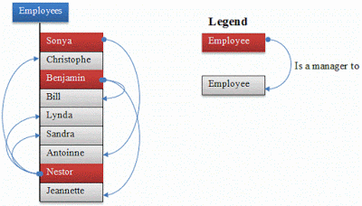](https://1.bp.blogspot.com/-A8OVkcRMrsM/VXrj9FBPKvI/AAAAAAAADA0/XZvHQHDVaNQ/s1600/Employee%2BManager%2Bquery.gif)

Answer: You need to know about self-join to solve this problem. In [Self Join](https://javarevisited.blogspot.com/2020/05/self-join-example-sql-query-to-find-employee-more-than-managers-leetcode-solution.html), you can join two instances of the same table to find out additional details as shown below

SELECT e.name, m.name

FROM Employee e, Employee m

WHERE e.mgr_id = m.emp_id;

**Question 12: There is a table which contains two columns Student and Marks, you need to find all the students, whose marks are greater than average marks i.e. list of above-average students.**  
Answer: This query can be written using subquery as shown below:

SELECT student, marks

FROM table

WHERE marks > SELECT AVG(marks) from table)

**Question 11: Write SQL Query to find duplicate rows in a database? and then write SQL query to delete them?**  
Answer: You can use the following query to select distinct records:

SELECT * FROM emp a

WHERE rowid = (SELECT MAX(rowid)

FROM EMP b

WHERE a.empno=b.empno)

to Delete:

DELETE FROM emp a

WHERE rowid != (SELECT MAX(rowid) FROM emp b WHERE a.empno=b.empno);

**Question 9: find all Employee records containing the word "Joe", regardless of whether it was stored as JOE, Joe, or joe.**

Answer :

SELECT * from Employees WHERE UPPER(EmpName) like '%JOE%';