**What is Spring boot?**

Sprint boot is a Java-based spring framework used for Rapid Application Development (to build stand-alone microservices). It has extra support of auto-configuration and embedded application server like tomcat, jetty, etc.

**Features of Spring Boot that make it different?**

* Creates stand-alone spring application with minimal configuration needed.
* It has embedded tomcat, jetty which makes it just code and run the application.
* Provide production-ready features such as metrics, health checks, and externalized configuration.
* Absolutely no requirement for XML configuration.

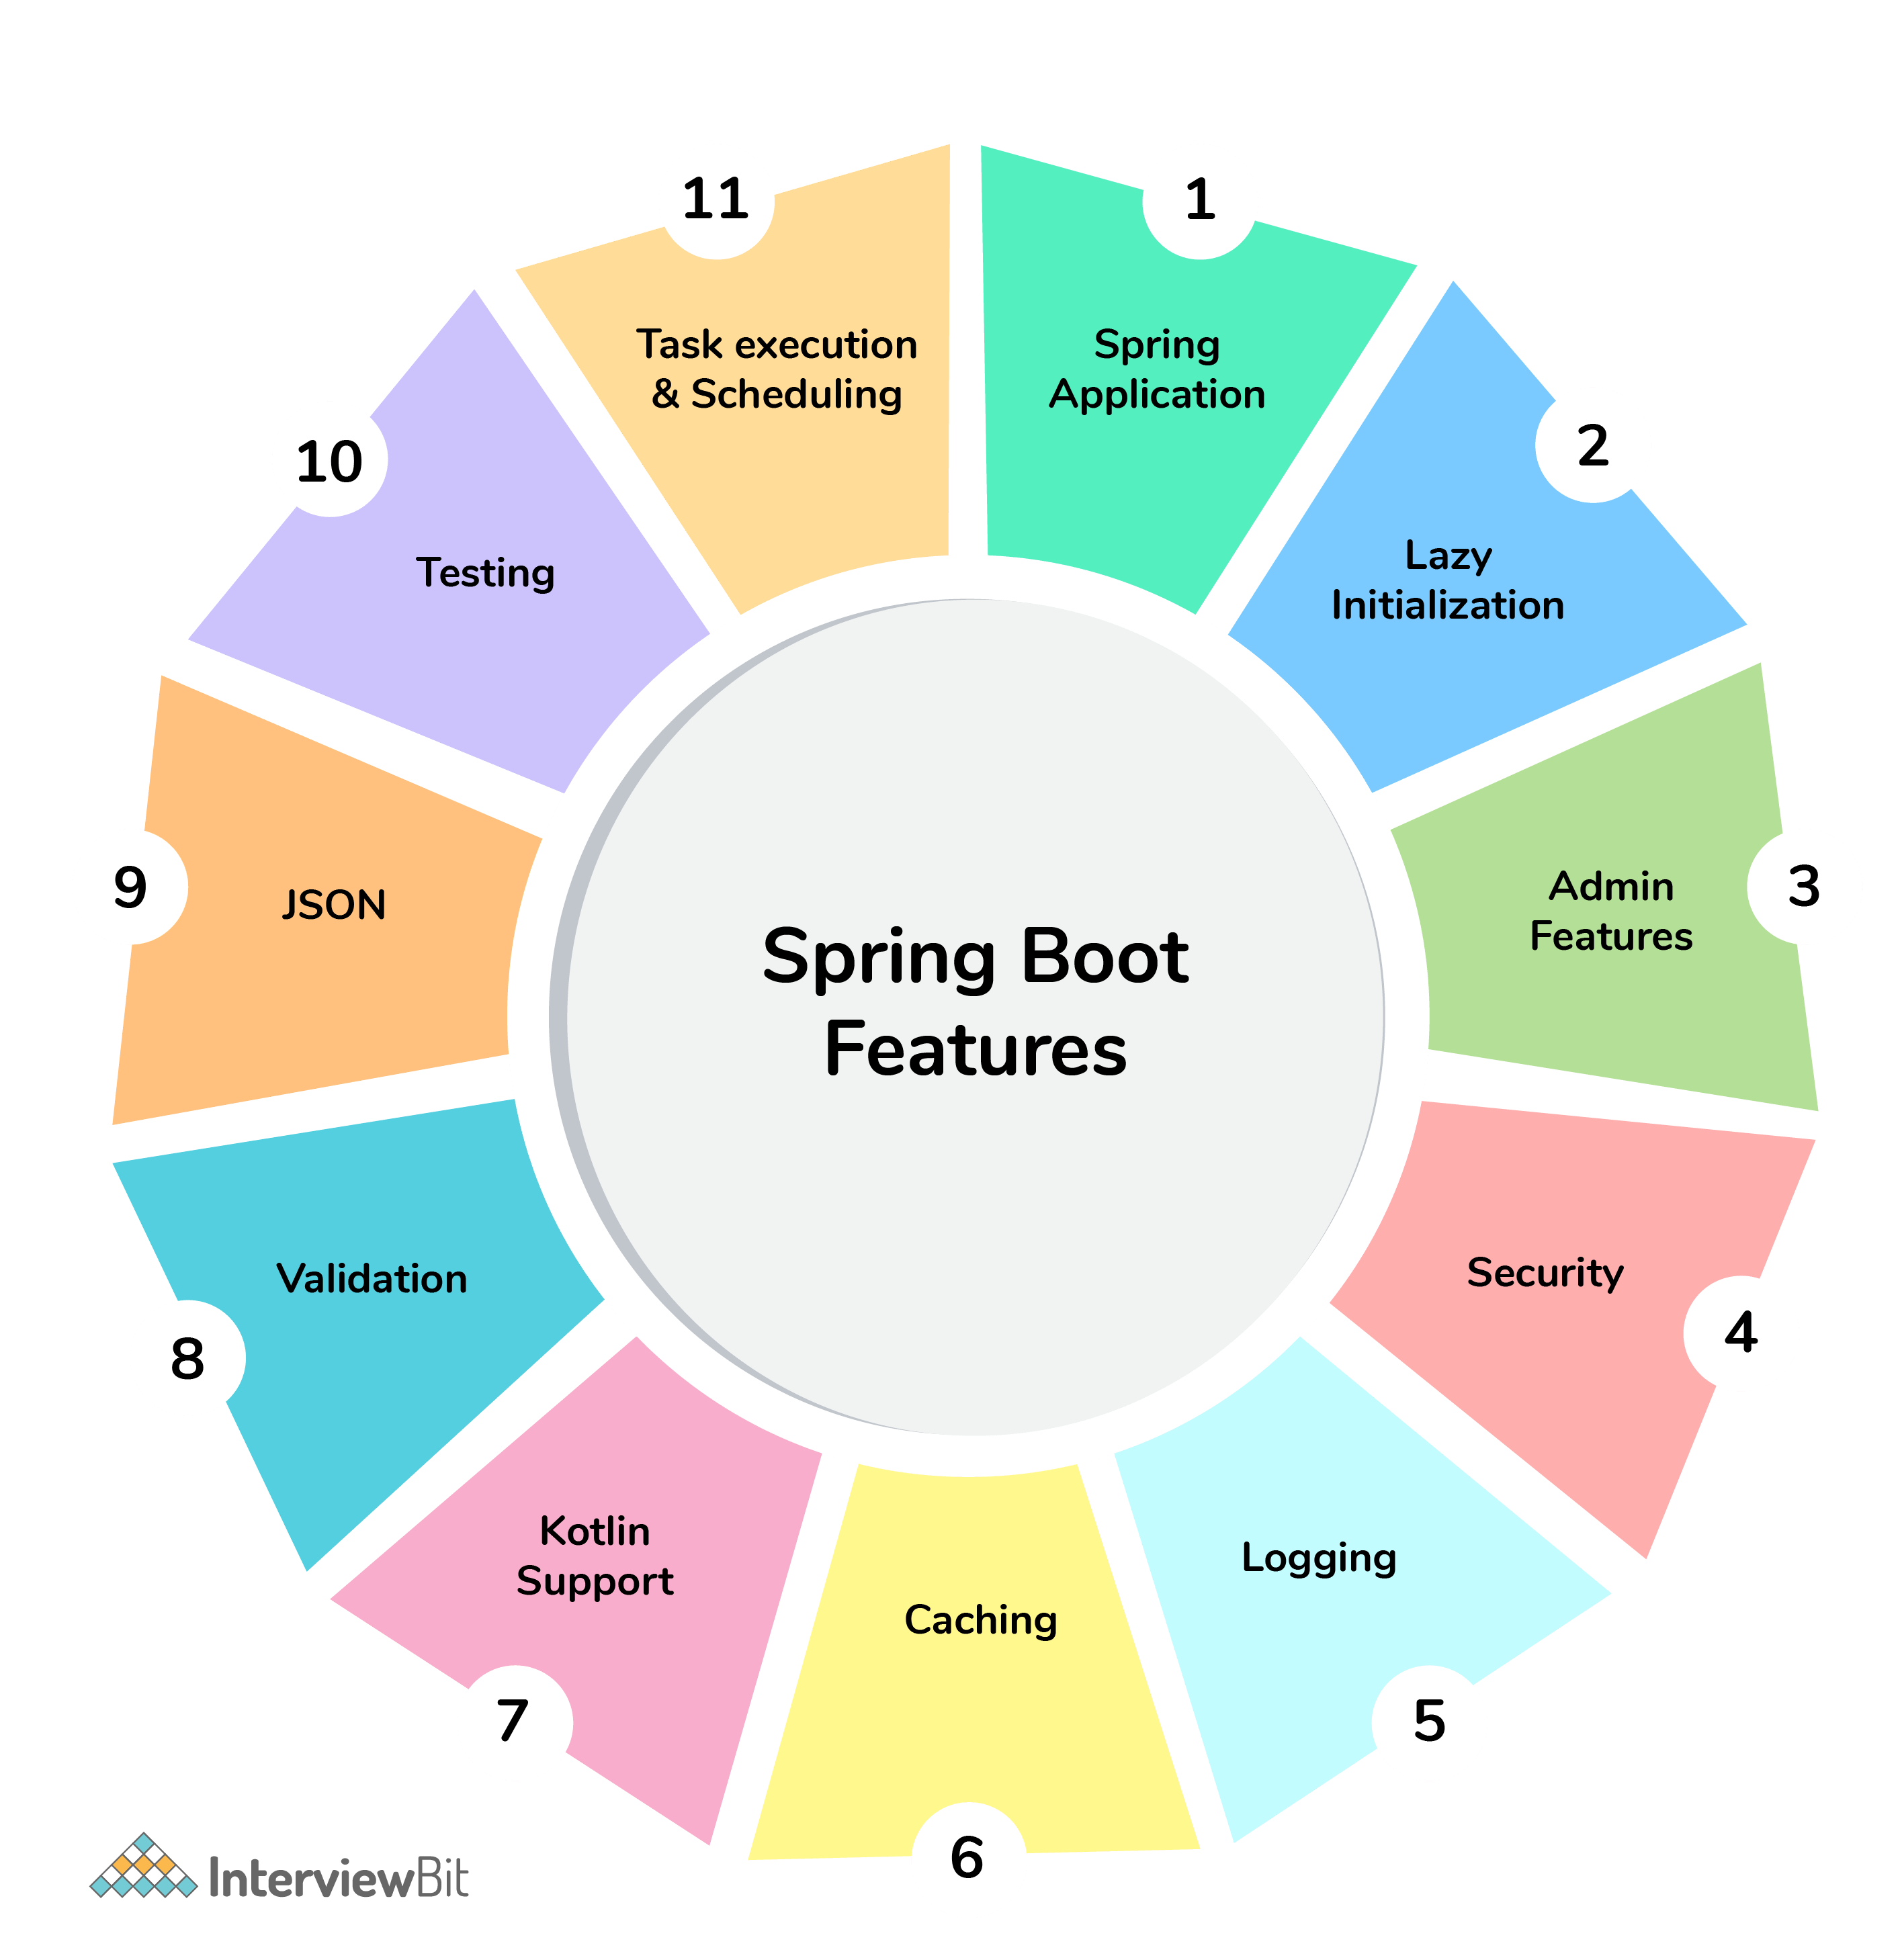

### **1. What are the advantages of using Spring Boot?**

The advantages of Spring Boot are listed below:

* Easy to understand and develop spring applications.
* Spring Boot is nothing but an existing framework with the addition of an embedded HTTP server and annotation configuration which makes it easier to understand and faster the process of development.
* Increases productivity and reduces development time.
* Minimum configuration.
* We don’t need to write any XML configuration, only a few annotations are required to do the configuration.

### **2. What are the Spring Boot key components?**

Below are the four key components of spring-boot:

* Spring Boot auto-configuration.
* Spring Boot CLI.
* Spring Boot starter POMs.
* Spring Boot Actuators.

### **3. Why Spring Boot over Spring?**

Below are some key points which spring boot offers but spring doesn’t:

* Starter POM.
* Version Management.
* Auto Configuration.
* Component Scanning.
* Embedded server.
* InMemory DB.
* Actuators

Spring Boot simplifies the spring feature for the user:

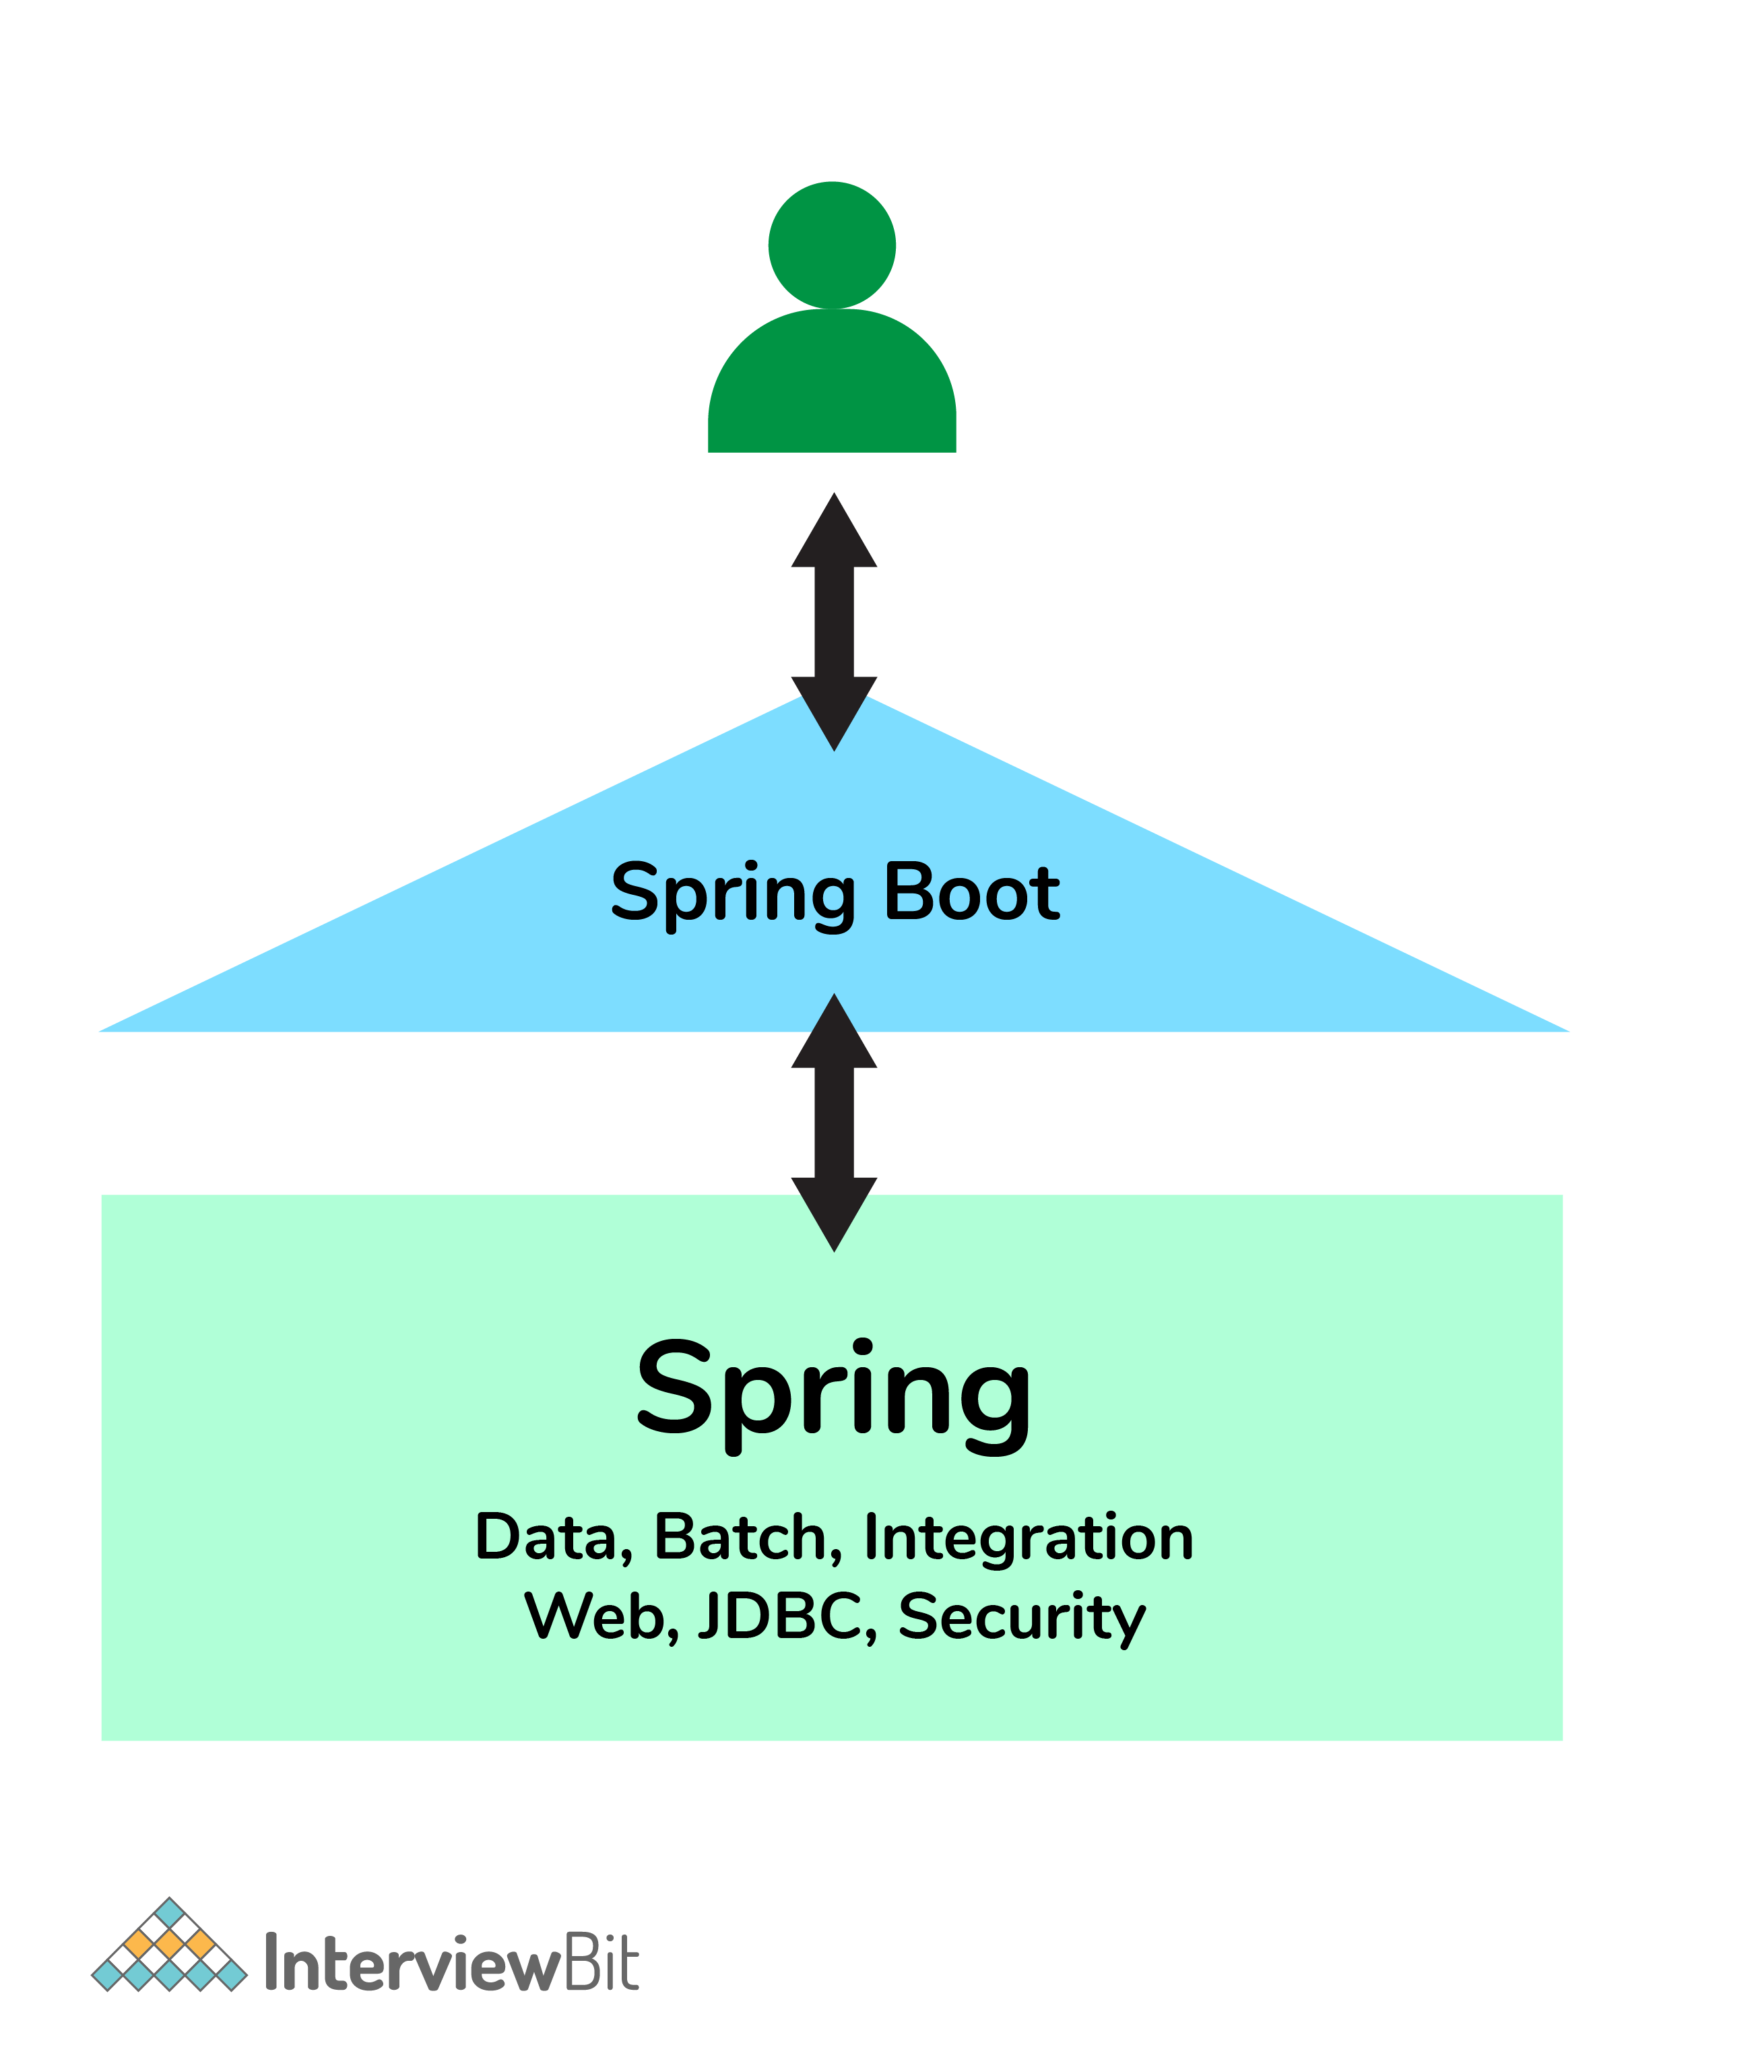

Spring vs Spring Boot

**4. What is the starter dependency of the Spring boot module?**

Spring boot provides numbers of starter dependency, here are the most commonly used -

* Data JPA starter.
* Test Starter.
* Security starter.
* Web starter.
* Mail starter.
* Thymeleaf starter

### **6. What does the @SpringBootApplication annotation do internally?**

The @SpringBootApplication annotation is equivalent to using @Configuration, @EnableAutoConfiguration, and @ComponentScan with their default attributes. Spring Boot enables the developer to use a single annotation instead of using multiple. But, as we know, Spring provided loosely coupled features that we can use for each annotation as per our project needs.

### **7. What is the purpose of using @ComponentScan in the class files?**

Spring Boot application scans all the beans and package declarations when the application initializes. You need to add the @ComponentScan annotation for your class file to scan your components added to your project.

### **8. How does a spring boot application get started?**

Just like any other Java program, a Spring Boot application must have a main method. This method serves as an entry point, which invokes the SpringApplication#run method to bootstrap the application.

@SpringBootApplication

**public** **class** **MyApplication** {

**public** **static** **void** **main**(String[] args) {

SpringApplication.run(MyApplication.class);

// other statements

}

}

### **9. What are starter dependencies?**

Spring boot starter is a maven template that contains a collection of all the relevant transitive dependencies that are needed to start a particular functionality.  
Like we need to import spring-boot-starter-web dependency for creating a web application.

<dependency>

<groupId> org.springframework.boot</groupId>

<artifactId> spring-boot-starter-web </artifactId>

</dependency>

### **18. Can we override or replace the Embedded tomcat server in Spring Boot?**

Yes, we can replace the Embedded Tomcat server with any server by using the Starter dependency in the **pom.xml** file. Like you can use spring-boot-starter-jetty as a dependency for using a jetty server in your project.

### **19. Can we disable the default web server in the Spring boot application?**

Yes, we can use **application.properties** to configure the web application type i.e **spring.main.web-application-type=none.**

<properties>

<servlet-api.version>3.1.0</servlet-api.version>

</properties>

<dependency>

<groupId>org.springframework.boot</groupId>

<artifactId>spring-boot-starter-web</artifactId>

<exclusions>

*<!-- Exclude the Tomcat dependency -->*

<exclusion>

<groupId>org.springframework.boot</groupId>

<artifactId>spring-boot-starter-tomcat</artifactId>

</exclusion>

</exclusions>

</dependency>

*<!-- Use Jetty instead -->*

<dependency>

<groupId>org.springframework.boot</groupId>

<artifactId>spring-boot-starter-jetty</artifactId>

</dependency>

### **20. How to disable a specific auto-configuration class?**

You can use exclude attribute of @EnableAutoConfiguration if you want auto-configuration not to apply to any specific class.

//use of exclude

@EnableAutoConfiguration(exclude={className})

### 23. Describe the flow of HTTPS requests through the Spring Boot application?

On a high-level spring boot application follow the MVC pattern which is depicted in the below flow diagram.

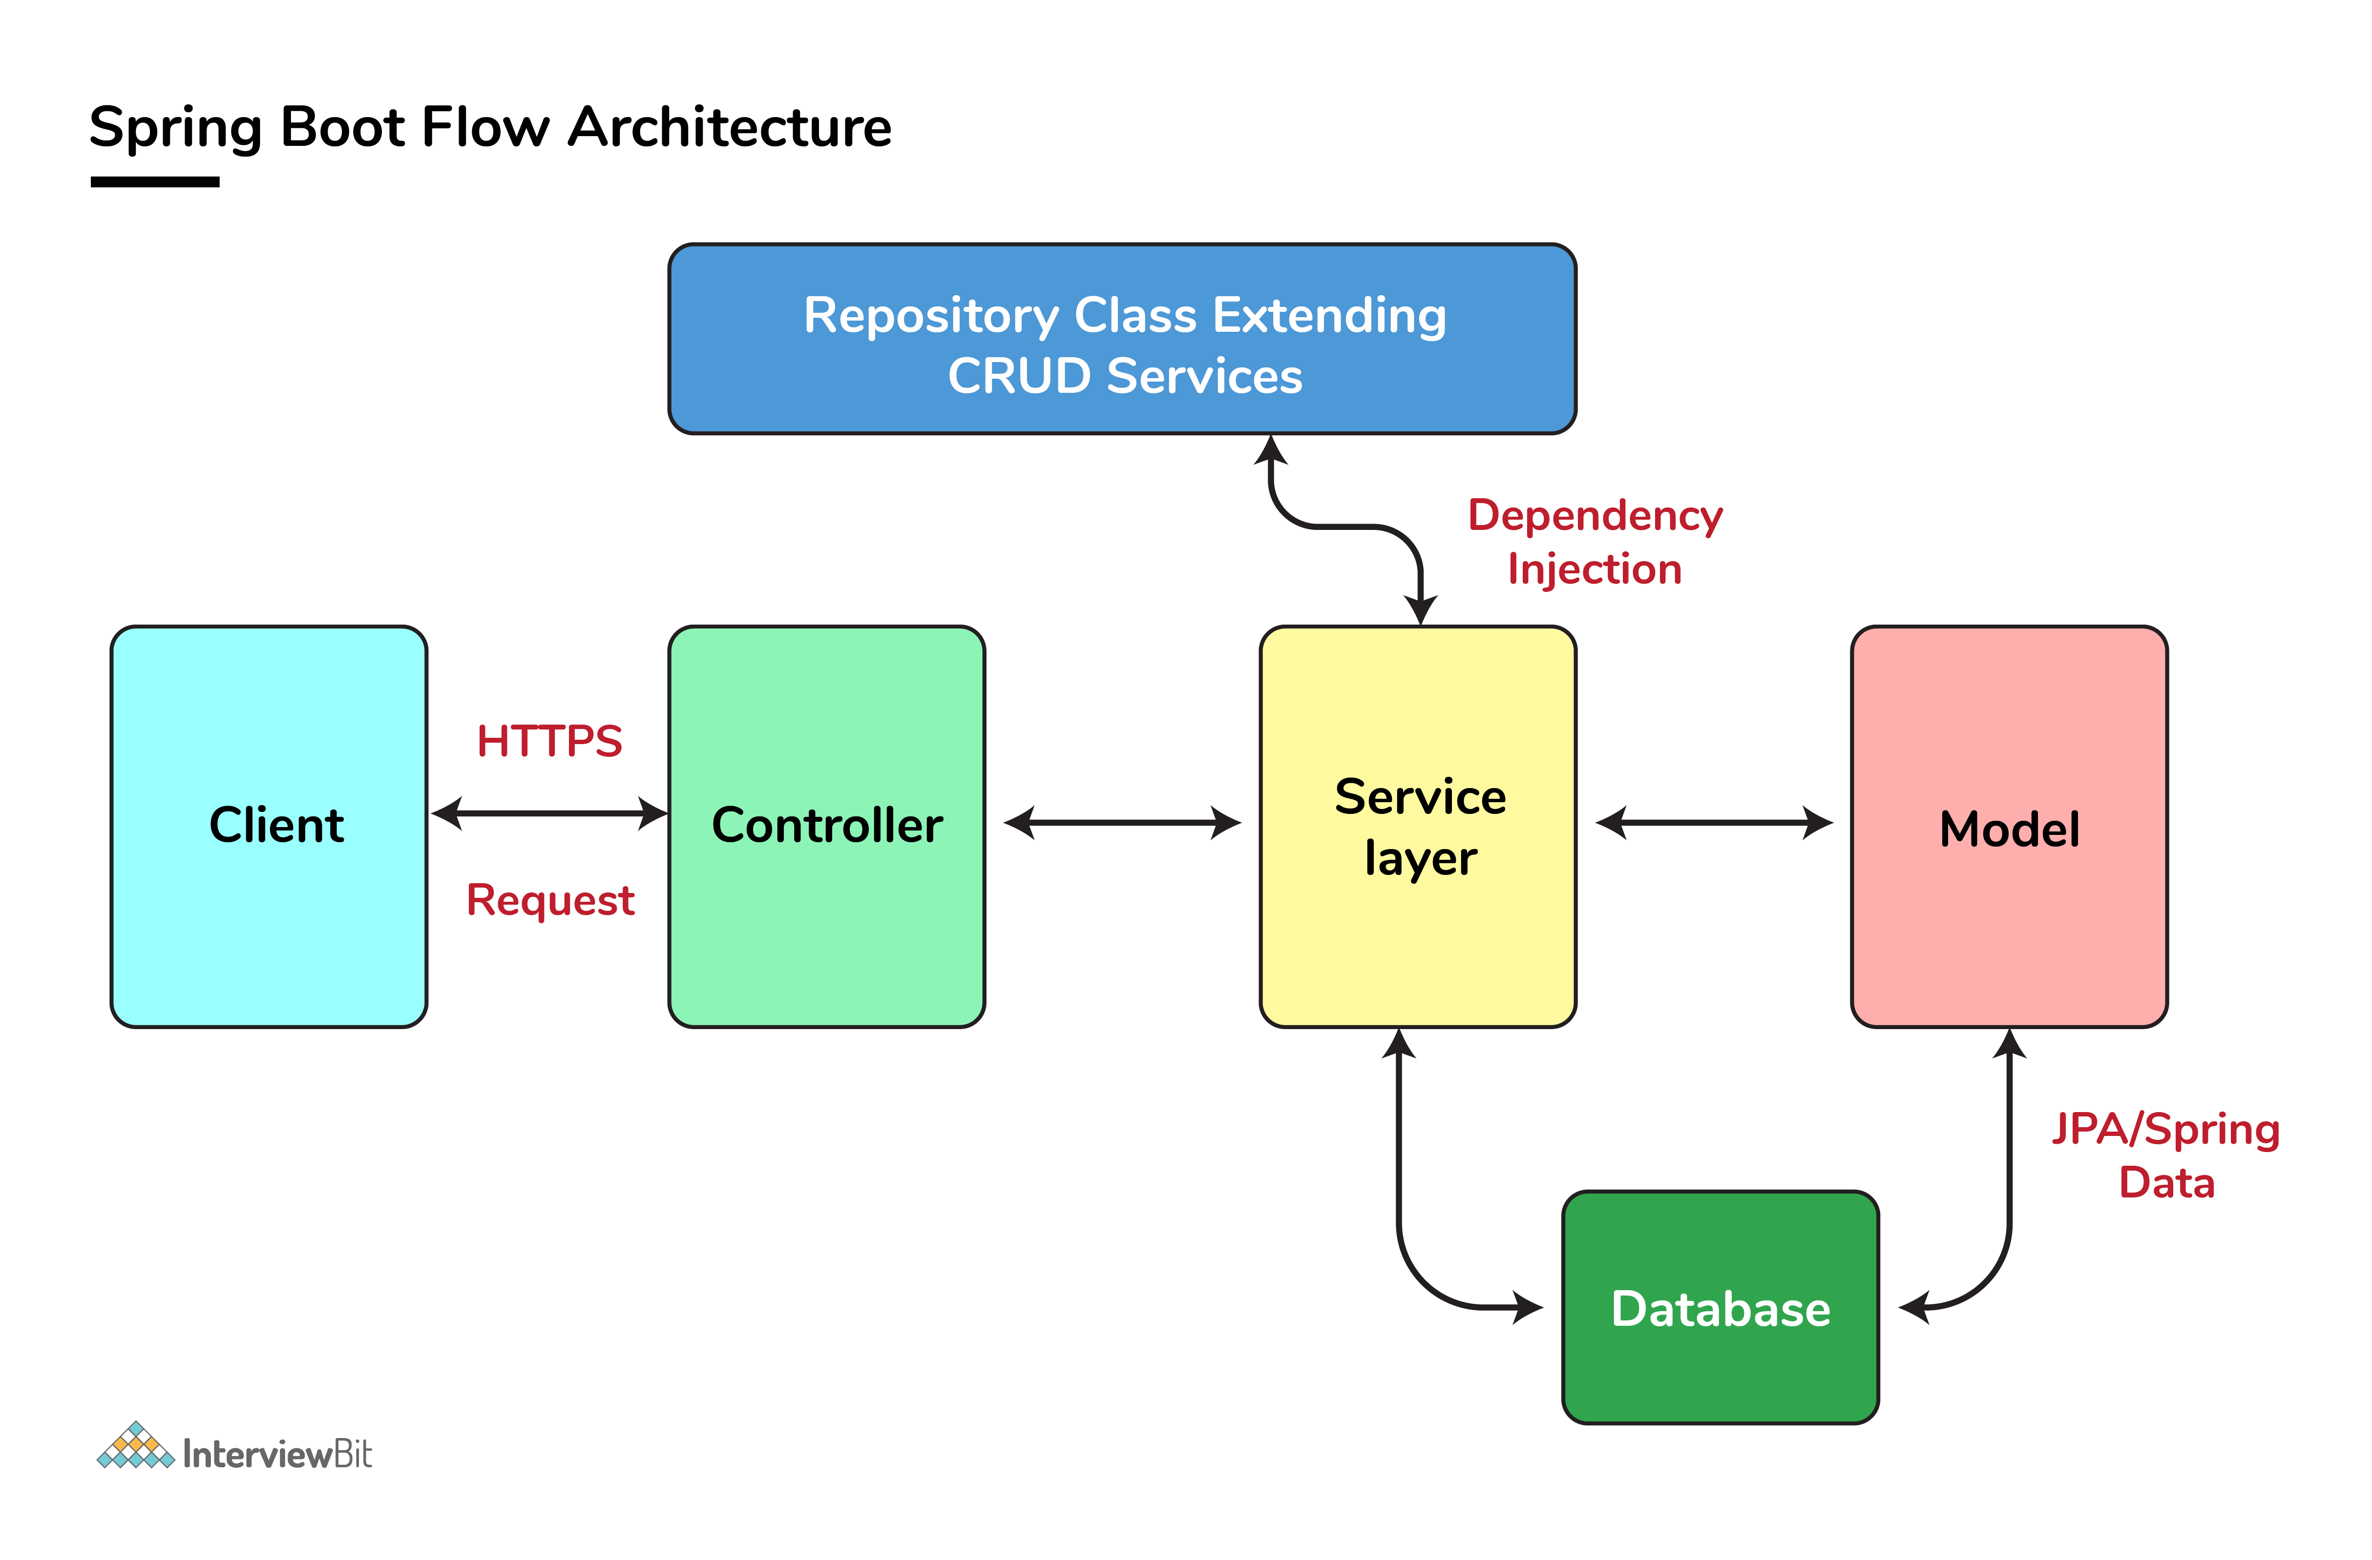

### **24. What is the difference between RequestMapping and GetMapping?**

RequestMapping can be used with GET, POST, PUT, and many other request methods using the method attribute on the annotation. Whereas getMapping is only an extension of RequestMapping which helps you to improve on clarity on request.

### 25. **What is the use of Profiles in spring boot?**

While developing the application we deal with multiple environments such as dev, QA, Prod, and each environment requires a different configuration. For eg., we might be using an embedded H2 database for dev but for prod, we might have proprietary Oracle or DB2. Even if DBMS is the same across the environment, the URLs will be different.

To make this easy and clean, Spring has the provision of Profiles to keep the separate configuration of environments.

### **26. What is Spring Actuator? What are its advantages?**

An actuator is an additional feature of Spring that helps you to monitor and manage your application when you push it to production. These actuators include auditing, health, CPU usage, HTTP hits, and metric gathering, and many more that are automatically applied to your application.

### 27. **How to enable Actuator in Spring boot application?**

To enable the spring actuator feature, we need to add the dependency of “spring-boot-starter-actuator” in pom.xml.

<dependency>

<groupId> org.springframework.boot</groupId>

<artifactId> spring-boot-starter-actuator </artifactId>

</dependency>

### **28. What are the actuator-provided endpoints used for monitoring the Spring boot application?**

Actuators provide below pre-defined endpoints to monitor our application -

* Health
* Info
* Beans
* Mappings
* Configprops
* Httptrace
* Heapdump
* Threaddump
* Shutdown

### **33. What is dependency Injection?**

The process of injecting dependent bean objects into target bean objects is called dependency injection.

* **Setter Injection:** The IOC container will inject the dependent bean object into the target bean object by calling the setter method.
* **Constructor Injection:** The IOC container will inject the dependent bean object into the target bean object by calling the target bean constructor.
* **Field Injection:** The IOC container will inject the dependent bean object into the target bean object by Reflection API.

### **34. What is an IOC container?**

IoC Container is a framework for implementing automatic dependency injection. It manages object creation and its life-time and also injects dependencies into the class.

**Autowiring** feature of **spring** framework enables you to inject the object dependency implicitly. It internally uses setter or constructor injection. **Autowiring** can't be used to inject primitive and string values. It works with reference only.