**Local Set up:**

Publisher Name : Eclipse OEPE,Weblogic 11g,Oracle Service Bus(OSB)

Product Name : Eclipse OEPE,Weblogic 11g,Oracle Service Bus(OSB)

Software Edition : Eclipse OEPE,Weblogic 11g,Oracle Service Bus(OSB)

Version : Eclipse OEPE,Weblogic 11g,Oracle Service Bus(OSB)

Business Justification : Eclipse OEPE,Weblogic 11g,Oracle Service Bus(OSB),

Show to L1Support guy this link : <https://www.oracle.com/tools/downloads/oepe-v1117-downloads.html>

ofm_osb_generic_11.1.1.7.0_disk1_1of1 🡪D:\L1\ofm_osb_generic_11.1.1.7.0_disk1_1of1\Disk1

Please get the folder access to required Oracle inside in program files

**Project Creation:**

1. We have to create project always inside OSBConfig🡪then your project(if new service)
2. Else we can manipulate the services from existing based on your requirement
3. Please follow the last step for check in process in OSB.

Project Structure/Service Structure:

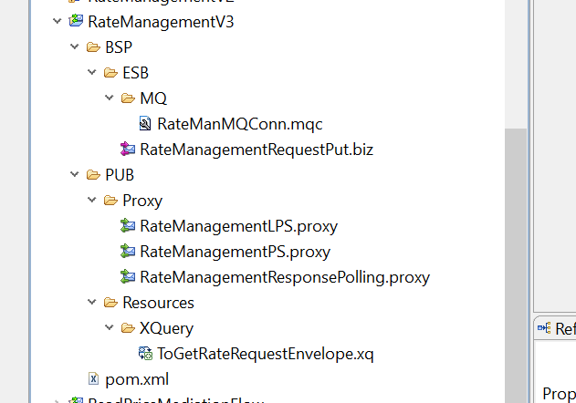

Related wsdl/xsd under below folder:

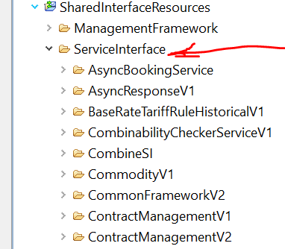

Every Service has wsdl/xsd path inside ServiceInterface folder

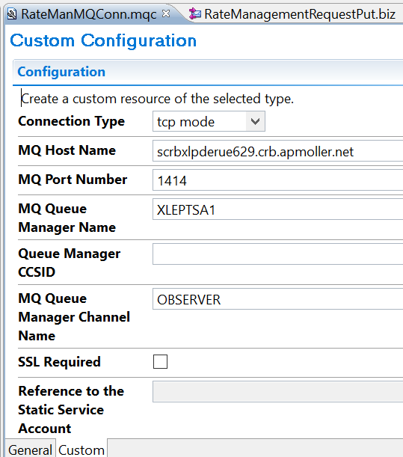

**Incase Service is running on through MQ**

1. we have to create MQ connection
2. We have to send email to IBM team to creation req/res mq details
3. Then We can consume in our services
4. We can test whether mq is reaching to ESB services
5. Below is the MQ request configuration to connect MQ service

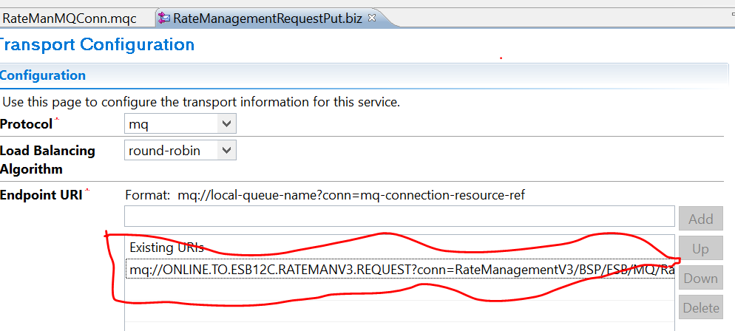

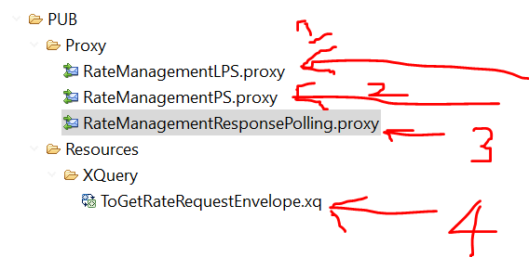

1. LPS will be having always business logic flow (connecting to DB,MQ etc)
2. PS proxy will be publishing the webservice from LPS
3. Reading the response from MQ and storing in Database
4. XQuery is having field mapping (It may one to one / one to many(list))

**FLOW**

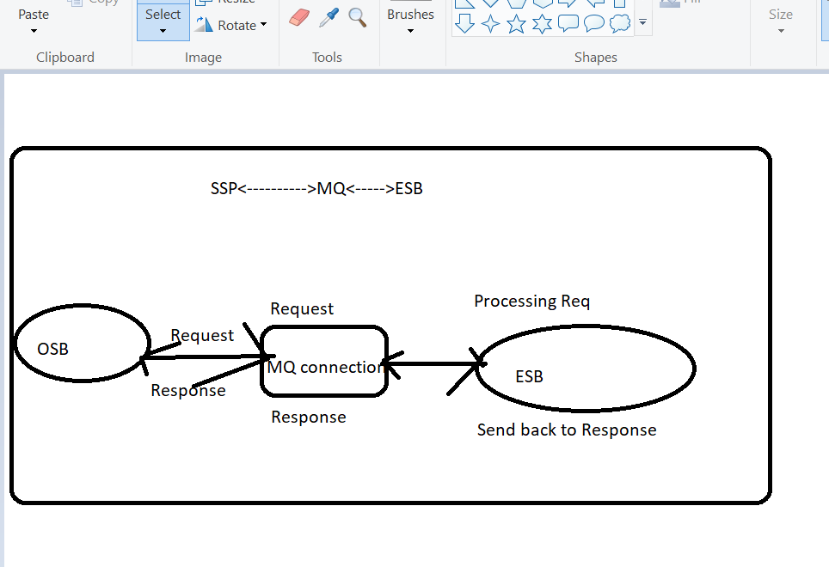

**XQuery Creation:**

**Field Mapping:**

**MFL Transformation:**

**THANK YOU TEAM**