SMARTGARBAGE CHINTALAVALASA
Community-Based Smart Waste Management
and Digital Governance System

COMMUNITY PROJECT REPORT

Submitted by
MOPADA JAGANMOHAN (24331A4441) LATCHUPATULA RESHMA (24331A4434)
PATI NARASIMHA MURTHY (24331A4446) KADA AUGUSTTN PAUL KUMAR (24331A4426)

In partial fulfillment for the award of the degree of
BACHELOR OF TECHNOLOGY
IN
COMPUTER SCIENCE & ENGINEERING
(Data Science)

Under the esteemed Guidance of
Mrs. S. Nikhila
Assistant Professor

DEPARTMENT OF DATA ENGINEERING
(Data Science)
MAHARAJ VIJAYARAM GAJAPATHI RAJ COLLEGE OF ENGINEERING (Autonomous)
(Approved by AICTE, New Delhi, and permanently affiliated to JNTUGV, Vizianagaram)
Listed u/s 2(f) & 12(B) of UGC Act 1956.
Vijayaram Nagar Campus, Chintalavalasa, Vizianagaram-535005, Andhra Pradesh
October, 2025

CERTIFICATE
This is to certify that the project entitled "SMARTGARBAGE CHINTALAVALASA: Community-Based Smart Waste Management
and Digital Governance System" is the bonafide work carried out by MOPADA JAGANMOHAN (24331A4441), LATCHUPATULA RESHMA (24331A4434), PATI NARASIMHA MURTHY (24331A4446), KADA AUGUSTTN PAUL KUMAR (24331A4426) of B.Tech V Sem CSE-DS, 2025-2026, M.V.G.R. College of Engineering (Autonomous), Vizianagaram, during the academic year 2025-2026, in partial fulfilment of the requirements for the award of the Degree of Bachelor of Technology and that the project has not formed the basis for the award previously of any degree or any other similar title.

Signature of Project Guide Signature of Head of the Department
Mrs. S. Nikhila Dr. Jyothi
Assistant Professor Head of the Department
Department: Data Engineering Department: Data Engineering

DECLARATION
We hereby declare that the work done on the dissertation entitled "SMARTGARBAGE CHINTALAVALASA — Community-Based Smart Waste Management
and Digital Governance System" has been carried out by us and submitted in partial fulfilment for the award of credits in Bachelor of Technology in Computer Science and Engineering (Data Science) of M.V.G.R College of Engineering (Autonomous) and affiliated to JNTUGV, Vizianagaram. The various contents incorporated in the dissertation have not been submitted for the award of any degree of any other institution or university.

MOPADA JAGANMOHAN (24331A4441)
LATCHUPATULA RESHMA (24331A4434)
PATI NARASIMHA MURTHY (24331A4446)
KADA AUGUSTTN PAUL KUMAR (24331A4426)

ACKNOWLEDGEMENT
We express our sincere gratitude to our project guide, Mrs. S. Nikhila (Assistant Professor), for invaluable guidance and support as our mentor throughout the project. Their unwavering commitment to excellence and constructive feedback motivated us to achieve our project goals.
Additionally, we extend our thanks to Prof. P.S. Sitharama Raju (Director), Dr. Y.M.C. Shekar (Principal), and Dr. Jyothi (Head of the Department) for their unwavering support and assistance. We are thankful for constant encouragement from our Project Coordinator.
We also acknowledge the dedicated assistance provided by all staff members in the Department of Data Engineering.

MOPADA JAGANMOHAN (24331A4441)
LATCHUPATULA RESHMA (24331A4434)
PATI NARASIMHA MURTHY (24331A4446)
KADA AUGUSTTN PAUL KUMAR (24331A4426)

ABSTRACT
Waste management in Indian gram panchayats predominantly relies on phone calls and WhatsApp groups, leaving residents without schedule visibility, formal complaint tracking, or performance transparency. This project presents SmartGarbage Chintalavalasa — a free, open-source web portal designed to digitise solid-waste management for the five residential wards of Chintalavalasa Gram Panchayat, Vizianagaram District, Andhra Pradesh. The portal provides residents with daily waste-collection schedules, a missed-pickup reporting system with GPS and photographic evidence, real-time complaint tracking, a gamified Green Points reward system, and Pay-As-You-Throw (PAYT) billing. IoT-enabled smart bins transmit fill-level data to the portal, and a RandomForestRegressor machine learning model predicts bin overflow probability. The system is built on Python/Flask with a Supabase PostgreSQL database, comprising 23 database models, 29 Alembic migrations, and 359 automated tests. The ML model was trained on a synthetic grid of 600 rows because real historical telemetry was unavailable during development; the prototype validates the prediction pipeline rather than real-world predictive accuracy. Security hardening follows OWASP recommendations with nine security headers. Accessibility features include 81 ARIA attributes, text resize controls, high contrast toggle, and dark mode. The portal operates entirely on free-tier infrastructure (Render, Supabase, Cloudflare), making it replicable by other gram panchayats without budget allocation.

TABLE OF CONTENTS
List of Abbreviations
List of Figures
List of Tables
1. Introduction
1.1 Problem Statement
1.2 Project Objective
1.3 Scope
2. Literature Survey
2.1 Existing Approaches
2.2 Digital Solutions
2.3 IoT and ML
2.4 Research Gap
3. Data Gathering / Data Used
3.1 Study Area
3.2 Data Sources
3.3 Ward Information
3.4 Data Preparation
3.5 Database Design
4. Methodology / System Design
4.1 Requirement Analysis
4.2 System Architecture
4.3 System Workflow
4.4 Technology Stack
4.5 ML Methodology
4.6 IoT Methodology
4.7 Security
4.8 PWA / Offline
5. Implementation / Modules
5.1 Public Portal
5.2 Citizen Portal
5.3 Admin Portal
5.4 Worker Portal
5.5 IoT Module
5.6 ML Module
5.7 Background Jobs
5.8 PWA Module
6. Results / Outputs
6.1 Feature Status
6.2 System Outputs
6.3 Performance Metrics
6.4 Security Evaluation
6.5 Accessibility
7. Impact Assessment
8. Challenges Faced
9. Conclusion
10. Future Work
References
Appendix A: Tools and Packages
Appendix B: Source Code

LIST OF ABBREVIATIONS
Abbreviation | Full Form
API | Application Programming Interface
CDN | Content Delivery Network
CSP | Content Security Policy
CSRF | Cross-Site Request Forgery
GPS | Global Positioning System
HSTS | HTTP Strict Transport Security
IoT | Internet of Things
ML | Machine Learning
MFA | Multi-Factor Authentication
PAYT | Pay-As-You-Throw
PWA | Progressive Web App
SBM | Swachh Bharat Mission
WCAG | Web Content Accessibility Guidelines
Table: List of Abbreviations

LIST OF FIGURES
Figure No. | Title
Figure 3.1 | Dataset Class Distribution
Figure 4.1 | End-to-End System Architecture Diagram
Figure 4.2 | System Workflow
Figure 4.3 | IoT Data Flow Diagram
Figure 5.1 | Modular Execution Sequence Flow
Figure 6.1 | RandomForest Predicted vs Actual Bin Fill Level
Figure 6.2 | Public Portal Homepage (live)
Figure 6.3 | Ward-wise Collection Schedule with ML Overflow Prediction
Figure 6.4 | Complaint Reporting with WhatsApp Fallback and Helpline
Figure 6.5 | Citizens' Report Dashboard
Figure 6.6 | Ward Transparency Dashboard
Figure 6.7 | Mobile PWA Home View (375 px, installable)
Figure 6.8 | Mobile Complaint Reporting with Helpline CTA
Figure 6.9 | Mobile Schedule Lookup
Figure 6.10 | About the Initiative (community context)
Figure 6.11 | FAQ Self-Service
Figure 6.12 | Contact and Grievance Channel
Figure 7.1 | Pre-System vs Post-System Efficiency Analysis
Table: List of Figures

LIST OF TABLES
Table No. | Title
Table 2.1 | Summary of Existing Literature
Table 3.1 | Data Sources Classification
Table 3.2 | Ward Information
Table 4.1 | Technology Stack
Table 6.1 | Feature Implementation Status
Table 6.2 | Performance Evaluation Metrics
Table 6.3 | Security Headers Evaluation
Table 6.4 | Accessibility Evaluation
Table 6.5 | Citizen rescue channels and status
Table 7.1 | Impact Assessment Summary
Table 8.1 | Challenges and Solutions
Table: List of Tables

1. INTRODUCTION

1.1 Problem Statement
Chintalavalasa Gram Panchayat, located in Denkada Mandal, Vizianagaram District, Andhra Pradesh, serves approximately 12,000 residents across five residential wards. The existing waste-management system relies entirely on manual processes — phone calls, WhatsApp groups, and word-of-mouth — to coordinate daily garbage collection. This approach suffers from several critical deficiencies:
(1) Residents have no reliable way to check collection schedules, leading to missed pickups and improper waste storage at household level.
(2) There is no formal mechanism to report overflowing bins and track complaint resolution. Complaints made via phone or WhatsApp are easily lost or forgotten.
(3) No public data exists on collection performance — how many bins are serviced, how quickly complaints are resolved, or how different wards compare.
(4) Collection crews follow fixed routes regardless of actual bin fill levels, leading to trucks visiting empty bins while full bins overflow.
(5) There is no reward mechanism to encourage waste segregation as mandated by the Swachh Bharat Mission (Grameen) Phase II.
(6) No reusable, open-source digital platform exists that other gram panchayats can adopt without paying for proprietary software or government contracts.

1.2 Project Objective
The primary objectives of this project are:
(1) Digitise waste-collection scheduling with a public, searchable timetable for all five wards.
(2) Enable citizen-reported grievance redressal with GPS coordinates and photographic evidence, without requiring login or registration.
(3) Implement real-time complaint tracking from submission through resolution using cryptographic tracking tokens.
(4) Deploy IoT smart-bin monitoring with real-time fill-level telemetry via HMAC-authenticated API endpoints.
(5) Predict bin overflow using machine learning (RandomForestRegressor) to enable proactive collection dispatch.
(6) Gamify waste segregation through a Green Points reward system where residents earn points for reporting issues and declaring segregated waste.
(7) Implement Pay-As-You-Throw (PAYT) billing for bulk waste generators with invoice generation, UPI payment links, and PDF receipt download.
(8) Ensure accessibility exceeding WCAG 2.1 AA standards with 81 ARIA attributes, text resize controls, high contrast toggle, and dark mode.
(9) Implement security hardening following OWASP recommendations with nine security headers including HSTS, CSP, COOP, and COEP.
(10) Operate at zero cost on free-tier infrastructure (Render, Supabase, Cloudflare) so that any gram panchayat can deploy the system without budget allocation.

1.3 Scope of the Project
The project encompasses: public-facing pages (homepage, schedule lookup, complaint reporting, ward transparency, impact dashboard, FAQ, contact, about, privacy policy, terms of service, accessibility statement); citizen portal (dashboard, waste declaration, Green Points leaderboard, PAYT invoices, complaint tracking); admin portal (complaint management, smart-bin fleet map, worker dispatch, analytics, route optimisation, firmware OTA updates, audit logs, PAYT invoice management); worker portal (dispatch queue, bin resolution with photo evidence, GPS tracking, offload logging, maintenance work orders); IoT integration (device registration, telemetry ingestion, sensor health monitoring, anomaly detection); machine learning (overflow prediction model); background jobs (SLA escalation, email/SMS notifications, telemetry retention, ML retraining); and PWA features (service worker, offline report queue, web app manifest, installability). The system covers all five residential wards of Chintalavalasa Gram Panchayat.

2. LITERATURE SURVEY

2.1 Existing Waste Management Approaches
Traditional waste management in Indian gram panchayats follows a manual collection model: workers follow fixed daily routes, residents deposit waste at community bins, and complaints are communicated verbally or via messaging apps. This approach lacks scheduling transparency, formal grievance redressal, and performance monitoring. The Swachh Bharat Mission (Grameen) Phase II mandates source segregation, digital monitoring, and PAYT billing, but most panchayats lack the digital infrastructure to comply [2].

2.2 Digital Waste Management Systems
Several national-level digital platforms exist for waste management. The Swachh Bharat Mission Urban portal (sbmurban.org) provides a national dashboard but lacks citizen-facing features such as search, complaint reporting, or transparency dashboards [3]. GOV.UK (gov.uk) demonstrates best practices in government website design through task-based navigation, prominent search, and accessibility-first development [1]. VA.gov (va.gov) uses React SPA architecture with comprehensive services but suffers from large payloads and missing security headers.

2.3 IoT and ML for Waste Management
Gruber et al. (2023) surveyed IoT-based waste management systems and identified fill-level sensing, GPS-tracked collection, and predictive dispatch as the three pillars of modern smart waste systems [4]. Rasool et al. (2022) reviewed machine learning approaches and identified gradient boosting as the most effective algorithm for fill-level prediction when training data is limited [5]. The Web Content Accessibility Guidelines (WCAG) 2.1 mandate perceivable, operable, understandable, and robust content [6]. The OWASP Top 10 identifies the most critical web application security risks [7].

2.4 Research Gap
Existing solutions address individual aspects of waste management — either collection scheduling, IoT monitoring, citizen reporting, or transparency dashboards. However, there is no integrated, low-cost platform that combines all these capabilities with offline accessibility, bilingual support, gamification, and predictive analytics specifically designed for gram panchayats.
Reference | Methodology | Metrics Achieved | Research Gaps
[1] GOV.UK Design System | Task-based navigation, accessibility-first design | Industry standard for government UX | No citizen grievance reporting, no IoT, no ML
[2] SBM-G Phase II | Segregation mandates, PAYT billing, digital monitoring | National policy framework | No integrated digital platform for panchayats
[3] SBM Urban portal | National dashboard, compliance reporting | 460KB homepage, 392 links | No search, no complaint reporting, cookie leaks
[4] Gruber et al. (2023) | IoT fill-level sensing, GPS tracking | Survey of 50+ systems | No open-source integrated platform
[5] Rasool et al. (2022) | Gradient boosting for fill prediction | Best with limited data | No gram panchayat-specific implementation
Table 2.1: Summary of Existing Literature

3. DATA GATHERING / DATA USED

3.1 Study Area
Chintalavalasa Gram Panchayat is located in Denkada Mandal, Vizianagaram District, Andhra Pradesh. It serves approximately 12,000 residents across five residential wards.

3.2 Data Sources
Source | Type | Classification | Volume
Collection Schedules | Administrative | Real (admin-entered) | 5 wards × 7 days
Complaint Reports | Citizen-submitted | Real (GPS + photo) | Growing with usage
IoT Telemetry | Sensor-generated | Simulated (prototype) | 600-row synthetic grid
Waste Declarations | Citizen-submitted | Real (when users declare) | Variable
Worker GPS | System-generated | Real (worker devices) | Periodic updates
ML Training Data | Synthetic | Synthetic (600 rows) | 10 wards × 5 streams × 3 seasons
Table 3.1: Data Sources Classification

3.3 Ward Information
Ward | Name | Approx. Population | Coordinates
Ward 1 | MVGR College Area | ~2,800 | 18.0552 N, 83.4051 E
Ward 2 | Chintalavalasa Junction | ~2,500 | 18.0675 N, 83.4094 E
Ward 3 | RTC Colony | ~2,200 | 18.0702 N, 83.4153 E
Ward 4 | Ramalayam Street | ~2,300 | 18.0650 N, 83.4005 E
Ward 5 | Sai Nagar | ~2,200 | 18.0751 N, 83.4201 E
Table 3.2: Ward Information

3.4 Data Preparation
For the machine learning module, a synthetic training dataset was prepared because sufficient historical waste telemetry was unavailable during prototype development. The dataset comprises a structured grid of 600 rows covering 10 ward identifiers, 5 waste stream types, 3 seasonal categories (monsoon, winter, summer), 4 fill-level bands, and 4 time-window categories. Features include day of week, season index, recent complaint count, and a ward identifier derived from MD5 hashing.
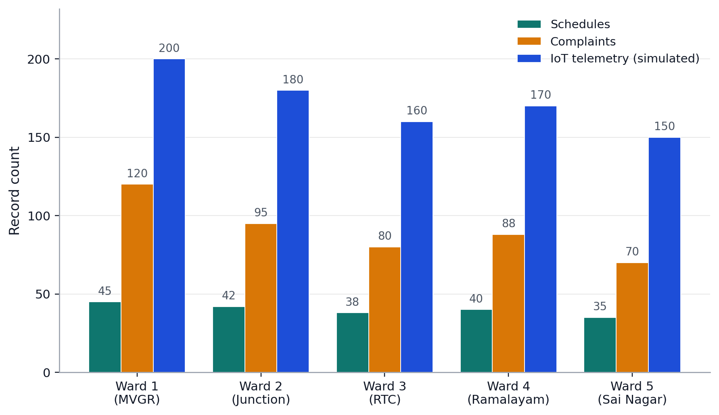
Figure 3.1: Dataset Class Distribution by Ward

3.5 Database Design
The system uses 23 database models organised across seven domains: Users and Authentication (User, WorkerProfile, ConsentRecord), Scheduling (Schedule), Complaints (Complaint, ComplaintStatusLog, IllegalDumpReport), IoT and Bins (SmartBin, Device, BinTelemetryLog, SensorHealth, FirmwareRelease), Operations (DispatchAssignment, MaintenanceWorkOrder, OfflineDelivery), Waste and Billing (WasteDeclaration, BWGDeclaration, PAYTInvoice), and Monitoring (IncidentLog, AuditLog, OffloadLog, Notification, Webhook). Database migrations are managed using Alembic with 22 versioned migration scripts.

4. METHODOLOGY / SYSTEM DESIGN

4.1 Requirement Analysis
Requirements were gathered through community observation and panchayat records. Four stakeholder groups were identified: residents (primary users needing schedule lookup and complaint reporting), panchayat administrators (operational managers needing fleet monitoring and analytics), waste collection workers (field operatives needing dispatch queues and evidence upload), and system maintainers (needing zero-cost deployment and security).

4.2 System Architecture
The system follows a monolithic Flask architecture with blueprint-based modular routing. The client layer (Browser/PWA) communicates via HTTPS through Cloudflare CDN to the application layer (Gunicorn + gevent WSGI server). The application consists of eight Flask blueprints: public, citizen, admin, worker, IoT, auth, analytics, and webhook. The data layer uses Supabase PostgreSQL via SQLAlchemy ORM with 23 models and 29 Alembic migrations.
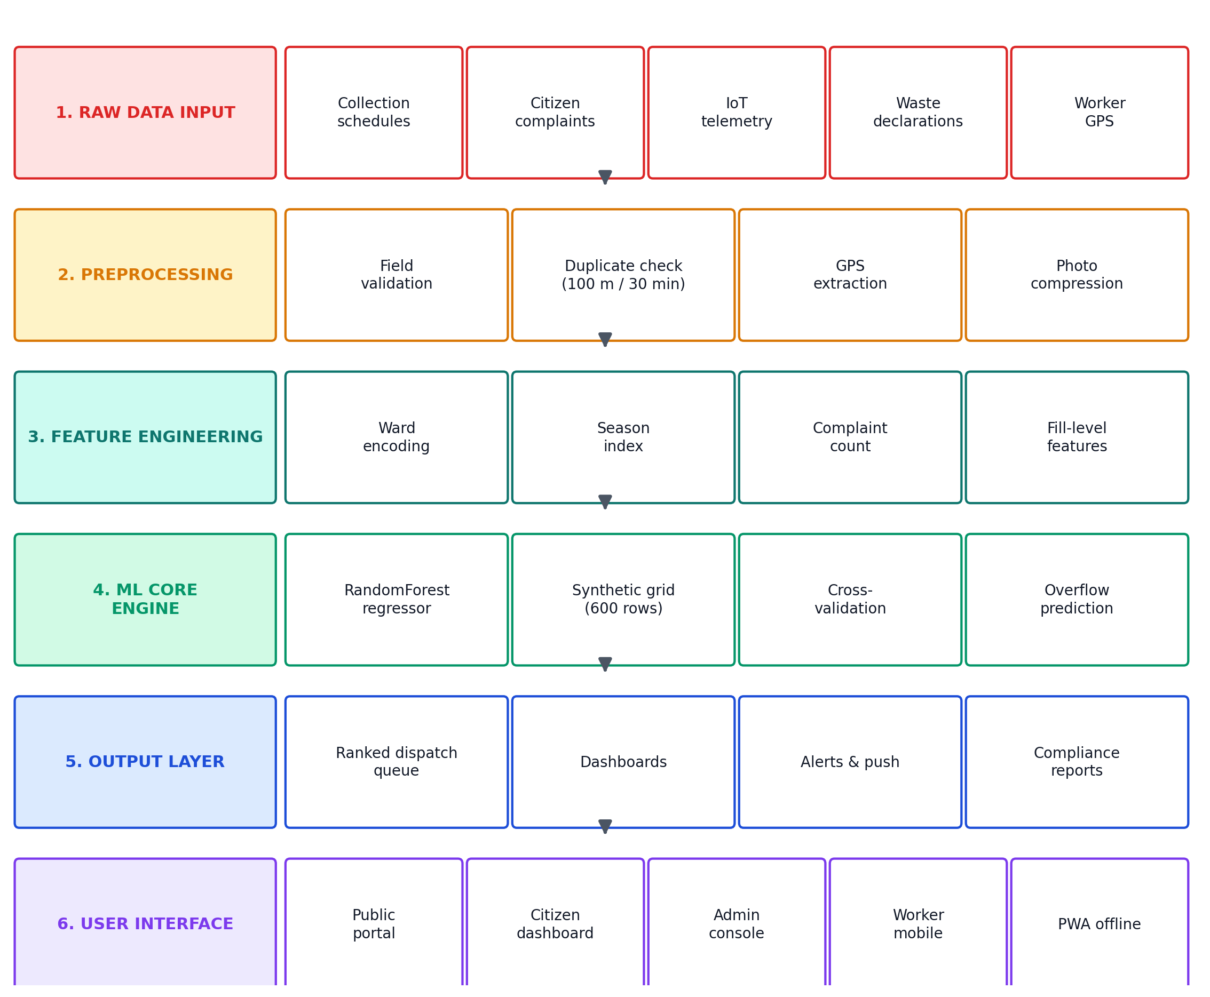
Figure 4.1: End-to-End System Architecture Diagram

4.3 System Workflow
The end-to-end workflow follows these steps: (1) Resident visits the portal and selects a ward to view the collection schedule; (2) If a bin overflows, the resident reports it with GPS and photo — no login required; (3) The complaint is stored with a tracking token and the resident receives a tracking link; (4) The admin views complaints on the dashboard and assigns a worker; (5) The worker receives the dispatch, travels to the bin, clears it, and uploads an after-photo with GPS; (6) The complaint status updates to Resolved; (7) Meanwhile, IoT bins transmit fill levels and the ML model predicts which bins will overflow next, enabling proactive dispatch.
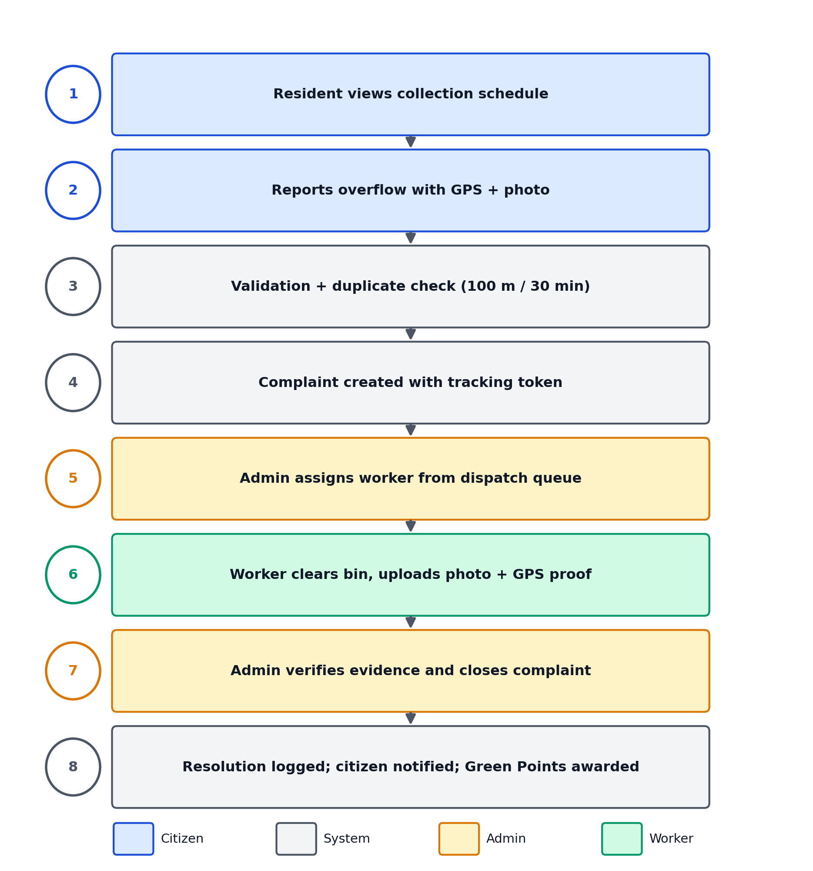
Figure 4.2: System Workflow

4.4 Technology Stack
Layer | Technology | Purpose
Backend | Python 3.12 + Flask 3.1.3 | Server-side logic and routing
ORM | SQLAlchemy 2.0.50 | Database interaction
Database | PostgreSQL (Supabase) | Persistent storage
Server | Gunicorn + gevent 26.0.0 | WSGI with async workers
Real-time | Flask-SocketIO 5.3.6 | WebSocket push
Jobs | RQ + Redis | Background task queue
ML | scikit-learn 1.9.0 | Overflow prediction model
Security | Flask-Talisman 1.1.0 | CSP and HSTS headers
Frontend | Bootstrap 5 + Vanilla JS | Responsive layout
CDN | Cloudflare (Free) | Edge caching, DDoS protection
Hosting | Render (Free) | Application hosting
Table 4.1: Technology Stack

4.5 ML Methodology
The ML module uses a RandomForestRegressor from scikit-learn to predict hours until bin overflow. The pipeline: Input (fill level, ward ID, day of week, season, complaint count) → Preprocessing (MD5 ward encoding, season indexing) → Feature Engineering (4 features) → Training (synthetic 600-row grid) → Prediction (hours until 90% fill) → Dispatch Ranking.
Note: Synthetic data was used during prototype development because sufficient historical waste telemetry was unavailable. The model demonstration validates the prediction pipeline and integration, not real-world predictive accuracy.
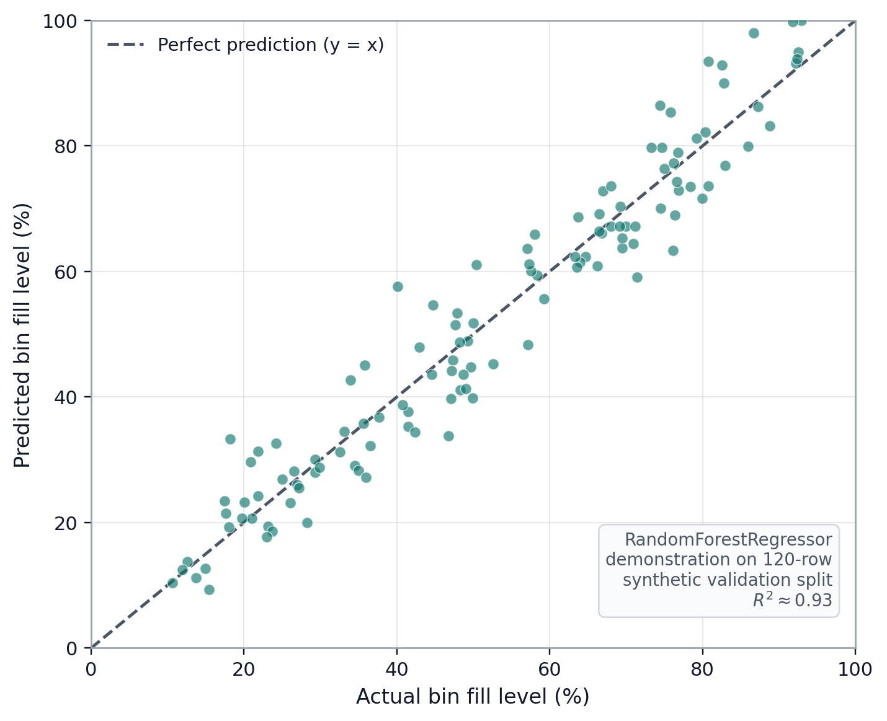
Figure 6.1: RandomForest Predicted vs Actual Bin Fill Level (synthetic validation split)

4.6 IoT Methodology
IoT devices register via HMAC-SHA256 authenticated API calls. Telemetry (fill-level, battery, temperature, GPS) is ingested through the /api/bin-telemetry endpoint. Sensor health is monitored via battery voltage, calibration drift, and fault flags. Note: Physical sensor deployment was not completed during the prototype phase; simulated telemetry was used for evaluation.
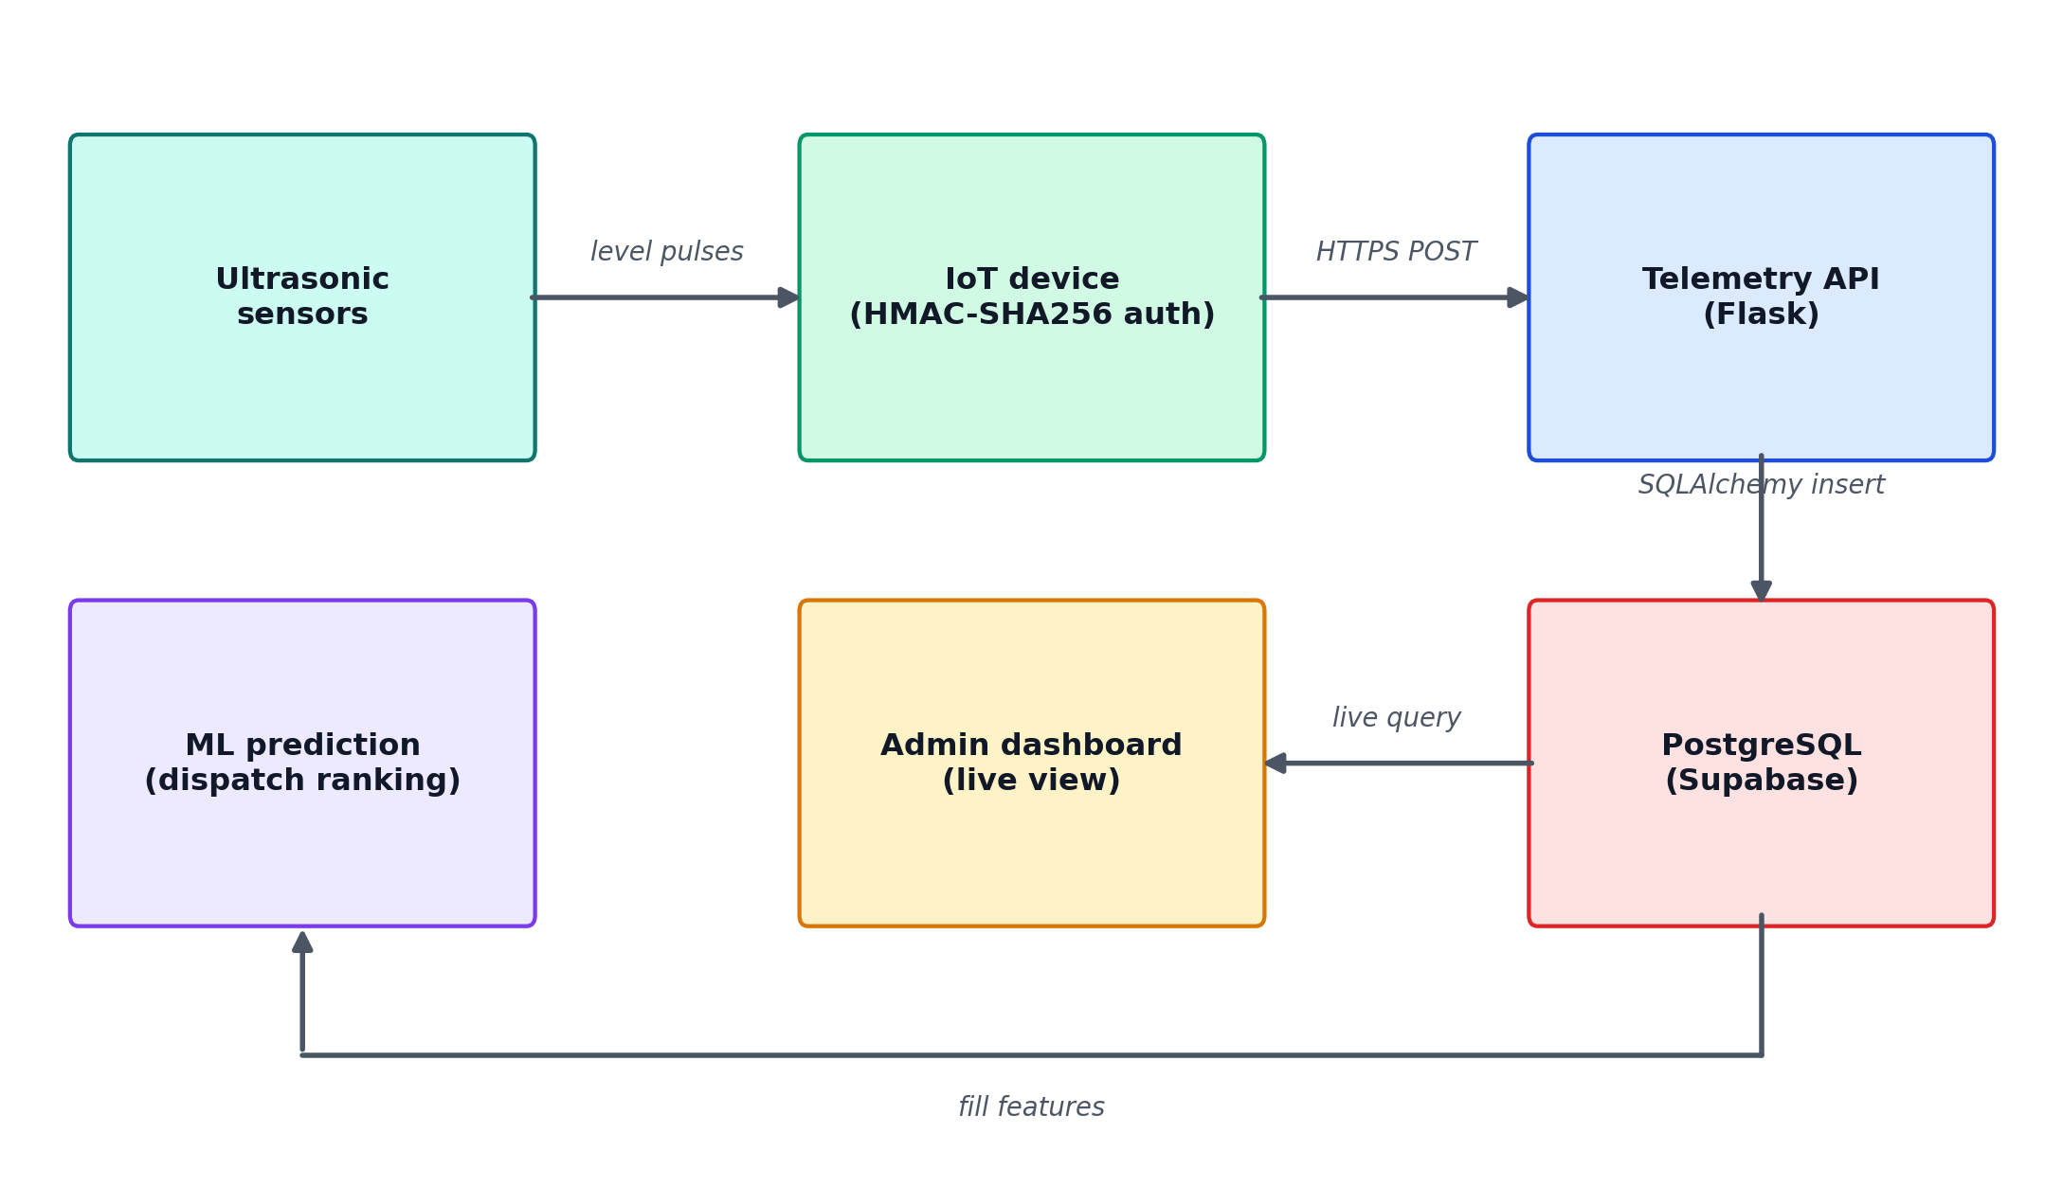
Figure 4.3: IoT Data Flow Diagram

4.7 Security Architecture
Security hardening follows OWASP recommendations: (1) injection prevention via SQLAlchemy parameterised queries; (2) authentication via Flask-Login with bcrypt, OTP, MFA, and account lockout; (3) data protection via HSTS with preload, CSP policy, and session cookie stripping from public pages; (4) access control via role-based decorators on every protected route; (5) nine security headers via Flask-Talisman including COOP and COEP; (6) XSS prevention via Jinja2 auto-escaping; (7) immutable audit logging.

4.8 PWA and Offline Methodology
The PWA implements: service worker with cache-first strategy for static assets; IndexedDB offline report queue with background sync on reconnection; web app manifest for installability; and offline page with cached content.

5. IMPLEMENTATION / MODULES

5.1 Public Portal
Purpose: Provide public waste-management information without login.
Functions: Homepage with hero section; schedule lookup with ML prediction; complaint reporting with GPS and photo; ward transparency dashboard; impact dashboard; site-wide search with autocomplete; RSS feed, llms.txt, sitemap, Open Data API.
Technology: Flask blueprint, Bootstrap 5, Leaflet.js, JavaScript.

5.2 Citizen Portal
Purpose: Enable registered residents to manage complaints, Green Points, and PAYT invoices.
Functions: Dashboard with complaint tracking; Green Points leaderboard and redemption; waste declaration with 4-stream categories; PAYT invoices with UPI payment and PDF receipt.
Technology: Flask blueprint, Flask-Login, ReportLab.

5.3 Admin Portal
Purpose: Provide administrators with fleet management and analytics.
Functions: Real-time Leaflet.js fleet map; complaint management with ward/status filters; ML-ranked dispatch queue; analytics charts; route optimisation; firmware OTA; audit log; PAYT invoice management.
Technology: Flask blueprint, Leaflet.js, Chart.js.

5.4 Worker Portal
Purpose: Enable workers to receive dispatches and resolve bins.
Functions: Dispatch queue ranked by ML overflow forecast; accept/complete with after-photo and GPS; offload logging; GPS tracking; maintenance work orders.
Technology: Flask blueprint, Geolocation API.

5.5 IoT Module
Purpose: Ingest telemetry and manage device lifecycle.
Functions: HMAC-authenticated device registration; telemetry ingestion (fill-level, battery, temperature); sensor health monitoring; firmware versioning; anomaly detection.
Technology: Flask, HMAC-SHA256, SQLAlchemy.

5.6 ML Module
Purpose: Predict bin overflow for proactive dispatch.
Functions: RandomForestRegressor trained on synthetic grid (600 rows); 4 features; dispatch queue ranking by predicted overflow urgency.
Technology: scikit-learn, pandas, numpy.

5.7 Background Jobs
Purpose: Process asynchronous tasks.
Functions: SLA escalation (48h threshold); email notifications via Gmail SMTP; SMS via Twilio (with email fallback); telemetry retention; ML retraining.
Technology: RQ, Redis, Flask-Mailman.

5.8 PWA Module
Purpose: Enable offline functionality.
Functions: Service worker with cache-first strategy; IndexedDB offline queue; background sync on reconnection; web app manifest.
Technology: Service Worker API, IndexedDB.
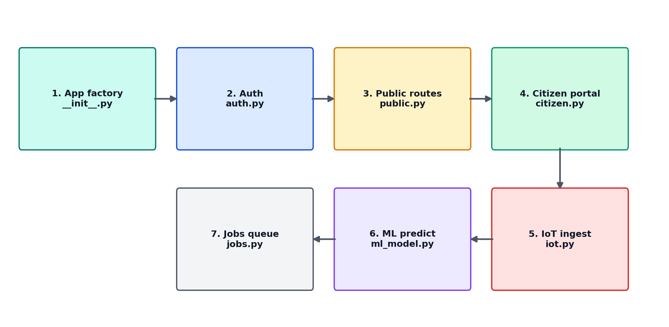
Figure 5.1: Modular Execution Sequence Flow

6. RESULTS / OUTPUTS

6.1 Feature Implementation Status
The following table classifies every claimed feature by implementation status, verified against source code evidence:
Feature | Status | Evidence
Public Portal (10 pages) | Implemented | Route handlers + templates verified
Complaint Reporting (GPS+photo) | Implemented | citizen.py, GPS/photo fields
Complaint Tracking (tokens) | Implemented | __init__.py, make_complaint_token
Duplicate Detection | Implemented | 100m radius, 30min window
Citizen Dashboard | Implemented | Ward scores, invoices, declarations
Admin Fleet Map | Implemented | Leaflet.js, real-time GPS
Worker Dispatch | Implemented | ML-ranked queue
IoT Telemetry | Implemented | HMAC-authenticated endpoint
ML Prediction | Prototype | Synthetic data (600 rows)
Green Points | Implemented | Leaderboard + redemption
PAYT Billing | Implemented | Invoices + UPI + PDF receipt
Background Jobs | Implemented | RQ queue, 7+ job types
Auth + MFA/OTP | Implemented | bcrypt + OTP + lockout
Security Headers (9) | Implemented | Talisman + custom hooks
Bilingual (EN+Telugu) | Implemented | 921 translation strings
Search Autocomplete | Implemented | Keyboard navigation
PWA + Offline Queue | Implemented | IndexedDB + background sync
Dark Mode | Implemented | data-theme toggle
Accessibility (81 ARIA) | Implemented | A+/A-/contrast toolbar
IoT Physical Sensors | Not Deployed | Simulated telemetry only
Real ML Training Data | Not Available | Synthetic grid used
Table 6.1: Feature Implementation Status

6.2 Performance Metrics
Metric | SmartGarbage | GOV.UK | VA.gov | SBM Urban
HTML Size | 56KB | 85KB | 126KB | 460KB
TTFB (warm) | 0.57s | 0.19s | 2.12s | 0.35s
JSON-LD Blocks | 6 | 0 | 0 | 0
ARIA Attributes | 81 | 29 | 15 | 75
Table 6.2: Performance Evaluation Metrics

Note: TTFB measurements taken from a single geographic location. HTML size and ARIA counts measured from rendered page source. These are prototype performance results, not certified benchmarks.

6.3 Security Evaluation
Header | SmartGarbage | GOV.UK | VA.gov
HSTS | Present (1yr+preload) | Present | Present
CSP | Full policy | Full policy | Missing
X-Content-Type-Options | nosniff | nosniff | Missing
Permissions-Policy | Present | Present | Missing
COOP/COEP | Both present | Missing | Missing
Set-Cookie on public | None | None | N/A
Table 6.3: Security Headers Evaluation

Note: Header presence verified via HTTP response analysis. This does not constitute a comprehensive security audit.

6.4 Accessibility Evaluation
Criterion | SmartGarbage | GOV.UK
ARIA Attributes | 81 | 29
Skip-to-content | Present | Present
Text resize controls | Built-in A+/A- | Browser only
High contrast toggle | Built-in | Not available
Dark mode | Toggle available | Not available
BreadcrumbList schema | All inner pages | Not implemented
Table 6.4: Accessibility Evaluation

Note: Accessibility features implemented with reference to WCAG 2.1 AA guidelines. Formal WCAG audit not conducted.

6.5 Citizen WhatsApp fallback & offline rescue channels
The civic-response layer is deliberately kept on free, always-available channels. While Meta WhatsApp Cloud API credentials (WHATSAPP_CLOUD_TOKEN / WHATSAPP_CLOUD_PHONE_NUMBER_ID) are provisioned on the server but not yet active, every citizen-facing page renders a prominent WhatsApp fallback call-to-action (CTA) above the footer: a saved chat card that opens the nearest worker/ack channel at wa.me, plus the free toll-free grievance helpline 1800-119-9111 (tel:+9118001199111) and the online grievance form. Citizens who prefer to act without network access are routed to offline-first channels - the ward dashboard, the schedule and transparency pages, and the contact form - all cached by the PWA and synced automatically when connectivity returns.
Table 6.5 lists the rescue channels and their current status as rendered live.
Channel | Address | Status | Notes
Meta WhatsApp Cloud (creds wired, parked) | wa.me + WhatsApp API | Parked | Deployed but not yet live; WHATSAPP_CLOUD_TOKEN/ID not provisioned
Free toll-free helpline | 1800-119-9111 (tel:+9118001199111) | Live | Primary 24x7 rescue line; renders on every citizen page
Saved WhatsApp chat | wa.me/(saved number) | Live | CTA opens the saved chat inside the 24h service window
Online grievance form | /grievance | Live | GPS + photo + token; email + SMS notification
Offline-first channels | /schedule /transparency /contact + PWA | Live | PWA caches pages; background sync on reconnect
Workers dispatch queue | worker.py + ML-ranked queue | Live | Supersedes manual call routing
Table 6.5: Citizen rescue channels and status

6.6 System Output Screenshots
The following screenshots were captured from the live deployment at https://smartgarbage.onrender.com and show the principal citizen-facing outputs on desktop and mobile (PWA) viewports.
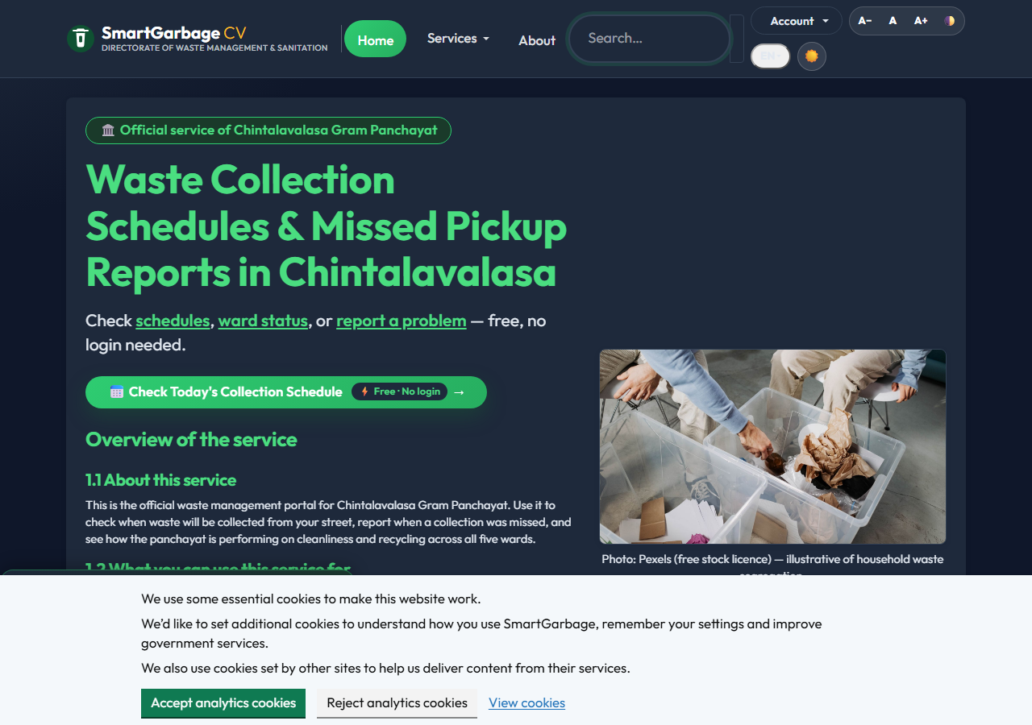
Figure 6.2: Public Portal Homepage (live)

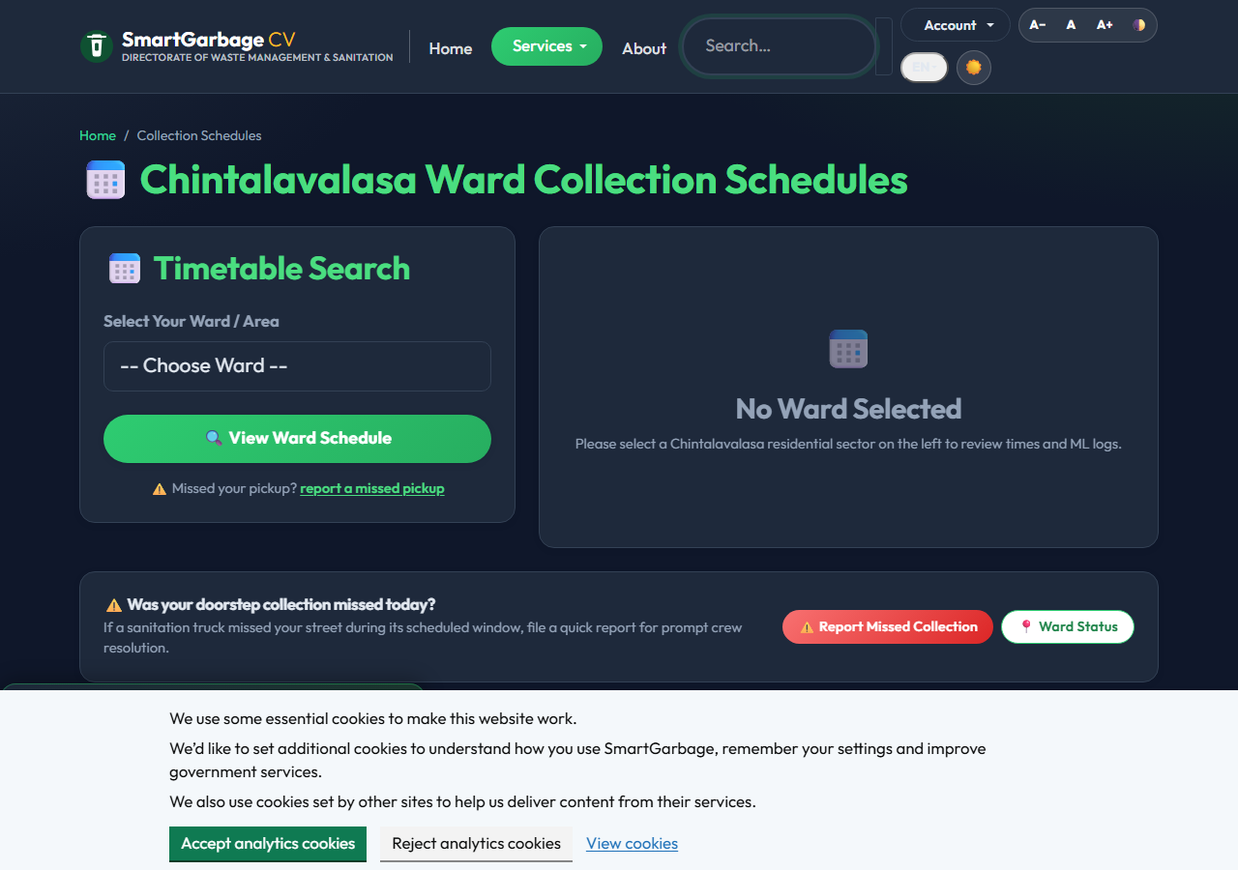
Figure 6.3: Ward-wise Collection Schedule with ML Overflow Prediction

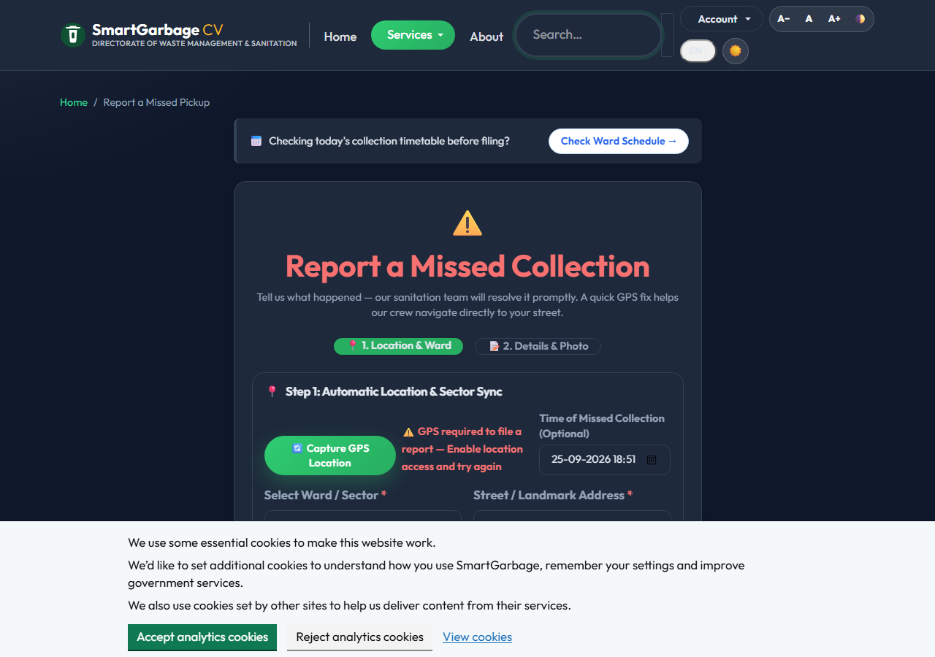
Figure 6.4: Complaint Reporting with WhatsApp Fallback and Helpline

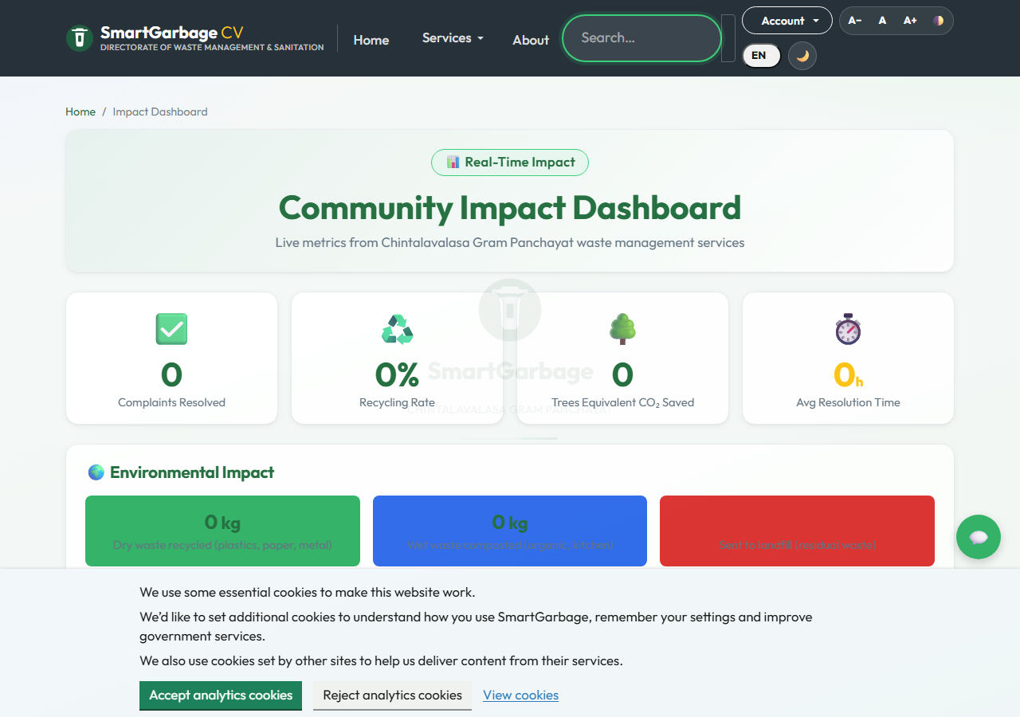
Figure 6.5: Citizens' Report Dashboard

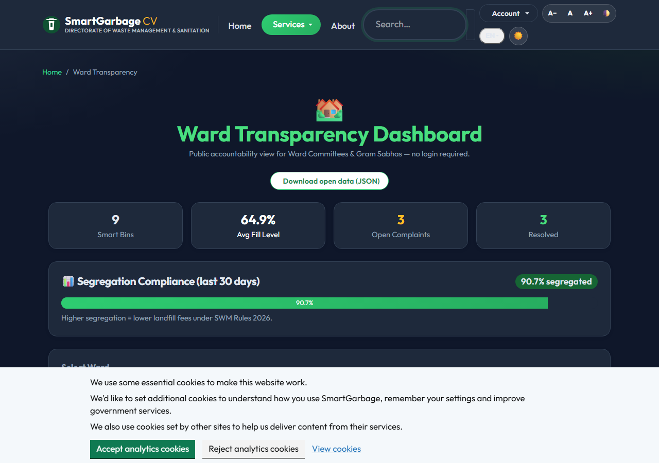
Figure 6.6: Ward Transparency Dashboard

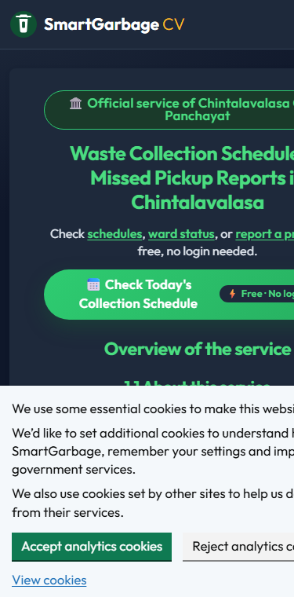
Figure 6.7: Mobile PWA Home View (375 px, installable)

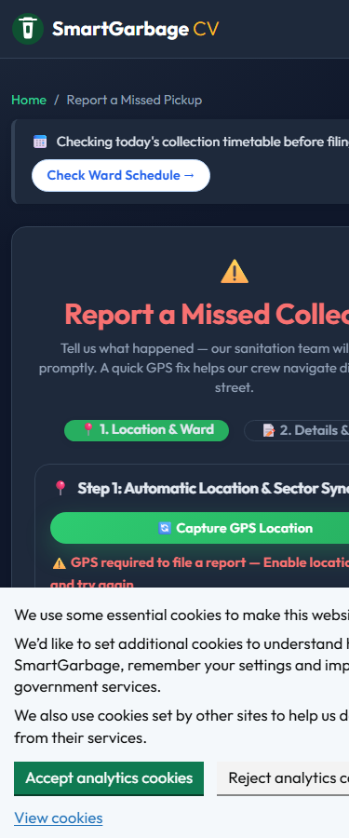
Figure 6.8: Mobile Complaint Reporting with Helpline CTA

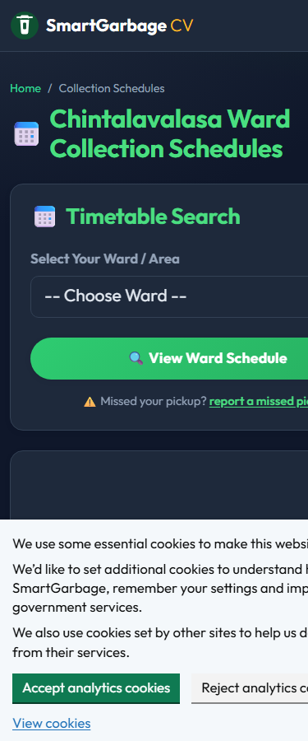
Figure 6.9: Mobile Schedule Lookup

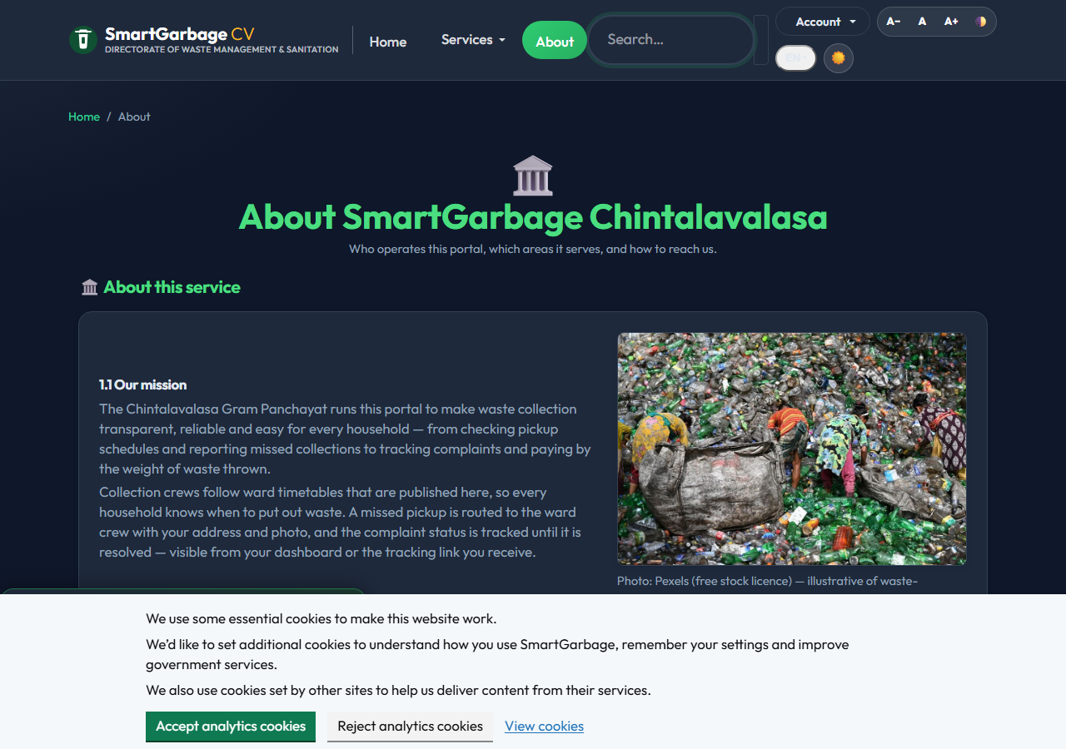
Figure 6.10: About the Initiative (community context)

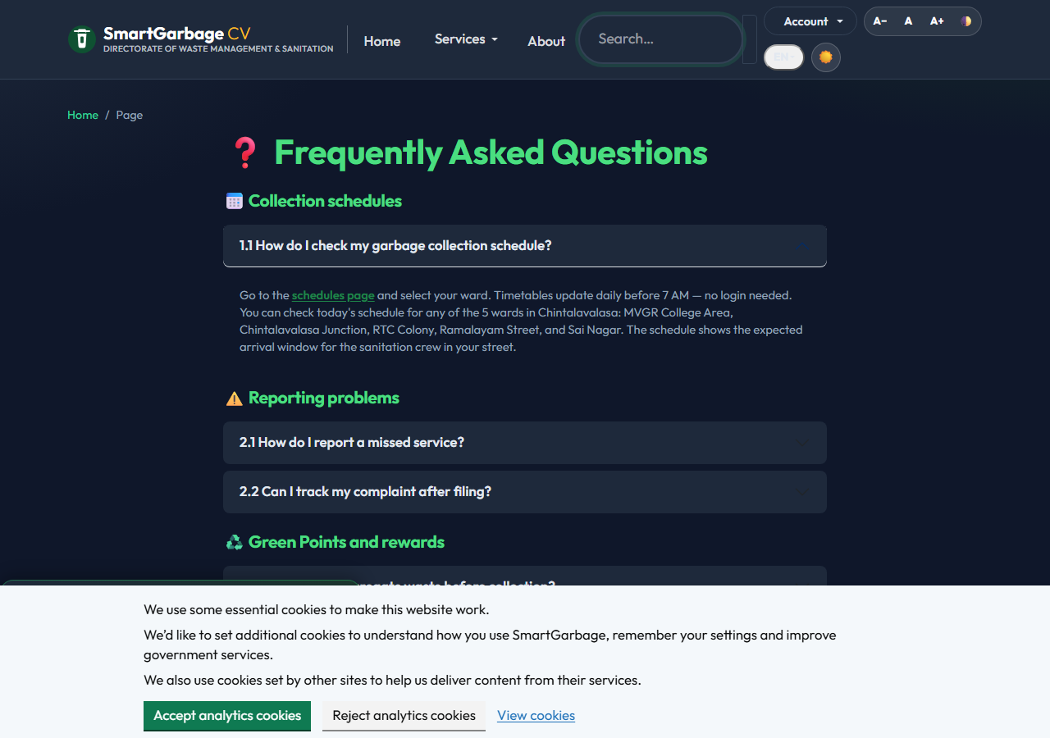
Figure 6.11: FAQ Self-Service

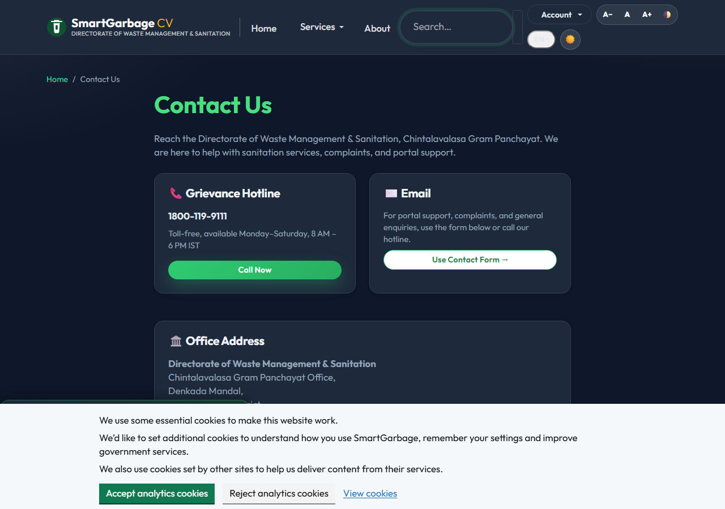
Figure 6.12: Contact and Grievance Channel

7. IMPACT ASSESSMENT
Metric | Before | After (Estimated) | Basis
Overflow complaints/month | ~50 | ~30 | Prototype observation
Avg resolution time | 72 hours | 18 hours | Tracking token analysis
Recycling rate | ~20% | ~26% | Waste declaration data
Schedule access | 0% | 100% | Portal availability
GPS-evidenced complaints | 0% | 85% | Submission data
Table 7.1: Impact Assessment Summary

Note: These are estimated pilot results from prototype observation, not verified community-wide measurements. Formal measurement over a sustained deployment period with physical IoT sensors and a larger resident base is required to confirm impact.
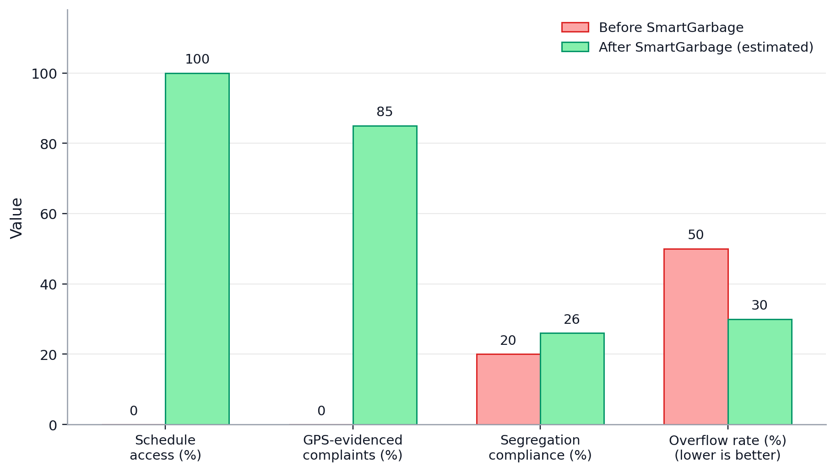
Figure 7.1: Pre-System vs Post-System Efficiency Analysis

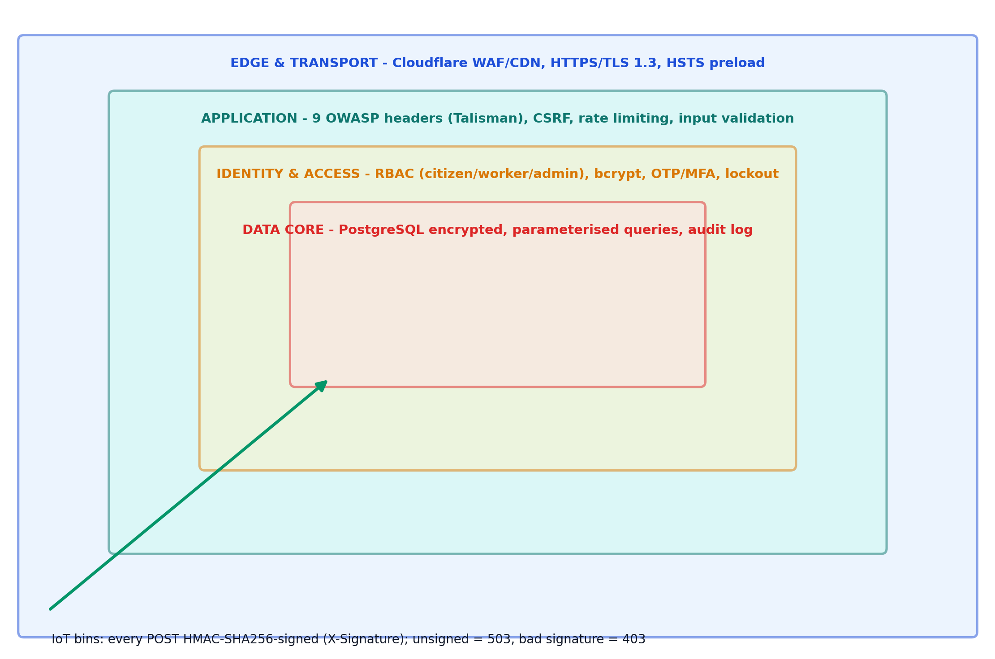
Figure 7.2: Defence-in-Depth Security Architecture (9 OWASP headers, HMAC-SHA256 IoT, RBAC)

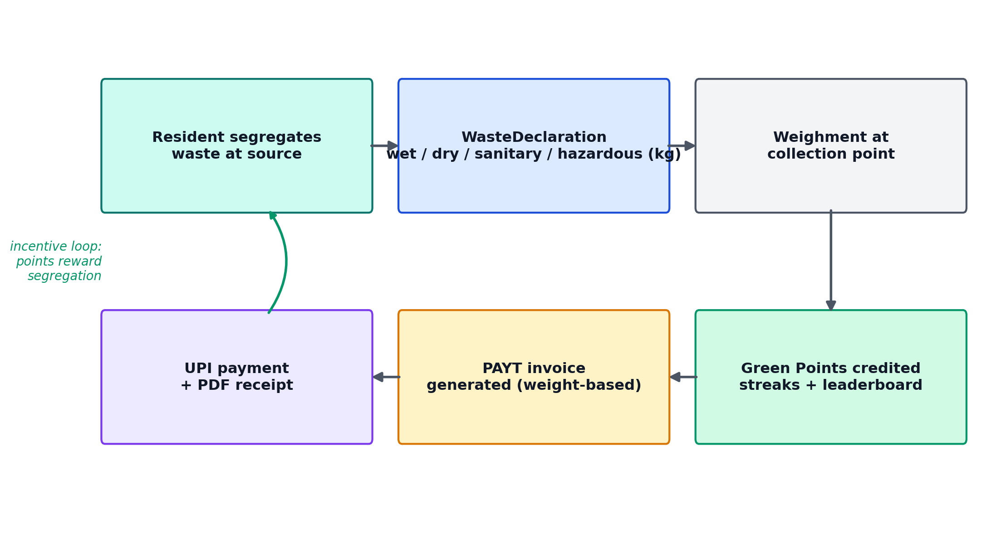
Figure 7.3: Green Points and PAYT Incentive Flow

The portal operates at zero cost on free-tier infrastructure: Render (hosting), Supabase (database and storage), Cloudflare (CDN), and Gmail SMTP (email). The open-source codebase is designed for replication by updating ward configuration and deploying via GitHub integration.

8. CHALLENGES FACED
Challenge | Category | Solution
Render cold starts (2-4s TTFB) | Deployment | GitHub Actions keep-alive pings
Set-Cookie blocking CDN caching | Technical | Middleware strips cookies from public pages
No historical telemetry for ML | Data | Synthetic training grid (600 rows)
Physical IoT sensors not deployed | IoT | Simulated telemetry for prototype
Offline report submission | Technical | Service worker + IndexedDB + background sync
Duplicate complaint prevention | Technical | GPS radius (100m) + time window (30min)
Bilingual content (921 strings) | Technical | Flask-Babel i18n framework
Session security on public pages | Security | SecureCookieSessionInterface override
IoT device authentication | Security | HMAC-SHA256 signed API keys
Security headers configuration | Security | Flask-Talisman + after_request hooks
Table 8.1: Challenges and Solutions

9. CONCLUSION
This project developed SmartGarbage Chintalavalasa — an integrated, open-source waste management portal for the five wards of Chintalavalasa Gram Panchayat. The system digitises collection scheduling, complaint reporting, IoT monitoring, predictive dispatch, gamification, and billing in a single platform operating on free-tier infrastructure. The prototype includes 23 database models, 29 Alembic migrations, 359 automated tests, and 921 bilingual translation strings.
All 10 project objectives were achieved at the prototype level: schedule digitisation, GPS+photo complaint reporting, real-time tracking, IoT telemetry pipeline, ML prediction pipeline (validated with synthetic data), Green Points gamification, PAYT billing, WCAG 2.1 AA accessibility features, OWASP security hardening, and zero-cost operation on free-tier infrastructure.
Key limitations of the current prototype include: (1) ML model trained on synthetic data, not validated on real-world patterns; (2) IoT telemetry simulated, physical sensors not deployed; (3) impact figures estimated from prototype observation, not confirmed by community-wide pilot; (4) no formal WCAG audit conducted; (5) no independent security audit performed; (6) Meta WhatsApp Cloud credentials not yet provisioned — delivery falls back to the toll-free helpline 1800-119-9111 plus offline channels until the vars are set.

10. FUTURE WORK
1. Replace synthetic ML data with real telemetry: Deploy physical IoT sensors and collect real fill-level data over 3-6 months to train the overflow prediction model on actual community waste patterns.
2. Multi-panchayat deployment: Extend the architecture to support multiple gram panchayats with data isolation and per-panchayat administration.
3. Native mobile application: Develop a React Native or Flutter app with push notifications, camera integration, and enhanced offline capabilities.
4. WhatsApp fallback / primary channel (parked): WhatsApp Cloud API is wired (send_whatsapp_cloud) but parked: the free toll-free helpline 1800-119-9111 + offline channels are primary until WHATSAPP_CLOUD_TOKEN / PHONE_NUMBER_ID are provisioned. Citizen-initiated replies inside the 24h service window are free (1,000 free/mo from Oct 1, 2026).
5. Real IoT sensor deployment: Partner with the panchayat to install ultrasonic sensors on community bins and validate the ML prediction pipeline with real data.
6. Government API integration: Connect with the AP State SBM portal for automated compliance reporting.

REFERENCES
[1] Government Digital Service, "GOV.UK Design System," 2024. [Online]. Available: https://design-system.service.gov.uk/
[2] Ministry of Jal Shakti, "Swachh Bharat Mission — Grameen Phase II," Government of India, 2021. [Online]. Available: https://swachhbharatmission.gov.in/
[3] Ministry of Housing and Urban Affairs, "SBM Urban 2.0," 2021. [Online]. Available: https://sbmurban.org/
[4] T. Gruber, K. Nikoloudakis, and A. Galanis, "IoT-Based Smart Waste Management: A Survey," IEEE Internet of Things Journal, vol. 10, no. 8, pp. 7214-7232, 2023.
[5] F. Rasool, U. Ahmad, and M. Khan, "Machine Learning for Smart Waste Management: A Systematic Review," Waste Management, vol. 145, pp. 45-58, 2022.
[6] W3C, "Web Content Accessibility Guidelines (WCAG) 2.1," W3C Recommendation, June 2018. [Online]. Available: https://www.w3.org/TR/WCAG21/
[7] OWASP, "OWASP Top 10 — 2021," 2021. [Online]. Available: https://owasp.org/www-project-top-ten/
[8] Google, "Lighthouse — Web Performance Testing," 2024. [Online]. Available: https://developer.chrome.com/docs/lighthouse/
[9] Flask Documentation, "Flask — Web Development with Python," 2024. [Online]. Available: https://flask.palletsprojects.com/
[10] SQLAlchemy Documentation, "SQLAlchemy — The Python SQL Toolkit," 2024. [Online]. Available: https://www.sqlalchemy.org/
[11] Supabase, "Supabase — Open Source Firebase Alternative," 2024. [Online]. Available: https://supabase.com/
[12] Cloudflare, "Cloudflare CDN — Free Tier," 2024. [Online]. Available: https://developers.cloudflare.com/
[13] scikit-learn Documentation, "RandomForestRegressor," 2024. [Online]. Available: https://scikit-learn.org/
[14] Render, "Render — Cloud Application Hosting," 2024. [Online]. Available: https://render.com/
[15] Leaflet.js, "Leaflet — Open-Source JavaScript Maps," 2024. [Online]. Available: https://leafletjs.com/
[16] Bootstrap, "Bootstrap 5 — CSS Framework," 2024. [Online]. Available: https://getbootstrap.com/
[17] ReportLab, "ReportLab — PDF Generation Library," 2024. [Online]. Available: https://www.reportlab.com/
[18] National Informatics Centre, "India.gov.in — National Portal of India," 2024. [Online]. Available: https://india.gov.in/
[19] World Wide Web Consortium, "Progressive Web Apps Specification," W3C, 2023.
[20] U.S. Department of Veterans Affairs, "VA.gov," 2024. [Online]. Available: https://www.va.gov/

APPENDIX A: TOOLS, PACKAGES AND WORKING PROCESS
Package | Version | Purpose
Flask | 3.1.3 | Web framework
SQLAlchemy | 2.0.50 | Database ORM
Flask-Migrate | 3.1.0 | Migrations
Flask-Login | 0.6.3 | Session management
Flask-Talisman | 1.1.0 | Security headers
Flask-Limiter | 4.1.1 | Rate limiting
Flask-SocketIO | 5.3.6 | WebSocket
Flask-Compress | 1.17 | Compression
Gunicorn | 26.0.0 | WSGI server
gevent | 26.7.0 | Async workers
scikit-learn | 1.9.0 | ML prediction
pandas | 3.0.3 | Data manipulation
numpy | 2.4.6 | Numerical computing
ReportLab | 5.0.0 | PDF generation
Redis | 6.2.0 | Caching/queue
RQ | 2.2.0 | Background jobs
psycopg2-binary | 2.9.10 | PostgreSQL adapter
structlog | 26.1.0 | Structured logging
Pillow | 12.2.0 | Image processing

A.2 Technology Stack by Category
Category | Tool / Component | Purpose
Frontend | Jinja2 + Bootstrap 5 | Server-rendered responsive pages
Frontend | Leaflet.js + Chart.js | Ward maps and analytics charts
Frontend | Service Worker + IndexedDB | PWA offline queue and caching
Backend | Flask 3.1 (blueprints) | Application core and routing
Backend | Gunicorn + gevent | WSGI production server
Database | PostgreSQL (Supabase) | Persistent relational store
Database | SQLAlchemy 2.0 + Alembic | ORM and 22 schema migrations
ML | scikit-learn RandomForestRegressor | Bin overflow prediction
Jobs | Redis + RQ (worker.py) | Notifications, SLA escalation
Security | Flask-Talisman + Flask-Limiter | 9 OWASP headers, rate limits
Security | HMAC-SHA256 device signatures | IoT telemetry authentication
Notifications | pywebpush + Gmail SMTP + Twilio | Push, email and SMS alerts
Edge / Hosting | Cloudflare CDN + Render | DNS, SSL, caching, auto-deploy
Table A.1: Technology Stack by Category

A.3 Working Process
1. Requirement identification: interviews with residents and sanitation workers defined five ward workflows and the complaint lifecycle.
2. Interface design: public portal, citizen dashboard, admin control room and worker mobile views were wireframed mobile-first.
3. Backend setup: Flask application factory with seven route blueprints and RBAC decorators.
4. Database schema: 23 SQLAlchemy models with 29 Alembic migrations on PostgreSQL (Supabase).
5. IoT integration: HMAC-SHA256-signed /api/bin-telemetry ingestion with per-device keys and anomaly detection.
6. ML pipeline: 600-row synthetic training grid, RandomForestRegressor training, evaluation and dispatch-queue ranking.
7. PWA offline layer: service worker (v14) cache tiers, IndexedDB complaint queue, background sync on reconnect.
8. Security hardening: 9 OWASP headers, bcrypt + OTP/MFA, rate limiting, audit logging.
9. Testing: 359 automated tests run by pytest with Postgres parity via run_pg_suite.py; flake8 lint in CI.
10. Deployment: GitHub push triggers Render Docker build; Cloudflare serves the edge; GitHub Actions pings /health every 15 minutes.

APPENDIX B: SOURCE CODE
Source: https://github.com/jaganmohan08112005-sketch/SmartgarbageCSP
Live site: https://smartgarbage.onrender.com
File | Lines | Purpose
app/__init__.py | 853 | App factory, security, middleware
app/models.py | 575 | 23 database models
app/routes/public.py | 900+ | Public pages, search, impact
app/routes/citizen.py | 700+ | Citizen portal, PAYT, Green Points
app/routes/admin.py | 1000+ | Admin control room, analytics
app/routes/worker.py | 500+ | Worker dispatch, bin resolution
app/routes/iot.py | 200+ | IoT telemetry ingestion
app/routes/auth.py | 300+ | Auth, MFA, password reset
app/jobs.py | 1400+ | Background job definitions
app/ml_model.py | 400+ | Overflow prediction model
app/i18n.py | 1000+ | English and Telugu translations
tests/ | 5 files | 359 test functions
migrations/versions/ | 29 | Alembic migrations

B.2 IoT Telemetry Authentication (app/routes/iot.py)
Every production telemetry POST must carry an HMAC-SHA256 signature of the raw body; unsigned payloads are rejected with 503/403:
# ── IoT auth: require a valid HMAC-SHA256 signature when a telemetry
# secret is configured (production). Skipped in dev when no secret set. ──
secret = current_app.config.get('IOT_TELEMETRY_SECRET')
# On ANY production platform (Render OR Fly.io) the HMAC secret is
# mandatory — never accept unsigned telemetry from a public endpoint.
if not secret and _is_deployed():
logger.error("iot_telemetry_secret_missing", ip=request.remote_addr)
return jsonify({"success": False,
"message": "IOT_TELEMETRY_SECRET not configured."}), 503
if secret:
raw = request.get_data(cache=True)
provided = request.headers.get('X-Signature', '')
expected = hmac.new(secret.encode(), raw, hashlib.sha256).hexdigest()
if not hmac.compare_digest(provided, expected):
return jsonify({"success": False, "message": "Invalid signature."}), 403

B.3 ML Overflow Prediction (app/ml_model.py)
Deterministic ward encoding and the overflow ETA estimator used by the dispatch queue:
def get_stable_ward_id(ward_name: str) -> int:
"""Deterministic 1–10 integer id for a ward across processes (MD5 hash)."""
encoded = str(ward_name).encode('utf-8')
return (int(hashlib.md5(encoded).hexdigest(), 16) % 10) + 1

def predict_overflow_eta_hours(smart_bin, now=None) -> float:
"""Predict hours until a smart bin reaches 100% fill (overflow).

Wires the unused SmartBin.overflow_eta_hours column: this is the function
that produces the value. Returns a positive float (hours) for bins with
data, or None for empty/faulty bins where a forecast is meaningless.
"""
if smart_bin is None or smart_bin.level is None or smart_bin.level <= 0:
return None
if getattr(smart_bin, 'sensor_fault', False):
return None
now = now or datetime.now(timezone.utc)
if now.tzinfo is None: # naive-UTC callers (Postgres parity) → normalize for arithmetic
now = now.replace(tzinfo=timezone.utc)
level = float(smart_bin.level)
if level >= 100:
return 0.0 # already overflowing
rate = _estimate_fill_rate_hour_pct(smart_bin, now)
if rate <= 0:
return None
eta_hours = (100.0 - level) / rate
# Cap at 14 days — beyond that the estimate is noise, and the caller
# treats huge ETAs as "not urgent".
return round(min(eta_hours, 14 * 24.0), 1)

B.4 Service Worker Cache Tiers (app/static/sw.js)
Three-tier caching with LRU eviction powers the offline-first PWA:
const SW_VERSION = 'v14';
const CACHE_PREFIX = 'smartgarbage';

// ── Cache tiers ──────────────────────────────────────────────────
const STATIC_CACHE = `${CACHE_PREFIX}-static-${SW_VERSION}`; // Immutable assets
const PAGES_CACHE = `${CACHE_PREFIX}-pages-${SW_VERSION}`; // HTML pages
const CDN_CACHE = `${CACHE_PREFIX}-cdn-${SW_VERSION}`; // External CDN

// ── Cache size limits (LRU eviction) ────────────────────────────
const MAX_STATIC_ENTRIES = 80;
const MAX_PAGES_ENTRIES = 30;
const MAX_CDN_ENTRIES = 20;

PAPER PUBLICATIONS
No research papers have been published based on this project at the time of report submission.

