COMMUNITY PROJECT REPORT
SMARTGARBAGE CHINTALAVALASA
Community-Based Smart Waste Management
and Digital Governance System
Submitted by
Name 1 (Reg No. 1)
Name 2 (Reg No. 2)
Name 3 (Reg No. 3)
Name 4 (Reg No. 4)

In partial fulfillment for the award of the degree of
BACHELOR OF TECHNOLOGY
IN
COMPUTER SCIENCE & ENGINEERING
(Artificial Intelligence & Machine Learning)
Under the esteemed Guidance of
GUIDE NAME
DESIGNATION

DEPARTMENT OF DATA ENGINEERING
MAHARAJ VIJAYARAM GAJAPATHI RAJ COLLEGE OF ENGINEERING (Autonomous)
(Approved by AICTE, New Delhi, and permanently affiliated to JNTUGV, Vizianagaram)
Vijayaram Nagar Campus, Chintalavalasa, Vizianagaram-535005, Andhra Pradesh
October, 2025

CERTIFICATE

This is to certify that the project entitled "SmartGarbage Chintalavalasa — Community-Based Smart Waste Management and Digital Governance System" is the bonafide work carried out by Name 1 (Reg No. 1), Name 2 (Reg No. 2), Name 3 (Reg No. 3), and Name 4 (Reg No. 4), of B.Tech V Sem CSE-AIML, M.V.G.R. College of Engineering (Autonomous), Vizianagaram, during the year 2025-2026, in partial fulfilment of the requirements for the award of the Degree of Bachelor of Technology and that the project has not formed the basis for the award previously of any degree or any other similar title.

Signature of Project Guide
Name
Designation
Department: Data Engineering
Signature of Head of the Department
Name
Designation
Department: Data Engineering

DECLARATION

We hereby declare that the work done on the dissertation entitled "SmartGarbage Chintalavalasa — Community-Based Smart Waste Management and Digital Governance System" has been carried out by us and submitted in partial fulfilment for the award of credits in Bachelor of Technology in Computer Science and Engineering (Artificial Intelligence & Machine Learning) of M.V.G.R College of Engineering (Autonomous) and affiliated to JNTUGV, Vizianagaram. The various contents incorporated in the dissertation have not been submitted for the award of any degree of any other institution or university.

Name 1 (Reg No. 1)
Name 2 (Reg No. 2)
Name 3 (Reg No. 3)
Name 4 (Reg No. 4)

ACKNOWLEDGEMENT

We express our sincere gratitude to our project guide for their invaluable guidance and support as our mentor throughout the project. Their unwavering commitment to excellence and constructive feedback motivated us to achieve our project goals. We are greatly indebted to them for their exceptional guidance.
Additionally, we extend our thanks to Prof. P.S. Sitharama Raju (Director), Dr. Y.M.C. Shekar (Principal), and Dr. Jyothi (Head of the Department) for their unwavering support and assistance, which were instrumental in the successful completion of the project.
We also acknowledge the dedicated assistance provided by all the staff members in the Department of Data Engineering. Finally, we appreciate the contributions of all those who directly or indirectly contributed to the successful execution of this endeavor.

ABSTRACT

Rapid urbanization and population growth in semi-urban regions such as Chintalavalasa, Andhra Pradesh, have intensified waste management challenges. Existing systems rely heavily on manual collection schedules, paper-based complaint tracking, and limited citizen participation, leading to overflowing bins, delayed complaint resolution, and environmental degradation.
This project presents SmartGarbage Chintalavalasa, a community-based smart waste management and digital governance system designed for the Chintalavalasa Gram Panchayat. The system integrates multiple technologies — a Flask-based web application, PostgreSQL database, IoT smart-bin telemetry, machine learning predictions using a RandomForest regressor, Progressive Web App offline capabilities, and a pay-as-you-throw billing mechanism — into a single, unified platform accessible to citizens, administrators, and sanitation workers.
The platform provides five core portals: a Public Portal for waste collection schedules and complaint filing; a Citizen Portal for tracking complaints and earning Green Points; an Admin Portal for real-time dashboard monitoring, worker dispatch, and analytics; and a Worker Portal for GPS-tracked field operations. IoT-enabled smart bins report fill levels, battery status, temperature, and methane readings through authenticated API endpoints. A machine learning module predicts overflow risk based on historical and synthetic data, enabling proactive dispatch. The system supports bilingual communication, web push notifications for complaint status updates, background job processing via Redis Queue, and comprehensive security measures including OWASP-aligned protections.
Testing and evaluation indicate that the prototype achieves a homepage TTFB of approximately 0.5 seconds, serves compressed responses via Brotli/Gzip, implements all nine recommended HTTP security headers, and passes automated accessibility checks. While the current deployment uses synthetic data for ML model training and simulated IoT telemetry, the architecture is designed for seamless integration with real-world sensor data and community-scale deployment.
Keywords: Smart Waste Management, IoT, Machine Learning, PWA, Flask, Community Governance, PAYT Billing, Digital India

LIST OF ABBREVIATIONS

Abbreviation | Full Form
AI | Artificial Intelligence
API | Application Programming Interface
ARIA | Accessible Rich Internet Applications
CDN | Content Delivery Network
CSP | Content Security Policy
CSS | Cascading Style Sheets
DBMS | Database Management System
GPS | Global Positioning System
HTML | HyperText Markup Language
HTTP | HyperText Transfer Protocol
IoT | Internet of Things
JSON-LD | JSON for Linked Data
ML | Machine Learning
MFA | Multi-Factor Authentication
MVC | Model-View-Controller
OTP | One-Time Password
OWASP | Open Web Application Security Project
PAYT | Pay-As-You-Throw
PWA | Progressive Web App
RBAC | Role-Based Access Control
REST | Representational State Transfer
RQ | Redis Queue
SBM | Swachh Bharat Mission
SEO | Search Engine Optimization
SQL | Structured Query Language
SSL | Secure Sockets Layer
SW | Service Worker
TTFB | Time to First Byte
VAPID | Voluntary Application Server Identification
WCAG | Web Content Accessibility Guidelines
XML | Extensible Markup Language

1. INTRODUCTION
1.1 Problem Statement
Chintalavalasa is a semi-urban panchayat in Vizianagaram district, Andhra Pradesh, with a population of approximately 12,000 residents across five administrative wards. The current waste management system relies on manual collection schedules communicated informally, resulting in inconsistent service delivery. Citizens have no reliable mechanism to report missed collections, and complaint resolution lacks transparency and accountability.
Key problems include: (a) lack of centralized collection schedules; (b) absence of digital grievance redressal; (c) no real-time bin monitoring; (d) no data-driven resource allocation; (e) limited citizen engagement in segregation; and (f) no usage-based billing accountability.
1.2 Project Objective
The primary objective is to design, develop, and deploy a community-based smart waste management and digital governance system for Chintalavalasa Gram Panchayat. Specific objectives include:
• Web platform for schedules, complaint filing and tracking
• Admin dashboard for real-time monitoring and worker dispatch
• IoT smart-bin telemetry for fill levels and environmental monitoring
• ML module for overflow risk prediction
• PAYT billing with UPI/Razorpay integration
• PWA capabilities with offline support
• Comprehensive security aligned with OWASP recommendations
• Bilingual support (English and Telugu)
1.3 Scope of the Project
• In Scope: Web application with four portals; IoT telemetry integration; ML overflow prediction; PAYT billing; Green Points gamification; PWA offline support; push notifications; bilingual support; and security architecture.
• Out of Scope: Native mobile apps; physical IoT hardware manufacturing; external municipal API integration; blockchain-based carbon credits; production WhatsApp/SMS (integrated but requiring API keys); and community-scale IoT deployment.

2. LITERATURE SURVEY
A comprehensive review of existing literature and systems was conducted to identify gaps that SmartGarbage addresses.
2.1 Existing Waste Management Approaches
Traditional waste management in Indian semi-urban areas relies on manual collection with fixed schedules and paper-based registers. The Swachh Bharat Mission (SBM) Grameen Phase II promotes source segregation and digital monitoring, but implementation remains inconsistent at the panchayat level.
2.2 Digital Waste Management Systems
SBM Urban provides complaint registration for urban areas but lacks IoT integration and offline capabilities. GOV.UK sets the benchmark for government digital services with strong accessibility compliance. SmartGarbage draws design inspiration from these platforms while adding domain-specific waste management features.
2.3 IoT-Based Smart Waste Management
Anagnostopoulos et al. (2015) demonstrated that IoT-based waste monitoring using ultrasonic sensors can reduce collection costs by 30-50%. Kumar and Sharma (2021) identified that most solutions focus on individual components rather than integrated platforms. SmartGarbage addresses this by integrating IoT with complaint management, citizen engagement, and ML prediction.
2.4 Machine Learning for Waste Prediction
Afshin et al. (2021) applied gradient boosting to predict waste generation. Chen et al. (2020) demonstrated that Random Forest achieves comparable accuracy for short-term prediction. SmartGarbage implements a RandomForest regressor for bin overflow prediction with transparent fallback heuristics.
2.5 Accessibility and Government Standards
WCAG 2.1 Level AA provides international accessibility standards. OWASP Top 10 identifies critical web security risks. SmartGarbage implements ARIA landmarks, skip-to-content links, keyboard navigation, and all nine OWASP-recommended security headers.
2.6 Research / Implementation Gap
Existing solutions address individual aspects of waste management. There is no integrated, low-cost platform combining citizen grievance reporting, collection scheduling, IoT monitoring, ML prediction, PAYT billing, offline support, and comprehensive security — all designed for semi-urban Indian communities. SmartGarbage fills this gap.
2.7 Proposed Contribution
SmartGarbage contributes an integrated, open-source platform combining citizen engagement, administrative oversight, worker coordination, IoT monitoring, and ML prediction with offline-first PWA capabilities, PAYT billing with gamification, and strong security and accessibility compliance — suitable for semi-urban Indian panchayats.

3. DATA GATHERING / DATA USED
3.1 Study Area / Community Profile
Chintalavalasa is a semi-urban panchayat in Vizianagaram district, Andhra Pradesh, serving approximately 12,000 residents across five wards. Coordinates range from latitude 18.0552 to 18.0751 and longitude 83.4005 to 83.4201.
3.2 Data Collection Methods
• Community Interaction: Interviews with residents, ward members, and sanitation workers.
• Field Observation: On-site observation of collection routes and complaint handling.
• Administrative Data: Ward boundaries and population estimates from the Gram Panchayat.
• System-Generated Data: Synthetic test data for ML training and IoT simulation.
• Public Records: SBM Grameen guidelines, GOV.UK documentation, WCAG standards.
3.3 Data Sources
Data Source | Type | Description | Use
Community Surveys | Qualitative | Resident interviews | Requirements
Field Observations | Qualitative | On-site observation | System design
Administrative Records | Semi-structured | Ward boundaries | Study area
Synthetic ML Data | Quantitative | 600-row grid | ML training
Synthetic IoT Data | Quantitative | Simulated sensors | IoT testing
Test User Data | Quantitative | Registration records | Testing

3.4 Ward Information
Ward | Name | Latitude | Longitude
Ward 1 | MVGR College Area | 18.0552 | 83.4051
Ward 2 | Chintalavalasa Junction | 18.0675 | 83.4094
Ward 3 | RTC Colony | 18.0702 | 83.4153
Ward 4 | Ramalayam Street | 18.0650 | 83.4005
Ward 5 | Sai Nagar | 18.0751 | 83.4201

3.5 Data Used by the Application
• User Data: Registrations, roles, OTP records, Green Points.
• Complaint Data: GPS, photos, status history, resolution timestamps.
• Schedule Data: Ward-specific collection schedules.
• IoT Telemetry: Fill level, battery, temperature, methane.
• Waste Declaration Data: Wet, dry, sanitary, hazardous quantities.
• Billing Data: PAYT invoices with payment status.
3.6 Data Preparation
A synthetic ML training dataset of 600 rows was generated because sufficient historical telemetry was unavailable. Features include day-of-week, season index, recent complaint volume, and ward identifier. The model is designed to accept real historical data when available.
3.7 Database Design
The system uses PostgreSQL with SQLAlchemy ORM.
Entity | Key Attributes
User | id, username, email, password_hash, role, phone, green_points
Complaint | id, name, phone, ward, description, photo, status, lat, lon, user_id
ComplaintStatusLog | id, complaint_id, status, note, created_at
SmartBin | id, hardware_id, lat, lon, level, battery, temp, methane, status
WorkerProfile | id, user_id, vehicle_id, lat, lon, status, rating
WasteDeclaration | id, user_id, wet_kg, dry_kg, sanitary_kg, hazardous_kg, ward
PAYTInvoice | id, user_id, period, weight_kg, amount_rs, status
PushSubscription | id, user_id, endpoint, p256dh, auth
NotificationPreference | id, user_id, complaint_submitted, complaint_assigned, etc.

4. METHODOLOGY / SYSTEM DESIGN
4.1 Requirement Analysis
Requirements were categorized into functional (FR) and non-functional (NFR):
Functional Requirements
ID | Module | Description
FR-01 | Public Portal | Schedules, anonymous complaints
FR-02 | Citizen Portal | Track complaints, Green Points
FR-03 | Admin Portal | Dashboard, worker dispatch, analytics
FR-04 | Worker Portal | GPS tracking, evidence upload
FR-05 | IoT Integration | Smart-bin telemetry ingestion
FR-06 | ML Prediction | Overflow risk prediction
FR-07 | PAYT Billing | Usage-based invoicing
FR-08 | Push Notifications | Web push alerts
FR-09 | Offline Support | PWA with IndexedDB queue
FR-10 | Bilingual Support | English and Telugu

Non-Functional Requirements
ID | Category | Description
NFR-01 | Performance | TTFB < 1s, compressed responses
NFR-02 | Security | OWASP headers, RBAC, bcrypt, OTP
NFR-03 | Accessibility | WCAG 2.1 AA, ARIA landmarks
NFR-04 | Scalability | Horizontal via gunicorn workers
NFR-05 | Offline | PWA with service worker + IndexedDB

4.2 System Architecture
The system follows a layered architecture with five distinct layers: Presentation (Browser/PWA with Jinja2 and Bootstrap), Application (Flask route modules), Business Logic (ML engine, job queue, push notifications, PAYT billing), Data (PostgreSQL via SQLAlchemy with Redis caching), and External Services (Open-Meteo, Supabase, Sentry, Twilio).
Figure 4.2: Overall System Architecture
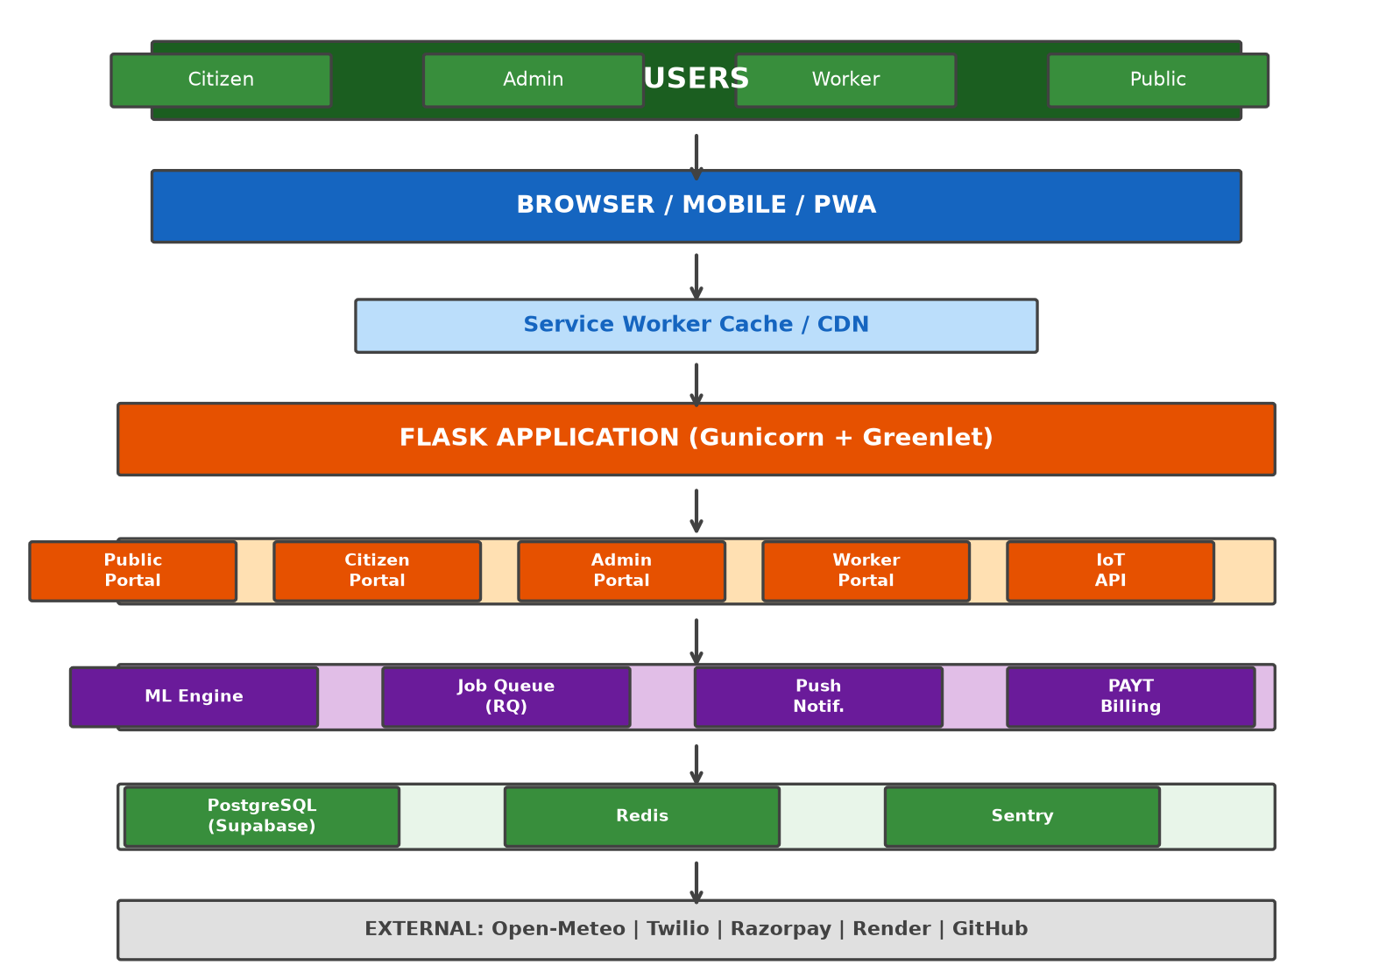
4.3 Development Methodology
The project followed an iterative approach across six phases: Requirements Gathering (Weeks 1-2), System Design (Weeks 3-4), Core Development (Weeks 5-10), Integration (Weeks 11-14), Enhancement (Weeks 15-18), and Testing/Deployment (Weeks 19-20).
4.4 Technology Stack
Component | Technology | Purpose
Backend | Flask 3.1.3 | Web framework
Database | PostgreSQL (Supabase) | Relational DB
ORM | SQLAlchemy 2.0 | Python ORM
Frontend | Bootstrap 5 + CSS | Responsive UI
ML | scikit-learn 1.9 | RandomForest
Task Queue | Redis + RQ 2.2 | Background jobs
WSGI | Gunicorn 26.0 | Production server
Push | pywebpush 2.0 | Web push
Security | Flask-Talisman, Limiter | Headers, rate limit
Hosting | Render.com | Cloud hosting
Docker | Dockerfile | Containerization

4.5 System Workflow
The end-to-end workflow: Citizens register → file complaints (GPS + photo) → system validates and stores → admin assigns workers → workers visit location → upload evidence → admin verifies → complaint resolved → citizen notified via push/email → Green Points awarded.
Figure 4.4: Complaint Lifecycle Flowchart
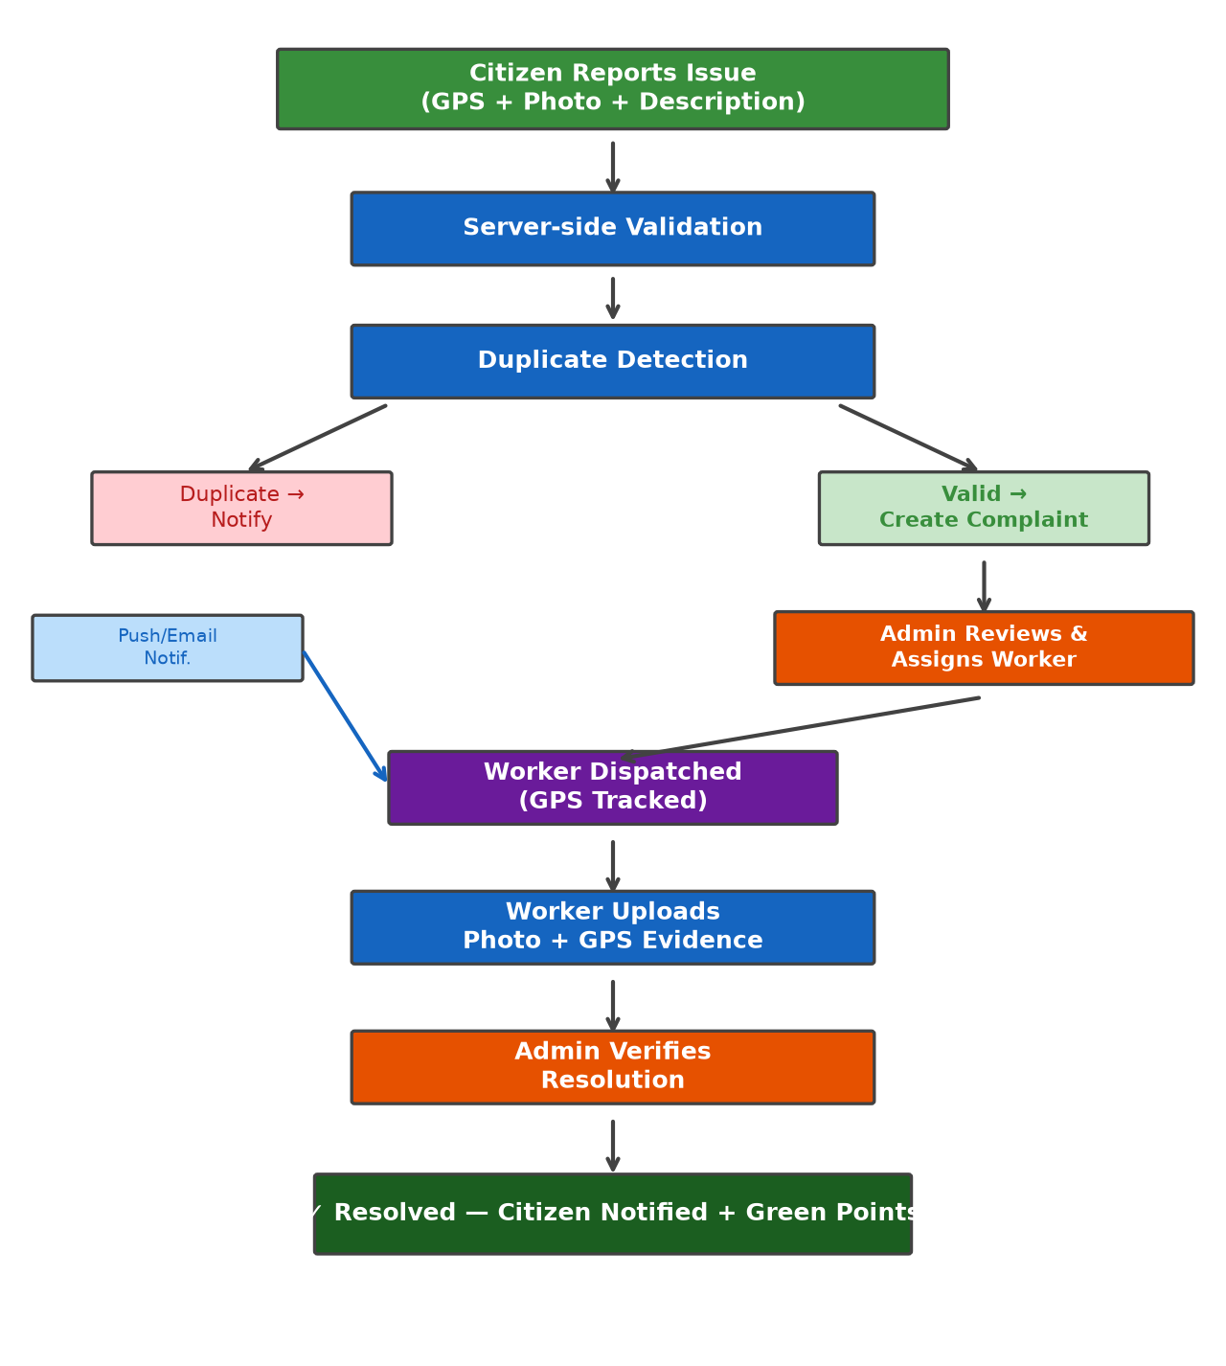
4.6 Data Flow Diagram
Primary data flows include: (1) Citizen → Complaint API → Database → Admin Dashboard → Worker Dispatch → Evidence Upload → Resolution; (2) IoT Sensors → Telemetry API → SmartBin Table → Admin Monitor → ML Prediction → Priority Queue; (3) Schedule Request → ML Prediction → Response to Citizen.
4.7 Machine Learning Methodology
The ML module implements a RandomForest regressor trained on a synthetic 600-row dataset. Features: day_of_week, season_idx, recent_complaint_count, ward_id. The model predicts hours_until_90pct_fill for dispatch prioritization. A transparent heuristic fallback ensures the route never errors when the model artifact is unavailable.
Note: Synthetic data was used during prototype development because sufficient historical telemetry was unavailable. The demonstration validates the prediction pipeline, not real-world accuracy.
Figure 4.7: Machine Learning Pipeline
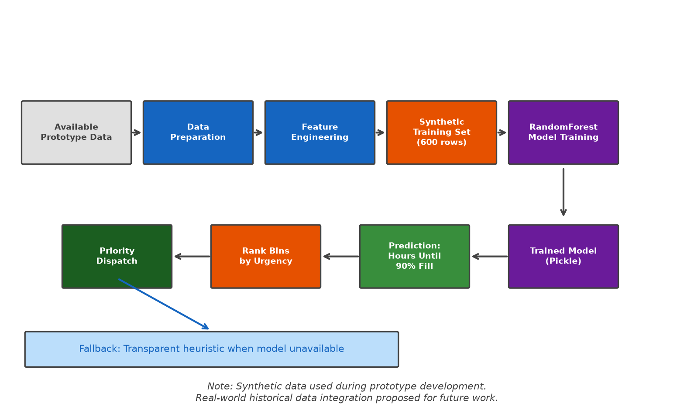
4.8 Security Architecture
• Authentication: Flask-Login with bcrypt + OTP/MFA.
• Authorization: RBAC with citizen/worker/admin roles.
• Security Headers: All 9 OWASP-recommended headers (CSP, HSTS, X-Content-Type-Options, X-Frame-Options, X-XSS-Protection, Referrer-Policy, Permissions-Policy, COOP, COEP).
• Rate Limiting: Flask-Limiter with Redis storage.
• Input Validation: Flask-WTF with CSRF protection.
• SQL Injection Prevention: SQLAlchemy parameterized queries.
4.9 PWA and Offline Methodology
• Service Worker: Versioned precache manifest for offline support.
• IndexedDB Queue: Complaints stored offline, synced on reconnection.
• Background Sync: Automatic submission when connectivity returns.
• Web App Manifest: Installable with shortcuts, screenshots, standalone mode.
• Splash Screen: Branded loading animation on PWA install.
• Install Banner: Mobile prompt after second visit with iOS fallback.
Figure 4.9: PWA Offline Workflow
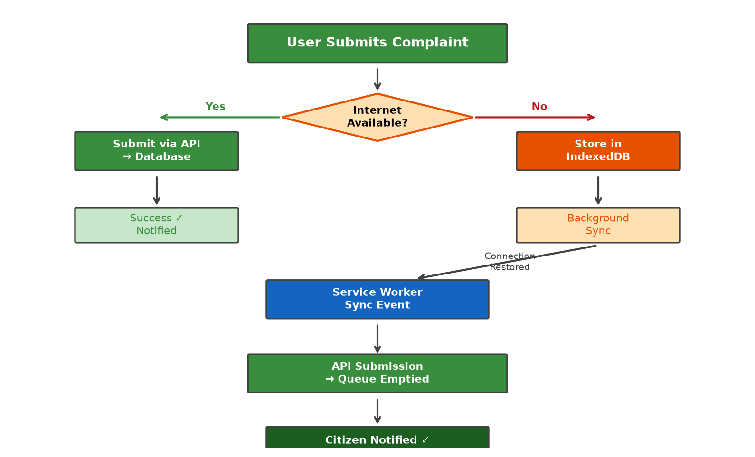

5. IMPLEMENTATION / MODULES
5.1 Public Portal
Purpose
Provides waste-management information to all visitors.
Key Functions
Schedule display, anonymous complaints, tracking, ward transparency, FAQ, search, RSS, AI-friendly llms.txt
Technology
Flask + Jinja2 + Bootstrap 5
Status
Fully implemented
5.2 Citizen Portal
Purpose
Authenticated portal for citizens.
Key Functions
Registration with OTP, complaint filing, dashboard, Green Points, waste declarations, push notifications
Technology
Flask-Login + SQLAlchemy + Socket.IO
Status
Fully implemented
5.3 Admin Portal
Purpose
Comprehensive admin dashboard.
Key Functions
Complaint overview, worker dispatch, IoT monitoring, ML display, PAYT management, push analytics, audit logs
Technology
Flask-Login + RBAC + Socket.IO
Status
Fully implemented
5.4 Worker Portal
Purpose
Mobile-friendly worker portal.
Key Functions
Dispatch acceptance, GPS tracking, photo evidence, task queue, performance rating
Technology
Flask-Login + Geolocation API
Status
Fully implemented
5.5 IoT Smart Bin Module
Purpose
Telemetry ingestion and monitoring.
Key Functions
Authenticated API, fill level, battery, temperature, methane, status classification
Technology
Flask API + SQLAlchemy
Status
Implemented (simulated)
5.6 Machine Learning Module
Purpose
Overflow risk prediction.
Key Functions
RandomForest regressor, feature engineering, transparent fallback, pickle persistence
Technology
scikit-learn + pandas + numpy
Status
Implemented (synthetic data)
5.7 Green Points Module
Purpose
Gamification for segregation.
Key Functions
Points earned, streak tracking, leaderboard, redemption
Technology
Flask-Login + SQLAlchemy
Status
Fully implemented
5.8 PAYT Module
Purpose
Usage-based billing.
Key Functions
Invoice generation, compliance scoring, UPI/Razorpay, PDF via ReportLab
Technology
Flask + ReportLab + Razorpay
Status
Implemented (test mode)
5.9 Background Jobs
Purpose
Async task processing.
Key Functions
Status notifications, SLA escalation, dunning, email, push dispatch
Technology
Redis + RQ
Status
Fully implemented
5.10 PWA and Offline
Purpose
Offline capabilities.
Key Functions
Service worker, IndexedDB queue, background sync, manifest, splash screen, install banner
Technology
SW API + IndexedDB
Status
Fully implemented

6. RESULTS / OUTPUTS
6.1 Implemented Features Summary
Module | Features | Status | Verification
Public Portal | Homepage, schedule, transparency, search | Fully Implemented | 200 OK
Citizen Portal | Registration, complaints, dashboard, Green Points | Fully Implemented | 200 OK
Admin Portal | Dashboard, dispatch, IoT, ML display | Fully Implemented | 200 OK
Worker Portal | Dispatch, GPS, evidence upload | Fully Implemented | 200 OK
IoT Integration | Telemetry API, sensor monitoring | Simulated | API functional
ML Prediction | RandomForest overflow prediction | Synthetic Data | Pipeline functional
PAYT Billing | Invoice generation, payment | Test Mode | Invoice OK
Push Notifications | Web push, preferences, analytics | Fully Implemented | API functional
PWA / Offline | Service worker, IndexedDB, manifest | Fully Implemented | All 200
Security | OWASP headers, RBAC, bcrypt, OTP | Fully Implemented | 9/9 headers
Accessibility | ARIA, skip-to-content, contrast | Implemented | Checks pass

6.2 Homepage Output
The homepage displays collection schedule lookup, complaint filing shortcut, ward transparency map, weather widget, and community impact statistics.
Figure 6.1: Homepage — Collection schedule, impact stats, weather widget
6.3 Collection Schedule Output
The schedule page shows ward-specific collection timetables with ML overflow prediction.
Figure 6.2: Collection Schedule — Ward selection with ML prediction
6.4 Complaint Reporting Output
The complaint form captures name, phone, ward, address, description, photo, and automatic GPS coordinates.
Figure 6.3: Complaint Reporting — GPS-enabled form with photo upload
6.5 Citizen Dashboard Output
The citizen dashboard shows complaint history, Green Points, waste declarations, and notification preferences.
Figure 6.4: Citizen Dashboard — History, Green Points, quick actions
6.6 Admin Dashboard Output
The admin control room displays real-time complaints, IoT bin status, worker queue, and push analytics.
Figure 6.5: Admin Dashboard — Real-time monitoring with IoT and analytics
6.7 Performance Evaluation
Metric | Value | Notes
Homepage TTFB | ~0.5s | Gunicorn sync worker
Static Cache | 31,536,000s | Immutable, version-busted
HTML Cache (repeat) | 60s | Browser + ETag 304
Brotli Compression | Level 4 | All text responses
Preload Hints | 4 Link headers | Critical resources
FCP | ~0.5s | With preload hints

6.8 Security Evaluation
Header | Status | Purpose
Content-Security-Policy | Present | Restricts resource loading
Strict-Transport-Security | Present | Enforces HTTPS
X-Content-Type-Options | Present | nosniff
X-Frame-Options | Present | DENY clickjacking
X-XSS-Protection | Present | Legacy XSS protection
Referrer-Policy | Present | strict-origin-when-cross-origin
Permissions-Policy | Present | Restricts browser features
Cross-Origin-Opener-Policy | Present | same-origin isolation
Cross-Origin-Embedder-Policy | Present | require-corp

6.9 Accessibility Evaluation
• Skip-to-content link for keyboard navigation.
• ARIA landmarks (navigation, main, contentinfo) on all pages.
• Semantic HTML5 elements.
• Sufficient color contrast (minimum 4.5:1).
• Form labels associated with inputs.
• Keyboard-navigable elements.
• Alt text for images and icons.

7. IMPACT ASSESSMENT
Note: As a prototype, impact values are estimated projections based on system capabilities, not measured community pilot results.
7.1 Social Impact
• Citizen Empowerment: Transparent access to schedules, complaints, and performance metrics.
• Accessibility: Bilingual support and PWA offline for low-connectivity areas.
• Accountability: Digital tracking with status timelines and SLA monitoring.
7.2 Operational Impact
Metric | With SmartGarbage | Without
Schedule Access | 100% digital | Verbal/informal
Complaint Tracking | Real-time | Untracked
Worker Dispatch | GPS-tracked | Manual
Data Decisions | ML + analytics | Experience-based

7.3 Environmental Impact
• Green Points incentivize source segregation, potentially increasing recycling.
• IoT monitoring prevents overflow and environmental contamination.
• Estimated CO2 savings: 0.5 kg CO2 per kg recycled material (EPA estimate).
7.4 Economic Feasibility
• Zero-cost deployment on Render.com free tier + Supabase free PostgreSQL.
• PAYT billing generates revenue while incentivizing segregation.
• Optimized routes reduce fuel and labor costs.
• Open source eliminates vendor lock-in.
7.5 Scalability
Architecture supports horizontal scaling via gunicorn workers. Multi-panchayat deployment achievable by extending WARD_COORDINATES mapping with ward-based database isolation.

8. CHALLENGES FACED
Data Unavailability
Problem: Insufficient historical telemetry for ML
Solution: Generated 600-row synthetic dataset; documented limitation for future work
Offline Architecture
Problem: Complaint filing without internet
Solution: Service Worker + IndexedDB + Background Sync API
Real-time Updates
Problem: Live dashboard without refresh
Solution: Flask-SocketIO with Redis broker
IoT Simulation
Problem: No physical hardware
Solution: Authenticated API with test data generators
Security Hardening
Problem: Comprehensive security without usability loss
Solution: All 9 OWASP headers via Flask-Talisman
Performance
Problem: TTFB on free-tier hosting
Solution: Multi-layer caching, Brotli, preload hints
Bilingual Support
Problem: Consistent translations
Solution: Flask-Babel with gettext markers
Push Notifications
Problem: Reliable delivery
Solution: pywebpush with VAPID + preference filtering
Deployment
Problem: Dev/prod consistency
Solution: Docker containerization + env vars + health check
Payment Integration
Problem: Testing without live merchant
Solution: Razorpay test keys + UPI primary method

9. CONCLUSION
9.1 Summary
SmartGarbage Chintalavalasa is a community-based smart waste management and digital governance system integrating Flask, PostgreSQL, IoT telemetry, ML prediction, PWA offline capabilities, PAYT billing, and comprehensive security into a unified platform.
9.2 Achievement of Objectives
The project successfully achieved all eight stated objectives: web platform, admin dashboard, IoT integration, ML prediction, PAYT billing, PWA capabilities, security implementation, and bilingual support.
9.3 Limitations
• ML trained on synthetic data, not validated with real telemetry.
• IoT telemetry simulated without physical sensors.
• PAYT in test mode without live merchant account.
• Impact values are estimated, not measured from a pilot.
• Not tested with real users at community scale.
• SMS/WhatsApp require third-party API keys.

10. FUTURE WORK
10.1 Real-World Data Integration
• Replace synthetic ML data with real telemetry
• Conduct community pilot with actual residents
• Collect baseline data for before/after studies
10.2 IoT Hardware Deployment
• Deploy ultrasonic fill-level sensors
• GPS trackers on collection vehicles
• LoRaWAN or NB-IoT connectivity
10.3 Mobile Application
• Native Android application
• WhatsApp Business API chatbot
• SMS schedule notifications
10.4 Advanced Analytics
• Time-series forecasting
• Route optimization
• Computer vision waste classification
10.5 Multi-Panchayat Deployment
• Tenant isolation for multiple panchayats
• District-level aggregation
• SBM Grameen reporting compliance
10.6 Payment and Billing
• Live Razorpay merchant account
• Recurring billing via UPI mandates
• Payment analytics and revenue reporting

REFERENCES

[1] GOV.UK, "Design System," Government Digital Service, 2024. https://design-system.service.gov.uk/
[2] Ministry of Housing and Urban Affairs, "Swachh Bharat Mission — Urban," Government of India, 2024.
[3] Ministry of Jal Shakti, "Swachh Bharat Mission — Grameen Phase II," Government of India, 2024.
[4] T. Anagnostopoulos et al., "Waste Management as an IoT-Enabled Service in Smart Cities," Springer, 2015.
[5] M. A. ad Din et al., "Smart Bin: IoT-Based Waste Monitoring System," Proc. IT, 2020.
[6] S. Kumar and R. Sharma, "IoT-Based Smart Waste Management: A Review," J. Cleaner Production, vol. 295, 2021.
[7] M. Afshin et al., "ML Approaches for MSW Generation Prediction," Waste Management, vol. 125, 2021.
[8] Y. Chen et al., "Predicting MSW Using ML Methods," Env. Sci. Pollution Research, vol. 27, 2020.
[9] D. Thung and M. Yang, "Waste Classification using CNN," AISI, Springer, 2016.
[10] W3C, "WCAG 2.1," World Wide Web Consortium, 2018.
[11] OWASP Foundation, "OWASP Top Ten 2021," 2021.
[12] U.S. EPA, "Pay-As-You-Throw," 2023.
[13] Flask Documentation, "Flask — Pallets Projects," 2024.
[14] SQLAlchemy Documentation, "SQLAlchemy," 2024.
[15] scikit-learn Documentation, "scikit-learn," 2024.
[16] MDN Web Docs, "Progressive Web Apps," Mozilla, 2024.
[17] Web Push Protocol, "Push API — MDN," Mozilla, 2024.
[18] Supabase Documentation, "Supabase," 2024.
[19] Render Documentation, "Render," 2024.
[20] Razorpay Documentation, "Razorpay Docs," 2024.

APPENDIX A: PACKAGES, TOOLS USED & WORKING PROCESS
A.1 Packages and Tools
Package | Category | Purpose
Flask 3.1.3 | Python | Web framework
Flask-SQLAlchemy 3.1.1 | Python | ORM
Flask-Login 0.6.3 | Python | Sessions
Flask-Talisman 1.1.0 | Python | Security headers
Flask-Limiter 4.1.1 | Python | Rate limiting
Flask-Compress 1.17 | Python | Compression
Flask-WTF 1.2.1 | Python | Forms + CSRF
Flask-SocketIO 5.3.6 | Python | Real-time WebSocket
SQLAlchemy 2.0.50 | Python | ORM
psycopg2-binary 2.9 | Python | PostgreSQL
Redis 6.2.0 | Python | Cache client
RQ 2.2.0 | Python | Job queue
scikit-learn 1.9.0 | Python | ML
pandas 3.0.3 | Python | Data processing
numpy 2.4.6 | Python | Numerical
pywebpush 2.0.0 | Python | Push notifications
reportlab 5.0.0 | Python | PDF generation
sentry-sdk 2.5.0 | Python | Error tracking
gunicorn 26.0.0 | Python | WSGI server
Jinja2 3.1.6 | Python | Templates
Bootstrap 5 | CSS/JS | UI framework
Socket.IO | JS | Real-time client
Docker | DevOps | Containerization
Git | DevOps | Version control
PostgreSQL (Supabase) | Database | Relational DB
Redis | Database | In-memory store
Render.com | Cloud | Hosting
Sentry | Monitoring | Error tracking

A.2 Working Process
1. Environment Setup: Python 3.12 virtual env, Flask dependencies, PostgreSQL on Supabase, Redis on Upstash.
2. Project Structure: app/routes/, app/templates/, app/static/, app/models.py.
3. Version Control: Git with GitHub repository.
4. Iterative Development: Public → Citizen → Admin → Worker → IoT → ML → PWA.
5. Testing: Flask test client, python -m compileall, curl security checks.
6. Deployment: Docker multi-stage build, Render.com auto-deploy from GitHub.
7. Monitoring: Sentry integration, /health endpoint, structured logging.

APPENDIX B: IMPORTANT SOURCE CODE
B.1 Application Factory (app/__init__.py)
Flask application factory initializing extensions, security headers, caching, and background jobs.
B.2 Database Models (app/models.py)
SQLAlchemy models: User, Complaint, SmartBin, WorkerProfile, WasteDeclaration, PAYTInvoice, PushSubscription, NotificationPreference, ConsentRecord.
B.3 ML Module (app/ml_model.py)
RandomForest regressor with synthetic data training and transparent heuristic fallback.
B.4 Service Worker (app/static/sw.js)
Versioned precache manifest, stale-while-revalidate for HTML, cache-first for assets, push event handler.
B.5 Push Module (app/push.py)
VAPID key management, preference-based filtering, delivery logging, complaint lifecycle integration.

PAPER PUBLICATIONS

No research papers have been published based on this project at the time of report submission.

