Defect Document - SauceLabs Demo

Below are defects identified & documents whilst testing SauceLabs.

# Defect#1 – Order can be placed with empty cart

**Steps to Reproduce:**

1. Navigate to login page  
2. Enter valid username  
3. Enter valid password  
4. Click login  
5. Navigate to inventory page

6. Click on ‘Cart’ icon

7. Navigate to cart page

8. Proceed to checkout without items

9. Fill Name & address and click on ‘Continue’

10. Click on ‘Finish’ and order is placed

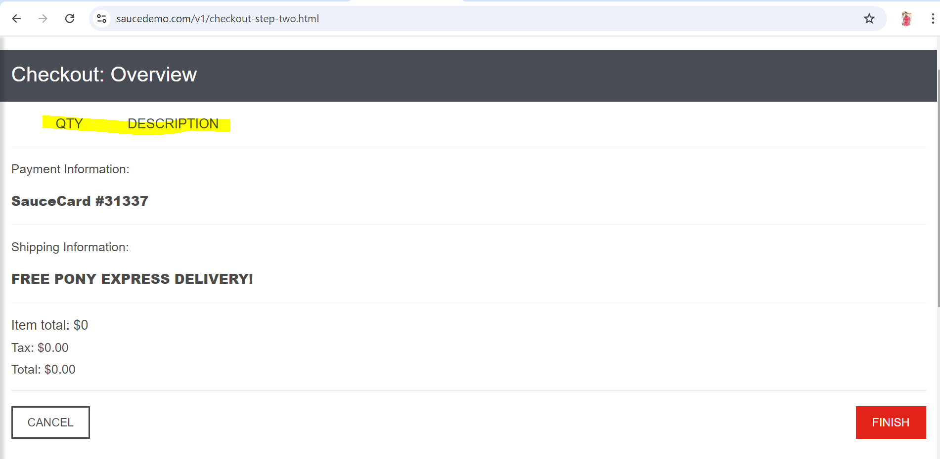

**Expected Result:**

1. Navigate to login page  
2. Enter valid username  
3. Enter valid password  
4. Click login  
5. Navigate to inventory page

6. Click on ‘Cart’ icon

7. Navigate to cart page

8. Proceed to checkout without items

**9. Error to be show and not allow user to navigate without minimum of 1 product**

**Actual Result:**

1. Navigate to login page  
2. Enter valid username  
3. Enter valid password  
4. Click login  
5. Navigate to inventory page

6. Click on ‘Cart’ icon

7. Navigate to cart page

8. Proceed to checkout without items

9. Fill Name & address and click on ‘Continue’

10. Click on ‘Finish’ and order is placed

**Impact:** High as it breaks a crucial functionality of the user journey.

# Defect#2 – Privacy Policy/Terms of service- Hyperlink not working

**Steps to Reproduce:**

1. Navigate to login page  
2. Enter valid username  
3. Enter valid password  
4. Click login  
5. Navigate to inventory page

6. Click on ‘Privacy policy’ & ‘Terms of Service’ at the end of the page

7. No action is performed

## 

**Expected Result:**

1. Navigate to login page  
2. Enter valid username  
3. Enter valid password  
4. Click login  
5. Navigate to inventory page

6. Click on ‘Privacy policy’ & ‘Terms of Service’ at the end of the page

**7. Hyperlink should be actionable and takes to the document.**

**Actual Result:**

1. Navigate to login page  
2. Enter valid username  
3. Enter valid password  
4. Click login  
5. Navigate to inventory page

6. Click on ‘Privacy policy’ & ‘Terms of Service’ at the end of the page

7. No action is performed

**Impact:** ‘Medium’ as user privacy policy is crucial.

# Defect#3 – Social Media- Hyperlink not working

**Steps to Reproduce:**

1. Navigate to login page  
2. Enter valid username  
3. Enter valid password  
4. Click login  
5. Navigate to inventory page

6. Click on ‘Social media’ icons at the end of the page

7. No action is performed

## 

**Expected Result:**

1. Navigate to login page  
2. Enter valid username  
3. Enter valid password  
4. Click login  
5. Navigate to inventory page

6. Click on ‘Social media’ icons at the end of the page

7. It should take to the application corresponding social media

**Actual Result:**

1. Navigate to login page  
2. Enter valid username  
3. Enter valid password  
4. Click login  
5. Navigate to inventory page

6. Click on ‘Social media’ icons at the end of the page

7. No action is performed

**Impact:** ‘Low’ as user Social media is not crucial for business.