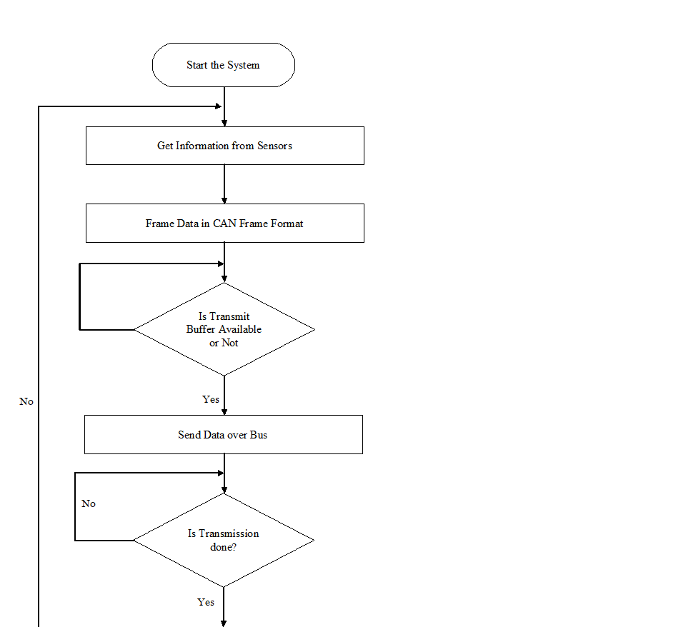

**Figure - Node A Flowchart**