# Mutual Fund Analytics Platform

## 1. Executive Summary

The Mutual Fund Analytics Platform was developed to analyze mutual fund performance, investor behavior, and risk metrics using Python, SQL, and Power BI. The project integrates multiple datasets including NAV history, Assets Under Management (AUM), SIP inflows, investor transactions, portfolio holdings, and benchmark data.

The project followed a complete analytics workflow consisting of data extraction, cleaning, transformation, database creation, exploratory data analysis, performance evaluation, advanced analytics, and dashboard development. Financial metrics such as CAGR, Sharpe Ratio, Sortino Ratio, Alpha, Beta, Maximum Drawdown, and Fund Score were calculated to evaluate fund performance and risk-adjusted returns.

An interactive Power BI dashboard was developed with four pages: Executive Overview, Fund Performance, Investor Analytics, and Risk Analytics. The platform provides valuable insights into mutual fund performance, investor participation, and risk management.

---

## 2. Data Sources

The project utilized multiple datasets covering different aspects of the mutual fund ecosystem.

### Datasets Used

- Fund Master Data
- NAV History Data
- Assets Under Management (AUM) Data
- SIP Inflow Data
- Category Inflow Data
- Benchmark Data
- Folio Statistics Data
- Scheme Performance Data
- Investor Transactions Data
- Portfolio Holdings Data

These datasets collectively provided information regarding fund performance, investor activity, benchmark comparison, and portfolio composition.

---

## 3. ETL Design

An ETL (Extract, Transform, Load) pipeline was developed using Python and Pandas to prepare the datasets for analysis.

### Extract

Data was collected from multiple CSV files containing mutual fund-related information.

### Transform

Data cleaning and preprocessing activities included:

- Missing value treatment
- Date format standardization
- Duplicate record removal
- Column standardization
- Data validation checks
- Data type conversion

### Load

The cleaned datasets were loaded into a SQLite database to enable structured storage and efficient querying.

### Benefits of ETL Pipeline

- Improved data quality
- Consistent data structure
- Faster analytical processing
- Better scalability and maintainability

---

## 4. Exploratory Data Analysis (EDA)

Exploratory Data Analysis was performed to identify trends, patterns, and relationships within the mutual fund data.

### Analyses Performed

#### NAV Trend Analysis

Daily NAV movements were analyzed across mutual fund schemes to understand performance trends over time.

#### AUM Growth Analysis

Assets Under Management growth was examined across fund houses to identify market leaders and growth patterns.

#### SIP Inflow Analysis

Monthly SIP inflows were analyzed to evaluate investor participation and investment trends.

#### Category Inflow Analysis

Different mutual fund categories were compared to understand investor preferences.

#### Investor Demographics

Investor information was analyzed using age groups, gender categories, and geographic distribution.

#### Sector Allocation Analysis

Portfolio holdings were aggregated to evaluate sector exposure across mutual fund schemes.

### Key EDA Findings

- Strong growth in SIP participation was observed.
- AUM increased significantly during the analysis period.
- Equity-oriented schemes attracted the highest investor interest.
- Investor participation expanded across both T30 and B30 cities.

---

## 5. Performance Analysis

Several industry-standard financial metrics were calculated to evaluate fund performance.

### CAGR (Compound Annual Growth Rate)

CAGR was calculated to measure annualized growth of mutual fund schemes over the selected period.

### Sharpe Ratio

Sharpe Ratio was used to evaluate risk-adjusted returns based on a risk-free rate assumption of 6.5%.

### Sortino Ratio

Sortino Ratio measured returns while considering downside risk only.

### Alpha and Beta

Alpha and Beta values were calculated relative to benchmark indices to assess fund manager performance and market sensitivity.

### Maximum Drawdown

Maximum Drawdown was computed to identify the largest decline experienced by each fund.

### Fund Score

A composite Fund Score was developed by combining:

- Return Rank
- Sharpe Ratio Rank
- Alpha Rank
- Expense Ratio Rank
- Drawdown Rank

### Generated Outputs

- alpha_beta.csv
- fund_scorecard.csv
- benchmark_comparison.png

---

## 6. Dashboard Development

A multi-page Power BI dashboard was developed to provide interactive insights.

### Executive Overview

The Executive Overview page presents high-level metrics including:

- Total AUM
- Total SIP Inflow
- Total Folios
- AUM Growth Trends

### Fund Performance

The Fund Performance page includes:

- Top Funds by 3-Year Return
- Top Funds by Sharpe Ratio
- Risk vs Return Analysis
- Category Filtering

### Investor Analytics

The Investor Analytics page provides:

- Age Group Distribution
- Gender Distribution
- T30 vs B30 Analysis
- State-wise Investment Distribution

### Risk Analytics

The Risk Analytics page includes:

- Top Funds by Sharpe Ratio
- Top Funds by Fund Score
- Top Funds by 3-Year Return
- Alpha vs Beta Analysis

---

## 7. Dashboard Screenshots

### Executive Overview Dashboard

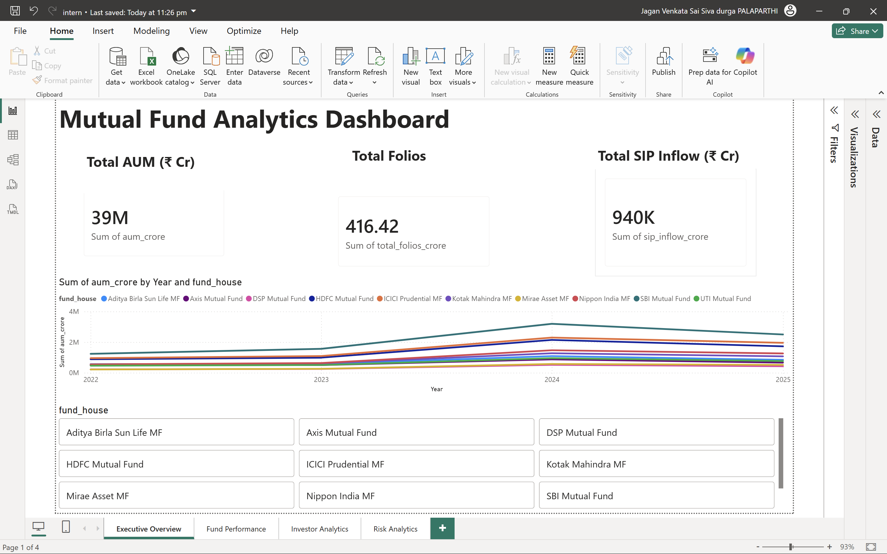

### Fund Performance Dashboard
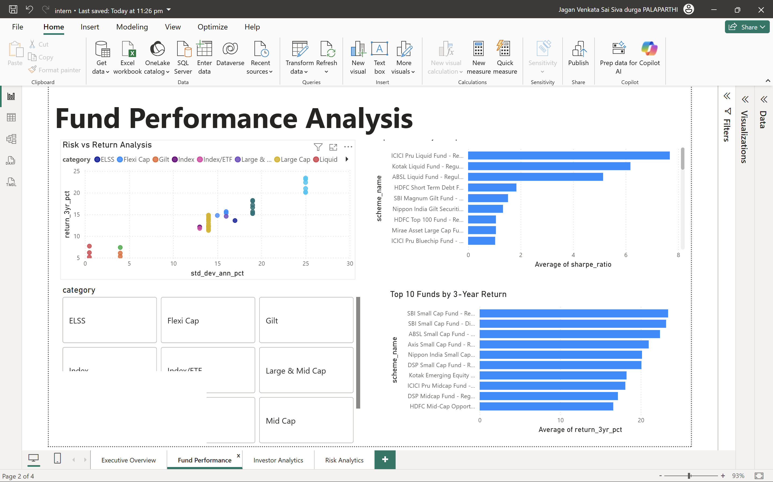
### Investor Analytics Dashboard
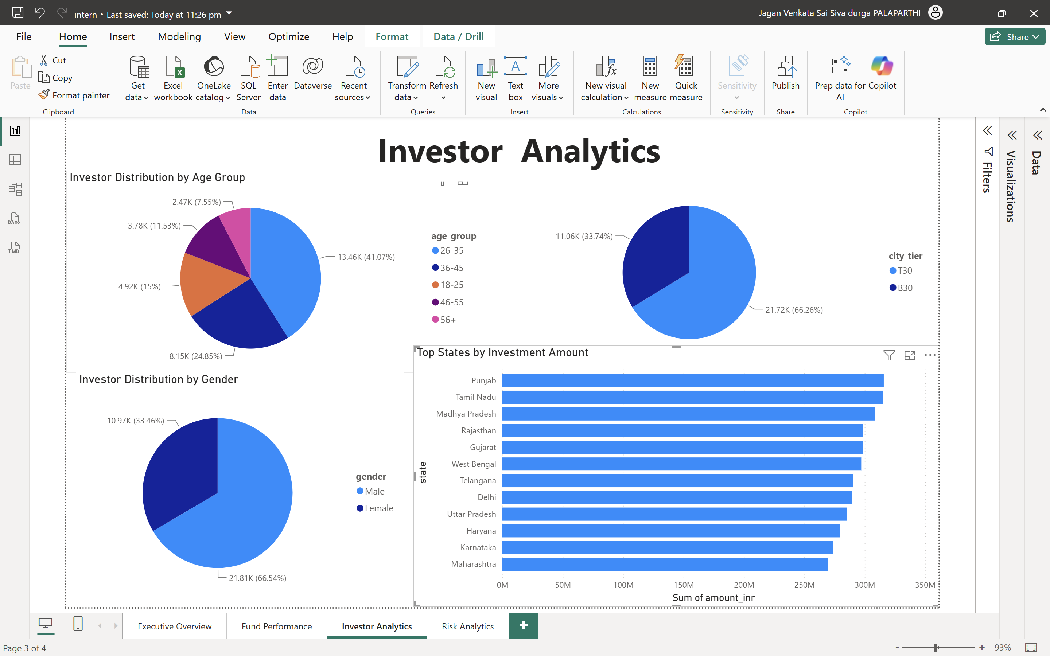
### Risk Analytics Dashboard

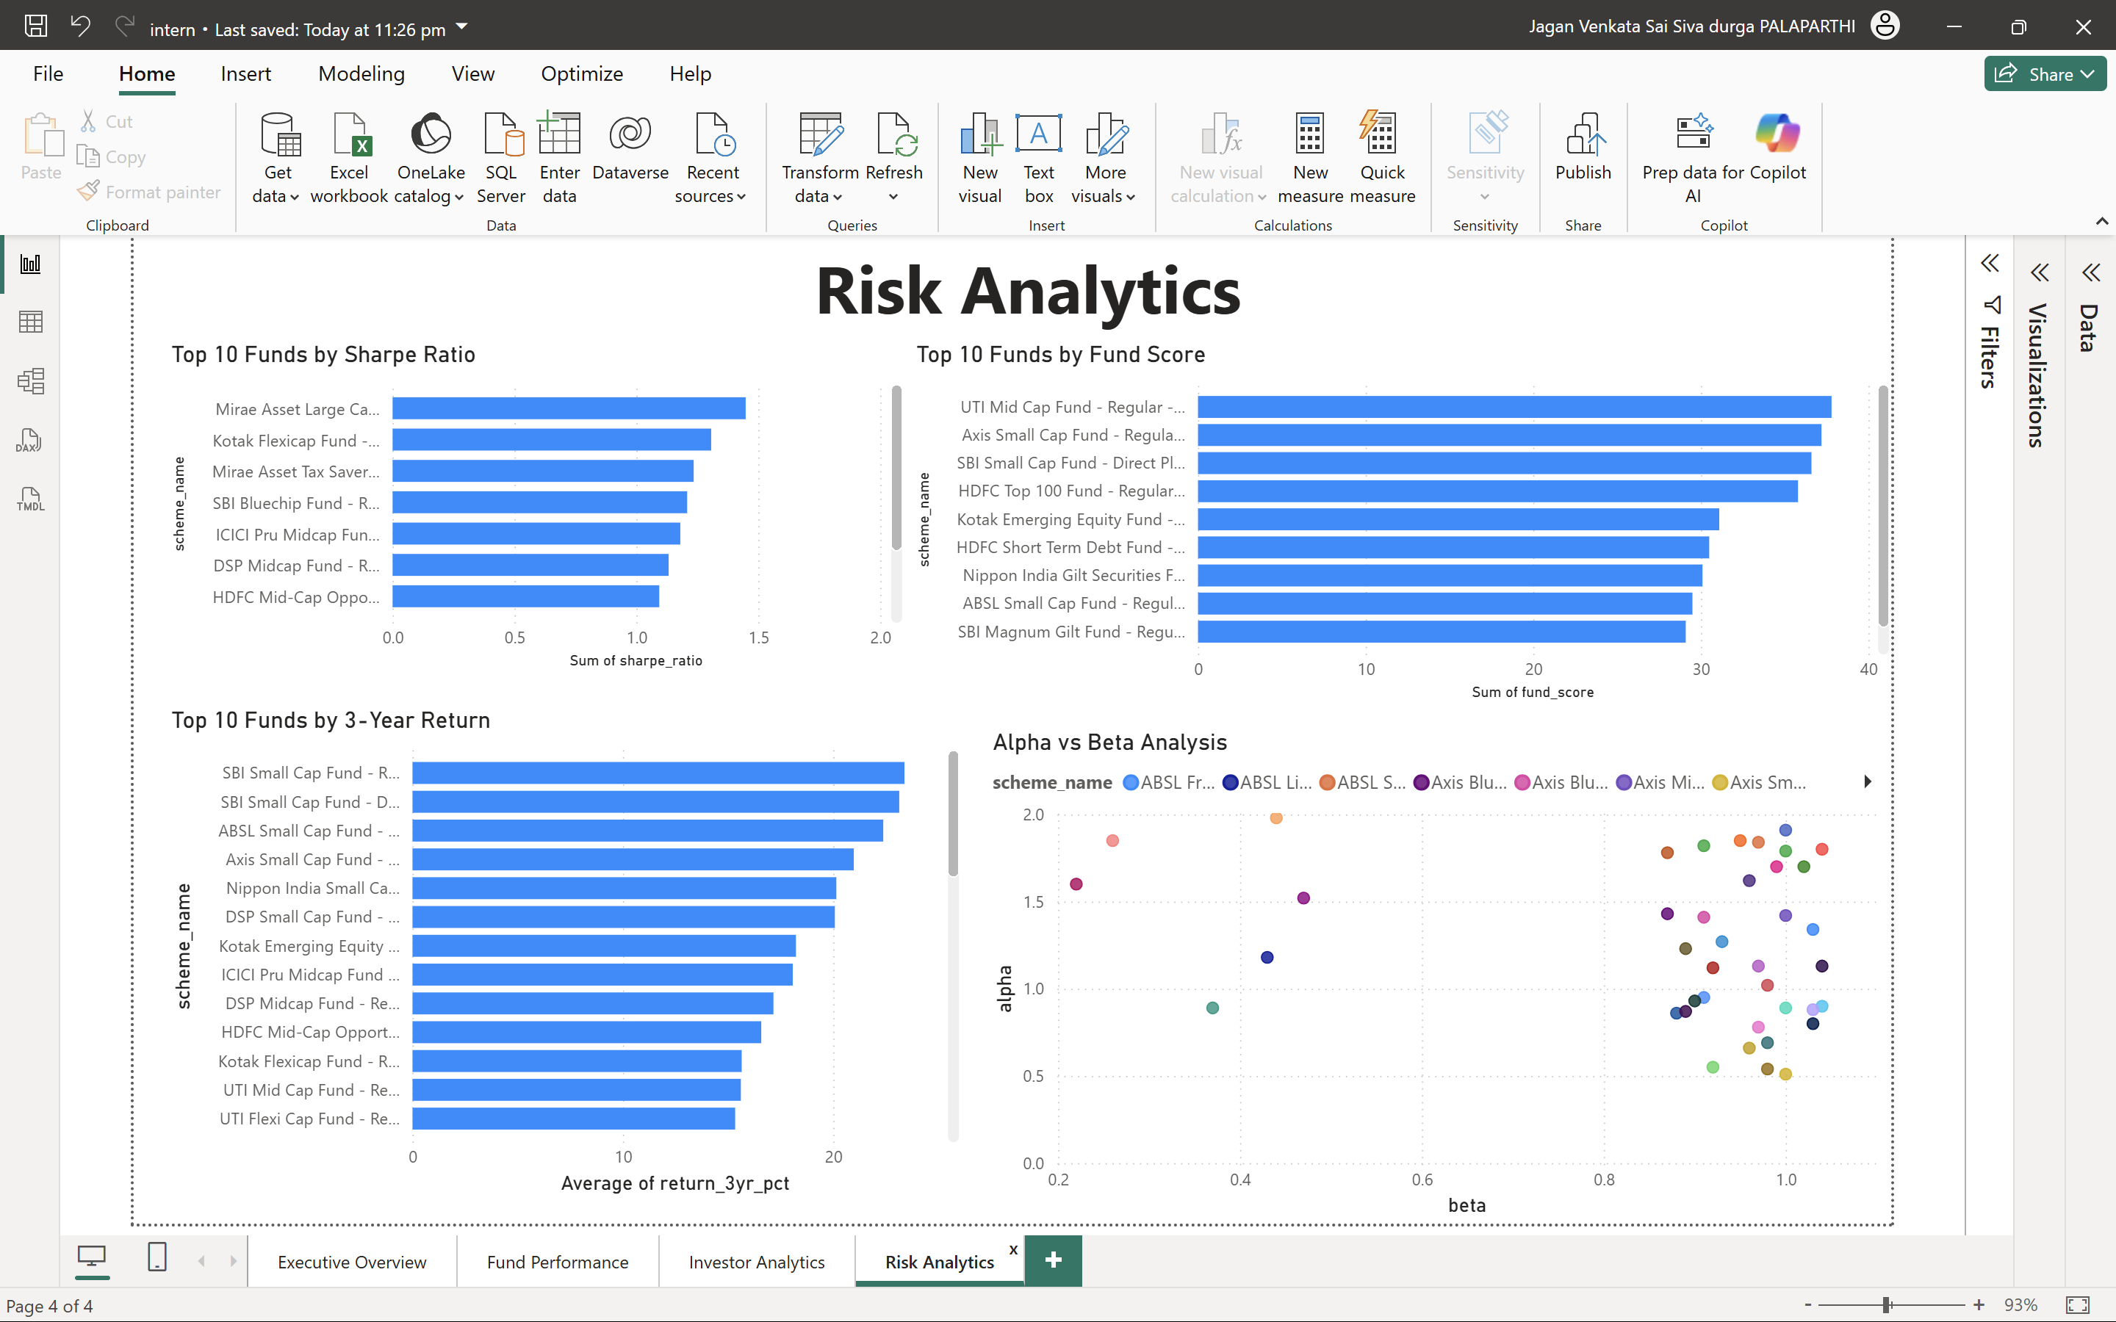
---

## 8. Limitations

The project has several limitations:

- Analysis is dependent on the quality of source datasets.
- Historical performance does not guarantee future returns.
- Benchmark coverage may be limited for certain schemes.
- Market conditions can significantly affect performance metrics.

---

## 9. Recommendations

Based on the analysis, the following recommendations are suggested:

- Continuously monitor risk-adjusted performance metrics.
- Expand investor participation in B30 cities.
- Improve portfolio diversification across sectors.
- Use dashboard insights for informed investment decision-making.
- Regularly update benchmark and market data.

---

## 10. Conclusion

The Mutual Fund Analytics Platform successfully integrates data engineering, exploratory analysis, performance evaluation, risk assessment, and business intelligence reporting into a single solution.

The project demonstrates practical application of Python, SQL, data analytics, financial modeling, and Power BI. The resulting platform provides meaningful insights into mutual fund performance, investor behavior, and risk characteristics while supporting data-driven decision-making.

