Here I use CRUD operation using MVC and entity framework 6.0 in Visual Studio 2015 Community edition. I used Microsoft SQL Server 2008 Express edition for creating database.

Database schema is given below:

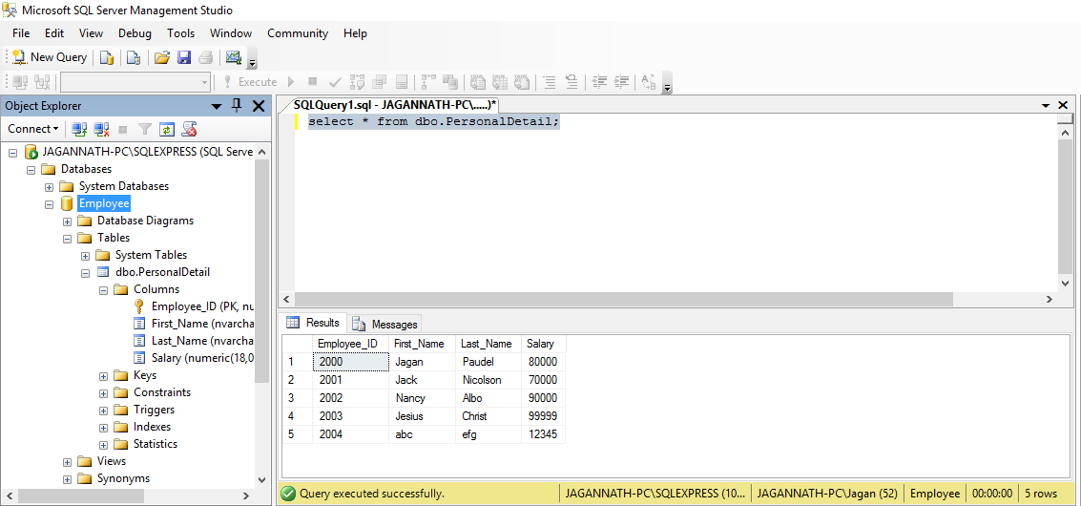

I created CRUDWebAPI project as service provider and CRUDWebAPI_Client as service consumer. CRUDWebAPI_Client call

BASE_URL = "http://localhost:54551/";

using

using System.Net.Http.Formatting;

using System.Net.Http;

using System.Net.Http.Headers;

and Newtonsoft.Json version 8.0.1.

Create page is given below:

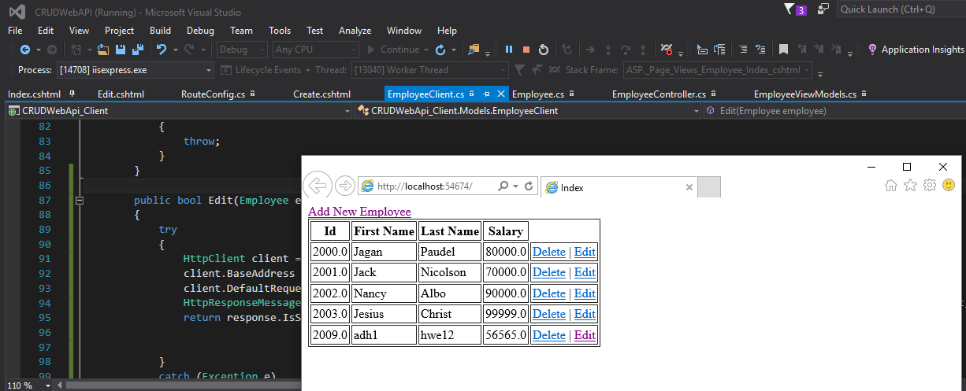

Add Employee Page is given below:

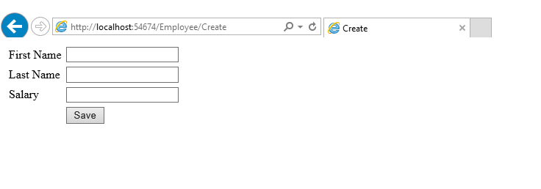

Edit Page is given below:

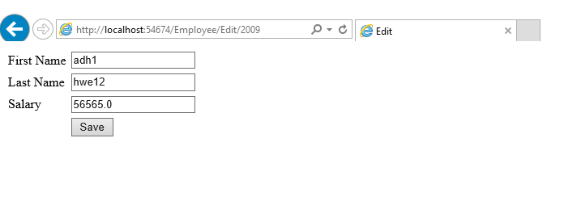

Delete page is given below:

