DEPARTMENT OF CSE, CS&IT, AI&DS
COURSE CODE: 24SDCS02 / 24SDCS02E / 24SDCS02P / 24SDCS02L FULL STACK APPLICATION DEVELOPMENT

Regid: 2400032700 Name: U.Vijay Kumar

#SKILL - 3 ➔ Working with HQL - Sorting, Pagination & Aggregates
Prerequisites:
- Basic knowledge of Hibernate
- Basic idea of HQL syntax

In this lab, you will extend the Hibernate module created in Skill 2 and perform advanced data retrieval using HQL, including sorting, pagination, filtering, and aggregate functions. These operations help in retrieving structured and meaningful data from the database using Hibernate.

Tasks:

- Use the Product entity created in Skill 2.
- Add 5–8 additional Product records into the database.
- Write HQL queries to retrieve all products sorted by price:
  - Ascending order
  - Descending order
- Write an HQL query to sort products by quantity (highest first).
- Implement pagination using HQL to display:
  - First 3 products
  - Next 3 products
- Write HQL queries for aggregate operations:
  - Count total number of products
  - Count products where quantity > 0
  - Count products grouped by description
  - Find minimum and maximum price
- Write an HQL query using GROUP BY to group products by description.
- Write an HQL query using WHERE to filter products within a price range.
- Write HQL queries using LIKE such as:
  - Names starting with certain letters
  - Names ending with certain letters
  - Names containing a pattern anywhere (substring)
  - Names with an exact character length
1. Use the Product entity created in Skill 2.
package com.klu.model;

import javax.persistence.*;

@Entity
@Table(name="product")
public class Product {
@Id
@GeneratedValue(strategy=GenerationType.IDENTITY)
int id;
private String name;
private String description;
private double price;
private int quantity;

public Product() {

}

public void setName(String name ) {
this.name = name;
}

public String getName() {
return name;
}

public void setDescription(String description) {
this.description = description;
}

public String getDescription() {
return description;
}

public void setPrice(double price ) {
this.price = price;
}

public double getPrice() {
return price;
}

public void setQuantity(int quantity ) {
this.quantity = quantity;
}

public int getQuantity() {
return quantity;
}

}

2. Add 5–8 additional Product records into the database.
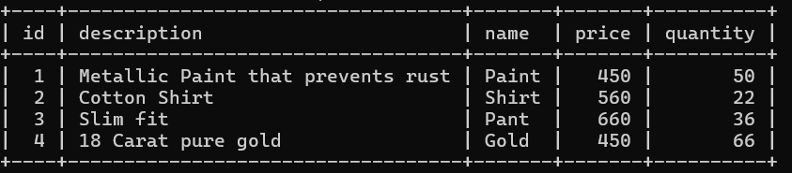

3.Write HQL queries to retrieve all products sorted by price:
  - Ascending order
  - Descending order

- private static void viewProductAsc() {
Session session = factory.openSession();
Query<Product> q = session.createQuery("from Product order by price", Product.class);
System.out.println("\nName | Description | Price | Quantity");
for (Product e : q.list()) {
System.out.println(e.getName() + " | " + e.getDescription() + " | " +
e.getPrice() + " | " + e.getQuantity());
}
session.close();
}

- private static void viewProductDesc() {
Session session = factory.openSession();
Query<Product> q = session.createQuery("from Product order by price desc", Product.class);
System.out.println("\nName | Description | Price | Quantity");
for (Product e : q.list()) {
System.out.println(e.getName() + " | " + e.getDescription() + " | " +
e.getPrice() + " | " + e.getQuantity());
}
session.close();
}

4.Write an HQL query to sort products by quantity (highest first).
private static void viewProductByQuantity() {
Session session = factory.openSession();
Query<Product> q = session.createQuery("from Product order by quantity desc", Product.class);
System.out.println("\nName | Description | Price | Quantity");
for (Product e : q.list()) {
System.out.println(e.getName() + " | " + e.getDescription() + " | " +
e.getPrice() + " | " + e.getQuantity());
}
session.close();
}

5. Implement pagination using HQL to display:
  - First 3 products
  - Next 3 products
g. private static void getFirstThreeProducts() {
Session session = factory.openSession();
Query<Product> q = session.createQuery("from Product", Product.class);
q.setFirstResult(0);
q.setMaxResults(3);
System.out.println("\nName | Description | Price | Quantity");
for (Product e : q.list()) {
System.out.println(e.getName() + " | " + e.getDescription() + " | " +
e.getPrice() + " | " + e.getQuantity());
}
session.close();
}
h. private static void getNextThreeProducts() {
Session session = factory.openSession();
Query<Product> q = session.createQuery("from Product", Product.class);
q.setFirstResult(3);
q.setMaxResults(3);
System.out.println("\nName | Description | Price | Quantity");
for (Product e : q.list()) {
System.out.println(e.getName() + " | " + e.getDescription() + " | " +
e.getPrice() + " | " + e.getQuantity());
}
session.close();
}

6. Write HQL queries for aggregate operations:
  - Count total number of products
  - Count products where quantity > 0
  - Count products grouped by description
  - Find minimum and maximum price

private static void aggregateFunctions() {
Session session = factory.openSession();
Query q1 = session.createQuery("select count(*) from Product");
long totalProducts = (Long) q1.uniqueResult();

Query q2= session.createQuery("select count(*) from Product where quantity>0");
long totalProducts1 = (Long) q2.uniqueResult();

Query q3 = session.createQuery("select count(*) from Product group by description");
long totalProducts2 = (Long) q3.uniqueResult();

Query q4 = session.createQuery("select max(price) from Product");
double maxPrice = (Double) q4.uniqueResult();

Query q5 = session.createQuery("select min(price) from Product");
Double minPrice = (Double) q5.uniqueResult();

System.out.println("\nTotal Number of Products: "+totalProducts);
System.out.println("Total Number of Products whose quantity is greater than zero: "+totalProducts1);
System.out.println("Total Number of Products grouped by description: "+totalProducts2);
System.out.println("Minimum Price: "+minPrice);
System.out.println("Maximum Price: "+maxPrice);

}

7. Write an HQL query using GROUP BY to group products by description.

private static void groupProductsByDesc() {
Session session = factory.openSession();
Query<Product> q = session.createQuery("from Product group by description", Product.class);
System.out.println("\nName | Description | Price | Quantity");
for (Product e : q.list()) {
System.out.println(e.getName() + " | " + e.getDescription() + " | " +
e.getPrice() + " | " + e.getQuantity());
}
session.close();
}

8. Write an HQL query using WHERE to filter products within a price range.
private static void getProductsWithinPriceRange() {
Scanner sc = new Scanner(System.in);
Session session = factory.openSession();
System.out.print("\nEnter the minimum price: ");
double mini=sc.nextDouble();
System.out.print("\nEnter the maximum price: ");
double maxi=sc.nextDouble();
Query<Product> q = session.createQuery("from Product where price between :min and :max", Product.class);
q.setParameter("min",mini);
q.setParameter("max",maxi);
System.out.println("\nName | Description | Price | Quantity");
for (Product e : q.list()) {
System.out.println(e.getName() + " | " + e.getDescription() + " | " +
e.getPrice() + " | " + e.getQuantity());
}
session.close();

}
9. Write HQL queries using LIKE such as:
  - Names starting with certain letters
  - Names ending with certain letters
  - Names containing a pattern anywhere (substring)
  - Names with an exact character length
- private static void productSearchByPattern() {
- Scanner sc = new Scanner(System.in);
- Session session = factory.openSession();
- System.out.print("\nEnter the product name pattern: ");
- String s = sc.nextLine();

- Query<Product> q = session.createQuery("FROM Product WHERE name LIKE :name", Product.class);
- q.setParameter("name", s + "%");
- System.out.println("\nName | Description | Price | Quantity");
- for (Product e : q.list()) {
- System.out.println(e.getName() + " | " + e.getDescription() + " | " +
- e.getPrice() + " | " + e.getQuantity());
- }
- session.close();

- }

10.Push the Hibernate project to GitHub.
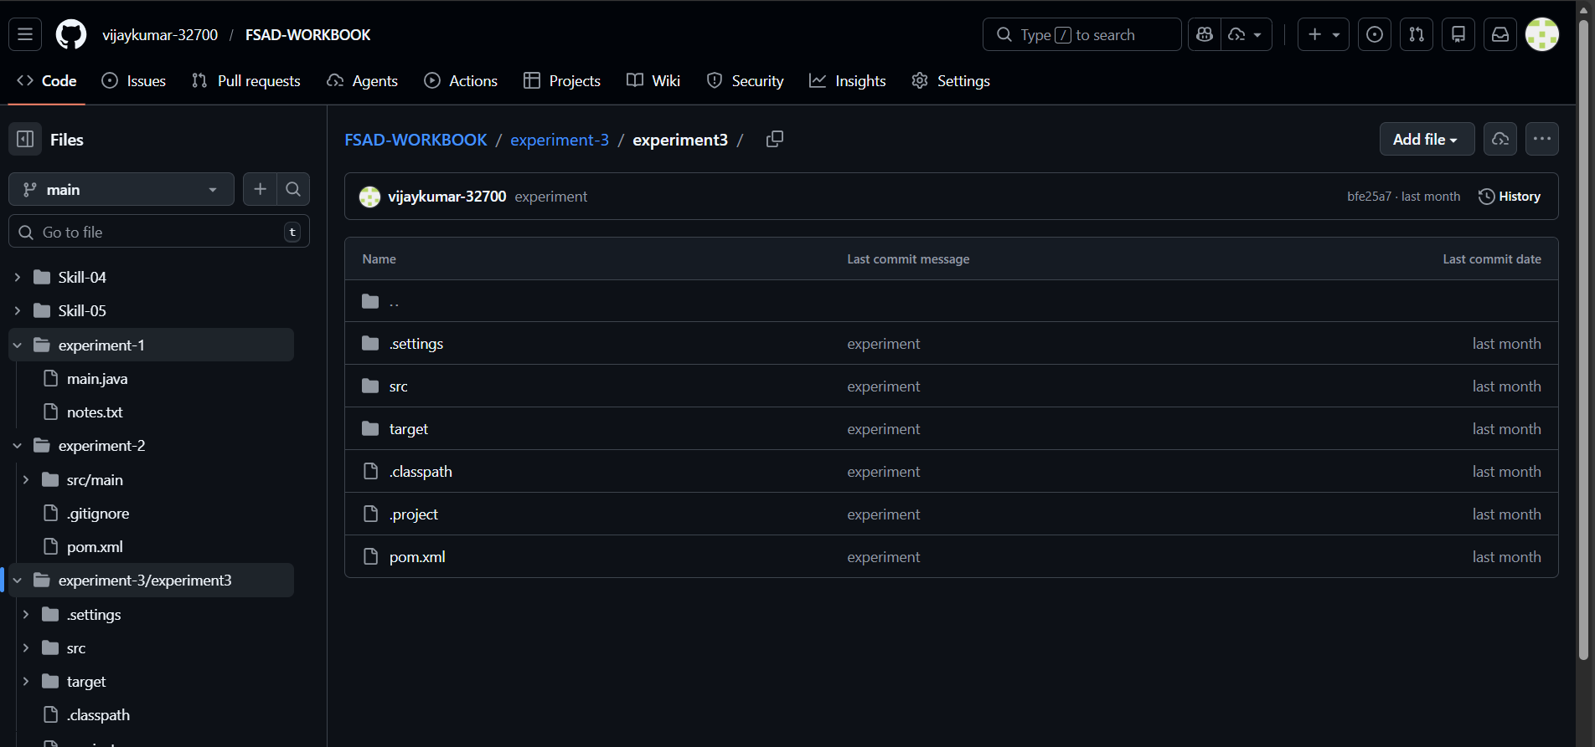

OUTPUT
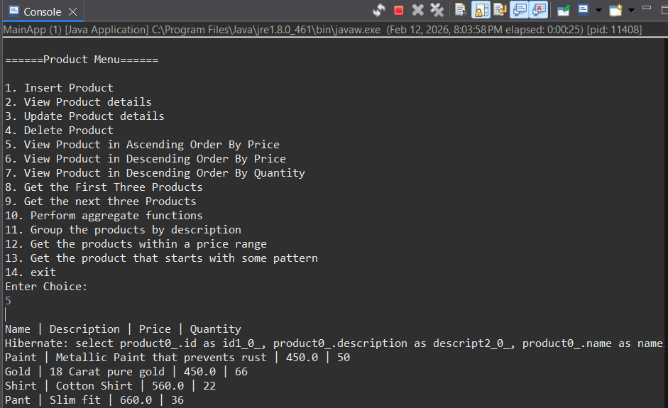

VIVA QUESTIONS:

- What is HQL and how does it differ from SQL?
- Why do we use sorting in HQL?
- What is pagination and where is it used?
- Name any three aggregate functions supported in HQL.
- What is the difference between HQL and HCQL (Hibernate Criteria Query Language)?

1. What is HQL and how does it differ from SQL?
HQL stands for Hibernate Query Language.
It is an object-oriented query language.
HQL works with entity classes and properties.
SQL works directly with database tables and columns.
HQL is database-independent, SQL is not.

2. Why do we use sorting in HQL?
Sorting is used to arrange query results in a specific order.
It improves data readability.
Sorting is done using the ORDER BY clause.
It can be ascending or descending.
Commonly used for reports and UI display.

3. What is pagination and where is it used?
Pagination divides large data into smaller pages.
It improves application performance.
Only a limited number of records are fetched at a time.
It is commonly used in web applications.
Examples include product lists and search results.

4. Name any three aggregate functions supported in HQL.
COUNT() counts the number of records.
SUM() calculates the total of values.
AVG() finds the average value.
Aggregate functions operate on groups of data.
They are often used with GROUP BY.

5. What is the difference between HQL and HCQL (Hibernate Criteria Query Language)?
HQL is string-based and written as queries.
HCQL is object-oriented and API-based.
HQL is easier for simple queries.
HCQL is better for dynamic queries.
HCQL provides compile-time type safety.

(For Evaluator’s use only)

 | Comment of the Evaluator (if Any) |  | Evaluator’s Observation  Marks Secured: out of  EMP ID & Full Name of the Evaluator:  Signature of the Evaluator Date of Evaluation:

