Cyclistic Bike-Share Case Study

By: Andy Garza

# 1. Business Task (ASK)

Cyclistic, a bike-share company in Chicago, aims to increase the number of annual members, as they are more profitable than casual riders. As a junior data analyst on the marketing team, my task is to analyze how annual members and casual riders use Cyclistic bikes differently. These insights will help the marketing team design targeted strategies to convert casual riders into members.  
  
Guiding Question:  
How do annual members and casual riders use Cyclistic bikes differently?

# 2. Data Sources (PREPARE)

The analysis uses public datasets provided by Motivate International Inc., available at: https://divvy-tripdata.s3.amazonaws.com/index.html  
  
Due to memory limitations in RStudio Cloud, only two datasets were used:  
- Divvy_Trips_2019_Q1.csv  
- Divvy_Trips_2020_Q1.csv  
  
These files contain details such as:  
- Start and end timestamps  
- Bike type  
- Start and end stations  
- User type (member or casual)  
  
Privacy-compliant: Data information gathered from public datasets.  
  
ROCCC Check:  
- Reliable: From Motivate, an official operator  
- Original: Directly from source  
- Comprehensive: Includes key attributes like duration and user type  
- Current: Though dated, relevant for the business question for this Case Study  
- Cited: Data used under public license

# 3. Data Cleaning and Preparation (PROCESS)

Data preparation was conducted in R using the tidyverse package. Key steps included:  
  
1. Column Standardization:  
- Renamed columns in 2019 dataset to match 2020 structure.  
  
2. Dataset Merging:  
- Combined both datasets into one unified table using bind_rows().  
  
3. Data Type Consistency:  
- Ensured columns like ride_id and rideable_type were characters.  
  
4. Column Removal:  
- Dropped unused fields like latitude, longitude, gender, and birthyear.  
  
5. Label Normalization:  
- Replaced old labels ('Subscriber', 'Customer') with 'member' and 'casual'.  
  
6. Feature Engineering:  
- Added new fields: ride_length, day_of_week, month, day, and year.  
  
7. Data Filtering:  
- Removed rides with negative duration or marked as maintenance (e.g., HQ QR).  
  
These steps ensured the dataset was accurate, consistent, and ready for analysis.

# 4. Summary of Analysis (ANALYZE)

Descriptive analysis was conducted on the cleaned and combined dataset using R. The focus was on comparing annual members and casual riders in terms of:  
- Total number of rides  
- Ride duration (mean, median, max, min)  
- Usage patterns by day of the week  
  
Key operations included:  
- Aggregating ride counts and durations by user type and weekday  
- Calculating summary statistics for ride_length  
- Sorting and grouping data using dplyr  
- Creating two main visualizations using ggplot2  
  
The data showed clear differences in behavior between user types, which are explored in the visualizations below.

# 5. Supporting Visualizations and Key Findings (SHARE)

## Visualization 1: Number of Rides by Rider Type and Weekday

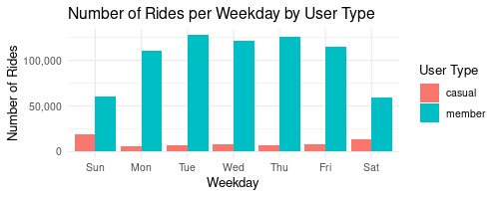

Key Findings:  
- Casual riders peak on weekends (Saturday & Sunday).  
- Members maintain consistent activity during weekdays (especially Monday–Friday).  
- Suggests members use the service primarily for commuting.

## Visualization 2: Average Ride Duration by Rider Type and Weekday

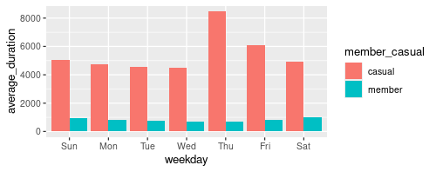Key Findings:  
- Casual riders take longer rides on average.  
- Longer durations are especially noticeable on weekends.  
- Indicates casual riders use bikes for leisure activities.

These insights support the development of targeted marketing strategies aimed at converting high-usage casual riders into annual members.

# 6. Recommendations and Next Steps (ACT)

## Final Conclusion

The analysis of Cyclistic’s bike-share data reveals clear behavioral differences between annual members and casual riders:  
- Casual riders are more active on weekends and tend to take longer rides, suggesting they use the service for leisure.  
- Annual members ride more consistently throughout the workweek, with shorter average durations, indicating regular commuting.  
  
These insights support the need for targeted marketing strategies to convert high-usage casual riders into annual members.

## Top Three Recommendations

**1. Launch Weekend Membership Promotions for Casual Riders**

- Offer time-limited weekend discounts or trial memberships to casual users who ride frequently on Saturdays and Sundays.  
- Promote via app notifications, email campaigns, and QR codes at high-traffic weekend stations.

**2. Develop a “Frequent Rider” Loyalty Program**

- Reward casual riders who use the service more than X times per month with discounts toward an annual membership.  
- This creates incentive for committed casual users to convert.

-Limit the service to no more than X times per month to casual riders to force a chance into annual membership, or wait a few days to unlock more riding days.

**3. Target Digital Campaigns Based on Ride Behavior**

- Use ride history to segment casual users and run social media or in-app campaigns focused on the benefits of annual membership (cost savings, convenience, unlimited rides).

-Limit the service to no more than X times per month to casual riders to force a chance into annual membership, or wait a few days to unlock more riding days.

- Emphasize commute-friendly perks like priority access to bikes during weekday mornings.

- Expand priority access to bikes not only during weekday but also weekends.

## Next Steps

- Portfolio: Add this case study and visualizations to my data analytics portfolio.  
- Presentation Practice: Prepare a brief presentation (slides or verbal pitch) to practice communicating these findings to stakeholders.  
- Additional Data: To improve this analysis, future data could include:  
 • Weather conditions (to confirm seasonal patterns),  
 • Demographic info (anonymized) for better audience targeting,  
 • In-app engagement data (to measure marketing impact).