2019 mutual funds

Axis Bluchinp Funds
Canara Robeco bluechip equeity

MultiCap
Mirae Asset Inida Equity Funds.
Kotak Standard Multicap Funds.

Mid Cap
Invesco India Equerity Funds.
L&T MidCap fund

Large And MidCap

Sundramp Large and MidCap Fund
Invesco India Growth Opportunityes Funds.

1. Axis bluechip 3500 rs.
2. L&t midcap 2000 rs
3. Hdfc small cap 2000 rs
4.Absl tax relief 2500 rs
5. Parag parikh long term equity 2500

Introduction Web Service

KEY TERMINOLOGY

- Request and Response
- Message Exchange Format
- XML and JSON
- Service Provider or Server
- Service Consumer or Client
- Service Definition
- Transport
- HTTP and MQ

- Request and Response
Request is input what need to pass to the service what type data or content type accept and response are out put from webservice it may be xml or JSON formate.

- XML and JSON
XML and JSON type of input and output which type service wil take as input and produce as output
- Service Provider or Server
Service Provider or Server means which will provide service based on request
- Service Consumer or Client
Service consumer means it consume the data based on requested data by clinet
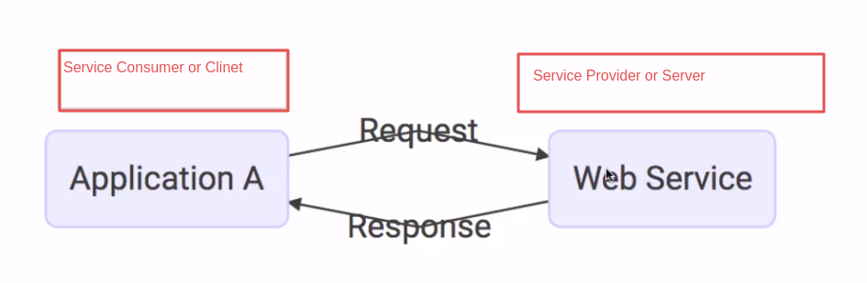
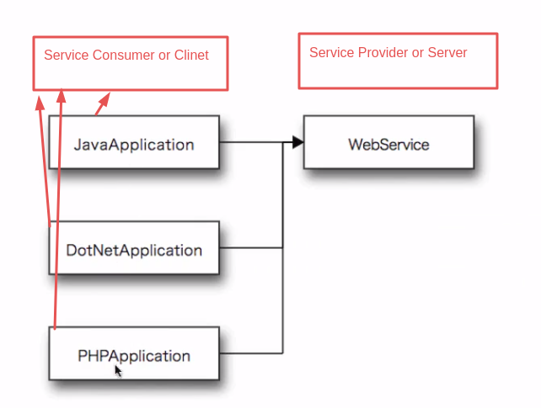

- Service Definition
Service Definition is define the formate for request and response input and output data type format, it may be JSON or XML format
Request Structure(like method type , request url type Path variable or Rerquest Params) and mandatory field.
Response Structure: it will define the whole structure of response what are the filed are availabe and what the mandatory field.
EndPoint means where is service is avilable (like URL).
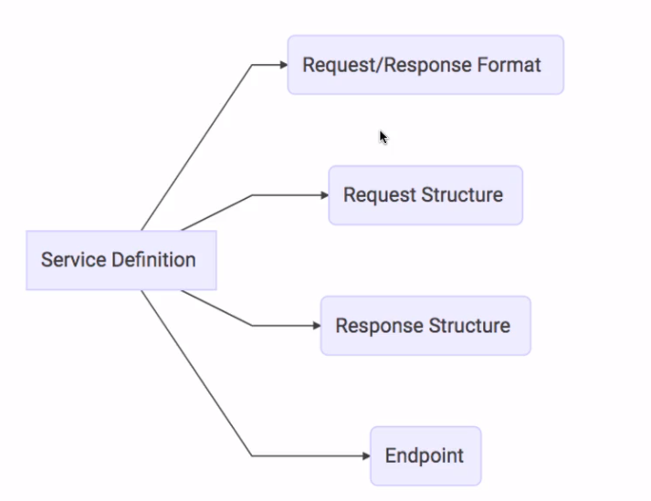

- Transport
Transport is define how is service is called , it service exposed in URL or service is exponse MQ two popular format are avilable HTTP and MQ

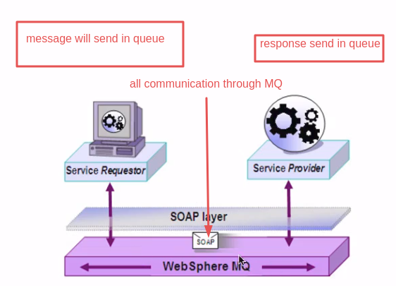

Type Of Web Service
- SOAP based web Service(Simple Object Access Protocol)
- RESTFULL web service
SOAP
SOAP is define special way of building web service in SOAP all communiction will happed in XML format. SOAP is define special structure for communication it not only the XML
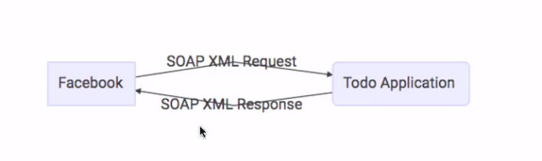
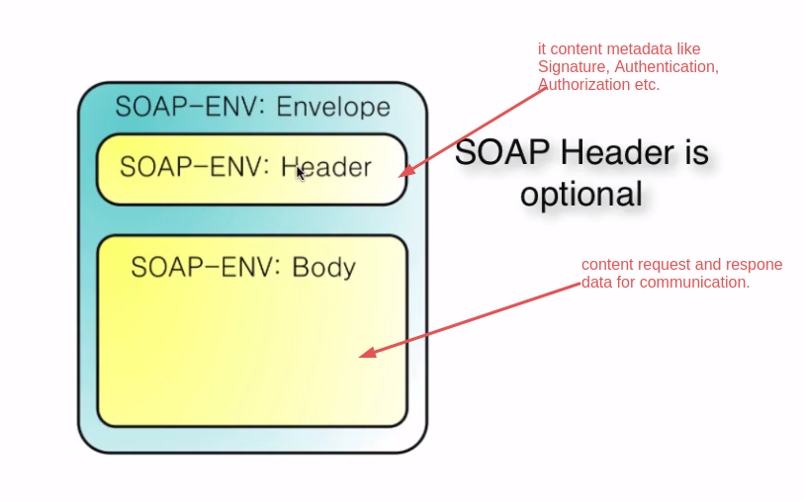
XML structure for SOAP request

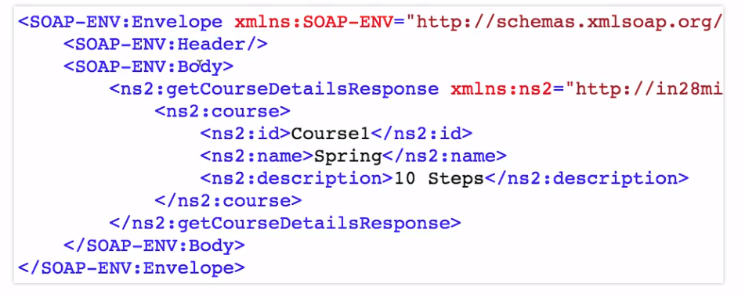

SOAP

- Format
- SOAP XML Request
- SOAP XML Response
- Transport
- SOAP over MQ
- SOAP over HTTP
- Service Defintion
- WSDL

WSDL(Web Service Definition Language)
WSDL is define EndPoint where is our service is exposed (avilable) ,
All Operation: define the all operation is avilabe to performs(update, delete,save the records ect).
Request strucuture : it define the input request what the parametes and method type is required for performs the operations
Response Structure: It define the structure of reponse what kind of reponse we can accept.

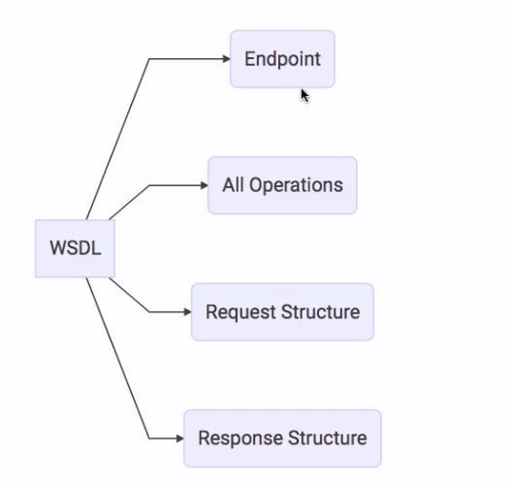

REST web service (Representational State Transfer )
REST web service is designed for based used of HTTP , all opertion are performs our the HTTP enviorment

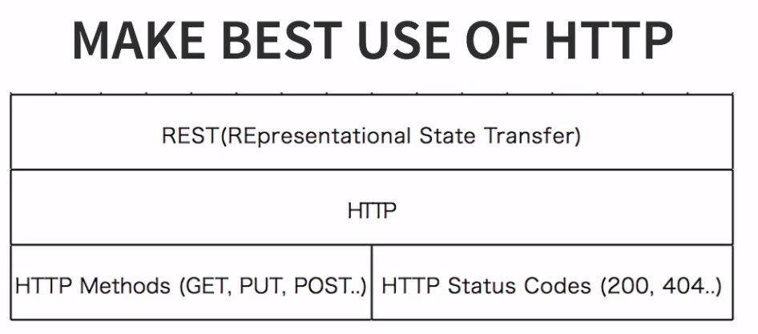

REST

Data Exchange Format
No Restriction.JSON is popular
Transport
allow only the HTTP
Service Definition
No Standard. It may be WADL/Swagger etc.

REST VS SOAP
Restrictions vs Architectral Approach.
Data Exchange Format (SOAP XML, REST XML,JSON or other format).
Service Definition( SOAP WSDL REST doesnt have special language (WADL/Swagger we can use)).
Transport(SOAP HTTP or MQ, REST only HTTP).
Ease Of implementation (Rest implementation is easy as compare to SOAP).

Key Abstraction Of Resource(WebService)

A Resource has an URI(Uniform Resource Identifier),
/api/get-userlist
/api/get-user-by-id/10
/api/get-usr-by-name?=jack

A resource can have different Representation of UI
XML,
HTML,
JSON,

Questions to Anser

What is Dispatcher Servlet?
Who is configuring dispatcher servlet?
What does dispatcher servlet do ?
who does the Bean object convert to JSON?
Who is configuring the error mapping?

First configure debug in properties file to check what the class are autoconfiger by spring boot
logging.level.org.springframework=debug(add propeties file)
SpringBoot Autoconfiguration:-
SpringBoot AutoConfiguration check the class path if class path avilable the class the its try to autoconfiguration in spring boot for furture use so we don't need to configure explicity spring boot it self configure those class Dispecher servlet, InternalViewResolver, JPA configuration, Exception handling, JSON paser ect. It all class are auto configure by spring boot.

Ex:

If run the application you will see the AUTO-CONFIGURATION REPORT in console.

Positive matches:

DispatcherServletAutoConfiguration matched:
DevToolsDataSourceAutoConfiguration matched:
JacksonAutoConfiguration matched:

These type output you will get in console means when we added dependency spring-boot-starter-web then all depdency install and it avlable in class path so spring auto configure those class

---------------Internalization configuration------------------------------

Post man pass in header
Accept-Language us or fr
Main Spring boot class
//set default language
@Bean
public LocaleResolver localeResolver() {

AcceptHeaderLocaleResolver localeResolver = new AcceptHeaderLocaleResolver();
localeResolver.setDefaultLocale(Locale.US);
return localeResolver;
}

Propeties files
spring.messages.encoding=UTF-8
spring.messages.basename=messages

base name different local file start name (like french message_fr.propeties) like these

Controller

@Autowired
MessageSource messageSource;

@GetMapping("api/international")
public ResponseEntity<AppUserBean> getUserByI18() {
return new ResponseEntity(messageSource.getMessage("good.morning.message", null, LocaleContextHolder.getLocale()), HttpStatus.OK);

}

create diffenrt language propeties file

message_fr.properties
good.morning.message=Bonjour

message.properties
good.morning.message=Good Morning

----------------------Implementing for support of XML-----------------------------------

add dependency in pom.xml for convert json to XML format

<dependency>
<groupId>com.fasterxml.jackson.dataformat</groupId>
<artifactId>jackson-dataformat-xml</artifactId>
<version>2.9.8</version>
</dependency>

Thsese dependcy is enough to Convert Json to XML data not need extra configuration just pass
the header in POST man
we can perform any Http method (GET POST DELETE)in XML format it will accept in post method data will be save in form of xml
Header

Key value
Accept application/xml

Out Put

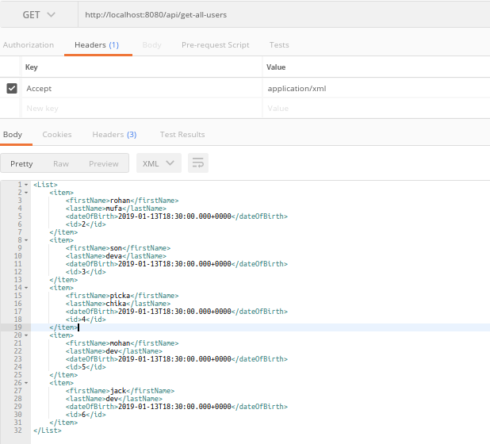

--------------------SWAGGER DOCUMENTATION -----------------------------------

Spring Boot makes developing RESTful services ridiculously easy. And using Swagger makes documenting your RESTful services easy.
Building a back-end API layer introduces a whole new area of challenges that goes beyond implementing just endpoints. You now have clients which will now be using your API. Your clients will need to know how to interact with your API. In SOAP based web services, you had a WSDL to work with. This gave API developers a XML based contract, which defined the API. However, with RESTFul web services, there is no WSDL. Thus your API documentation becomes more critical.
API documentation should be structured so that it’s informative, succinct, and easy to read. But best practices on, how you document your API, its structure, what to include and what not to is altogether a different subject that I won’t be covering here. For best practices on documentation,
Maven dependency to add in pom.xml

<!-- https://mvnrepository.com/artifact/io.springfox/springfox-swagger2 -->
<dependency>
<groupId>io.springfox</groupId>
<artifactId>springfox-swagger2</artifactId>
<version>2.6.1</version>
</dependency>

<!-- https://mvnrepository.com/artifact/io.springfox/springfox-swagger-ui -->
<dependency>
<groupId>io.springfox</groupId>
<artifactId>springfox-swagger-ui</artifactId>
<version>2.6.1</version>
</dependency>

Enable to Swagger so we need to configure in project

Basic example
@Configuration
@EnableSwagger2
public class SwaggerConfig {

public static final Contact DEFAULT_CONTACT = new Contact(

"Jagasan Dansena",
"http://localhost:8080",
"jk@gmail.com"

);

public static final ApiInfo DEFAULT_API_INFO = new ApiInfo(
"Awesome API title", "Awesome API Desc", "1.0",
"urn:tos", DEFAULT_CONTACT,
"Apache 2.0",
"http://www.apache.org/licenses/LICENSE-2.0"
);

private static final Set<String> DEFAULT_PRODUCED_AND_CONSUME =
new HashSet<>(Arrays.asList(
"application/json",
"application/xml")
);

@Bean
public Docket api() {

return new Docket(DocumentationType.SWAGGER_2)
.apiInfo(DEFAULT_API_INFO)
.produces(DEFAULT_PRODUCED_AND_CONSUME)
.consumes(DEFAULT_PRODUCED_AND_CONSUME);

}

}

Swagger API exposer URL

http://localhost:8080/v2/api-docs
It will display all information about porject like what the controller, what are the URL in project along with give meta data information what the HTTP method for spcific url
It exposewhat the consume and response,
It expose the HTTP code,
It exponse the Entity or Bean propeties in details,
It expose about URL and HTTP method,
It exponse all Controller in API,
It exponse the Valdiation of data (for mandatory filed and what are the value are required)

It represent the JSON format

http://localhost:8080/swagger-ui.html
It will expose the all above information in form of UI representation,

Model Layer Validation

@ApiModel(description=" basic details of AppUser Bean")
public class AppUserBean {

@ApiModelProperty(notes=" update time Id should not be null")
private Long Id;

@Size(min=2, message=" First name must be atleast two char. ")
@ApiModelProperty(notes=" first Name mandatory ",required=true)
private String firstName;
private String lastName;

@Past
@ApiModelProperty(notes=" Bith day should less then current date ")
private Date dateOfBirth;

}

Controller Layer Validation

@PostMapping("api/save-user")
public ResponseEntity<String> saveUser( @Valid @RequestBody AppUserBean bean) {
appUserService.saveUser(bean);
return new ResponseEntity("User Saved Successfully", HttpStatus.OK);
}

------------------------------------Spring boot Actuator------------------------------

<dependency>
<groupId>org.springframework.boot</groupId>
<artifactId>spring-boot-starter-actuator</artifactId>
</dependency>
<dependency>
<groupId>org.springframework.data</groupId>
<artifactId>spring-data-rest-hal-browser</artifactId>
</dependency>
----------------------HAL (Hypertext Application Language)-----------------------
HAL is a simple format that gives a consistent and easy way to hyperlink between resources in your API.

Adopting HAL will make your API exlporable, and its documentation easily discoverable from within the API itself. In sort, it will make your API easier to work with and therefore more attractive to client developers.

APIs that adopt HAL can be easily served and consumed using open source libraries avilable for most major programming languages. It's also simple enough that you can just deal with it as you would any other JSON.

http://localhost:8080/actuator ( for actuator info)
http://localhost:8080/browser/index.html#/ (HAL )

throw HAL we can monitor and check the info,health of Spring boot application
It similar kind of post man which allow to access the Rest API
management.endpoints.web.exposure.include=* (config in propeties file to allow to access the url by end point )

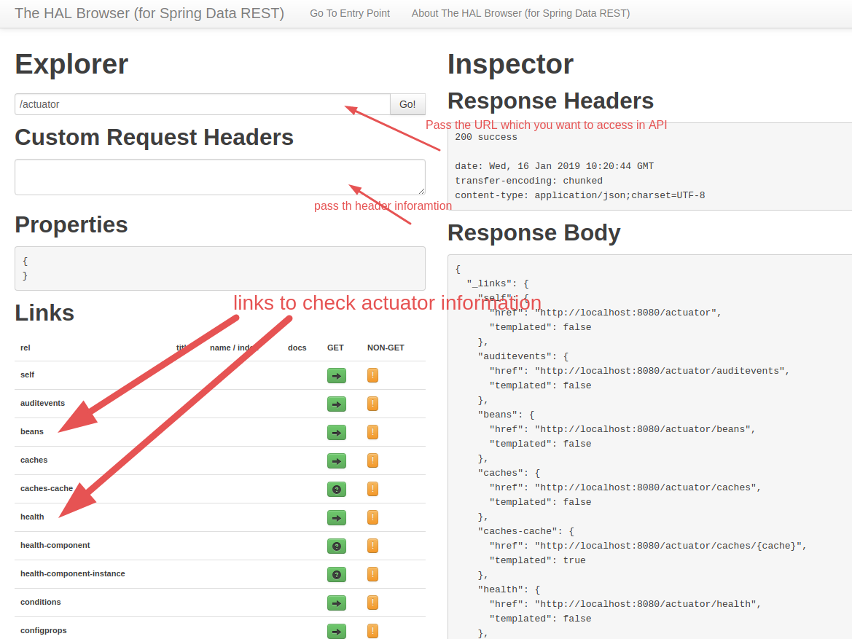

Filtering

if you don't want to exponse the some secure data to client side then just add one annotation to ignore the propeties

@ApiModel(description=" basic details of AppUser Bean")
public class AppUserBean {
private Long Id;
private String firstName;
private String lastName;
@JsonIgnore
private String password;
private Date dateOfBirth;

}
Passowrd filed won't be expose in client so restrication some filed to client then we can use @JsonIgnore
----------------for multiple we can used in class level -------------------

@JsonIgnoreProperties(value= {"lastName","password"})
public class AppUserBean {
private Long Id;
private String firstName;
private String lastName;
private String password;
private Date dateOfBirth;
}
above class level jsonIngone are static filtering the peropeties , if you want to different scenario diffierent propeties to filter the data then it wont be work and also class level filtering have problem if any time change the propeties filed name then also need to changed in JsonIgnore propeties

Dynaic filtering
Dynaic filtering we can filter theose propeties we want in dyniac based requirement scenarios
see the below example
Controller
@GetMapping("api/dynamic-fillter")
public ResponseEntity<MappingJacksonValue> getDynaicFilter() {
AppUserBean bean = new AppUserBean();
bean.setId(10l);
bean.setFirstName("Priya");
bean.setLastName("Dev");
bean.setDateOfBirth(new Date());
bean.setPassword("12345");
//Dynamic Filter of beans
SimpleBeanPropertyFilter fileter = SimpleBeanPropertyFilter.filterOutAllExcept(
"firstName","id","dateOfBirth") ;
FilterProvider provider = new SimpleFilterProvider().addFilter("filterId",fileter);
MappingJacksonValue value = new MappingJacksonValue(bean);
value.setFilters(provider);
return new ResponseEntity(value, HttpStatus.OK);

}

Add the Id of filter in Bean so filter will idenfity the which propeties will be ignore

@JsonFilter("filterId")
public class AppUserBean {

private Long Id;
private String firstName;
private String lastName;
private String password;
private Date dateOfBirth;

}

-----------------------------------Versioning---------------------------------------------

- Media type versionong ( “content negotiation” or “accept header”) GitHub
- (Custom) headers versioning (Microsoft comp.)
- URI Versioning (Twitter api using)
- Request Parameter Versioning (Amazon)

Factors
- URI pollution,
- Misues of HTTP Headers,
- Caching,
- Can we wxecute the request on the browser?
- API Documentation,
- No perfect Solution,

Versioning mean we can maintain the change of API with different level of code change. So we have all code changes from starting to end the API chages code.
Versioning means if already developed a coded after deployment of code in production if we are changing or modfiy the code based CR then we have to maintain the previous code along with new code so that we need to maintain the vesioning
So maintain the versioning we have different approch to create the different URL based of version or Use request param to different the versioning or last option have also use header but it will complex to implement the vesioning in Headers.

Example URL Versioning

public class PersonV1 {
private String name;

public String getName() {
return name;
}
public void setName(String name) {
this.name = name;
}

}

public class Name {

private String firstName;
private String lastName;

public String getFirstName() {
return firstName;
}
public void setFirstName(String firstName) {
this.firstName = firstName;
}
public String getLastName() {
return lastName;
}
public void setLastName(String lastName) {
this.lastName = lastName;
}

}

public class PersonV2 {

private Name name;

public Name getName() {
return name;
}

public void setName(Name name) {
this.name = name;
}

}

above code create two version of Person information PersonV1 are just have stirng name, but in PersonV2 have Name object which content firstName and LastName.

Controller

@RestController
public class PersonVersioningController {

// below example are URI versioning
@GetMapping("v1/person")
public PersonV1 getPersonV1() {
return getObjP1();
}
@GetMapping("v2/person")
public PersonV2 getPersonV2() {
return getObjP2();
}

//below are Param versioning
@GetMapping(value="/person/param",params="version=1")
public PersonV1 getParamPersonV1() {
return getObjP1();
}
@GetMapping(value="/person/param",params="version=2")
public PersonV2 getParamPersonV2() {
return getObjP2();
}
// below are Header versioning
//Header pass the key API-VERSION and value are 1/2
@GetMapping(value="/person/header",headers="API-VERSION=1")
public PersonV1 getHeaderPersonV1() {
return getObjP1();
}
@GetMapping(value="/person/header",headers="API-VERSION=2")
public PersonV2 getHeaderPersonV2() {
return getObjP2();
}
//produce is basically Media(mime) type versioning
//pass the key in header Accept and value application/vnd.company.app-v1+json/application/vnd.company.app-v2+json
@GetMapping(value="/person/produce",produces="application/vnd.company.app-v1+json")
public PersonV1 getProducePersonV1() {
return getObjP1();
}
@GetMapping(value="/person/produce",produces="application/vnd.company.app-v2+json")
public PersonV2 getProducePersonV2() {
return getObjP2();
}

private PersonV1 getObjP1() {
PersonV1 p1 = new PersonV1();
p1.setName("raaz kumar");
return p1;

}
private PersonV2 getObjP2() {
PersonV2 p2 = new PersonV2();
Name name = new Name();
name.setFirstName("jack");
name.setLastName(" dev");
p2.setName(name);
return p2;
}
}

Basic of Spring boot

Goals
-Enable building production ready application quickly
-Provide Common no-functional features
- Embedded servers
-Metrics
-Health checks
-externalized configuration

What is Spring boot NOT !
-ZERO code generation
-Niether an application server nor a web server (tomcat, jetty)
Features
Quickly Create Spring applications,
Embedded Servers- Tomcat, Jetty or Undertow
Quick Start Projects with Auto Configuration
-web (when added start-web then it included multiple dependency like, dispatcher servlet, validation, internal view reslover,unit testing dependency,web server,spring core,MVC,log4j, jackson, tomcat, spring-context etc)
-JPA(it added all the depency JPA related)
Production-ready features
-metrics, health check and externalized configuration
(through actuvator we chacke the server status is runing or not, we can check which are failed, how many time service are call, check memory consume by api, we can beans what are propeties are there etc.)

What is AutoConfiguration ?

@SpringBooApplication will do three thing
1) these is spring context file.
2)it enable component scan (componet scan is automatically scan the class in these pkg or sub pkg which annotated by componet, bean, repository,service,controller etc),
3)it enable auto configuration,
SpringApplication.run() it run the spring context, it also return Application conext

ApplicationContext context = SpringAppliction.run(ClassName,ars);

for(String name: context.getBeanDefinitionName()){
Sysout(name); // it return the all name of bean
}
SpringBoot trigger the autoconfiguration jar and it will look through jar which are avilable in class path then it configure in spring boot like (InternalViewResolver,dispecture servlet ect ),

Spring boot lokks at a( Frameworks avaiable on the CLASSPATH b)Existing configuration for the application based on these, Spring boot provides basic configurarion need to configure that application with thses frameworks, This is called Auto Configuration.

Exampel AutoConfiguration
We will take a look at DataSourceAutoConfiguration.
Typically all Auto Configuration classes look at other classes avilable in the class path, if specific classes are available in the classpath, then configuration for that functionality is enabled through auto configuration, Annotations like @ConditionalOnClass, @ConditionalOnMissingBean help in providing these features!

@ConditionalOnCkass({DataSource.class,EmbeddedDataBaseType.class}): this configuration is ebaled only when these class are available in the classpath.

@Configuration
@ConditionalOnClass({DataSource.class,EmbeddedDataBaseType.class})
@EnableConfigurationPropeties(DataSourcePropeties.class)
@Import({Register.class,DataSourcePoolMetaDataProvidersConfiguration.class})
public class DataSourceAutoConfiguration{

}

@ConditionalOnMissingBean: this bean is configured only if there is no other bean configured with the same name.

---------------SpringBoot vs Spring MVC(Compare)?-----------------------------
What is Spring Boot? What is Spring MVC? What is spring Framework? What are their goals? How do they compare?

Feature of Spring
Most Important advantage of spring in DI
Most important feature of spring Framework is Dependency Injection. At the core of All Spring Modules Dependency Injection or IOC Inversion of Control.
Why is this important? Beause, When DI or IOC is used properly, we can develop loosely coupled applications, And loosely coupled applications can be easly unit tested.

Dupicationa/Plumbing Code
Does Spring framework stop with dependency Injection? No. It builds on the core concept of dependency Injection with a number of spring Modules.
* Spring JDBC
*Spring MVC,
*Spring AOP,
*Spring ORM,
*Spring JMS,
*Spring Test,
Consider Spring JMS and Spring JDBC for a moment.
Do these modules bring in any new functionality? No. We can do all this with j3EE or JEE So, what do these bring in? They bring in simple abstractions. Amin of these abstraction is to

* Reduce Boilerplate code/ reduce Duplication
* Promote Decoupling/Increase unit Testablity

For Example, you need much less code to use a JDBC Template or a JMSTemplate compared to taditional JDBC or JMS

Feature2 : Good Intefartion with Other Framework
Greate thing about spring framewok is that is does not try to solve problems which are already solved. All that is does is to provider a great intergration with frameworks which provide gread solutions.

*Hibernate For ORM
*iBatis for Object Mapping.
*Junit & Mockito for Unit Testing

Spring MVC Framework provides decoupled way of developing web applications. With Simple Concepts like Dispatcher servlet, ModelAndView and View Resolver, It makes it easy to develop web applications.

Why do we need Spring Boot?
Spring based application have lot of configuration.
1) dispatcher servlet
2)Internal view resolver
3) transcation manager
4) entity manager
5)data source etc..

Spring boot advantage
1) autoconfiguration
2) auto configuration web server
3)actuator
4) spring-boot-logging
5) spring-boot-starter-log4j2
6)dev tools
7)default Error Handling
8)support YML

--------------------------Micro Service------------------------------------------------------

In Short, the microservice architectural style is an approach to developing a single application as a suite of small services, each runing in its own process and communicating with lightweight mechanisms, often an HTTP resource API, These services are build around business capablities and
independently deployable by full automated deployment machinery and there is centralized management of these services, which may be written in different programming languages and use different data storage technologies

CHALLENGES FOR MICROSERVICE
Bounded context:
bounded context mean what we have do in specific mciroservice and what we don't have do in mocroservie, So it is diffecult to identitfy the specific task for specific microservice which is independent to each other,(you don't have right bussiness logic to implements in new projects)

Configuration Managemnet:
Here is challenges is configuration for mulitple micorserive in different service Suppose we have 50 microservice and we want to configure in these 50 microserive in different enviornment.

Dynamic Scale Up and Scale Down:
diificlut to manage the multiple instance of perticular microservice synamic and dyanic down means which we have to up runing and which instance we have to kill.
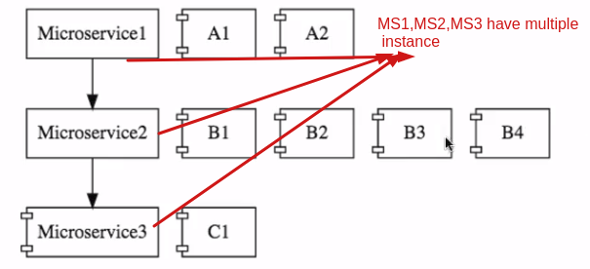

It is difficult to distribute the load blance to mulptile of instance of microservice.

VISIBILITY
it is difficult to identify the bugs, Means identify the bugs in multiple microservice where its raised because centralized the logs , it difficult to identify bug of specific request where is bugs came.
Monitorig the Multiple microservice which runing or down is difficult.

PACK OF CARDS.
Prevent the down of microservice, if one microservice is down then make sure other service will be runing, there is chance one centeral microservice , if it fail then other are won't be works.

----------------------------------------SPRING CLOUD---------------------------------------
Spring Cloud provides tools for developers to quickly build some of the common patterns in distributed systems( eg. Configuration management, service discovery, circuit breakers, intelligent routing, micro-proxy, control bus, one time tokens, global locks, leadership election, distributed sessions, cluster state). Coordination of distributed systems leads to boiler plate patterns, and using spring cloud developers can quickly stand up services and applications that implement those patterns. They will work well in any distributed evnironment, including the developer' own laptop,bare metal data cenres and managed platforms such as Cloud Foundry.

-----SPRING PROVIDE SOLUTION FOR CHALLENGES MICROSERVICE--------

Configuration Managemnet:
There is lot of configuration for these microservices that the operations team need to manages,
Spring cloud config server provides an approach where you can store all configuration for all
the different evnironment of all the microservices in a Git Repositoy, So you can store all the configuration for diffferent evnironment of different microservices in just one place in a centralized location and spring cloud config server can be used to expose that configuration
to all the microservices, this helps us to keep the configuration in one place and that makes it very easy to maintain the configuration for all microservices.

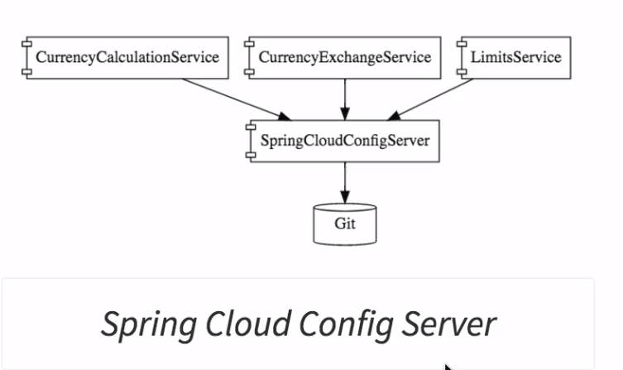

Dynamic Scale Up and Scale Down:

* Naming Server (Eureka)
* Ribbon (Client Side Load Balancing)
* Feign(Easier REST Clients)
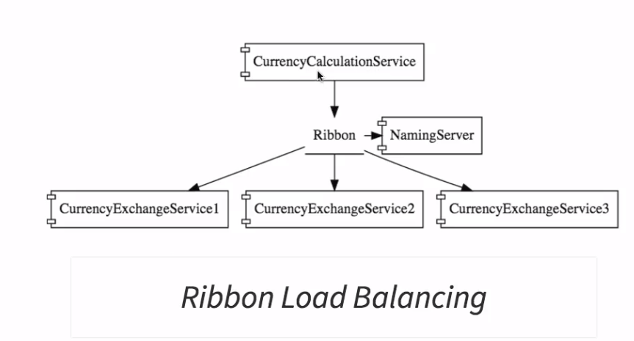

In the example you are looking at there is MicroService is called currency calcultation service which is talking to the currency exchange service.As you can see in the diagram there are multiple instances of the currency exchanges service and it's possible that at any point in time new instances can be added in or removed out And we would want to currency calculations that we want to be able to distibute the load between all the instance of the currency exchange service.
Who would want to be able to dynamically check what are the available instances of the currency exchange service and make sure that the load is distributed among all of them.
The solution which we would be discussing in this course would be using a naming server which is Eureka. So all the instances of all MicroServices would register with naming server.
So the naming server has two important features.
1) One is Service Registration so all microservices can register with the microservices
2) second one is service discovery So in this example the currency calculation service can ask the Eureka naming server Hey naming server give me the current instances of currency exchange service and the naming service would provide those URLs to the currency calculations. This helps to establish dynamic relationship between te currency calculation service and the instances of the currency exchanges service.
We will use Ribbon for client side load balancing. That means the currency calculation service will host ribbon and it would make sure that the load is evenly distributed among the existing instance that is gets from the namig server we will also use Eeign in the currency calculation service as a mechanism to write simple RESTful clients the solutions for visiblity.

VISIBILITY AND MONITORING
ZipKin Distributed Tracing
Netflix API Gateway
We would use spring cloud Sloat to assign ID ot request across multiple components and we would use the ZipKin distibuted tracing to trace a request across multiple components.
One of the important things about microservices is these microservices have a lot of common features.
For Example Logging, sercurity, analystics and things like that you don't want to implement all these common features in every microservice. API Gateways provides great solutions to these kind of challenges. We will use a netflix Zuel API gateway.

FAULT TOLERANCE(PACK OF CARDS)
* hystrix
in this could we will also implemet fault tolerance using hystrix if a service is down Hystrix help us to configure a default response in this video.

MICRO SERVICE ADVANTAGE

NEW TECHNOLOGY & PROCESS ADAPTION
Architecture is the most important advantage of the microservices architecture is that it enables you to adapt new technology and processes very easy
When we build applications as a combination of microservices which can communicate with each other using simple messages each ot these microservices can be build in different techologies.typical more monolithic applications people would not have that flexiblity.
For example Microservice one might be java micro service two might be Nodejs Microservice three might be Kotlin and tomorrow there might be a language XYZ which is really doing well and which
provides a lot of benefits to you and you can easliy create a micro service in the specific language.
And alos for the new microservices that we create we can bring in new processors as well.
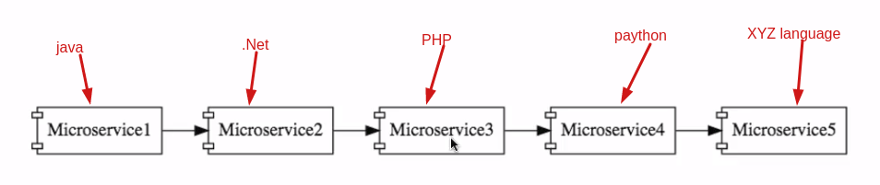
DYNAMIC SCALING
The other important advantage of microservices is dynamic scaling consider an online shopping application They don't really have the same amount of load or same amount of traffic or same amount of users throughout the year especially during the holiday season. The load on the application will be lot and during the rest of the year might not be so much load during the Black Friday there might be a huge amount of load. If your microservice are cloud enabled they can scale dynamically and you can procure hardware and release that dynamically as well. So you can scale up your applications and scale them down based on the Loadd because you are developing smaller components It is much easier to release micro services compared to monolith applications.
This means that you can bring new features faster to market and that's a big advantage to have in the modern world.

As discussed earlier spring cloud config server mix up configuration from a git, we want to connect our limit service to spring cloud config server. We have to the limit services ready and we have spring cloud config server but we have not really connected them,
Before we thing about connecting them to git repository we need to install a local git.
So what I will do is go to Google and you can do a search for git is the one of the most popular version control systems as you would already know all the code for this particular code is stored in git hub which is open source cloudbase installation of kit,
What I will do is I will go the first result se git-scm.com if you going there,
So you can get a basic introduction to get what we would want to do is to install git in our local machine.

project 1 limit-service
add the following MVN dependency
spring-boot-starter-actuator,
spring-boot-starter-web,
spring-boot-devtools,
and below
<dependencies>

<dependency>
<groupId>org.springframework.cloud</groupId>
<artifactId>spring-cloud-starter-config</artifactId>
</dependency>

</dependencies>

project 2 spring-clound-config-server
required dependency
<dependencies>
<dependency>
<groupId>org.springframework.cloud</groupId>
<artifactId>spring-cloud-config-server</artifactId>
</dependency>
</dependencies>

After the follow the below project to configure the git for global propeties for all project modules

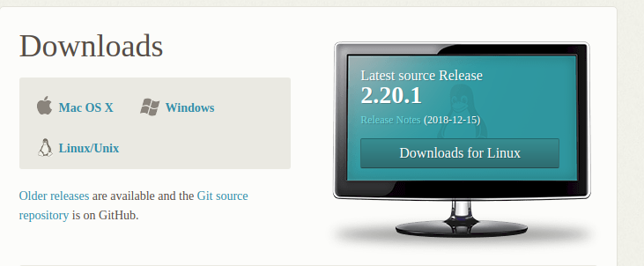

After the crate new floder to local git like git-localconfig-repo after that open terminal thses folder localtion and int the folder
2) after that your spring-cloud-config-server folder right click ---> buildpath---> link source

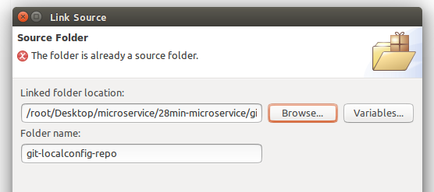
git the path of git-localconfig-repo after clicked the fined

3) afte you see the git-localconfig-repo are linked in your projects

4)git-localconfig-repo folder create propeties file of limits-service, so in these properties will configure the all configuration

5) propeties name limits-service.propeties

6) after that you to add these in your local git see below command and do its
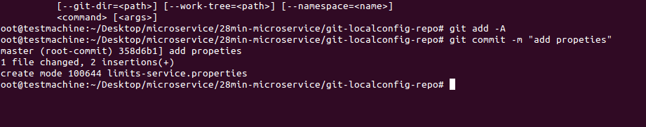
Connect the spring-cloud-config-server project to git-localconfig-repo.
1) we want to configure the local repository git to our spring cloud config server, So we need to copy the path local git repository and configure the spring-cloud-config-server propeties files.
Example
application.propeties

spring.cloud.config.server.git.uri=file:///root/Desktop/microservice/28min-microservice/git-localconfig-repo

Enable to config project with helop of @EnableCinfigServer annotation to make our project as config server

@EnableConfigServer
@SpringBootApplication
public class SpringCloundConfigServerApplication {

public static void main(String[] args) {
SpringApplication.run(SpringCloundConfigServerApplication.class, args);
}

}

Run the application with below url
http://localhost:8888/limits-service/default

Results
{
"name": "limits-service",
"profiles": [
"default"
],
"label": null,
"version": "358d6b19517fa57aeff733d6c2eda7b14b5b7031",
"state": null,
"propertySources": [
{
"name": "file:///root/Desktop/microservice/28min-microservice/git-localconfig-repo/limits-service.properties",
"source": {
"limits-service.maximum": "888",
"limits-service.minimum": "8"
}
}
]
}

So What we have done in this step is establish the connection bewteen the spring cloud config server and the git repository
One of the importan things about a spring cloud config server. It's stored configuration for multiple services so I can store configuration for limits service currency, exchange service and currency calculations service. And also it can store configurations for each of these services for different environments for example the limit serive let's say it has four enviroments Dev, QA, stage and production we can store all the configurations related to all those for environments using this spring cloud config server .

We want to able to store the configuration for all those evnironments inside the GIT repository

Steps
Example if want to create the different enviornments for limi-service.properties then do
1) for dev env. Limi-service-dev.properties
2) for QA env. Limi-service-qa.properties
3) for Stage env. Limi-service-stage.properties
4) for Production env. Limi-service-prod.properties

Note: Now you have to commit the changes to local git repostiory so it will available

Now try the with different URL to access the properties value

http://localhost:8888/limits-service/qa QA env.
http://localhost:8888/limits-service/dev Dev env.
http://localhost:8888/limits-service/stage Stage env.
http://localhost:8888/limits-service/prod Prod env.
http://localhost:8888/limits-service/default default

Now what we will do at a later point in one of the next steps is Connect the limits service to the spring cloud config server.
What we are doing right now is connecting spring cloud config server to GIT in the latest step we will connect the limits service to the spring cloud config server and you would see that these specifc values are being picked up that's.

--------------Connect the limits-service to spring-cloud-config-server--------------
Lets connect the limits service to pick up the configuration from the spring-cloud-config-server service.

What we will do is connect the limits-service to pick up the configuration from the spring-cloud-config-servier service,
Now what we have to do is limit service configuration. We don't want it to be from application dot propeties we would want it to connect to the spring cloud config server and pick it up.
So here limit-service talk to the spring cloud config server and pick up the configuration from there one of the important things is if you want to pick up the configuration from a spring cloud config server the property file has to be renamed, I should not use the name application.prperties but I would start calling bootstrap.properties.
So insted of application.propeties the name is bootstrao.properties so let's rename this do.
The other important thing is we don't really want to configure values in here because all the configuration in spring-cloud-config-server.
Typically the things which would be present in Bootstrap propeties are configuraion of what is the name of the applictaion then you need to tell limit service where this spring cloud config server is which URL can be used to talk to this spring cloud config server if I say Spring.cloud.config.server

Step1) chage the limits service properties file name to bootstrap.properties
step2) set up the spring-cloud-config-server the url to access the limit-service properties values

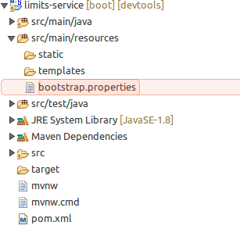

bootstrap.properties

spring.application.name=limits-service
spring.cloud.config.uri=http://localhost:8888/

Now run the both application and hit the below ulr
http://localhost:8080/limits

{
"maximum":888,
"minimum":8
}

The value are taking form spring-cloud-cnfig-service default properties, if you want to get value of specific enviornment then need to configure in limit-service which evnironments you wants

Let's now configure a dev profile and QA profile then see what values are picked up from the spring cloud config server the important thing for you to understand it's the fact that right now all the configuration for the limits service is coming from where it's coming from the GIT repository.
Note we not really configuring anyting in the limit service. The only thing which we are configuring the limits service is what is the URI of the spring cloud config server that's the only thing other than that all the other configuration for limits service is being configured in the GIT repository..
The advantage of configuraring stuff in the GIT repository is now the entire configuration of limits service is seprated from the deployment of the limits service. You don't really need to worry about what configuration that needs to be used when deploying it would automatically pick it up from the GIT repository.

So new configure the active profile in limits-service bootstrap.properties

boostrap.properties
spring.profiles.active=dev

Now insted of default properties it will take the value form active profile which are configure in bootstrap.propreties.

Note:
1) if any thing you changed in spring-cloud-config need to commit other wise won't be reflect
2) if devtool is avilable in api still need to restart the srever if any changed are done in spring-cloud-config
3) if dev, qa,stage any key are missed then it will take from default properties
Example
Dev env. We just set min value then max value will be take from default properties

limits-service.minimum=1

Project structure of spring-cloud-config-server

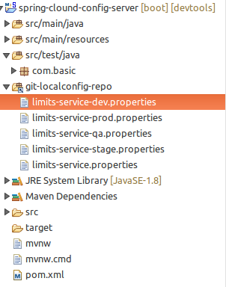

Once you have spring cloud config server installed connecting a new Micro service to it is cakewalk, the great thing about the spring cloud config server is now all application configuration is in one place it's inside the GIT repository. Once you restrict the access to the GIT repository all the application configuration is at one place and it's also very secure.

