Why HashSet and HashMap doesn't maintain insertation order?

HashSet stores elements in a hash table (actually through a HashMap instance , where element in the HashSet is the key to HashMap and dummy object is passed as a value). So the below answer is applicable to both HashMap and HashSet . Hashing determines where the object has to be placed in a HashMap. In Detail : HashMap internally uses an array to store key and value pairs (i.e the reference to HashMap.Entry objects where HashMap.Entry objects have the fields to store hash, key ,value , link to next HashMap.Entry object - a linked list implementation) . The index to above array is calculated from the key using hash function. The hash function accepts the hashcode of the key (key.hashCode()) and calculates the hash using formula given below and returns hash. The index is calculated based on the hash value and the length of array (Capacity) with the formula ( h & (length-1) , h -> hash value, length -> array capacity) so that the elements (key-value pairs) can be distributed in the array within the given range (capacity) . Array can be resized if required but the length should be a power of two. So whenever the length (capacity) of the array is resized to 2^n , the index of the element is also changed .Thus the iteration order is changed.
Function to calculate hash using the hashcode of key.
//fromJava Source code . This function ensures that hashCodes that differ only by constant multiples at each bit position have a bounded number of collisions (approximately 8 at default load factor).
static int hash(int h) {
h ^= (h >>> 20) ^ (h >>> 12);
return h ^ (h >>> 7) ^ (h >>> 4);
}
public class HashMap3 {

public static void main(String args[]) {
int length=128; // capacity
HashMap hm=new HashMap(length);
hm.put("545", "Kumar");
hm.put("5143", "Jegan");
hm.put("767", "Akshu");
hm.put("1766", "Lakshan");

Iterator it = hm.entrySet().iterator();
while (it.hasNext()) {
Map.Entry keyValue= (Map.Entry)it.next();
System.out.println( "Index : " + (hash(keyValue.getKey().hashCode()) & (length -1) )+ " " + keyValue.getKey() + " -> " + keyValue.getValue());
}

HashSet<String> set = new HashSet<String>(length);
set.add("Apple");
set.add("Banana");
set.add("Orange");
set.add("Pine Apple");

for (String fruit : set){
System.out.println("Index : " + (hash(fruit.hashCode()) & (length -1) )+ " Element : " + fruit);
}
}
static int hash(int h) {
h ^= (h >>> 20) ^ (h >>> 12);
return h ^ (h >>> 7) ^ (h >>> 4);
}
}
Difference between HashSet and ArrayList in Java
1. Implementation : HashSet implements Set interface in Java while ArrayList implements List interface.
2. Internal implementation: HashSet is backed by an HashMap while ArrayList is backed by an Array. Find out how HashSet works internally in java
3. Ordering : HashSet is an unordered collection and doesn't maintain any order while ArrayList maintains the order of the object in which they are inserted.
4. Duplicates : HashSet doesn't allow duplicates though ArrayList allows duplicate values.
5. Index based : The fifth difference between HashSet and ArrayList is that ArrayList is index based you can retrieve object by calling get(index) or remove objects by calling remove(index) while HashSet is completely object based.HashSet also doesn't provide get() method.

Similarities between HashSet and ArrayList
1. Allows null : Both HashSet and ArrayList allows null.
2. Synchronized : Both HashSet and ArrayList are non synchronized collection class. One needs to avoid using them in multithreading environment.
3. Traversal : Both HashSet and ArrayList can be traversed through iterator in java.
4. Iterator : Both HashSet and ArrayList classes iterator are fail-fast i.e they will throw ConcurrentModificationException as soon as they detect any structural change in ArrayList or HashSet.

When does collision occur in HashMap
A collision will occur when two different keys have the same hashCode, which can happen because two unequal objects in Java can have the same hashCode.

A collision will occur when two different keys have the same hashCode, which can happen because two unequal objects in Java can have the same hashCode.
A collision occurs when a hash function returns same bucket location for two different keys. Since all hash based Map class e.g. HashMap uses equals() and hashCode() contract to find the bucket. HashMap calls the hashCode() method to compute the hash value which is used to find the bucket location as shown in below code snippet from the HashMap class of JDK 1.7 (jkd1.7.0_60) update.
Summary
1) HashMap handles collision by using linked list to store map entries ended up in same array location or bucket location.
2) From Java 8 onwards, HashMap, ConcurrentHashMap, and LinkedHashMap will use the balanced tree in place of linked list to handle frequently hash collisions. The idea is to switch to the balanced tree once the number of items in a hash bucket grows beyond a certain threshold. This will improve the worst case get() method performance from O(n) to O(log n).
3) By switching from linked list to balanced tree for handling collision, the iteration order of HashMap will change. This is Ok because HashMap doesn't provide any guarantee on iteration order and any code which depends upon that are likely to break.
4) Legacy class Hashtable which exists in JDK from Java 1 will not use the balanced binary tree to handle frequent hash collision to keep its iteration order intact. This was decided to avoid breaking many legacy Java application which depends upon iteration order of Hashtable.
5) Apart from Hashtable, WeakHashMap and IdentityHashMap will also continue to use the linked list for handling collision even in the case of frequent collisions.
6) Collision in HashMap is possible because hash function uses hashCode() of key object and equals() and hashCode() contract doesn't guarantee different hashCode for different objects. Remember, they guarantee same hash code for the equal object but not the vice-versa.
7) A collision will occur on Hashtable or HashMap when hashCode() method of two different key objects will return same values.
That's all about how HashMap in Java handles collisions. In general, this method is called chaining because all objects stored in the same bucket are chained as linked list. In general, all hash table based classes in Java e.g. HashMap, HashSet, LinkedHashSet, LinkedHashMap, ConcurrentHsahMap, Hashtable, IdentityHashMap and WeakHashMaap uses linked list to handle collisions.
From JDK 8, a balanced tree will be used to implement chaining instead of linked list to improve worst case performance of HashMap from O(n) to O(log n) for HashMap, LinkedHashMap, and ConcurrentHashMap. Since HashSet internally uses HashMap and LinkedHashSet internally uses LinkedHashMap they will also benefit from this performance improvement.

HashMap and HashSet faster for insertion and retreiving the elements

If your application demands faster insertion and faster retrieval then HashMap is the ultimate choice. While selecting the data structure, you must keep two things in your mind. First one is that the data structure must give better performance while inserting the new elements and second one is that it should give even more better performance while searching for an element. Because insertion and retrieval are two operations which you perform very frequently in your applications. These things will matter even more when you are handling the big data. HashMap is the most sought after data structure when you are handling the big data with more preference to insertion and retrieval operations.
HashMap is the most used data structure in java because it gives almost constant time performance of O(1) for put and get operations irrespective of how big is the data. As you already know, HashMap stores the data in the form of key-value pairs. In this post, we will see how HashMap works internally in java and how it stores the elements to give O(1) performance for put and get operations.

How put() method works?

public V put(K key, V value) {
if (key == null)
return putForNullKey(value);
int hash = hash(key);
int i = indexFor(hash, table.length);
for (Entry<K,V> e = table[i]; e != null; e = e.next) {
Object k;
if (e.hash == hash && ((k = e.key) == key || key.equals(k))) {
V oldValue = e.value;
e.value = value;
e.recordAccess(this);
return oldValue;
}
}

modCount++;
addEntry(hash, key, value, i);
return null;
}

Step 1 : First checks whether the key is null or not. If the key is null, it calls putForNullKey()method. table[0] is always reserved for null key. Because, hash code of null is 0.

Step 2 : If the key is not null, then it calculates the hash code of the key by calling hash()method.
Step 3 : Calls indexFor() method by passing the hash code calculated in step 2 and length of the table[] array. This method returns index in table[] array for the specified key-value pair.
Step 4 : After getting the index, it checks all keys present in the linked list at that index ( or bucket). If the key is already present in the linked list, it replaces the old value with new value.
Step 5 : If the key is not present in the linked list, it appends the specified key-value pair at the end of the linked list.
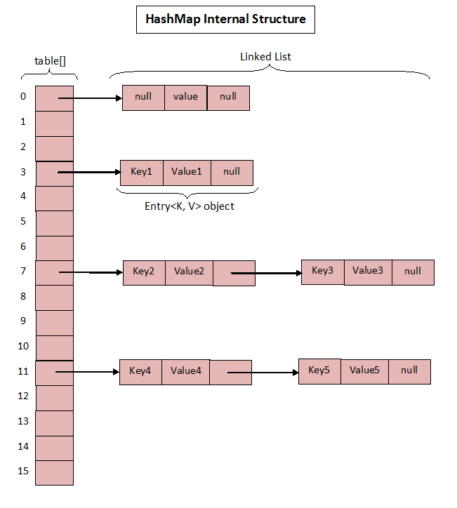

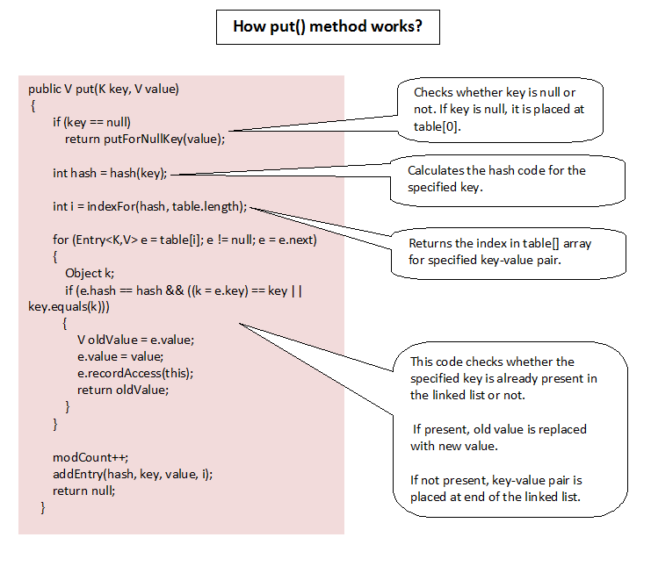

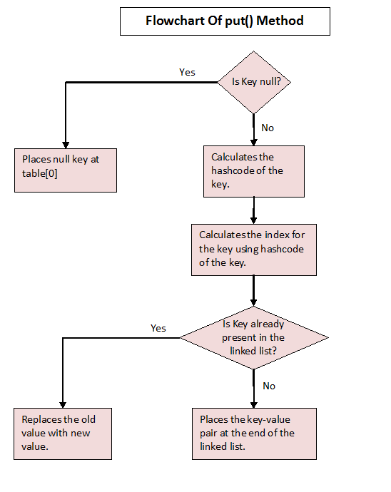

How get() method Works?

public V get(Object key) {
if (key == null)
return getForNullKey();
int hash = hash(key.hashCode());
for (Entry<K , V> e = table[indexFor(hash, table.length)]; e != null; e = e.next) {
Object k;
if (e.hash == hash && ((k = e.key) == key || key.equals(k)))
return e.value;
}
return null;
}

Step 1 : First checks whether specified key is null or not. If the key is null, it calls getForNullKey()method.
Step 2 : If the key is not null, hash code of the specified key is calculated.
Step 3 : indexFor() method is used to find out the index of the specified key in the table[] array.
Step 4 : After getting index, it will iterate though linked list at that position and checks for the key using equals() method. If the key is found, it returns the value associated with it. otherwise returns null.

Differences Between HashMap And HashSet In Java :
1) Hierarchy
HashSet implements the Set interface which in turn extends the Collection interface, the top level interface in the Java Collection Framework. But, HashMap implements the Mapinterface which starts it’s own hierarchy totally different from the Collection interface.
2) Data Storage
HashSet stores the data as objects where as HashMap stores the data as key-value pairs. Where each value is recognized and retrieved by it’s key.

3) Internal Structure
HashSet internally uses HashMap to store it’s elements [See more]. HashSet is sometimes considered as a wrapper around the HashMap. On the other hand, HashMap internally uses an array of Entry<K, V> objects to store the data.
4) Duplicate Values
HashSet doesn’t allow duplicate elements. If you try to insert duplicate element, HashSetwill be unchanged. Where as HashMap allows duplicate values but doesn’t allow duplicate keys.
5) null values
HashSet can hold only one null value where as HashMap can hold multiple null values but allows only one null key.
6) Insertion Operation
Insertion operation on HashSet requires only one object where as insertion operation on HashMap requires two objects, key and value.
7) Performance
Performance of both is almost the same. But, some developers say that HashMap is slightly faster than the HashSet.
8) Usage
Use the HashSet when you need uniqueness of the data. Otherwise, HashMap is always preferred as HashSet internally uses HashMap to store the data.
