Stream API
java.util.stream pkg

Parallel processing-> parallel processing is all about dividing a larger task into smaller task, then processing the sub task in parllel and then combining the result to get the final output.
Java8 stream API provided a similar mechnism to work with java collections. The java8 streams concepts is based on converting collection to a Stream,
processing the elements in parallel and then gathering the resulting elemetns into a Collection.s

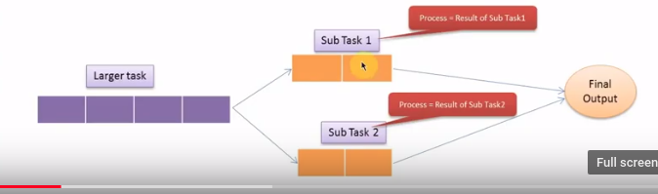

Different between Collection and Streams

1) collections are in-memory data structure which hold elements within it. Each elements in the collection is computed before it actual becomes a part of that collections. On the other hand Streams are fixed data structures which computes the elements on-demand basic.

2) the java 8 stream api can be seen as lazily constructed collections, where the values are computed when user demands for it, Actual Collections behave absolutely opposite to it and they are set of eagerly computed values(no matter if the user demands for a particular value or not)

Stream API
- Stream doesn't store elemets.It simply conveys elements form a source such as data strucutre ,an array or an I/O channel, through a pipeline of computational operations.

- Stream is functionaline nature. Operations performed on stream does not modify it's source. For example filtering a Stream obtained from a collection produces a new stream without the filtered elements, rather than removing elements from the source collection.

- Stream is lazy and evaluates code only when required.

- The elements of stream are only visited during the life of a stream, Like an Iterator, a new stream must be generated to revisit the same elemets of the source.

- Starting from Java8, the java collections will start having method that return Stream. this is possible because of another cool feature of java8. Which is default methods. Streams can be defiled as a sequence of elemetnts from a source that supports aggregate operations. The source here refers to a Collection, IO Operation or Arrays who prvoides data to a stream, Stream keeps the order of the data as it is in the source just like functionla programing languages,Streams support Aggregate Operations, the common aggregation operation are filter,map,reduce,find,match,sort these operations can be executed in series or in parallel.

- The streams also support pipelining and internal iterations. The java8 streams are designed such a way that most of its stream operations returns stream only. This help us creating chain of various stream operations. This is called as pipelining. The pipelined operations looks similar to a sql query.

- In java we traditionally use for loops or iterate through the collections. These kind of iterations are called as external iterations and they are clearly visible in the code. Java8 stream operations has methods like foreach,map,filter etc. Which internally iterates through the elements. The code is completely unware of the iteration in the background.these kind of iterations are called as internal iterations.

- We can use stream to filter,collect,print and convert from one data structure to other etc.

Example fiter

Filter are basically used to filter a object with certain criteria it used Predicate function which have test() method that return type boolean.

public class Java8Filter1 {
public static void main(String args[]) {
List<String> names = Arrays.asList("ram", "pradeep", "steve", "jack", "pink", "priya");
/**
* convert the list to Streams returns a sequential Stream with this collection
* as its source
*/
Stream<String> stream = names.stream();
/**
* filter the name stared with the P returns a stream consisting of the elements
* of this stream that match the given predicate. Filter accept the predicate
* and return boolean
*/
stream = stream.filter(name -> name.startsWith("p"));
// Collect the output and convert stream to list
names = stream.collect(Collectors.toList());
names.forEach(name -> {
System.out.println(name);
});
}

}

