**Room Painting Cost** 

Ram purchases an office building which has a room, that contains n doors and m windows. All doors have the same dimension and all windows have the same dimension.  
Given dimensions of the room, door and window, and cost for painting 1sq meter. Find the total cost for painting the **four walls** of the building.  
  
**Input Format:**

The first line of the input contains 3 integers that corresponds to the length, width and height of the room, respectively.  
The second line of the input contains an integer that corresponds to the number of Doors.  
The third line of the input contains an integer that corresponds to the number of Windows.

The fourth line of the input contains 2 integers that corresponds to the length and width of the door, respectively.

The fifth line of the input contains 2 integers that corresponds to the length and width of the window, respectively.

The sixth line of the input contains an integer that corresponds to the cost of painting the wall per sq. meter.  
  
All dimensions are given in meters. 

**Output Format:**  
Output is an integer that corresponds to the cost of painting the room.  
  
**Sample Input:**

10 20 30

2

5

10 3

5 3

10  
  
**Sample Output:**  
16650  
  
**Hint:  
Formula:**  
Total area of the 4 walls =  2*Length*Height+2*Width*Height

**Travel Fare** 

Ravi is a dynamic businessman, who keeps travelling frequently. For him, time and money, both matters.  
There are three mode of travel which Ravi prefers. He would choose one of the 3, only after a calculation that involves both time and money.  
The calculation is done as given below:  
    Weightage for fare: x  
    Weightage for time: y  
Then the travelling quotient is calculated as "x*fare+y*duration".  
  
The 3 modes of travel are Train, Bus and Flight.  
Given fare and duration for the 3 modes, calculate the traveling quotients. Ravi would choose the mode for which the traveling quotient is minimum.  
Can you please help Ravi in chossing the mode of travel?  
  
**Input Format:**

The first line consists of 2 integers which corresponds to the fare weightage and time weightage, respectively.

The second line consists of 2 integers which corresponds to the train fare and train duration(in minutes), respectively.

The third line consists of 2 integers which corresponds to the bus fare and bus duration(in minutes), respectively.

The fourth line consists of 2 integers which corresponds to the flight fare and flight duration(in minutes), respectively.

**Output Format:**  
Output is one of the 3 strings ...  "Train" or "Bus" or "Flight".

**Sample Input:**  
20 4  
300 4  
30 5  
3000 3  
  
**Sample Output:**   
Bus

**Bus Game** 

In a village, N kids were playing the bus game.  
The rules for the bus game is as follows:  
Starting from the number 1,  the kids keep telling the consequtive numbers one by one.  A number 'X' will be given. The kid who gets a number which is divisible by X should say "Bus", instead of the original number , and the next kid will continue with the next number. This will go on in a circular manner. If any kid says incorrectly, that kid is out of the game.  
The kids are very clever. So they won't make any mistake while telling the numbers. They make mistake only while telling "Bus".  
  
Write a program to find the kid's number(index starting from 1) who went wrong.  
  
**Input Format:**

The first input is an integer, that corresponds to the number of kids, N.  
The second input is an integer, that corresponds to the number X.  
The following lines are strings, which correspond to the number said by the kids. The input stops only when any kid says incorrectly.

**Output Format:**  
Output is an integer value which represents the kid's number who went wrong.  
  
**Sample Input:**  
5  
4  
1  
2  
3  
Bus  
5  
6  
7   
8   
  
**Sample Output:**  
3

**Tank Filling** 

In a village, children are playing under an overhead tank. The tank contains one master inflow tap and n outflow taps, which act as a water-fall for the kids.  
Given all flow rates and capacity of the tank, determine the time taken to fill the tank. Print "Impossible"  if its impossible to fill the tank.  
  
**Input Format:**  
First line of the input is an integer that corresponds to the water-flow rate of the master inflow tap.  
Second line of the input is an integer that corresponds to the volume of the tank in litres.  
Third line corresponds to the number of outflow taps.  
The following n lines are integers that corresponds to the water-flow rates of the outflow taps.  
  
**Note:**The unit of water-flow taps is litres/minute.  
  
**Output Format:**  
Output is an integer value that corresponds to the time(in minutes) for filling the tank. Print "Impossible" if the tank cannot be filled.  
  
**Assume**: Output will always be an integer.  
  
**Sample Input 1:**  
20  
48  
4  
2  
3  
1  
2  
  
**Sample Output:**  
4  
  
  
**Sample Input 2:**

|  |
| --- |
| 15 30 6 4 3 8 12 10 6  **Sample Output 2:** Impossible |

**Mobile Lock Pattern** 

Given the coordinates of  a lock pattern configuration, check whether it is a Valid Lock Pattern or not. A valid Lock pattern will be formed only by joining the adjacent neighbours.  If it is a valid lock pattern and if there is   
       1)   Above 75% coverage, print "Excellent",   
       2)  Above 50% coverage, print "Good",   
       3)  Above 25% coverage, print "Average",   
       4)  Else print "Poor".   
  
(Coverage need to be calculated with respect to the total grid size)   
  
        If it is an  invalid lock pattern, print "Invalid".   
  
**Assume** that the pattern grid will always be a square.   
**Note:**   
To make the problem less complicated the following relaxations are made:   
1) The testcases will not contain any overlap through a point in the pattern.   
2) The pattern will always end at a new point.   
3) The points given in the testcases always lie within the pattern grid. No need to check if the point is outside the grid.

**Input Format:**   
The first line is an integer that corresponds to the side length of the pattern grid.   
The second line is an integer that corresponds to the number of coordinates in the lock pattern, n.   
The following n lines have the following pattern : x-coor y-coor   
  
**Output Format:**   
Print "Invalid" if there is the pattern is not properly linked, else print "Excellent " or "Good" or "Average" or "Poor", based on the number of points covered.   
  
**Sample Input 1:**   
3   
5   
1 1   
2 1   
3 1   
2 2   
3 3   
**Sample Output 1:**   
Good   
  
**Sample Input 2:**   
3   
6   
1 1   
2 1   
3 1   
2 2   
3 1   
3 3   
**Sample Output 2:**   
Invalid

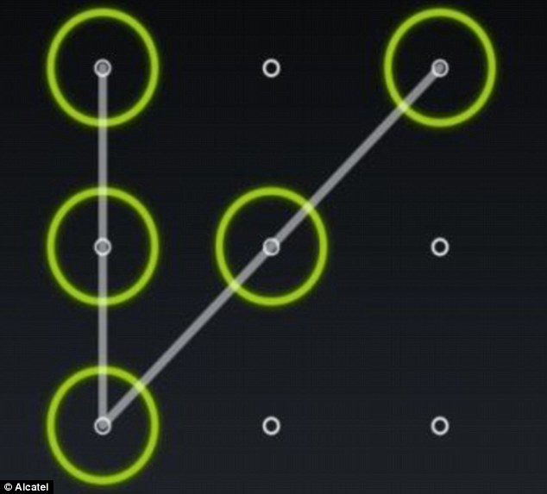

**Square and Tower**

In a city, there are N mobile signal towers. Raj is creating an application to visualize the coverage area of the signal towers.

        For simplicity, the following are assumed:   
1) the shape of the city is square.   
2) the signal coverage is in the form of a square.   
3) the side length of the signal coverage is **3 meters**.

        Given side length of the city, number of towers, and coordinates of towers, find whether whole city is under coverage.  If the whole city is not under signal coverage, find how much area is not under coverage.   
  
Assume that the two of the end of points of the city are  (0,0) and (n-1,n-1).   
**Input Format:**   
First input corresponds to n, length of the city.   
Second input corresponds to the number of towers, t.   
The next n lines of the input follow the following format: x and y coordinates of each tower, respectively.   
  
Consider that tower is always placed at valid position.   
  
**Output Format:**   
Print "Yes" if the whole city is under coverage. Else, print "No", along with the left out area.   
  
**Sample Input 1:**

5

3

2 2

0 1

4 1   
  
**Sample output 1:**

No

8   
  
**Sample Input 2:**   
3   
1   
1 1   
**Sample Output 2:**   
Yes   
  
  
**Explanation for sample 1:**

|  |  |  |  |  |  |
| --- | --- | --- | --- | --- | --- |
| 4 |  | **T3** |  |  |  |
| 3 |  |  |  |  |  |
| 2 |  |  | **T1** |  |  |
| 1 |  |  |  |  |  |
| 0 |  | **T2** |  |  |  |
|  | 0 | 1 | 2 | 3 | 4 |

Green colour indicates the coverage area.   
Red colour indicates the area which is not under coverage.   
Total red area = 8.