CSS
HTML5
Subjective test html+css, core java, SQL(1 Qn from SELECT)
Bootstrap
CSS
We have learnt
Syntax
Selectors
How to inline, internal, external
Box model

Task:
CSS tables

Getting started with Bootstrap:
What is bootstrap?
Is a CDN and open source, many providers like Google, W3Schools etc are providing their version of Bootstrap which is css, jquery that can be applied to our html page to enhance the appearance and effects of the UI.

Bootstrap typography
When the bootstrap CDN is applied to a html file, a default style is applied to the elements.
Primary
Success
Info
Warning
Danger
https://www.w3schools.com/bootstrap4/tryit.asp?filename=trybs_txt_bgcolors&stacked=h

Grid Model

Module 1 Revision:
UML
Unified Modelling Language
UML diagrams are used to represent the entire software artificats that are going to be constructed.
Before start coding, these diagrams are drawn to keep a record of what we exactly promised to do.
UML is an unified version of Rambaugh, Jacobson and Booch modelling techniques.

UML diagrams are categorized into:
Static / Structural
Dynamic / Behavioral

In UML 2.2 there are 14 types of UML diagrams, which are divided into these two categories:
- 7 diagram types represent structural information
- Another 7 represents general UML diagram types for behavioral modeling, including four that represent different aspects of interactions.
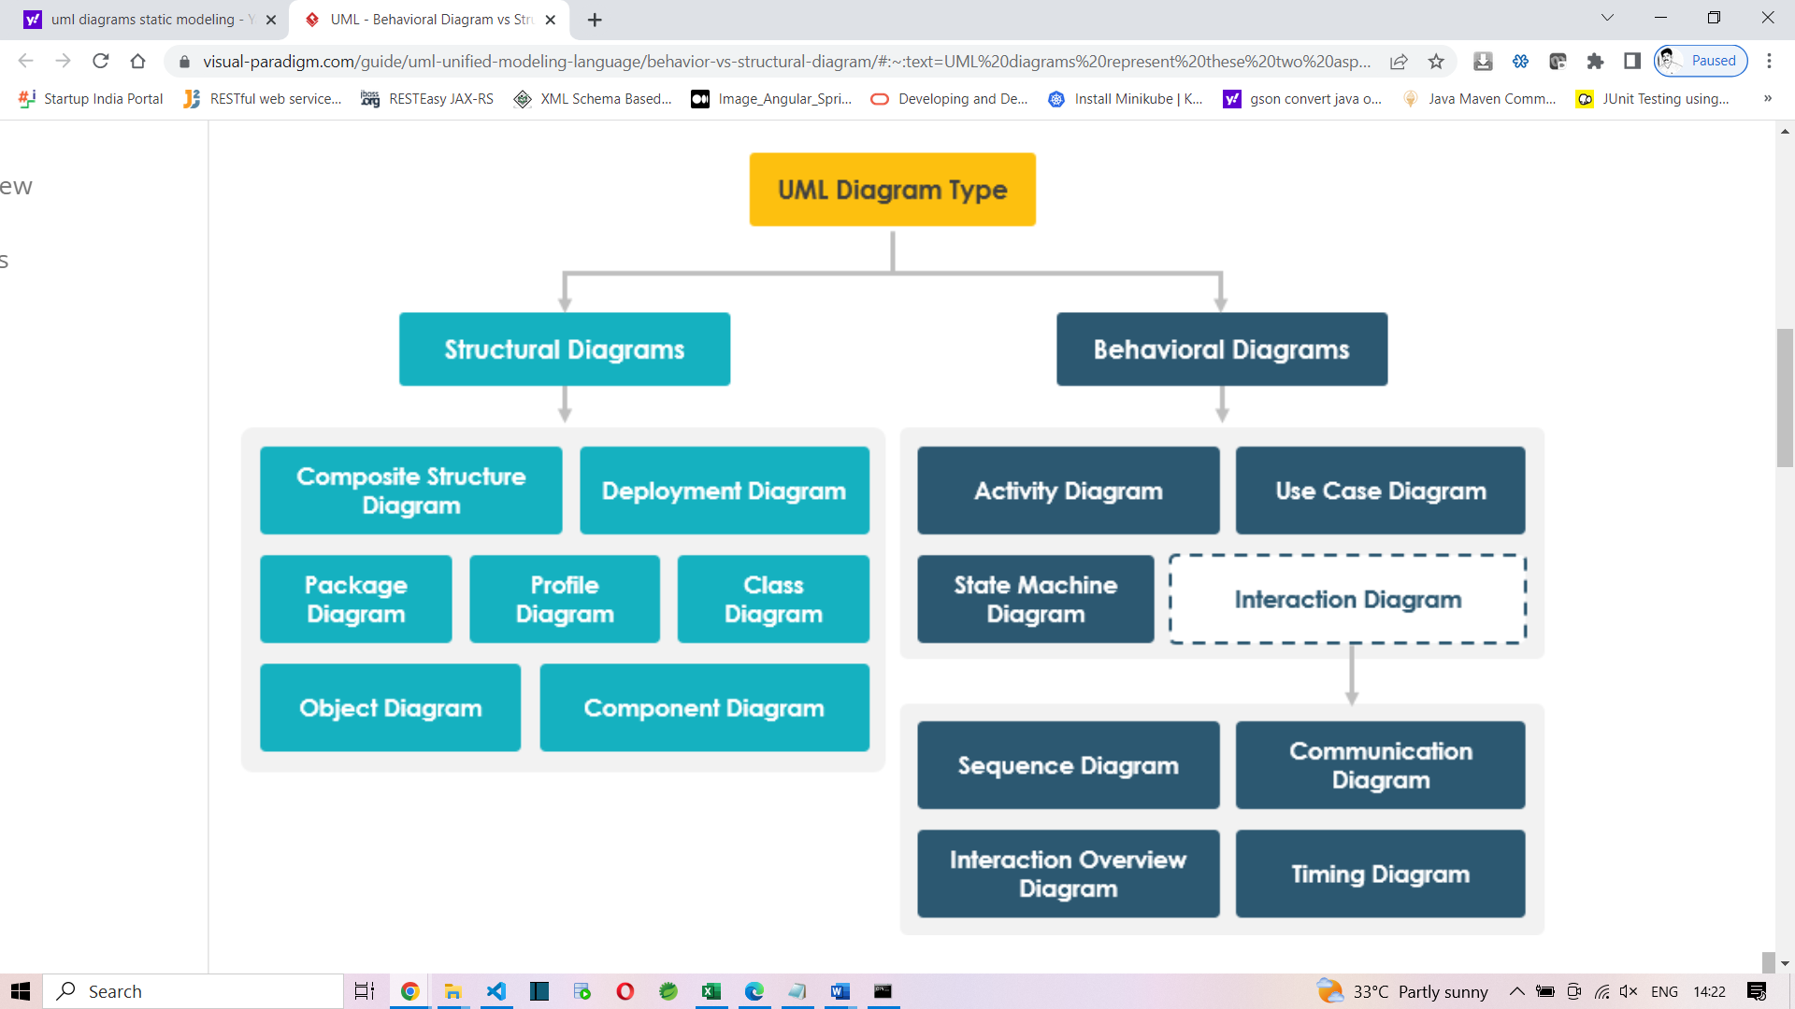
Callenge:
Digits - II
Write a program to read a non-negative integer n, compute the sum of its digits. If sum is greater than 9 repeat the process and calculate the sum once again until the final sum comes to single digit.Return the single digit.
Include a class UserMainCode with a static method getDigitSum which accepts the integer value. The return type is integer.
Create a Class Main which would be used to accept the string and call the static method present in UserMainCode.
Input and Output Format:
Input consists of a integer.
Output consists of integer.
Refer sample output for formatting specifications.
Sample Input 1:
9999
Sample Output 1:
9
Sample Input 2:
698
Sample Output 2:
5

Solution:
import java.util.Scanner;

public class App {

public static int digitSum(int num)
{
int sum=0;
if(num>9)
{
//get the digits and sum
String str=num+"";
sum=0;
for(char c : str.toCharArray())
{
int digit=Character.getNumericValue(c);
sum+=digit;
}
if(sum>9)
return digitSum(sum);
}
return sum;
}
public static void main(String[] args) {
Scanner sc=new Scanner(System.in);
int input=sc.nextInt();
System.out.println(digitSum(input));
}

}

Add and Reverse
Given an int array and a number as input, write a program to add all the elements in the array greater than the given number. Finally reverse the digits of the obtained sum and print it.
Include a class UserMainCode with a static method “addAndReverse” that accepts 2 arguments and returns an integer.The first argument corresponds to the integer array and the second argument corresponds to the number.
Create a class Main which would get the required input and call the static method addAndReverse present in the UserMainCode.

Example:
Input Array = {10,15,20,25,30,100}
Number = 15
sum = 20 + 25 + 30 + 100 = 175
output = 571
Input and Output Format:
The first line of the input consists of an integer that corresponds to the number of elements in the array.
The next n lines of the input consists of integers that correspond to the elements in the array.
The last line of the input consists of an integer that corresponds to the number.
Output consists of a single integer.
Sample Input
6
10
15
20
25
30
100
15
Sample Output
571

Solution:
import java.util.Scanner;

public class App {

public static void main(String[] args) {
Scanner sc=new Scanner(System.in);
int n=sc.nextInt();
int arr[]=new int[n];
for(int i=0;i<n;i++)
{
arr[i]=sc.nextInt();
}

int num=sc.nextInt();

int sum=0;
for(int i=0;i<n;i++)
{
if(arr[i]>num)
sum+=arr[i];
}

//reverse the sum
StringBuilder sb=new StringBuilder(sum+"");
sb.reverse();
int result=Integer.parseInt(sb.toString());
System.out.println(result);
}

}
Flush Characters
Write a program to read a string from the user and remove all the alphabets and spaces from the String, andonly store special characters and digit in the output String. Print the output string.
Include a class UserMainCode with a static method getSpecialChar which accepts a string. The return type (String) should return the character removed string.
Create a Class Main which would be used to accept a string and call the static method present in UserMainCode.
Input and Output Format:
Input consists of a strings.
Output consists of an String (character removed string).
Refer sample output for formatting specifications.

Sample Input :
cogniz$#45Ant
Sample Output :
$#45

Solution:
import java.io.*;
import java.text.SimpleDateFormat;
import java.util.*;
public class Main {
public static void main(String[] args) {
Scanner sc=new Scanner(System.in);
String s1=sc.next();
String s2=s1.replaceAll("[a-zA-Z]", "");
System.out.println(s2);
}
}

---------------Long route------
import java.util.regex.Matcher;
import java.util.regex.Pattern;

public class App2 {

public static void main(String[] args) {
String input="P@$$w0rd";
StringBuilder sb=new StringBuilder(input);
Pattern p = Pattern.compile("[0-9A-Za-z]+");
Matcher m = p.matcher(input);
while(m.find())
{
System.out.println(m.group());
int index=sb.indexOf(m.group());
int length=m.group().length();
System.out.println(index+" to "+(index+length));
sb.delete(index, (index+length));
}
System.out.println("Result="+sb.toString());
}

}
Another route:
Character.isLetter
Character.isDigit
Other than that is symbol

Discussion on Module 1 topics:

Entity classes, Serialization/De-Serialization
●Error/ Exceptions Handling, Custom Exceptions
●Reading and writing data from files, JSON, and XML
●

CUSTOMER PURCHASE PRODUCT

CUSTOMER
PRODUCT

in db:
CUSTOMER
PRODUCT
these are tables

in java:
Customer
Product

Object - Relational mapping
ORM

select * from HR.EMPLOYEES;

100 Steven King 24000
101 Neena Kochar 17000

List<Employee>

Serialization
is a process of converting an object into a series of bytes.

Deserialization
is vice versa

java -ea App

java -da App

interoperable

