Plan for the day:
- Java hands on practice for M1
- Online coding challenges
- Module 1 curriculum
- Some of our participants are going to present their topics
- Online coding challenge: few of our team will choose a question online and all of us will take that challenge
BDD
Selenium, TestNg, etc
Code Quality, SonarQube metrics
PLSQL
OOAD & UML
Joins in SQL
Comparable and Comparator

JOINS
Whenever we need to retrieve columns from more than one table, we need JOIN
If you provide valid JOIN condition only, then JOIN will produce meaningful result. Otherwise, if you ignore the join condition, then you will get CARTESIAN PRODUCT of the both tables.
PRODUCT means, MULTIPLICATION.
First table 10 rows. Second table 10 rows. CARTESIAN PRODUCT = 100 rows.

CROSS JOIN also do the CARTESIAN PRODUCT. (no join condition)
NATURAL JOIN
SELECT * FROM HR.EMPLOYEES NATURAL JOIN HR.DEPARTMENTS;
SELECT * FROM HR.EMPLOYEES JOIN HR.DEPARTMENTS USING(DEPARTMENT_ID);

INNER JOIN
Produces result of only matching rows based on condition
OUTER JOIN
LEFT JOIN
All rows from left side table, and matching rows from right side table
RIGHT OUTER JOIN
All rows from right side table, and matching rows from left side table
FULL OUTER JOIN
All rows from both sides and their matching rows.

IN OUTER JOIN, if matching rows are not found, then NULL is placed there

Display all ACCOUNT holders name who has taken atleast 1 loan

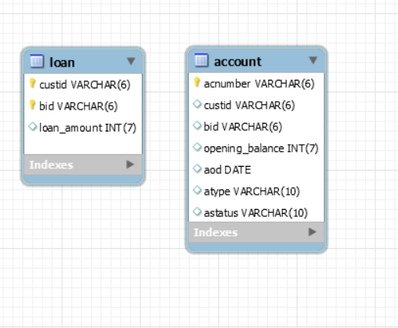
select distinct a.custid from account a
where exists
(select * from loan l where l.custid=a.custid);
The above query is correlated subquery.

select substring_index(substring_index('123 main road, Chennai-600002',',',-1),'-',1);
to extract Chennai from the address.

Munish presents the Testing concepts now.
Verification vs Validation
Quality Assurance
Quality Control
Black Box or Functional Testing
Grey box
White Box
Unit testing
Integration testing
Regression testing
Acceptance testing
System testing
Prograd Feedback link:-

https://forms.gle/r9p5PrMWPKt1rnaH6

