CSS3
What are the 3 methods of using CSS?
Inline
Internal
External
<p id=”p1” class=”para”>This is a paragraph</p>

Precedence in which order style is applied to this element paragraph

External stylesheet: red.css

#p1
{
color:magenta
}
p
{
color:red;
}
<p id=”p1” class=”para”>This is a paragraph</p>
Now, internal css
<style>
P
{
color:blue;
}
</style>
<p id=”p1” class=”para” style=”color:yellow”>This is a paragraph</p>

Selectors
Universal *
Pseudo selector input:[type=text]

Div > P
Div P
SELECTORS

Scaffolding
<!DOCTYPE html>
<html lang="en">
<head>
<title>Bootstrap Example</title>
<meta charset="utf-8">
<meta name="viewport" content="width=device-width, initial-scale=1">
<link rel="stylesheet" href="https://maxcdn.bootstrapcdn.com/bootstrap/3.4.1/css/bootstrap.min.css">
<script src="https://ajax.googleapis.com/ajax/libs/jquery/3.6.4/jquery.min.js"></script>
<script src="https://maxcdn.bootstrapcdn.com/bootstrap/3.4.1/js/bootstrap.min.js"></script>
</head>
<body>

<nav class="navbar navbar-inverse">
<div class="container-fluid">
<div class="navbar-header">
<a class="navbar-brand" href="#">WebSiteName</a>
</div>
<ul class="nav navbar-nav">
<li class="active"><a href="#">Home</a></li>
<li class="dropdown"><a class="dropdown-toggle" data-toggle="dropdown" href="#">Page 1 <span class="caret"></span></a>
<ul class="dropdown-menu">
<li><a href="#">Page 1-1</a></li>
<li><a href="#">Page 1-2</a></li>
<li><a href="#">Page 1-3</a></li>
</ul>
</li>
<li><a href="#">Page 2</a></li>
</ul>
<ul class="nav navbar-nav navbar-right">
<li><a href="#"><span class="glyphicon glyphicon-user"></span> Sign Up</a></li>
<li><a href="#"><span class="glyphicon glyphicon-log-in"></span> Login</a></li>
</ul>
</div>
</nav>

<div class="container">
<h3>Right Aligned Navbar</h3>
<p>The .navbar-right class is used to right-align navigation bar buttons.</p>
</div>

</body>
</html>
<!DOCTYPE html>
<html lang="en">
<head>
<meta charset="UTF-8">
<meta http-equiv="X-UA-Compatible" content="IE=edge">
<meta name="viewport" content="width=device-width, initial-scale=1.0">
<link rel="stylesheet" href="jag.css">
<title>Document</title>
</head>
<body>
<div class="jumbotron">
<h1 class="text-center">Hi this is done by best Batch of Wave II</h1>
</div>
<div class="row">
<div class="col-md-4">
<form action="">
User name: <input type="text" name="" id="" class="form-control">
Password: <input type="password" name="" id="" class="form-control">
<br>
<input type="submit" value="Submit" class="btn btn-success">
&nbsp;
<input type="reset" value="Reset" class="btn btn-warning">
</form>
</div>
<div class="col-md-4">
<form action="">
User name: <input type="text" name="" id="" class="form-control">
Password: <input type="password" name="" id="" class="form-control">
<br>
<input type="submit" value="Submit" class="btn btn-success">
&nbsp;
<input type="reset" value="Reset" class="btn btn-warning">
</form>
</div>
<div class="col-md-4">
<form action="">
User name: <input type="text" name="" id="" class="form-control">
Password: <input type="password" name="" id="" class="form-control">
<br>
<input type="submit" value="Submit" class="btn btn-success">
&nbsp;
<input type="reset" value="Reset" class="btn btn-warning">
</form>
</div>
</div>
<div class="row">
<div class="col-md-2"></div>
<div class="col-md-8">
<table class="table table-bordered table-striped table-hover">
<thead>
<tr>
<th>SNo.</th><th>First Name</th><th>Last Name</th><th>Salary</th>
</tr>
</thead>
<tbody>
<tr>
<td>1</td>
<td>Raja</td>
<td>Siva Kumar</td>
<td>1234567</td>
</tr>
<tr>
<td>1</td>
<td>Raja</td>
<td>Siva Kumar</td>
<td>1234567</td>
</tr>
<tr>
<td>1</td>
<td>Raja</td>
<td>Siva Kumar</td>
<td>1234567</td>
</tr>
<tr>
<td>1</td>
<td>Raja</td>
<td>Siva Kumar</td>
<td>1234567</td>
</tr>
<tr>
<td>1</td>
<td>Raja</td>
<td>Siva Kumar</td>
<td>1234567</td>
</tr>
<tr>
<td>1</td>
<td>Raja</td>
<td>Siva Kumar</td>
<td>1234567</td>
</tr>
</tbody>
</table>
</div>
<div class="col-md-2"></div>
</div>
</body>
</html>

Flex box
display:none;
display:block;
display:inline;
display:inline-block;
display:flex;
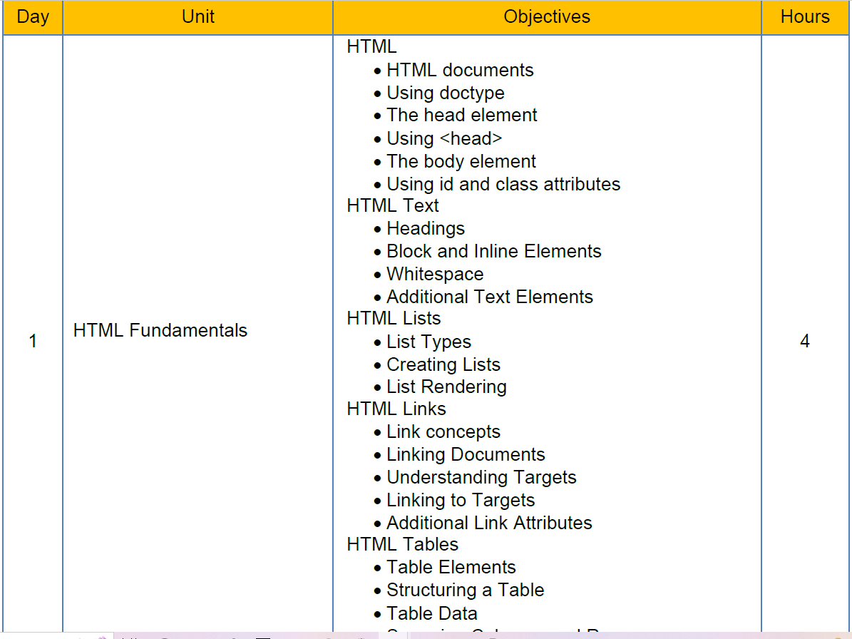
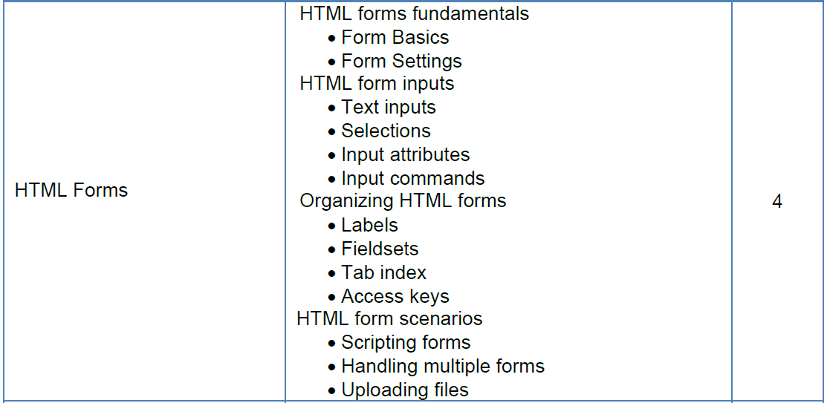
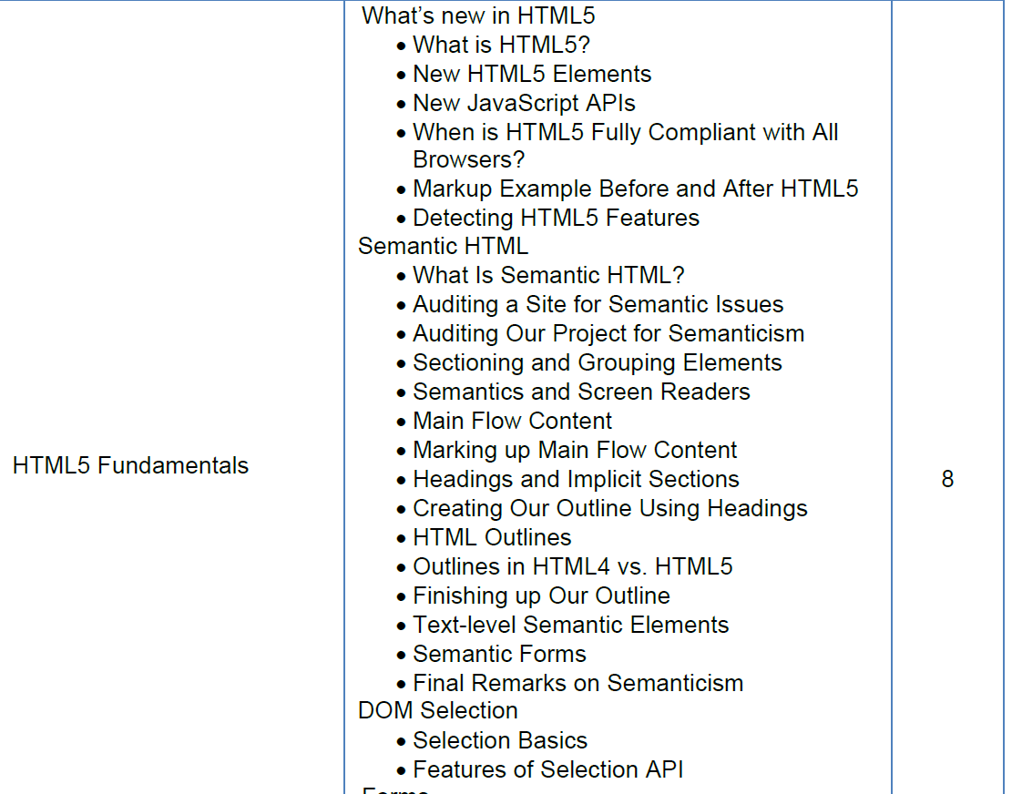---------------
CSS
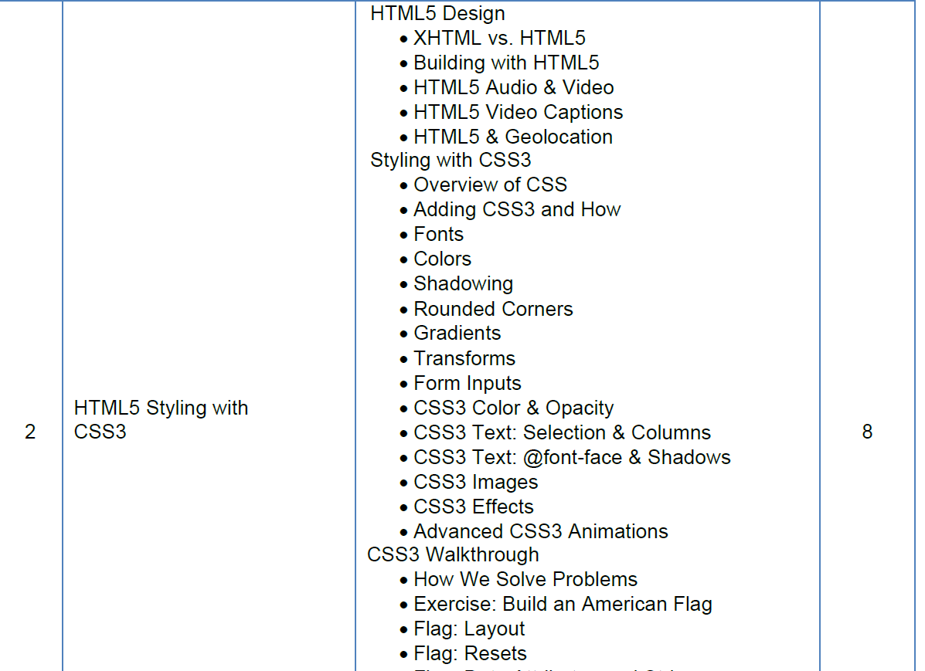

BOOTSTRAP
