Java Full stack Layered Architecture
What is a layered architecture?
Is the most preferred architecture for building applications.
In which we divide the application into multiple layers.

An application can be in
Monolithic architecture (or)
2-tier architecture (or)
3-tier architecture (or)
n-tier or multi tier architecture

What are the services offered by a application software?
Presentation / UI / Front End
Business / Domain / Middle tier
Data / Back End
---------------------
monolithic:
a single application provides all the 3 services:
if you see EXCEL, it provides UI / front end also
it provides data storage service also
it provides business services like calculation, validation, formatting, etc
ex: MS Access

2-tier architecture
Server database
Client UI

Where is the business layer??????
It can be a part of server or client or both
If a server provides business service also, then it is called as “Fat server”
If a client provides business service also, then it is called as “Fat client”

3-tier architecture
--------------------------
Clear separation of
Application
Business
Data
Layers in three different deliverable products

n-tier architecture
--------------------------
- UI
- Functionality
- Business
- Application
- Data

UI proxy Business dao Data

Layered Architecture:
UI layer
Module 2 is UI layer HTML5, CSS3, Javascript ES6, Angular
Business Layer
Spring Core, Spring AOP, Spring MVC, Spring REST
Data Layer
Spring data JPA
MySQL / PostgreSQL

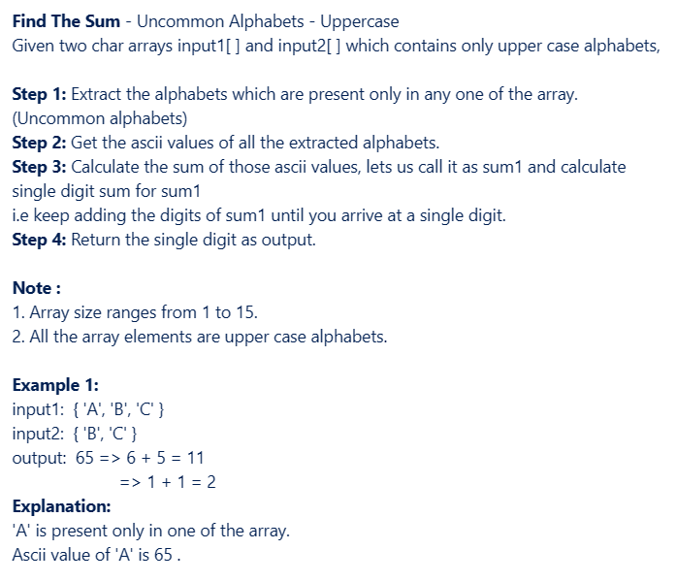
ArrayList<Character> uncommon=new ArrayList<>();
for(char c1 : input1)
{
//check if c is present in input2 array
boolean flag=false;
for(char c2 : input2)
{
if(c1==c2)
{
flag=true;
break;
}
}
if(!flag)
uncommon.add(c1);

}

for(char c1 : input2)
{
//check if c is present in input1 array
boolean flag=false;
for(char c2 : input1)
{
if(c1==c2)
{
flag=true;
break;
}
}
if(!flag)
uncommon.add(c1);

}

// System.out.println(uncommon);
int sum=0;
for(Character c : uncommon)
{
int ascii=c;
// System.out.println(ascii);
sum+=ascii;
}

while(sum>9)
{
String str=sum+"";
int total=0;
for(char c : str.toCharArray())
{
int digit=c-48;
total+=digit;
}
sum=total;
}
return sum;

