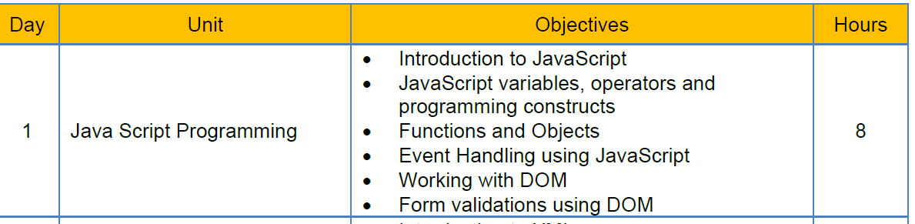

https://github.com/jagasia/ng

Javascript:
In our capstone project, the front end is Seen through a browser.
Because our project is a web application.
What is the role of javascript?
Validations
Calculations
Computations

In HTML, I am able to create TEXTBOX, DROPDOWN LIST, RADIO, CHECK BOX, BUTTON, etc
Then why we need javascript?
The above things done in HTML are static aspects of a web page.
What are dynamic aspects of a web page?
When I select a country in dropdownlist, corresponding states must be displayed.
When I click a button, the user name and password are checked and result is displayed.
When I type data in a textbox, the data is validated and only correct data is allowed.
When I type confirm password, it is compared with password and if it is matching or not is verified.
In response to an user interaction, some validation / calculation / computation happens.
Advantages of javascript:
Runs in client. So server does not need additional infrastructure. Browser itself can run javascript code.

Disadvantages of javascript:
Javascript runs in clients machine. So client may fear that it is harmful.

int i=20; float f=2.2f;
var i=20; var f=2.2;

if(i<20)

for(var i=0;i<20;i++)
{}
while(i>100)
{}

console.log(“”);

console.log(new Date());
System.out.println(new Date());

window.alert(“hello world”);

Javascript data types:

Activity:
Javascript data types:
Primitives:
Type | typeof return value | Object wrapper
Null | "object" | N/A
Undefined | "undefined" | N/A
Boolean | "boolean" | Boolean
Number | "number" | Number
BigInt | "bigint" | BigInt
String | "string" | String
Symbol | "symbol" | Symbol

var x; // x is undefined
var x=20; // x is number type
var y=20;
if(x===y) //means, x and y are same
== is used for equals or not
=== is used for same or not same type and same value

In javascript, semicolon is not compulsory, when there is a line separator.
Var x=20 Var y=30
Javascript Operators and Programming constructs:
Activity:
Identify the operators used in javascript
Activity:
Programming constructs like
if - else
Switch
While
Do while
For loop
For each
var arr=[12,40,18,7,9,8,11,15];
for(var x of arr)
{
console.log(x);
}

var arr=[12,40,18,7,9,8,11,15];
for(var x in arr) //in is for index
{
console.log(x);
}

var arr=[1,2,3,4,5,56,8,9];

Operators in javascript:
- Arithmetic Operators
- Assignment Operators
- Comparison Operators
- String Operators
- Logical Operators
- Bitwise Operators
- Ternary Operators
- Type Operators

Arithmetic Operators:
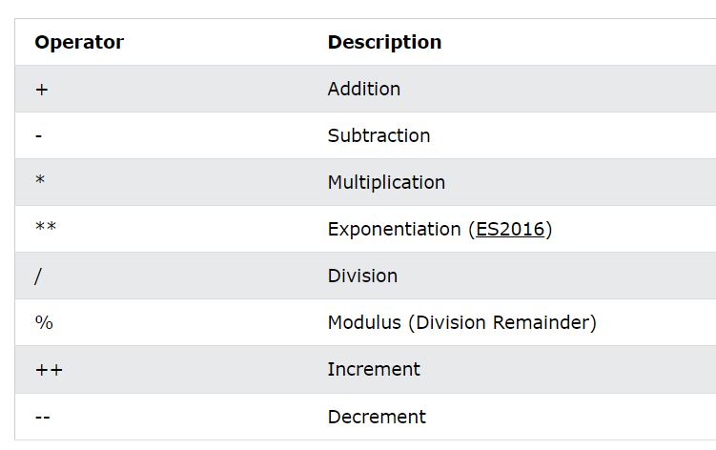
Assignement operators:
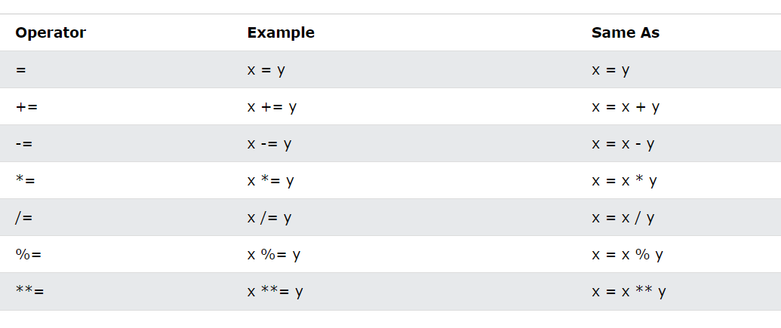

NULLIS COALESCE ASSIGNMENT
(x)??=fn1();

JavaScript Comparison Operators

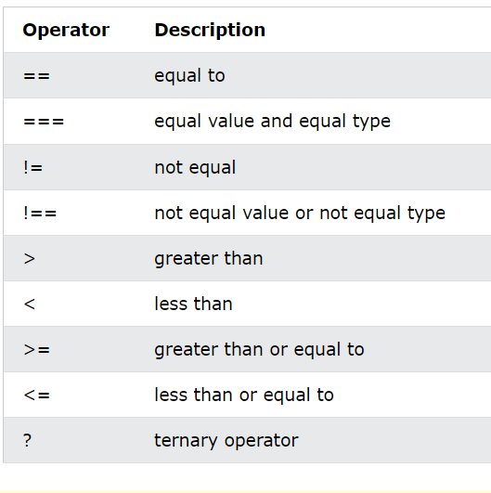
console.log((x>y)?20:10);

