SQL
DDL
DML
DCL
TCL

DQL
SELECT query

SELECT query is used to retrieve record(s) from table(s).

syntax:
SELECT <<expressions>>|columns
FROM <<table1>>, <<table2>> | <<table1>> JOIN <<table2>>
[WHERE <<condition1>> AND | OR <<condition2>>]
[GROUP BY <<expression>>]
[HAVING <<condition>>]
[ORDER BY <<column1>>,<<column2>>]

To learn by example, we need some sample schema.

schema (in mysql) is a database.
schema (in oracle) is a private space of an user.
ex: hr schema
sys schema

in livesql
SELECT * FROM HR.EMPLOYEES;

Basic select query:

SELECT * FROM HR.EMPLOYEES;
SELECT employee_id, first_name FROM HR.EMPLOYEES;
in this above query, what is * means?
all columns.
* or column list we mention in that place decides the PROJECTION

What is PROJECTION?
a table may have many columns. But we project only relevant columns.

What is SELECTION?
a table may have many rows, But we select only the rows that pass a criteria.

SELECT * FROM HR.EMPLOYEES where SALARY>15000;
We got 3 rows only.
UNION
SELECT * FROM HR.EMPLOYEES where SALARY>15000
union
SELECT * FROM HR.EMPLOYEES where SALARY>10000 AND SALARY<=15000;

UNION vs UNION ALL

UNION ALL
includes duplicate rows (from both queries)
in that case the number of rows is always equal to sum of both query rows.

INTERSECT
SELECT * FROM HR.EMPLOYEES where SALARY>15000
intersect
SELECT * FROM HR.EMPLOYEES where SALARY>10000
we got 3 rows

PRODUCES THE COMMON ROWS amont the 2 select statements

UNION
UNION ALL
MINUS
PRODUCT

MINUS
SELECT * FROM HR.EMPLOYEES where SALARY>10000
minus
SELECT * FROM HR.EMPLOYEES where SALARY>15000;

PRODUCT
is done when we use JOINs
Reminder: JOINS

-----------------------------------
SELECT
column list
alias
SELECT EMPLOYEE_ID, FIRST_NAME, LAST_NAME, SALARY
FROM HR.EMPLOYEES --projection
WHERE SALARY>10000; --selection

WHERE:
you can give conditions
multiple conditions using AND OR operators

SELECT EMPLOYEE_ID, FIRST_NAME, LAST_NAME, SALARY
FROM HR.EMPLOYEES
WHERE SALARY>10000
AND SALARY<=12000;

Task:
write select query on HR.EMPLOYEES and display
different set of columns,
and conditions to filter the rows based on different columns like SALARY, DEPARTMENT_NO etc.

Observation:
When the WHERE condition is based on (=)primary key column (here it is EMPLOYEE_ID), then we get 1 row. Example: SELECT * FROM HR.EMPLOYEES WHERE EMPLOYEE_ID=102
Try to get 1 result using conditions on non-primary key column. (use AND OR operators on multiple columns).
|| for concatenation
SELECT FIRST_NAME || LAST_NAME

In WHERE Condition
What are all operators we can use?
COMPARISON OPERATORS
> < >= <= = <> !=
We can modify these operators using ANY ALL (we will use during sub queries).

LOGICAL OPERATORS
NOT AND OR

BETWEEN NOT BETWEEN
IN NOT IN

IS NULL
IS NOT NULL

=NULL will not work
SELECT * FROM HR.EMPLOYEES WHERE DEPARTMENT_ID IS NULL;

LIKE operator
Is used to use wild cards. Ex: LIKE ‘A%’
LIKE ‘A_’
2 wild card characters are used in LIKE operator.
% means 0 or more characters
_ means only 1 1 and only 1

Task
Find all the employees, whose first name ends with e

SELECT * FROM HR.EMPLOYEES WHERE FIRST_NAME LIKE '%e'

Now we have listed the operators, we need to observe them.
Task:
Find the employees where salary is in the range of 5000 to 10000 (inclusive) without using >= <= = etc comparison operator.
Steps for PostgreSQL
- In software centre, search for “PostgreSQL”
- Install
After installation:
- In start menu, type psql and enter
All default values, just press enter

Problem:
Psql is not found in start menu

Solution:
Go to
C:\Program Files (x86)\PostgreSQL\10\bin
In address bar click on empty space and type cmd and enter
You have come to command prompt at the bin location

Type the following command:
psql -U postgres
<<it will prompt the password of the user “postgres”>>
Type the password as “postgres”. It will not be visible. But type correctly

Now, you can see
postgres=#

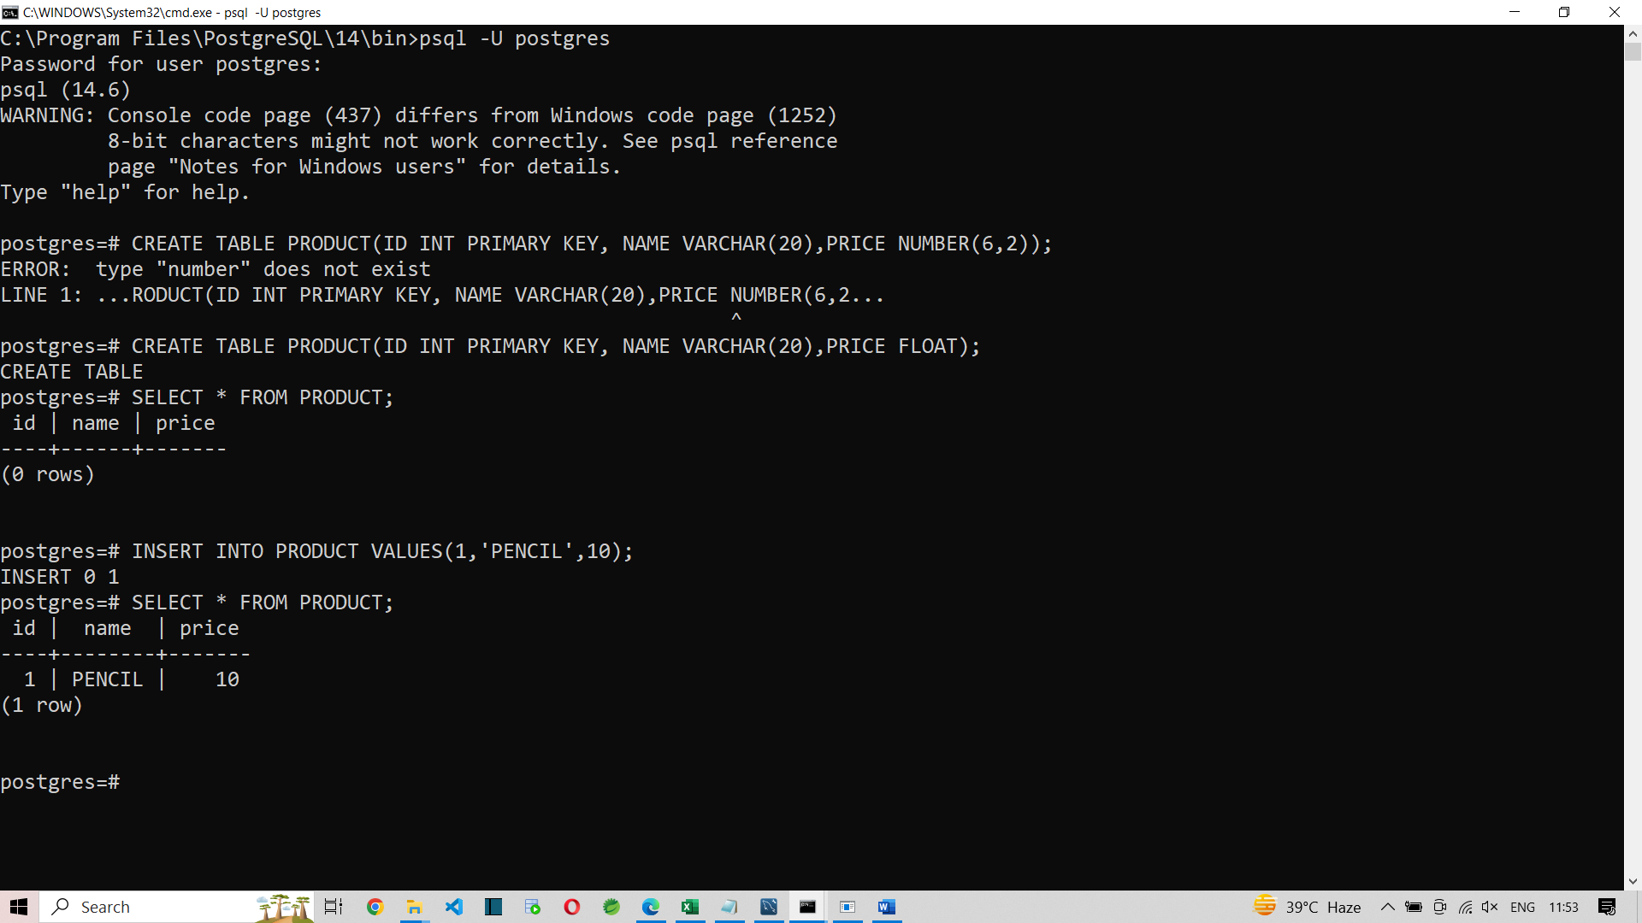

Lets continue to learn SELECT statement.
SELECT
WHERE

Lets learn ORDER BY
The result will be sorted based on ORDER BY expression.
SELECT * FROM HR.EMPLOYEES
ORDER BY FIRST_NAME DESC;
The above query returns the records in the order of FIRST_NAME ie in descending order.
ASC means Ascending order. If we do not mention ASC also it is ascending order.

SELECT * FROM HR.EMPLOYEES
ORDER BY salary;

SELECT * FROM HR.EMPLOYEES
ORDER BY hire_date;

So we can sort based on numeric, char, date type of columns.

We can sort records based on multiple columns.
SELECT * FROM HR.EMPLOYEES
ORDER BY DEPARTMENT_ID, SALARY;
The above query sorts the employee records based on department_id and if the department_ids are same for employees, their records are sorted by their salary.

SELECT * FROM HR.EMPLOYEES
ORDER BY DEPARTMENT_ID desc, SALARY asc;
We can also use expressions in ORDER BY clause:
SELECT * FROM HR.EMPLOYEES
ORDER BY EXTRACT(DAY FROM HIRE_DATE);

Task:
Practise the ORDER BY class
ASC
DESC
Multiple columns
Expressions
Functions in Oracle

