Normalization
Is a scientific or step by step formal process to arrive at the correct set of tables in a database.
Reduces redundancy
What is redundancy? Unnecessary repeatation of same data in multiple locations
Update Anamolies
What is update anamolies? If you repeat same data in many locations, we may update them inconsistently. Example, In attendance table, if we have trainer name, it may be updated differently in different rows.

Functional Dependency
It is based on a column depends on another column or whole entity.
For example, In Candidate table, phone number is based on candidate. But State is based on city, not on candidate.

Large table split into multiple tables, with relationship like primary key of one table is foreign key of another table, this is what we do when we do normalization. If we split tables, we do normalization. If we merge tables, we do de-normalization.

Step by Step normalization:
1st Normal Form
2nd Normal Form
3rd Normal Form
Boyce Codd Normal Form
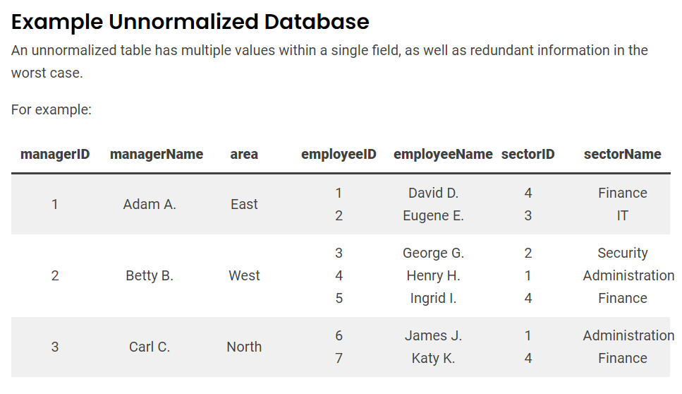
First Normal Form:
A table is said to be in 1st Normal form if every cell in the table contains precisely only 1 data.
Ex:
SNO NAME ADDRESS
1 Raja 12, Main road, Chennai 600002
2 Siva 14, Raja street, Coimbatore 641002
The above table has a column address, which contains many data. So if it is like
SNO NAME® ADDRESS1 CITY PINCODE
1 Raja 12, Main road, Chennai 600002
2 Siva 14, Raja street, Coimbatore 641002

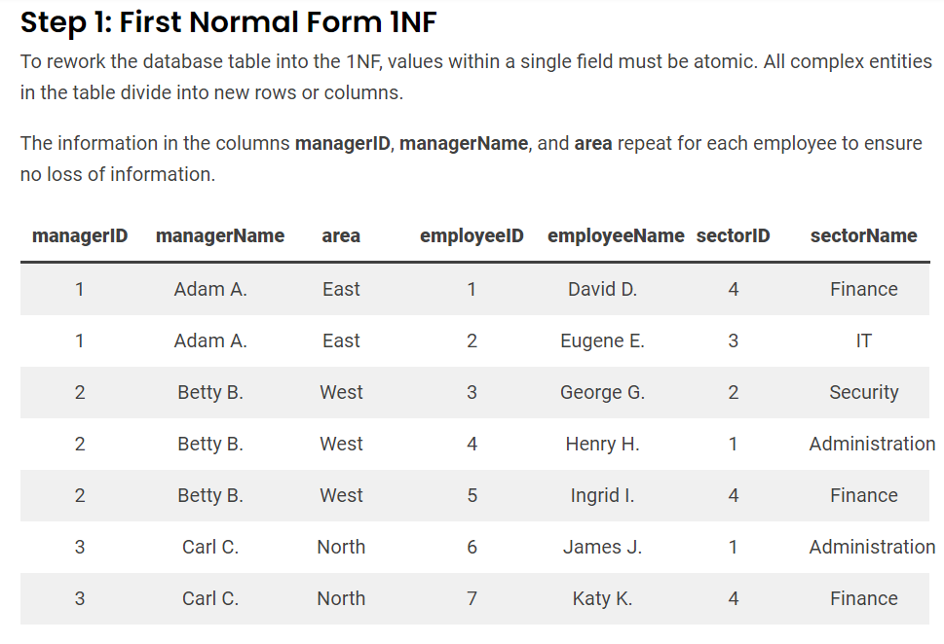
Second Normal Form:
A table is said to be in 2nd Normal form, if it is already in 1st normal form and every field in that table is dependent on whole key (entity).


Third Normal Form:
A table is said to be in 3rd Normal form, if it is already in 2nd normal form and every field is dependent on the primary key.
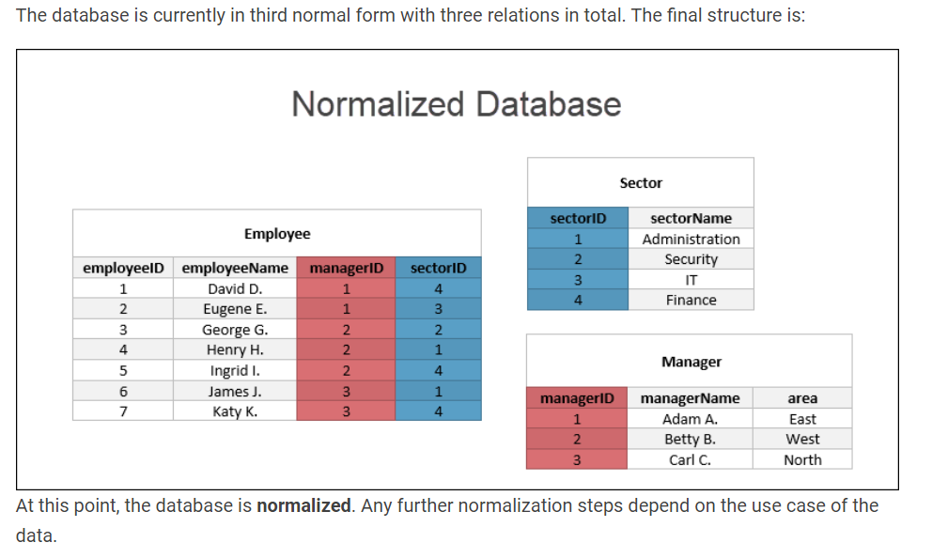

Activity:
Identify
First, Second and Third normal forms
Design patterns
Creational
Structural
Behavioral
SOLID principles
Single Responsibility Principle
Open – Closed Principle
Liskov Substitution Principle
Interface Segregation Principle
Dependency Inversion Principle

- Single Responsibility Principle
A class should implement only one functionality.

- Open – Close Principle
Open for Extension, Closed for Modification.

- Liskov Substitution Principle
If a method has an argument of type A, then we can substitute that with B or C or D, provided B, C, D are sub classes of A

- Interface Seggregation Principle
Instead of declaring an object of class, it is always good to declare ref var of an interface
List<Integer> marks=new ArrayList<Integer>(); //this is better than
ArrayList<Integer> marks=new ArrayList<Integer>();

- Dependency Inversion Principle

class Car1
{
Sony sony;
}

class Car2
{
Jbl jbl;
}

The above car classes have tightly coupled audio systems.

class Car3
{
Audio audio; //Audio is an interface
}

interface Audio
{}

class Sony implements Audio
{}

class Jbl implements Audio
{}

Reminder:
Creational
Structural
Behavioural

Stored Procedures
What is PLSQL?
Procedural Language Extension to SQL
SQL Statements are executed by sqL Engine.
PLSQL statements are executed by plsql engine.

In PLSQL
We can declare variables
We can use programming constructs like
Conditions and Looping

Every PLSQL program has a block structure

[DECLARE]
BEGIN
[EXCEPTION]
END

It is understood that a plsql program always have
BEGIN
END;

set serveroutput on;

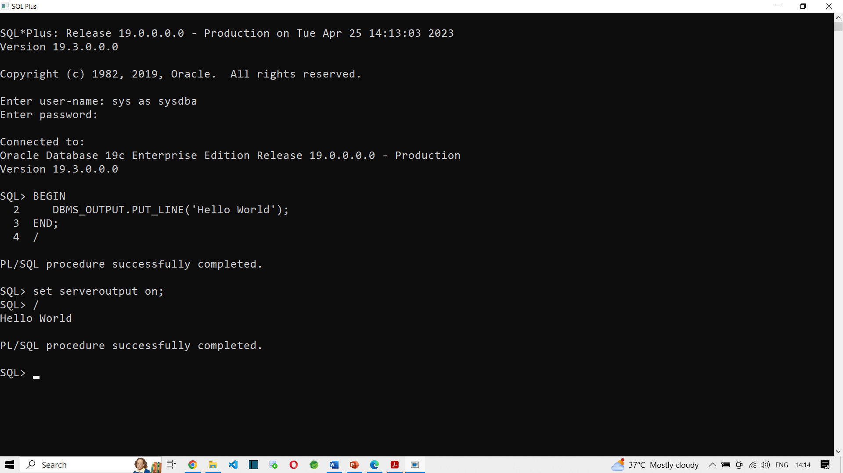

How to declare variables in PLSQL?
You can declare variables only in the DECLARE block
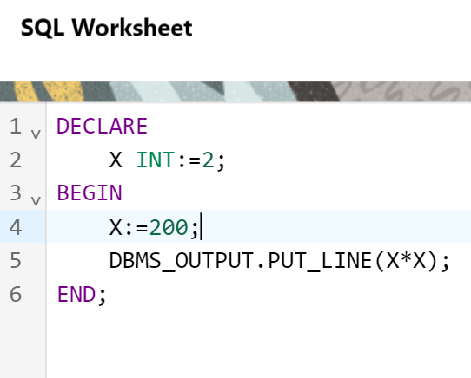

Can we run SQL statements inside PLSQL program?
Of course.

DECLARE
X INT;
BEGIN
SELECT 2*3 INTO X FROM DUAL;
DBMS_OUTPUT.PUT_LINE(X);
END;

--

DECLARE
X INT;
BEGIN
SELECT SALARY INTO X FROM HR.EMPLOYEES; --More than 1 row is retrieved, so we cannot store it in a scalar variable
DBMS_OUTPUT.PUT_LINE(X);
END;

ORA-01422: exact fetch returns more than requested number of rows ORA-06512: at line 4

DECLARE
X INT;
BEGIN
SELECT SALARY INTO X FROM HR.EMPLOYEES WHERE EMPLOYEE_ID=100;
DBMS_OUTPUT.PUT_LINE(X);
END;
Statement processed.
24000

These are PLSQL programs. Also called as Anonymous programs.
Because these programs do not have a name. Hence they are not stored in database.

How to use IF conditions in PLSQL?
DECLARE
X INT;
BEGIN
SELECT SALARY INTO X FROM HR.EMPLOYEES WHERE EMPLOYEE_ID=100;
IF X>20000 THEN
DBMS_OUTPUT.PUT_LINE('NOT ELIGIBLE FOR BONUS');
ELSIF X>10000 THEN
DBMS_OUTPUT.PUT_LINE('ELIGIBLE FOR 10% BONUS');
ELSE
DBMS_OUTPUT.PUT_LINE('ELIGIBLE FOR 50% BONUS');
END IF;
DBMS_OUTPUT.PUT_LINE(X);
END;

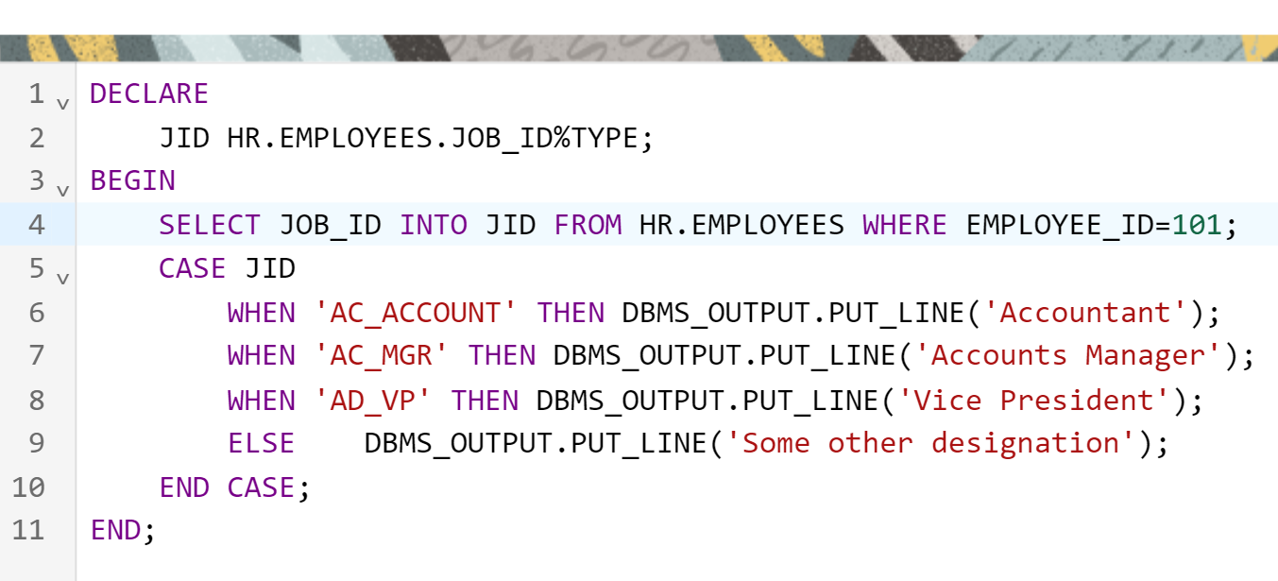

We can also do Looping:
DECLARE
JID HR.EMPLOYEES.JOB_ID%TYPE;
I INT:=100;
BEGIN
LOOP
DBMS_OUTPUT.PUT_LINE(I);
I:=I+1;
IF I>110 THEN
EXIT;
END IF;
END LOOP;
END;

Statement processed.
100
101
102
103
104
105
106
107
108
109
110

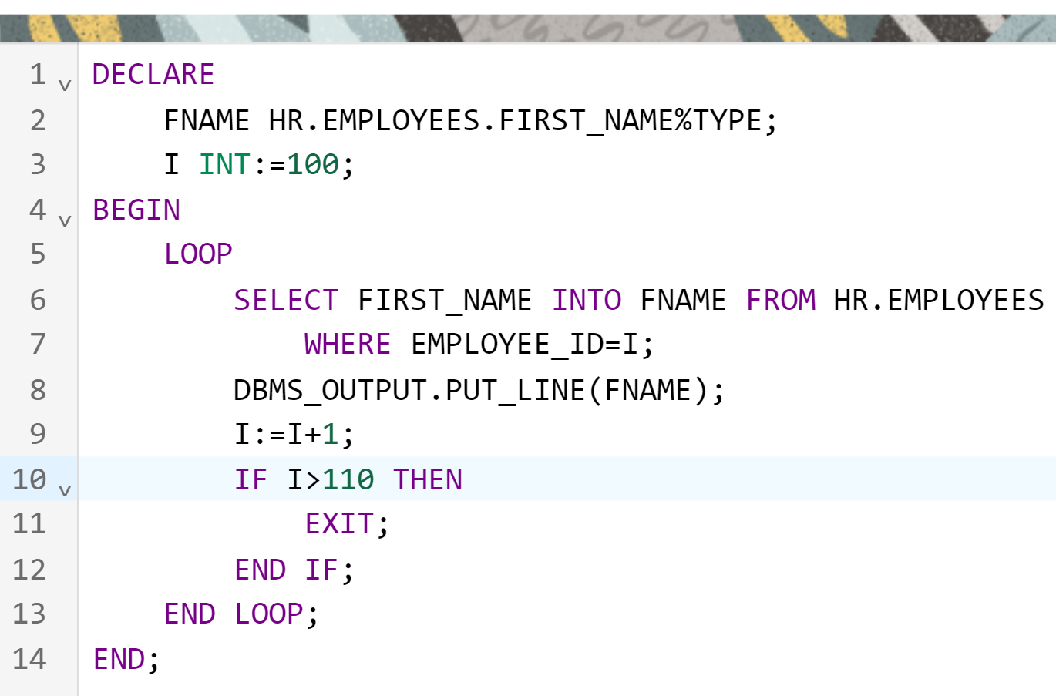

Statement processed.
Steven
Neena
Lex
Alexander
Bruce
David
Valli
Diana
Nancy
Daniel
John

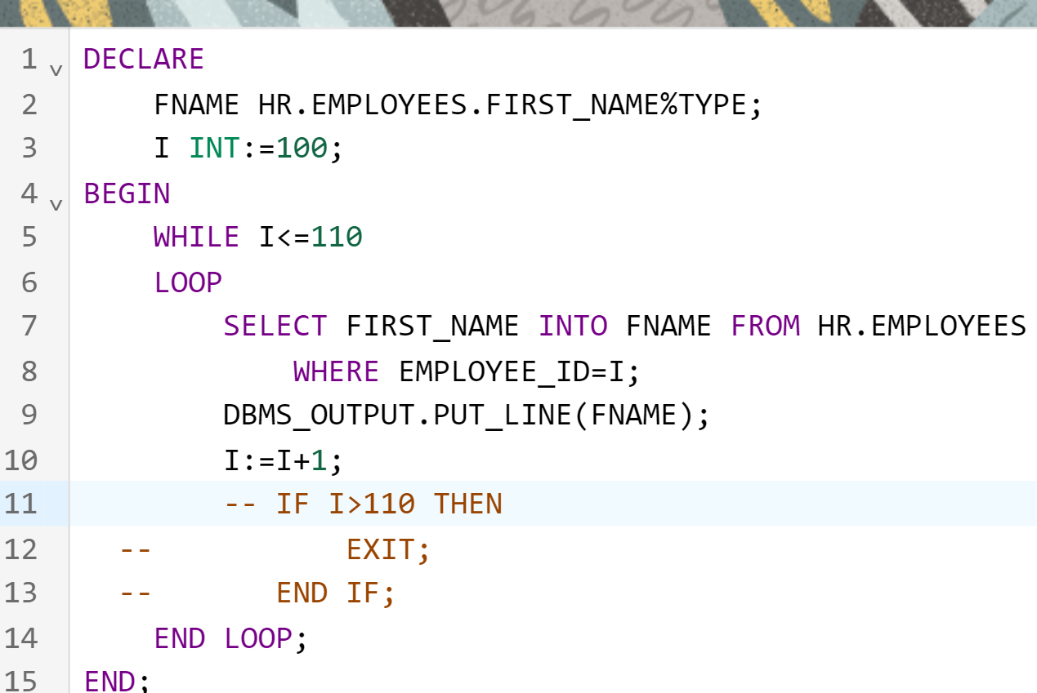

Same output. But we earlier used BASIC LOOP, now we use WHILE LOOP

Shall we use FOR LOOP now.
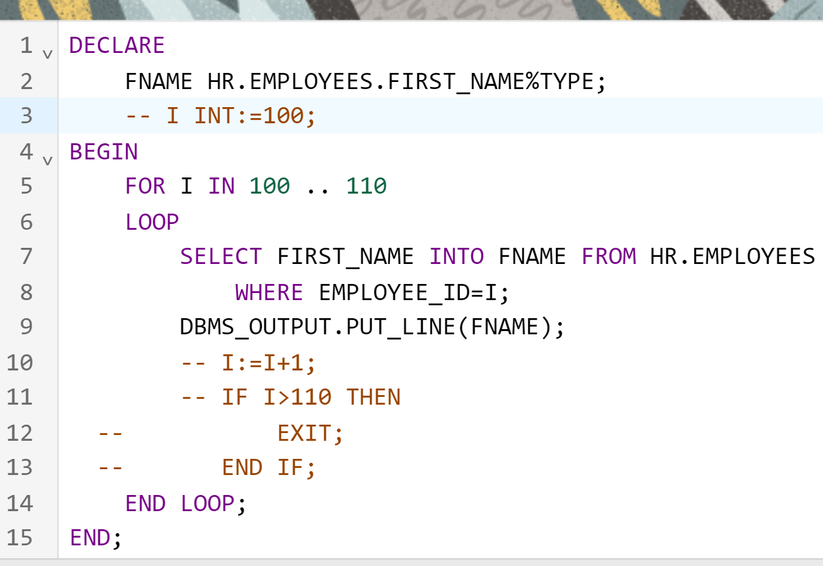

Notice that FOR loop variable need not be declared. If I is already declared, then it ignores that I and use Local loop variable I inside loop.

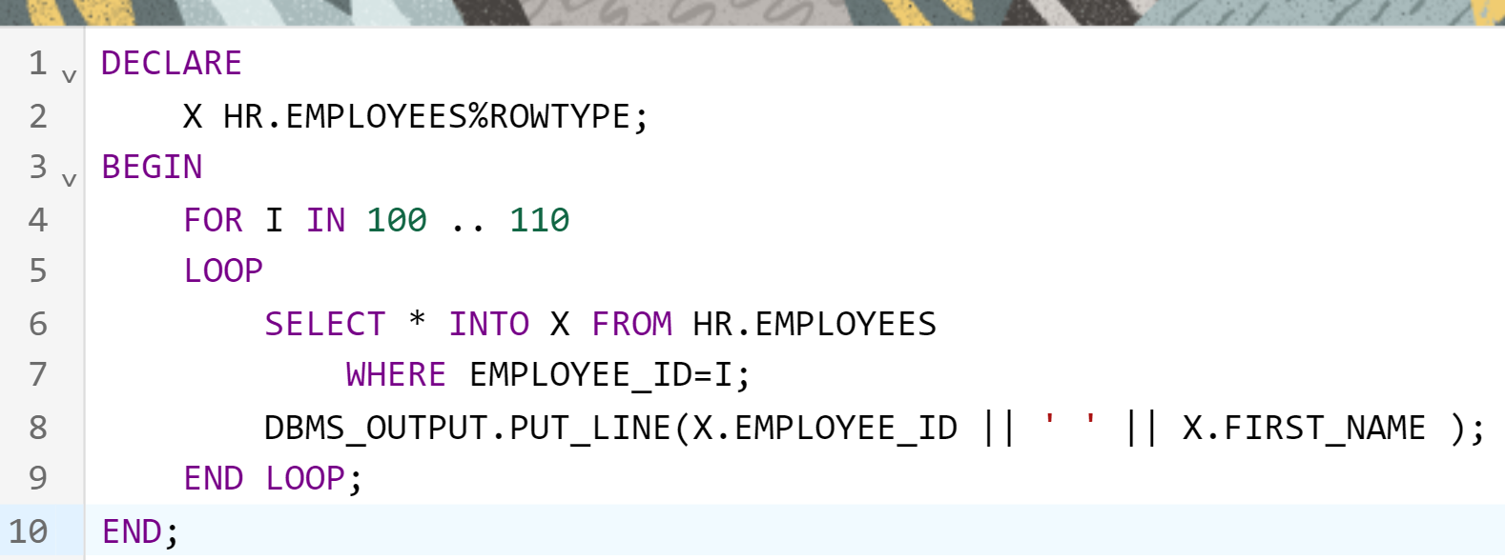

PROCEDURES
------------------------
They are named PLSQL programs
They are stored in the database as object.

We can call the procedure from
A plsql program (or from)
Another procedure (or from)
A function (or from)
A trigger

Etc

Procedure is like a void method in java.

I am going to modify the PLSQL program we did above into a procedure.
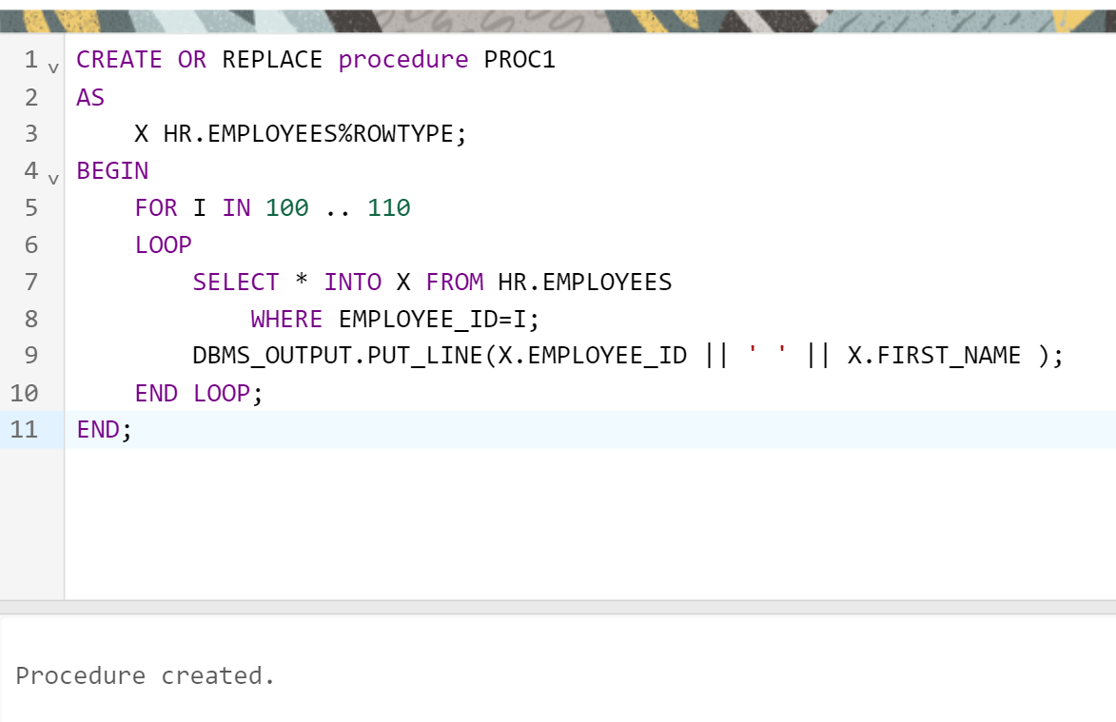

To call this procedure:
We can call this proc from a plsql program

BEGIN
proc1;
END;

Statement processed.
100 Steven
101 Neena
102 Lex
103 Alexander
104 Bruce
105 David
106 Valli
107 Diana
108 Nancy
109 Daniel
110 John

PROCEDURES, can have parameters.

CREATE OR REPLACE procedure PROC1(M INT, N INT)
AS
X HR.EMPLOYEES%ROWTYPE;
BEGIN
FOR I IN M .. N
LOOP
SELECT * INTO X FROM HR.EMPLOYEES
WHERE EMPLOYEE_ID=I;
DBMS_OUTPUT.PUT_LINE(X.EMPLOYEE_ID || ' ' || X.FIRST_NAME );
END LOOP;
END;

To call this procedure:
DECLARE
X INT;
Y INT;
BEGIN
X:=100;
Y:=106;
PROC1(X,Y);
END;

Procedures can have
IN
OUT
IN OUT
Parameters.

Collections.sort(arr);
Sqr(2,x); x=4
Cube(2,x) x=8
Sqrt(4,x) x=2

Here, in above examples, x is OUT parameter, because the procedure fills output in that parameter.

CREATE OR REPLACE PROCEDURE PRCAJAY(X INT, Y OUT INT)
AS
BEGIN
Y:=X*X;
END;

We call this procedure using PLSQL program:
DECLARE
X INT:=2;
Y INT;
BEGIN
PRCAJAY(2,Y);
DBMS_OUTPUT.PUT_LINE(Y);
END;

Output is 4

CREATE OR REPLACE PROCEDURE PRCSQR(X IN OUT INT)
AS
BEGIN
X:=X*X;
END;

The above is IN OUT

DECLARE
X INT:=4;
BEGIN
PRCSQR(X);
DBMS_OUTPUT.PUT_LINE(X);
END;

Lets create a PLSQL Function.

CREATE OR REPLACE FUNCTION fnKalyan
RETURN INT
AS
BEGIN
RETURN 200;
END;

How to call the function?
A function can be called from
A plsql program
Another function
A procedure
SQL Statements
SELECT fnKalyan() FROM DUAL;

DECLARE
x INT;
BEGIN
x:=fnKalyan();
DBMS_OUTPUT.PUT_LINE(x);
END;

Demo:
Single row functions (scalar)

CREATE OR REPLACE FUNCTION fnBonus(SAL INT)
RETURN INT
AS
BEGIN
RETURN SAL+SAL*2;
END;

Lets use this in our EMPLOYEES table

select first_name, salary, fnBonus(salary) as Bonus
from hr.employees;

Task:
Create a plsql function that accepts employee id as input and returns the salary as output.

Task:
Create a plsql function that accepts employee id as input and returns the entire row as output.

create or replace function fn2(id1 INT)
return HR.EMPLOYEES%ROWTYPE
as
emprec HR.EMPLOYEES%ROWTYPE;
begin
SELECT * INTO emprec FROM HR.EMPLOYEES WHERE EMPLOYEE_ID=id1;
return emprec;
end;

DECLARE
result HR.EMPLOYEES%ROWTYPE;
BEGIN
result:=fn2(101);
DBMS_OUTPUT.PUT_LINE(result.FIRST_NAME || ' ' || result.LAST_NAME);
END;

