CSS - Cascading Style Sheet

Why do we need Stylesheet?

In HTML itself we can do styling like

Font family

Font color

Size

Background (color/ image)

Alignment

Block or inline

It is almost possible to stay only with HTML also

Then why we need CSS?

Suppose, you are creating a website of 10 pages.

All pages appear in some theme. Say blue theme.

We want users to choose yellow theme.

A change in one page, needs change in all other 9 pages.

We want consistent look or appearance in all the 10 pages.

Ex: all <p> should be in justify alignment and in font Verdana and size 12

CSS was introduced with intention to

Separate the roles of a html developer and a designer (designer works with CSS)

It is possible for a person to work on style alone. And then apply that style in one or more html pages.

Syntax:

<<selector>>

{

Key1:value1;

Key2:value2;

}

There are several hundreds of style attributes in css like

Color

Background-color

Font-family

Text-align

Font-size

Background : value1 value2 value3

Selectors:

To use css in a html file, we have 3 ways:

What are the 3 different ways we can use css?

Inline <p style=”text-align:center”>

Internal <style>

External

Inline

All inline styles are specified in the “style” attribute of an element.

It is mentioned in the line of the element

    <p style="color:red;text-align: right;">First para</p>

    <p style="font-family:'Courier New', Courier, monospace">2nd Para</p>

    <p>III para</p>

Internal

We use <style> element to apply style for entire page. Internal to the page

<!DOCTYPE html>

<html lang="en">

<head>

    <meta charset="UTF-8">

    <meta http-equiv="X-UA-Compatible" content="IE=edge">

    <meta name="viewport" content="width=device-width, initial-scale=1.0">

    <title>Document</title>

    <style>

        p

        {

            text-align: center;

            color: #00ff00;

        }

    </style>

</head>

<body>

    <p>First para</p>

    <p>2nd Para</p>

    <p>III para</p>

</body>

</html>

External

Separate file with extension .css is created

And apply that css in html file using

<link>

p

{

    color: red;

    text-align: center;

}

<!DOCTYPE html>

<html lang="en">

<head>

    <meta charset="UTF-8">

    <meta http-equiv="X-UA-Compatible" content="IE=edge">

    <meta name="viewport" content="width=device-width, initial-scale=1.0">

    <title>Document</title>

    <link rel="stylesheet" href="red.css">

</head>

<body>

    <p>First para</p>

    <p>2nd Para</p>

    <p>III para</p>

</body>

</html>

Task:

Practice inline, internal, external css with simple examples like

Color

Text-align

You can start identifying various css selectors.

Selectors:

Id

Class

Element (simple)

Group

Universal

Pseudo/attribute

Element / simple selector

p

{

    color: blue;

    text-align: left;

}

div

{

    background-color: yellow;

}

ID selector

p

{

    color: blue;

    text-align: left;

}

#p2

{

    color:orange

}

div

{

    background-color: yellow;

}

Class selector

    <p class="odd right">One</p>

    <p class="even ">Two</p>

    <p class="odd center">Three</p>

    <p class="even">One</p>

    <p class="odd right">One</p>

    <p class="even">One</p>

    <p class="odd">One</p>

.odd

{

    color:aqua

}

.even

{

    color:brown

}

.right

{

    text-align: right;

}

.center

{

    text-align: center;

}

p.center {  
  text-align: center;  
  color: red;  
}

Universal selector:

* {  
  text-align: center;  
  color: blue;  
}

Grouping selectors: Look at below code before grouping:

h1 {  
  text-align: center;  
  color: red;  
}  
  
h2 {  
  text-align: center;  
  color: red;  
}  
  
p {  
  text-align: center;  
  color: red;  
}

After grouping:

h1, h2, p {  
  text-align: center;  
  color: red;  
}

Challenge:

**Sum of Rows and Columns**  
  
As Aadharsh did not perform well in his last internal test,his teacher gave him an assignment inorder to increase his internal marks.The assignment was to print all  row wise sum and column wise sum in a matrix.Given a 2D matrix of size M x N,write a program to help Aadharsh with his assignment.  
  
**Input Format:**  
First input is an integer that denotes the row size.  
Second input is an integer that denotes the column size.  
Third input consists of a series of integers separated by a space that denotes the matrix values.  
  
**Output Format:**  
Output is of two lines  
  1) First line consists of series of integers separated by space that denotes the sum of each rows.  
  1) Second line consists of series of integers separated by space that denotes the sum of each columns.  
  
**Sample Input 1:**  
3  
3  
1 2 3  
4 5 6  
7 8 9  
  
**Sample Output 1:**  
6 15 24  
12 15 18  
  
  
**Sample Input 2:**   
1  
4  
15 32 498 36  
  
**Sample Output 2:**  
581   
15 32 498 36

Solution:

import java.util.Scanner;

public class App {

public static void main(String[] args) {

Scanner sc=new Scanner(System.in);

int rows=sc.nextInt();

int cols=sc.nextInt();

int arr[][]=new int[rows][cols];

for(int i=0;i<rows;i++)

{

for(int j=0;j<cols;j++)

{

arr[i][j]=sc.nextInt();

}

}

//row sum 0,0 + 0,1 +0,2

for(int i=0;i<rows;i++)

{

int sum=0;

for(int j=0;j<cols;j++)

{

sum+=arr[i][j];

}

System.out.print(sum+"\t");

}

System.out.println();

//col sum 0,0 1,0 2,0

for(int j=0;j<cols;j++)

{

int sum=0;

for(int i=0;i<rows;i++)

{

sum+=arr[i][j];

// System.out.println("i="+i+" : j="+j);

}

System.out.print(sum+"\t");

}

}

}

Comments in css:

/* This is a single-line comment */  
p {  
  color: red;  
}

border:2px solid Tomato;

vs

            border-width: 12px;

            border-style: dashed;

            border-color: blue;

<h1 style="background-color:rgb(255, 99, 71);">...</h1>  
<h1 style="background-color:#ff6347;">...</h1>  
<h1 style="background-color:hsl(9, 100%, 64%);">...</h1>  
  
<h1 style="background-color:rgba(255, 99, 71, 0.5);">...</h1>  
<h1 style="background-color:hsla(9, 100%, 64%, 0.5);">...</h1>

[Try it Yourself »](https://www.w3schools.com/Css/tryit.asp?filename=trycss_color_values)

Colors: Try it yourself

Backgrounds: Try it yourself

Border: Try it yourself (all, bottom, rounded, blue left etc)

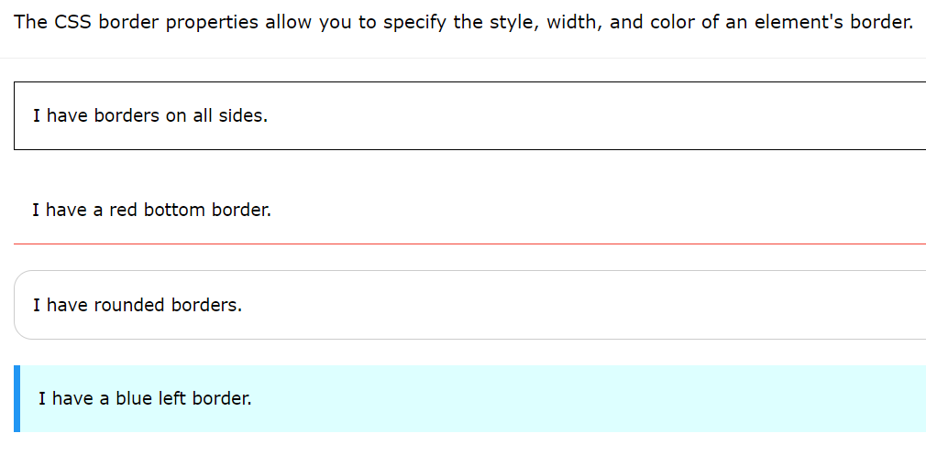

<!DOCTYPE html>

<html>

<head>

<style>

p.dotted {border-style: dotted;}

p.dashed {border-style: dashed;}

p.solid {border-style: solid;}

p.double {border-style: double;}

p.groove {border-style: groove;}

p.ridge {border-style: ridge;}

p.inset {border-style: inset;}

p.outset {border-style: outset;}

p.none {border-style: none;}

p.hidden {border-style: hidden;}

p.mix {border-style: double dotted solid none ;}

</style>

</head>

<body>

<h2>The border-style Property</h2>

<p>This property specifies what kind of border to display:</p>

<p class="dotted">A dotted border.</p>

<p class="dashed">A dashed border.</p>

<p class="solid">A solid border.</p>

<p class="double">A double border.</p>

<p class="groove">A groove border.</p>

<p class="ridge">A ridge border.</p>

<p class="inset">An inset border.</p>

<p class="outset">An outset border.</p>

<p class="none">No border.</p>

<p class="hidden">A hidden border.</p>

<p class="mix">A mixed border.</p>

</body>

</html>

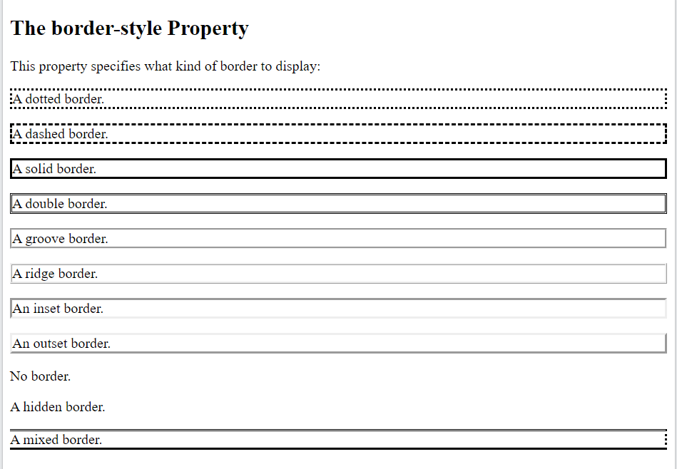

CSS Box Model: IMPORTANT

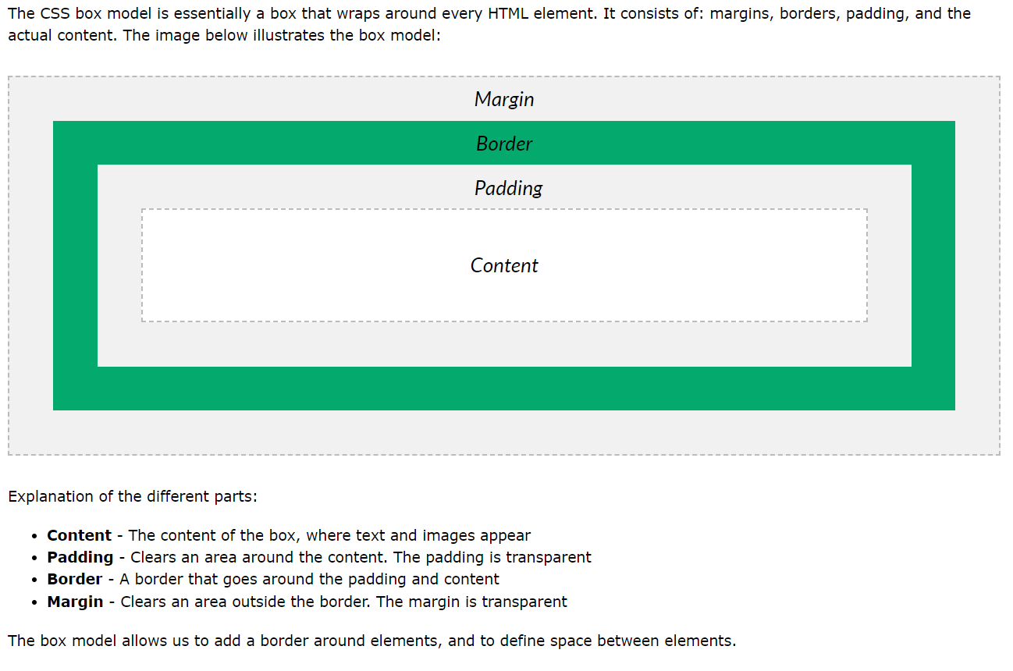

<!DOCTYPE html>

<html>

<head>

<style>

div {

background-color: lightgrey;

width: 300px;

border: 15px solid green;

padding: 150px;

margin: 120px;

}

</style>

</head>

<body>

<h2>Demonstrating the Box Model</h2>

<p>The CSS box model is essentially a box that wraps around every HTML element. It consists of: borders, padding, margins, and the actual content.</p>

<div>This text is the content of the box. We have added a 50px padding, 20px margin and a 15px green border. Ut enim ad minim veniam, quis nostrud exercitation ullamco laboris nisi ut aliquip ex ea commodo consequat. Duis aute irure dolor in reprehenderit in voluptate velit esse cillum dolore eu fugiat nulla pariatur. Excepteur sint occaecat cupidatat non proident, sunt in culpa qui officia deserunt mollit anim id est laborum.</div>

</body>

</html>

Challenge:

**Is a Chessboard**

Somu is preparing himself to build a Chess Game app. For that he needs to learn and workout a lot problems on 2-D Arrays. In the initial phase, given a 2D array with 1's and 0's , where 1 represents black color and 0 represents white color of the chess board, he wants to find whether it resemples a chess board or not.  
Write a program to help Somo to determine whether the given 2-D Array resembles a Chess board or not. If it doesn't resemble, calculate the minimum number of cells that need to be changed.  
  
**Assume** that the board is of any dimension and need not be a square.  
  
**[Note :** The first cell in the chess board can either be black or white.]  
  
**Input Format:**  
First line of the input is an integer that denotes the Row Size.  
Second line of the input is an integer that denotes the Column Size.  
Rest of the input are colours of the board, represented in matrix format.  
  
**Output Format:**  
Output is a String "true", if the matrix resembles a valid chess-board. Else print "False" , along with the number of cells need to be changed.  
  
**Sample Input 1:**  
3  
4  
1 0 1 0  
0 1 0 1  
1 0 1 0  
  
**Sample Output 1:**  
true  
  
**Sample Input 2 :**  
3  
3  
0 1 0  
1 0 0  
0 1 0  
  
**Sample Output 2:**  
false   
1   
  
**Explanation for Sample 2:**  
If the element at 2nd row and 3rd col is changed to '1', it becomes a valid chess board. So the output is 1.

Solution:

**import** java.util.Scanner;

**public** **class** App {

**public** **static** **void** main(String[] args) {

Scanner sc=**new** Scanner(System.***in***);

**int** rows=sc.nextInt();

**int** cols=sc.nextInt();

**int** input[][]=**new** **int**[rows][cols];

**for**(**int** i=0;i<rows;i++)

{

**for**(**int** j=0;j<cols;j++)

{

input[i][j]=sc.nextInt();

}

}

//based on the first element 0,0 the entire chessboard can be planned

//check our plan with actuals then decide true or false.

**int** ideal[][]=**new** **int**[rows][cols];

**int** first = input[0][0];

first=Math.*abs*(first-1);

**int** rowStart=first;

**for**(**int** i=0;i<rows;i++)

{

first=rowStart;

**for**(**int** j=0;j<cols;j++)

{

first=Math.*abs*(first-1);

ideal[i][j]=first;

}

rowStart=Math.*abs*(rowStart-1);

}

**int** countErrors=0;

**for**(**int** i=0;i<rows;i++)

{

**for**(**int** j=0;j<cols;j++)

{

// System.out.print(ideal[i][j]+"\t");

**if**(input[i][j]!=ideal[i][j])

{

countErrors++;

}

}

// System.out.println();

}

System.***out***.println(countErrors==0);

**if**(countErrors>0)

{

System.***out***.println(countErrors);

}

}

}

Collections

List

ArrayList

LinkedList

Set

TreeSet

HashSet

LinkedHashSet

Map

TreeMap

HashMap

LinkedHashMap

Iterator

ListIterator

Comparable

Comparator

Collections.sort

EntrySet

KeySet

values()

Stream api

Lambda

Functional interface

Method reference

List and Set are collections.

Map is application of collection.

List and Set have some methods in common

add()

remove(index)

remove(Object)

ArrayList<Integer> marks….

marks.add(20);

marks.add(30);

marks.add(0);

marks.add(1);

To remove an element based on its value. Value is 30

marks.remove(30); ArrayIndexOutOfBoundsException

marks.remove(new Integer(30)); //only when the list is of type Integer, it is a problem

remove(int) is always index

Set

Does not allow duplicates

Order of elements in a set is based on the type of Set.

Is unordered collection

Reminder: Html5

What are the features of HTML5