Launch an EC2 instance - steps: <https://docs.aws.amazon.com/AWSEC2/latest/UserGuide/EC2_GetStarted.html>

**Step 1: Launch an instance**

You can launch a Linux instance using the AWS Management Console as described in the following procedure. This tutorial is intended to help you quickly launch your first instance, so it doesn't cover all possible options. For information about advanced options, see [Launch an instance using the new launch instance wizard](https://docs.aws.amazon.com/AWSEC2/latest/UserGuide/ec2-launch-instance-wizard.html). For information about other ways to launch your instance, see [Launch your instance](https://docs.aws.amazon.com/AWSEC2/latest/UserGuide/LaunchingAndUsingInstances.html).

**To launch an instance**

1. Open the Amazon EC2 console at <https://console.aws.amazon.com/ec2/>.
2. From the EC2 console dashboard, in the **Launch instance** box, choose **Launch instance**, and then choose **Launch instance** from the options that appear.
3. Under **Name and tags**, for **Name**, enter a descriptive name for your instance.
4. Under **Application and OS Images (Amazon Machine Image)**, do the following:
   1. Choose **Quick Start**, and then choose Amazon Linux. This is the operating system (OS) for your instance.
   2. From **Amazon Machine Image (AMI)**, select an HVM version of Amazon Linux 2. Notice that these AMIs are marked **Free tier eligible**. An *Amazon Machine Image (AMI)* is a basic configuration that serves as a template for your instance.
5. Under **Instance type**, from the **Instance type** list, you can select the hardware configuration for your instance. Choose the t2.micro instance type, which is selected by default. The t2.micro instance type is eligible for the free tier. In Regions where t2.micro is unavailable, you can use a t3.micro instance under the free tier. For more information, see [AWS Free Tier](https://aws.amazon.com/free/).
6. Under **Key pair (login)**, for **Key pair name**, choose the key pair that you created when getting set up.

**Warning**

Do not choose **Proceed without a key pair (Not recommended)**. If you launch your instance without a key pair, then you can't connect to it.

1. Next to **Network settings**, choose **Edit**. For **Security group name**, you'll see that the wizard created and selected a security group for you. You can use this security group, or alternatively you can select the security group that you created when getting set up using the following steps:
   1. Choose **Select existing security group**.
   2. From **Common security groups**, choose your security group from the list of existing security groups.
2. Keep the default selections for the other configuration settings for your instance.
3. Review a summary of your instance configuration in the **Summary** panel, and when you're ready, choose **Launch instance**.
4. A confirmation page lets you know that your instance is launching. Choose **View all instances** to close the confirmation page and return to the console.
5. On the **Instances** screen, you can view the status of the launch. It takes a short time for an instance to launch. When you launch an instance, its initial state is pending. After the instance starts, its state changes to running and it receives a public DNS name. If the **Public IPv4 DNS** column is hidden, choose the settings icon ( Settings icon. ) in the top-right corner, toggle on **Public IPv4 DNS**, and choose **Confirm**.
6. It can take a few minutes for the instance to be ready for you to connect to it. Check that your instance has passed its status checks; you can view this information in the **Status check** column.

After launching EC2 instance, connect to the instance using SSH client:

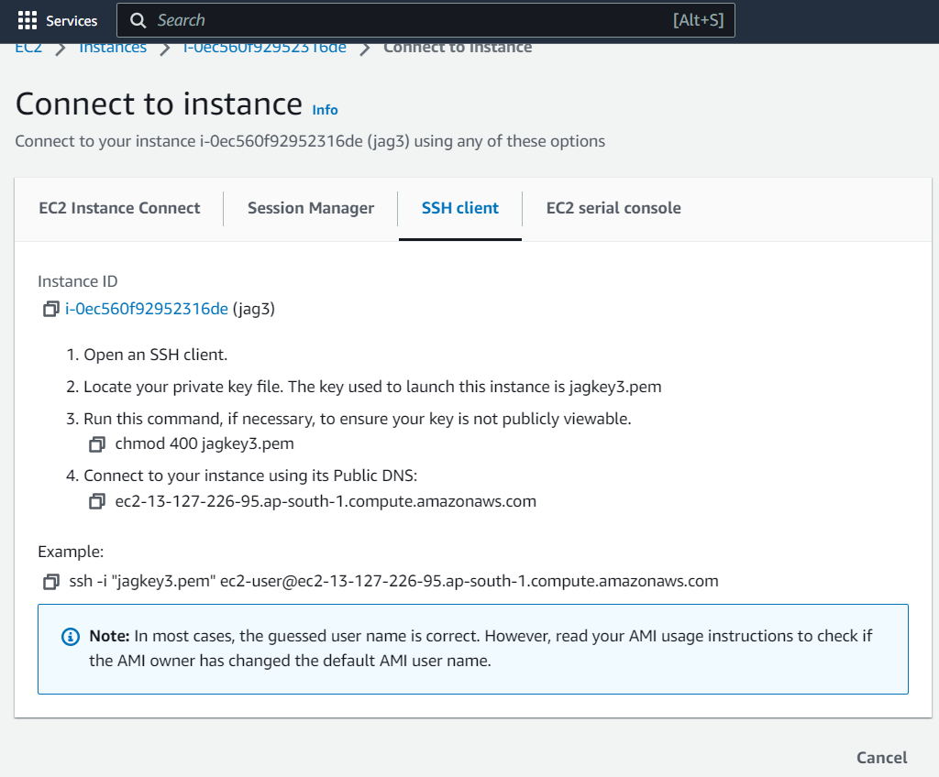

In cmd: paste the example command as seen above.

INSTALL Docker:

