Plan for the day:

1. Java hands on practice for M1
2. Online coding challenges
3. Module 1 curriculum
4. Some of our participants are going to present their topics
5. Online coding challenge: few of our team will choose a question online and all of us will take that challenge

BDD

Selenium, TestNg, etc

Code Quality, SonarQube metrics

PLSQL

OOAD & UML

Joins in SQL

Comparable and Comparator

JOINS

Whenever we need to retrieve columns from more than one table, we need JOIN

If you provide valid JOIN condition only, then JOIN will produce meaningful result. Otherwise, if you ignore the join condition, then you will get CARTESIAN PRODUCT of the both tables.

PRODUCT means, MULTIPLICATION.

First table 10 rows. Second table 10 rows. CARTESIAN PRODUCT = 100 rows.

CROSS JOIN also do the CARTESIAN PRODUCT. (no join condition)

NATURAL JOIN

SELECT * FROM HR.EMPLOYEES NATURAL JOIN HR.DEPARTMENTS;

SELECT * FROM HR.EMPLOYEES JOIN HR.DEPARTMENTS USING(DEPARTMENT_ID);

INNER JOIN

Produces result of only matching rows based on condition

OUTER JOIN

LEFT JOIN

All rows from left side table, and matching rows from right side table

RIGHT OUTER JOIN

All rows from right side table, and matching rows from left side table

FULL OUTER JOIN

All rows from both sides and their matching rows.

IN OUTER JOIN, if matching rows are not found, then NULL is placed there

Display all ACCOUNT holders name who has taken atleast 1 loan

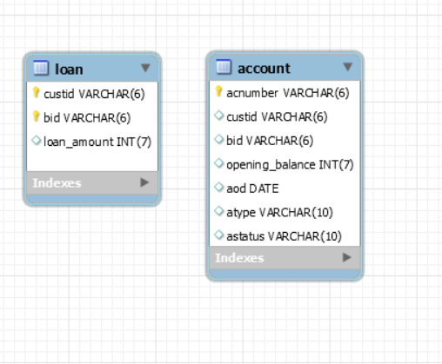

select distinct a.custid from account a

where exists

(select * from loan l where l.custid=a.custid);

The above query is correlated subquery.

select substring_index(substring_index('123 main road, Chennai-600002',',',-1),'-',1);

to extract Chennai from the address.

Munish presents the Testing concepts now.

Verification vs Validation

Quality Assurance

Quality Control

Black Box or Functional Testing

Grey box

White Box

Unit testing

Integration testing

Regression testing

Acceptance testing

System testing

Prograd Feedback link:-

<https://forms.gle/r9p5PrMWPKt1rnaH6>