CSS3

What are the 3 methods of using CSS?

Inline

Internal

External

<p id=”p1” class=”para”>This is a paragraph</p>

Precedence in which order style is applied to this element paragraph

External stylesheet: red.css

#p1

{

color:magenta

}

p

{

color:red;

}

<p id=”p1” class=”para”>This is a paragraph</p>

Now, internal css

<style>

P

{

color:blue;

}

</style>

<p id=”p1” class=”para” style=”color:yellow”>This is a paragraph</p>

Selectors

Universal \*

Pseudo selector input:[type=text]

Div > P

Div P

SELECTORS

Scaffolding

<!DOCTYPE html>

<html lang="en">

<head>

<title>Bootstrap Example</title>

<meta charset="utf-8">

<meta name="viewport" content="width=device-width, initial-scale=1">

<link rel="stylesheet" href="https://maxcdn.bootstrapcdn.com/bootstrap/3.4.1/css/bootstrap.min.css">

<script src="https://ajax.googleapis.com/ajax/libs/jquery/3.6.4/jquery.min.js"></script>

<script src="https://maxcdn.bootstrapcdn.com/bootstrap/3.4.1/js/bootstrap.min.js"></script>

</head>

<body>

<nav class="navbar navbar-inverse">

<div class="container-fluid">

<div class="navbar-header">

<a class="navbar-brand" href="#">WebSiteName</a>

</div>

<ul class="nav navbar-nav">

<li class="active"><a href="#">Home</a></li>

<li class="dropdown"><a class="dropdown-toggle" data-toggle="dropdown" href="#">Page 1 <span class="caret"></span></a>

<ul class="dropdown-menu">

<li><a href="#">Page 1-1</a></li>

<li><a href="#">Page 1-2</a></li>

<li><a href="#">Page 1-3</a></li>

</ul>

</li>

<li><a href="#">Page 2</a></li>

</ul>

<ul class="nav navbar-nav navbar-right">

<li><a href="#"><span class="glyphicon glyphicon-user"></span> Sign Up</a></li>

<li><a href="#"><span class="glyphicon glyphicon-log-in"></span> Login</a></li>

</ul>

</div>

</nav>

<div class="container">

<h3>Right Aligned Navbar</h3>

<p>The .navbar-right class is used to right-align navigation bar buttons.</p>

</div>

</body>

</html>

<!DOCTYPE html>

<html lang="en">

<head>

    <meta charset="UTF-8">

    <meta http-equiv="X-UA-Compatible" content="IE=edge">

    <meta name="viewport" content="width=device-width, initial-scale=1.0">

    <link rel="stylesheet" href="jag.css">

    <title>Document</title>

</head>

<body>

    <div class="jumbotron">

        <h1 class="text-center">Hi this is done by best Batch of Wave II</h1>

    </div>

    <div class="row">

        <div class="col-md-4">

            <form action="">

                User name: <input type="text" name="" id="" class="form-control">

                Password: <input type="password" name="" id="" class="form-control">

                <br>

                <input type="submit" value="Submit" class="btn btn-success">

                &nbsp;

                <input type="reset" value="Reset" class="btn btn-warning">

            </form>

        </div>

        <div class="col-md-4">

            <form action="">

                User name: <input type="text" name="" id="" class="form-control">

                Password: <input type="password" name="" id="" class="form-control">

                <br>

                <input type="submit" value="Submit" class="btn btn-success">

                &nbsp;

                <input type="reset" value="Reset" class="btn btn-warning">

            </form>

        </div>

        <div class="col-md-4">

            <form action="">

                User name: <input type="text" name="" id="" class="form-control">

                Password: <input type="password" name="" id="" class="form-control">

                <br>

                <input type="submit" value="Submit" class="btn btn-success">

                &nbsp;

                <input type="reset" value="Reset" class="btn btn-warning">

            </form>

        </div>

    </div>

    <div class="row">

        <div class="col-md-2"></div>

        <div class="col-md-8">

            <table class="table table-bordered table-striped table-hover">

                <thead>

                    <tr>

                        <th>SNo.</th><th>First Name</th><th>Last Name</th><th>Salary</th>

                    </tr>

                </thead>

                <tbody>

                    <tr>

                        <td>1</td>

                        <td>Raja</td>

                        <td>Siva Kumar</td>

                        <td>1234567</td>

                    </tr>

                    <tr>

                        <td>1</td>

                        <td>Raja</td>

                        <td>Siva Kumar</td>

                        <td>1234567</td>

                    </tr>

                    <tr>

                        <td>1</td>

                        <td>Raja</td>

                        <td>Siva Kumar</td>

                        <td>1234567</td>

                    </tr>

                    <tr>

                        <td>1</td>

                        <td>Raja</td>

                        <td>Siva Kumar</td>

                        <td>1234567</td>

                    </tr>

                    <tr>

                        <td>1</td>

                        <td>Raja</td>

                        <td>Siva Kumar</td>

                        <td>1234567</td>

                    </tr>

                    <tr>

                        <td>1</td>

                        <td>Raja</td>

                        <td>Siva Kumar</td>

                        <td>1234567</td>

                    </tr>

                </tbody>

            </table>

        </div>

        <div class="col-md-2"></div>

    </div>

</body>

</html>

Flex box

display:none;

display:block;

display:inline;

display:inline-block;

display:flex;

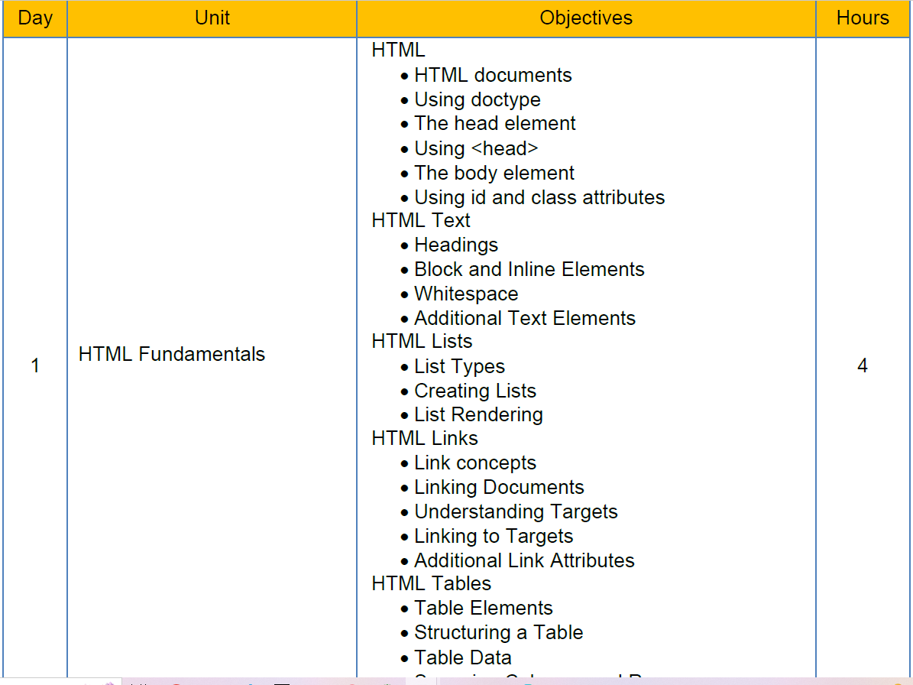

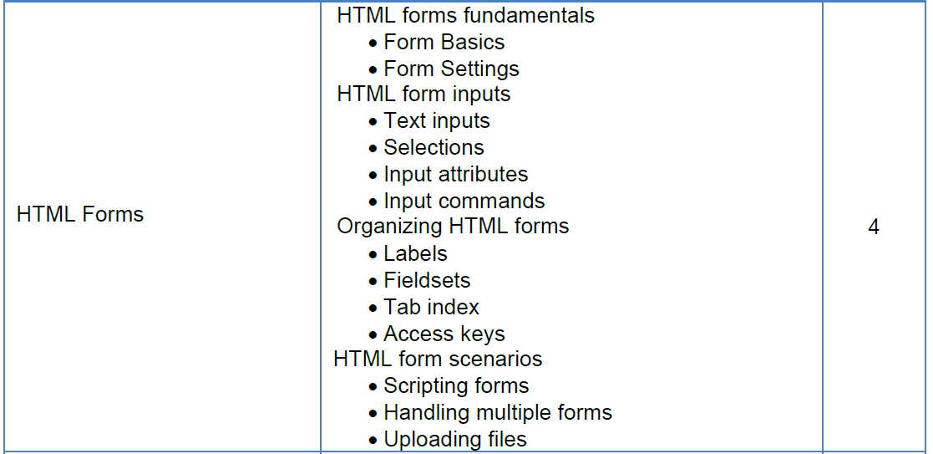

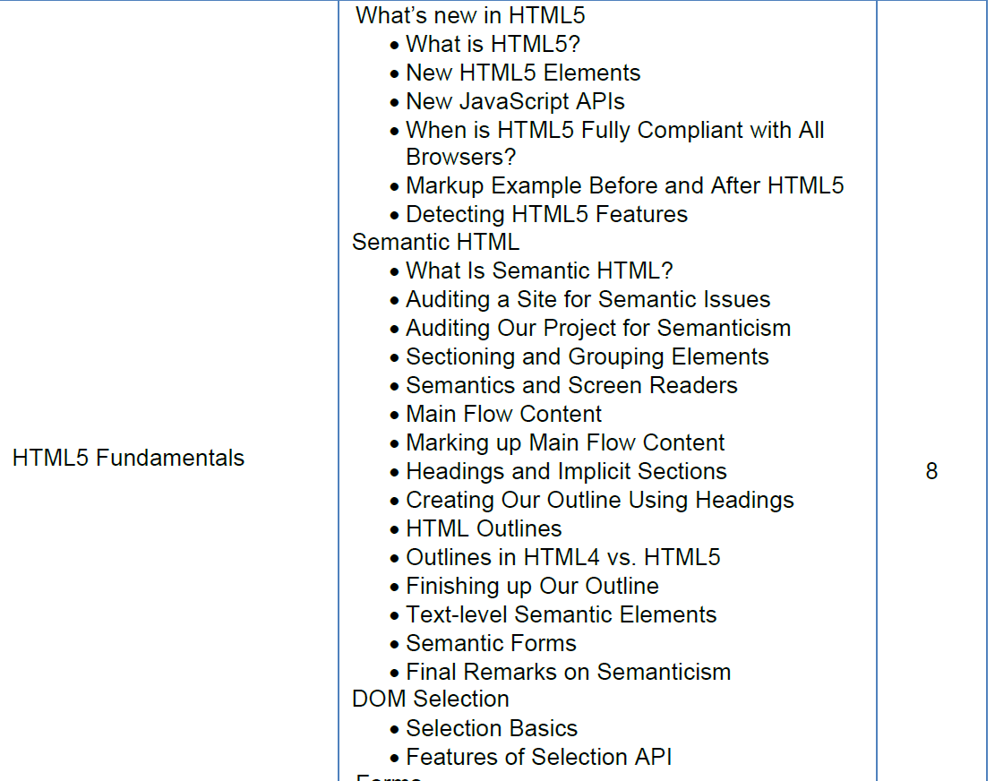---------------

CSS

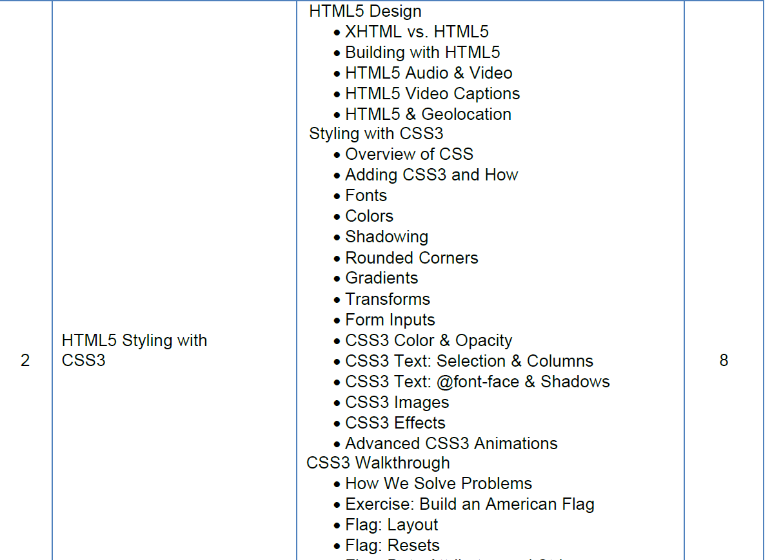

BOOTSTRAP

